The Future Generation:
An Examination of College Students Political Activity.

Kyle E. Davis
Western Illinois University,
Cellular: 309-255-8537
KE-Davis3@wiu.edu

Faculty Supervisor: Dr. Jonathan Day, Department of Political Science

The Future Generation:
An Examination of College Students Political Activity.

Kyle Davis
Western Illinois University, Macomb

Abstract

With political participation on the decline, this research analyzes student behavior to understand how college students are politically mobilized. This study found that what matters to student political participation and knowledge more than religious attendance is the amount of time they have been in college, a belief that their input matters, their membership in a Greek organization, and whether they watch national news or read the newspaper. This research provides an update to our understanding of what most influences a college students’ political participation and level of political knowledge.

Introduction

A
s the future generation of students increasingly decide to continue their education and join universities these students are met with joining a new culture. This culture includes meeting people from other ethnic backgrounds, upbringings, and religions. Religious activity in particular has frequently shown to have a positive effect on students’ political engagement (Smith and Walker 2012). Yet, polls shows that often students are left becoming less religiously active after the first year of college (Bryant, Choi, Yasuno 2003). Pascarella and Terenzini (1991) suggested this is because

“[i]n living at home the student is not only reinforced in the religious value system of parents and siblings but is also insulated from any of the potentially challenging effects of close and continuing associations with other students whose religious values may be quite different.” (p. 314)

Other scholars have noted the decline in religiosity among college students. Glenn Vernon (1968) first brought this to attention suggesting that researchers should look into the growing group of non-religious (“none”) category of individuals. Furthermore, Alexander Astin (1998) in a longitudinal research of college students from 1966-1996 also found that students who identify as having no religious affiliation are on the rise. Additionally, Astin found that students’ political engagement has declined over these years.
Should institutions, searching to make a more politically active future generation, be concerned? After all, many political scientists and sociologists have found a positive relationship between religion as a civic activity and political engagement (Smith and Walker 2012, Leal and Jones-Correa 2001, Djupe and Grant 2001, Martinson and Wilkening 1987, Anderson 1966). These findings parallel Robert Putnam’s (1995) explanation of how the decline in social capital leads to political inactivity. Religion often has an independent effect on political participation; these findings remain consistent even in ethnic minorities like Latino evangelicals (Lee and Pachon 2007). However, little research has been done combining these two fields. That is, few researchers have analyzed the effect of civic involvement on college student’s political participation. Specifically, little has been said about college student’s religious attendance and how much this impacts the student’s political mobilization. Yet, research is heavily saturated helping give a better knowledge of how religion plays a role in politics as a whole.
As an example, politicians increasingly have targeted a population’s religious trait to gain popularity (Sheets, Domke and Greenwald 2011, Weber and Thornton 2012, Domke and Coe 2008). Bethany Albertson (2011) has suggested that since religious attachments are made from early on in one’s life that when politicians use religious coded language that oftentimes one will be unaware of the appeal. Yet little has been said of how, or if at all, these strategies affect college students.
Because of the increased number of non-religious university students but the positive impact religious attendance has on political mobilization, we are left wondering what outcome will result in students’ political engagement. University students undergo a retreat from their hometown and end up forging new identities while at school. During this time of development, it is critical to understand what has the largest influence on students’ political participation as we seek to understand the future generation.

Theory

Little has been researched on what the most important factors are of why college students become politically active. William Galston (2001) researched the topic and explained that college student’s political participation is greatly increased when the student is involved in a civic education. Furthermore, the student’s political participation has received mixed results when the student is allowed to reflect upon their experiences in being civically active. This paper serves to update the literature on how students become politically active and to find out how important religious activity is to a college students’ political engagement when compared to a number of variables.
With students’ religious attendance on the decline (Bryant et. al 2003), I hold that other variables have come to take a larger effect on students’ political participation. The year a student is in college and a student’s belief that their input matters will have a greater impact on political participation than religious participation. The year a student is in college is more likely to be important because the longer one is in college the more opportunities and conversations students have had to lead the student to become more civically engaged. Additionally, the longer a student is in college the more likely they are to understand the importance of political engagement. A student’s belief that their vote or voice matters is important because when a student believes their input is important the more likely they are to give it through political participation.
In addition, in college there are many opportunities to remain civically engaged that are not attending religious services. For example, joining a Greek fraternity or sorority (also known as “Greek life” due to the idea of an interconnected organizational community) or even keeping informed with national news or reading the local newspaper. Joining a Greek organization boosts civic engagement because of the intense involvement most Greek organizations have with the university community. Intense involvements by the student should lead to an increase in political participation if Putnam is correct about his idea of civic engagement leading to a more politically active society (Putnam 1995). Also, keeping in touch with the local news encourages civic engagement because students will be informed of local and national issues and know why upcoming elections matter. Furthermore, many university classes and residence halls offer guest lectures and programs that keep students informed and socially active. Being in this environment for more time may result in more political participation among students.
It is important to clarify that religious activity may still have an effect on college student’s political participation independent of these other factors. However, it is likely that college students’ level of political participation is influenced by these other factors to a greater degree than their religious involvement. This expands upon the literature which studies adults and the impact of religion on political participation by showing the relative impact of religious activity compared to other factors for college students (Smith and Walker 2012, Jones-Correa and Leal 2001, Djupe and Grant 2001, Martinson and Wilkening 1987, Anderson 1966).
For it to be true that these other variables have a greater impact on student political participation than religious participation the hypothesis must be true that other student engagements hold a greater influence on college students’ political participation than religious involvements. It is likely to be seen that students who identify as an Atheist or Agnostic do not take a decline in political participation just because of the lack of religious service attendance. Similarly, students who are religious will not take a decline in political participation just because of a lack of religious involvement.

Data and Method

To test the hypotheses, I used data drawn from a survey conducted in 2007 on the Western Illinois University Macomb and Quad Cities campuses. The survey was conducted through the emails of approximately 13,000 students. Over one thousand responded to the survey which asked students multiple questions including questions on student’s political knowledge, participation, and their religious involvement.
The dependent variable, “Political Participation Index” is a compilation of seven questions creating the functional form:

Political Participation Index = F(student government involvement, political organization involvement, internship program involvement, student elections involvement, participation in discussions on political issues, involvement in demonstrations or protests, and the frequency to which the student follows political campaigns)

Table 1: Descriptive Statistics of Political Participation
 | N | Minimum | Maximum | Mean | Std. Deviation
Political Participation Index | 1031 | .00 | 7.00 | 1.91 | 1.46

The political participation variable is coded from zero to seven with zero being “no participation” and a seven meaning “very high participation”. The mean of the students’ self-reported political participation is 1.91. The Political Participation Index includes both active participation such as involvement with student government or a political organization, and passive participation such as following the presidential campaigns or if they have discussed political issues with others.
The internship variable is included in the political participation index because the internship variable serves as a measure of successful networking and experience. Networking involves appealing to employers and this is very similar to how a politician appeals to voters because both require communication, appearance, and persuasion. Furthermore, the internship variable serves to measure the students experience with using their skills in their field. For both of these reasons the internship aspect is added to the political participation index.
Another variable used to gauge the political participation of students is the “political knowledge” variable. This variable is used to test the student’s sophistication in the information about the 2008 presidential election. The questions were all asked separately and each question had twenty individuals the respondent could select to answer each question. This variable consists of four questions creating the functional form:

Political Knowledge = F(knowing which candidate is of Hispanic descent, knowing which candidate played an attorney on the NBC television series “Law and Order”, knowing which candidate was once the governor of Massachusetts, knowing which candidate was a former vice presidential candidate)

Table 2: Descriptive Statistics of Political Knowledge
 | N | Minimum | Maximum | Mean | Std. Deviation
Political Knowledge | 1186 | .00 | 4.00 | 1.6 | 1.39

The political knowledge variable is coded from zero to four with zero meaning “no knowledge” and four being “a lot of knowledge”. The mean of the student’s political knowledge was 1.6 out of 4 questions. This variable is used as a second dependent variable to better understand if a student is politically active. For example, if a student knows that Mitt Romney was the governor of Massachusetts this would indicate that the student at some point learned this from being engaged in a political conversation or learned about this knowledge from a national or local media outlet. For this reason it is assumed that being more knowledgeable about recent political figures one would be more politically active. Likewise, if one is more politically active one would have more knowledge about political figures.
Finally, the target independent variable is the student’s frequency with religious services. The question was stated, “Since entering college, how frequently or infrequently have you attended a religious service?” This question tries to focus on the college student’s religious engagement after leaving home.

Table 3: Descriptive Statistics for Attending Religious Services
 | N | Minimum | Maximum | Mean | Std. Deviation
Attending Religious Services | 1018 | .00 | 3.00 | .96 | 1.11

The variable is coded from zero to three with a zero response meaning “not at all” and a three being “very frequently”. A one response indicates the student “does not attend frequently” and a two response indicates the student attends “somewhat frequently”. Analyzing the descriptive statistics for this variable we see that the mean of the responses is .96. This indicates that the average of responses landed just below a one meaning “not very frequently”. This parallels the literature because it was reported that most students abandon religious services after leaving home (Pascarella, Terenzini 1991). This may also be explained by students simply not having as much time to attend religious services.

Figure 1: Mean of Political Participation, Political Knowledge and Religious Services Attendance Sorted by Religious Identification.
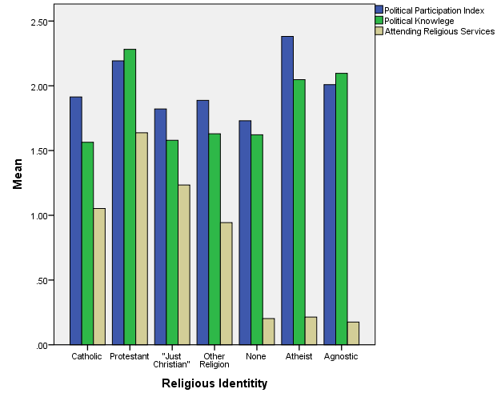

When looking at the mean of all of these variables and categorizing each of these by how the respondent identified religiously we see the spread of surveyed students more clearly. We see that students who identify with a religion do not have higher political participation or political knowledge even with higher amounts of religious service attendance then non-religious respondents. Respondents that identified as Atheist have reported the highest amount of political participation; additionally, non-religious respondents have the second highest political knowledge behind Protestant respondents. Among religious respondents there does not appear to be a correlation between religious attendance and higher political participation. For instance, Catholic respondents have lower religious attendance than respondents that identified as “Just Christian” yet Catholic respondents have higher political participation and nearly equal political knowledge. In order to see if students gain political participation from other sources we must use a statistical model that includes respondent’s religious attendance and the other possible variables.
The method used is an OLS regression. Using this statistical estimator we can see if any variables are correlated with the dependent variable. One independent variable used is the “year in college” which is coded from one to six. A one indicates the respondent is in freshman standing and new to college whereas a six indicates the respondent is a graduate student and has had a lot of university experience. The other variables used include “belief in personal impact abilities” which asks the student if they believe that their vote/voice matters in politics, “joining Greek life” is a dichotomous variable that records if the student is involved in a lettered organization or not, and “frequency of watching national news on TV” along with “frequency of reading the newspaper” record the media consumption of the respondent per week.
Three other variables had been used in previous models, including the student’s family income, the student’s ethnicity, and the student’s satisfaction with their education. These three variables did not have a significant relationship with political participation and so were excluded from the model. The student’s sex was used for the model on political knowledge only since it was found to be insignificant with respect to political participation. The student’s sex is coded one for male and two for female.

Findings

Table 4: Political Knowledge Analysis
Model |  | Unstandardized Coefficients |  | Standardized Coefficients | t | Sig.
 |  | B | Std. Error | Beta
1 | (Constant) | .958 | .177 | ----- | 5.412 | .000
 | Attending Religious Services | .076 | .037 | .060 | 2.038 | .042
 | Political Participation Index | .153 | .030 | .159 | 5.111 | .000
 | Belief in Personal Impact Abilities | .122 | .049 | .073 | 2.513 | .012
 | Year in College | .165 | .024 | .209 | 6.974 | .000
 | Frequency of Watching National News on TV | .112 | .019 | .185 | 5.786 | .000
 | Frequency of Reading the Newspaper | .045 | .019 | .071 | 2.305 | .021
 | Sex | -.421 | .083 | -.150 | -5.094 | .000
*Dependent Variable: Political Knowledge

In the first regression we seek to better understand the student’s political knowledge. As stated earlier, if we can better understand what factors correlate with an increase in political knowledge then we can better understand the frequency to which a student is surrounded by political conversation or news. In the first regression we see that attending religious services holds a lower absolute value standardized coefficient beta then all other variables in the model (Beta = 0.06 for Attending Religious). This means that Political Participation (Beta = 0.159), Belief in Personal Impact Abilities (Beta = 0.073), Year in College (Beta = 0.209), Frequency of Watching National News on TV (Beta = 0.185), Frequency of Reading the Newspaper (Beta = 0.071), and the Sex of the individual (Beta = -0.15) all have a greater influence on political knowledge than Attending Religious Services. Next, It makes sense to see political participation leading to a higher amount of political knowledge because if a student is involved in politics then the student has most likely gained political knowledge about the presidential election. Furthermore, we see that a student’s belief in their personal impact in politics leads to a higher amount of political knowledge. This too is understandable because if a student is more willing to believe that their vote and voice matter then they are more receptive to learning about politics. Also, a student’s year in college has a larger effect on political knowledge than religious involvements. This is understandable because the longer one is in college perhaps the more mature the student has become and the more relevant politics appear. Also, this may be because as students age they begin to care more about politics because the impacts of politics are more recognizable (for example trying to gain a job in a tough economy or paying taxes). Finally, we see that students who watch national news and read the newspaper have more political knowledge and to a larger effect then attending religious services. Paying attention to news means the student is more likely to see political advertisements and political coverage thus making the student more knowledgeable about politicians and more likely to know why participation matters.
Using the OLS regression we are able to make more precise observations about the data collected. This is done by creating a percentage of the unstandardized coefficient beta to the index (in this case four questions were factored into determining political knowledge). For instance, we see that for every one unit increase in the frequency that the student responded they attend religious services they exhibit a 1.9% increase in political knowledge. This impact is substantively insignificant when compared to other independent variables. For example, every year a student completes in college the student gains 4.1% more political knowledge. While this may also seem substantively insignificant it does show us which is more influential on how college students develop political knowledge. The observed increase in political knowledge as a college student advances in their education is precisely what should be expected from academic institutions. Note that every student will increase their political participation as they advance through college regardless of major or field of study.
While this first regression may lead us to understand more of what factors correlate with an increase in political knowledge it only indirectly attempts to understand what factors correlate with an increase in political participation. The next regression tests these variables on political participation.
Table 5: Political Participation Analysis
Model |  | Unstandardized Coefficients |  | Standardized Coefficients | t | Sig.
 |  | B | Std. Error | Beta
1 | (Constant) | .492 | .119 | ----- | 4.145 | .000
 | Attending Religious Services | .046 | .039 | .035 | 1.166 | .244
 | Political Knowledge | .182 | .034 | .175 | 5.393 | .000
 | Belief in Personal Impact Abilities | .207 | .051 | .119 | 4.019 | .000
 | Year in College | .085 | .026 | .103 | 3.313 | .001
 | Joining Greek Life | .604 | .143 | .122 | 4.218 | .000
 | Frequency of Watching National News on TV | .121 | .020 | .193 | 5.948 | .000
 | Frequency of Reading the Newspaper | .068 | .020 | .104 | 3.314 | .001
*Dependent Variable: Political Participation Index

In the second regression we see all of the variables are statistically significant with the exception of “attending religious services” variable. The null result for attending religious services means that we do not have evidence from this data that attending religious services influences political participation. We find that having political knowledge leads students to be more active in politics which is similar to the first regressions findings of students who are more involved in politics having more political knowledge. We see that students who believe their vote and input matters will have higher political participation. The longer a student is in school also correlates to more political participation. Furthermore, a student who is involved in a fraternity or sorority is far more likely to be involved in politics then a student who is not a member of Greek life. Finally, a student who watches national news and reads the newspaper is more likely to participate in politics.
Like before, this regression can lead us to better understand the degree of impact an independent variable can have. We see that for every unit increase in the belief that that the student’s actions matter results in a 2.9% increase in political participation. Additionally, joining a Greek organization results in a 8.6% increase in political participation. Also for every additional day that a student watches national news or reads the newspaper the student increases their political participation by 1.7% and 1% respectively. Finally, for every year a student remains in college their political participation increases by 1.2%.

Figure 2: Political Participation and Political Knowledge by Year in College
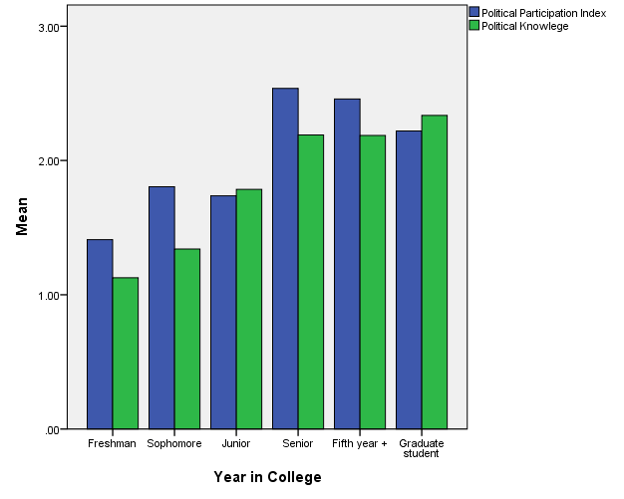

We see the findings more clearly in the above graph which shows us the rise in political participation and political knowledge over the course of a college student’s experience. As stated before, for every year a student completes of college their political participation rises 1.2%. Similarly, for every year of college a student completes they are 4.1% more politically knowledgeable. This could be explained by multiple reasons including the maturity of the student that is being developed, the student learns more about politics in their general education courses, or that the student understands politics as more important as they advance in college. These explanations seem to be more impactful on political participation than the student’s religious attendance in their college years. These results also help speak to the importance of staying in school as political participation is very critical to a function democracy.
Figure 3: Political Participation and Political Knowledge by Greek Life Membership
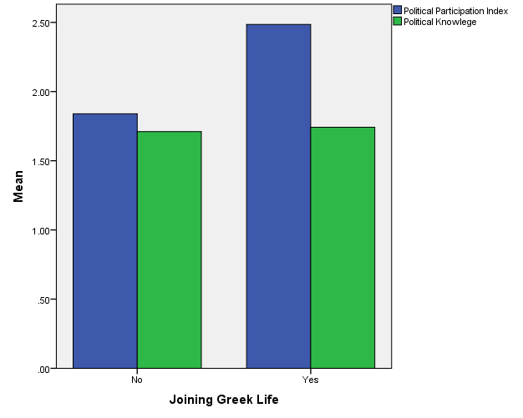

Similar to a student’s year in college we see that students who are involved in Greek life have 8.6% higher political participation. This may be because students who are involved in Greek life are more willing to participate having already joined one organization or that students who join Greek life are familiar with some political processes (voting in executive members of their organization) and are willing to do the same through other means. Future research could look into both a student’s year in college and their involvement in Greek organizations to discover the root causes for more political participation. It is understandable that joining a Greek organization would lead to more political participation than being religiously active because of the skills and practices that a student who is involved in Greek life will gain.
Finally, it is understandable that other independent variables like believing in the impact of one’s actions and watching or reading the news would have a greater influence on political participation than religious attendance. If a student believes their vote and voice matter then it is understandable that they are more willing to vote or speak out. This belief can be aided by a student’s friends, teachers, mentors or parents to better motivate a student to be politically active. Additionally, a student who is well informed is more likely to be politically active. This mirrors Putnam’s research on political activity and the idea that being a part of society will lead to more involved and stronger democracies (Putnam 1995). All of these independent variables lead us to a better understanding of what influences a student to become more politically engaged.

Conclusion

With the literature noting that non-religious students are on the rise (Astin 1998) and if the main objective is to increase student’s political participation then we must look to see where this new generation of students is gaining their political participation and one must support these involvements. Most notably the analysis shows that students who join Greek life, believe their vote and voice matters, and stay in school will tend to be more politically active.
Future qualitative or quantitative research could be done to see how more or less effective fraternities or sororities are at causing students to become politically active. Also one could analyze the political participation between a university with large and complex Greek life to a university with little to no Greek organizations. I recognize that when having an ordinal level dependent variable it may be best to use an ordered logistic regression yet I have decided to remain with the OLS regression in this paper because it is easier to interpret. However, future research could use a more advanced statistical technique such as an ordered logistic regression.
There is also some possible arguments against including one’s internship involvement into the measure of political participation. I understand that this may account for the large amount of senior students’ political engagement (even higher of that of graduate students). Yet, I still feel as though there must be a way to measure the skills one uses when looking for employment. Those looking to gain employment in an internship must use self-advertisement, speech, and persuasion – all of which are political skills used in say an election caucus. Future research could control for this variable or use an entirely different measurement to account for these skills.
Next, if it is true that students who believe their input matters are more politically active, then a university should support this philosophy. Political participation is increasingly more of an issue as voter turnout reaches new-found lows (Astin 1998). Future research could analyze schools who host programs and have reminders of upcoming elections and if these schools would be likely to succeed in having higher political participation among their students.
Finally, analysis shows that students who stay longer in college have more political participation. Perhaps future research could expand upon this and note which year hosts the highest political participation for public versus private universities. It is understandable to say that the longer one stays in school the more time one has to become involved; however, it may be more interesting to see if the development of the student leads to higher political participation. It may be the case that maturity has an independent effect on political participation.
Overall, for university students, this study reveals that that religious participation does not significantly impact a student’s political participation and was found to be the least influential on political knowledge. With non-religious students on the rise, students have adopted other means to stay involved in politics like joining a Greek organization, staying in school, watching national news on TV, and even reading the newspaper. These involvements that students take part in should be supported in hopes of raising political participation for the future generation of students in the United States.

References

Albertson, Bethany L. 2011. “Religious Appeals and Implicit Attitudes” Political Psychology 32(1): 109-129.

Anderson, Grace M. 1966. “Voting Behaviour and the Ethnic-Religious Variable: A study of a Federal Election in Hamilton, Ontario” The Canadian Journal of Economics and Political Science 32(1): 27-37.

Astin, Alexander W. 1998. “The Changing American College Student: Thirty-Year Trends, 1966-1996” The Review of Higher Education 21(2): 115-135.

Bryant, Alyssa N. Choi, Jeung Yun. Yasuno, Maiko. 2003. “Understanding the Religious and Spiritual Dimensions of Students’ Lives in the First Year of College” Journal of College Student Development 44(6): 723-745.

Djupe, Paul A. and Grant, Tobin J. 2001. “Religious Institutions and Political Participation in America” Journal for the Scientific Study of Religion 40(2): 303-314.

Domke, David. and Coe, Kevin. 2008. “The God Strategy: How Religion became a Political Weapon in America” Oxford University Press.

Galston, William A. 2001. “Political Knowledge, Political Engagement, and Civic Education” Annual Review of Political Science 4: 217 – 234.

Leal, David L. and Jones-Correa, Michael A. 2001. “Does Religion Matter?” Political Research Quarterly. 54(4): 751-770.

Lee, Jongo and Pachon, Harry P. 2007. “Leading the Way, An Analysis of the Effect of Religion on the Latino Vote” American Politics Research 35(2): 252-272.

Martinson, Oscar B. and Wilkening, Eugene A. 1987. “Religious Participation and Involvement in Local Politics Throughout the Life Cycle” Sociological Focus 20(4): 309-318.

Pascarella, E. T., and Terenzini, P. T. 1991. “How College affects Students: Findings and Insights from 20 Years of Research” San Francisco: Jossey-Bass. pg. 314.

Putnam, Robert D. 1995. “Bowling Alone: America’s Declining Social Capital” Journal of Democracy: January 1995: 65-78.

Sheets, Penelope. Domke, David S. Greenwald, Anthony G. 2011. “God and Country: The Partisan Psychology of the Presidency, Religion, and Nation” Political Psychology 32(3): 459-484.

Smith, Lauren E. and Walker, Lee Demetrius. 2012. “Belonging, Believing, and Group Behavior: Religiosity and Voting in American Presidential Elections” Political Research Quarterly 66(2): 399-413.

Vernon, Glenn M. 1968. “The Religious ‘Nones’: A Neglected Category” Journal for the Scientific Study of Religion 7(2): 219-229.

Weber, Christopher. and Thornton, Matthew. 2012. “Courting Christians: How Political Candidates Prime Religious Considerations in Campaign Ads” The Journal of Politics 74(2): 400-413.

