WORKFORCE PLANNING

IN THE

WATER/WASTEWATER INDUSTRY

By: A. Amber Ford
Email: amber.ford@wku.edu
MPA Student
Department of Political Science
Western Kentucky University
Bowling Green, KY 42101

Introduction

“When the well is dry, we know the worth of water” (Benjamin Franklin, (1706-1790, Poor Richards’ Almanac, 1746) Each day millions of people use indoor shower and toilet facilities; drink water from a tap or fountain and never think twice about the potential health risks in doing so. The reason is simply this, the Federal Water Pollution Control Act gave birth to “publicly owned treatment works for the improvement of wastewater treatment” as well as the current infrastructure that brings clean water to our homes, businesses and public facilities across the United States. (US Environment Protection Agency, http://www.epa.gov/agriculture/lcwa.htm) The operation of these facilities requires a staff of individuals as diversified in their area of expertise as they are in their education and experience. The combination of this and the demand of the public to have such a resource available to them at minimal cost pose a unique challenge to those individuals responsible for the management and direction of each of these organizations. For this discussion, I will attempt to give the reader(s) an overview of the politics, procedures and general management style of a local water/wastewater management organization as well as an analysis and critique of the same from the perspective of a non-managerial employee.
Organizational Structure
First, it’s important to understand the make-up of most water and wastewater management organizations. They are typically publicly owned and at the very least publicly governed. Each state varies in laws regarding the structure of these organizations and depending upon their charter they can be known as a “district”, “association”, “municipal”, “authority”, etc. Each designation comes with its own unique regulations as provided for within the law of the governing state. This further determines whether the organization reports to a board of commissioners, the mayor, board of directors, or a combination of them all. The day to day operations are typically directed by a “superintendant”, “chief executive officer”, or “general/operations manager”. Most water and wastewater organizations are small in comparison to their electricity supplying counterpart as water infrastructure often requires less manpower to operate.
Water management organizations need personnel that specialize in hydrology; water extraction and deliver in addition to infrastructure design; installation; maintenance and repair as well as water specimen collection, testing and quality reporting. Wastewater management organizations require personnel that specialize in the treatment of human/biohazard waste as well as other organic matter that may be discharged into the water system such as grease, chemicals, pharmaceuticals, etc. with the objective being to sanitize and release the water back into the source water system. Wastewater management requires its own expertise in infrastructure design, installation, maintenance and repair. To put it nicely, it takes a “special kind” of individual to be willing to work with and around sewage on a daily basis. You must only travel within a few hundred feet of a treatment facility on a hot summer day to appreciate their plight.
Recruiting, Retention and Education
Each state is continually fighting a shortage of qualified individuals to meet the ever growing demand of water and wastewater treatment. Most utilities live “paycheck to paycheck”. Water and wastewater rates are a constant source of public scrutiny and a political hot potato for local governments as consumers feel that they should simply not have to pay a hefty fee to have access to a natural resource that covers more than two-thirds of the planet. Conversely, less than three percent of available water is suitable for human consumption; (US Geological survey, http://ga.water.usgs.gov) making water potable is an expensive endeavor; and raising utility rates is as unpopular as tax increases forcing the balance between politics and personnel to be tenuous at best requiring industries such as this to be resourceful and creative.
Retention is at the forefront of many water and wastewater utilities today. It is estimated that as boomers begin to retire, Kentucky alone will be faced with replacing 50 qualified water and wastewater operators each year with the onset of thirty-five thousand such vacancies nationwide over the next ten years. (http://waterky.org) These concerns are echoed by Gary Larimore, Executive Director of the Kentucky Rural Water Association as he states,
“Obviously one of our growing concerns is the aging workforce and the challenges our industry has with recruiting new people to fill those vacancies. We need to do a better job of marketing our product and services in order to make it more attractive to those looking for a career.” (E-mail correspondence 2/2/11)

Though it is forecast that the up and coming generation known as millennials has the numbers necessary to fill the gap, their largely digital appetite doesn’t have them lining up for such opportunities. However, continued technological advancements and appropriate marketing of such career opportunities may lend themselves to improved recruiting techniques. According to Sam Wade, Deputy CEO of the National Rural Water Association,
“The majority of systems are small, 92% service less than 10,000 population 60% of those about 1,000 or less. In 1996 there were 54,728 community water supply systems in 2008 there were 51,988 according to EPA data, this documents that systems are consolidating into larger more complex systems driven increased regulations and technology. National Rural and its state affiliates view this issue as a high priority, and have incorporated a Career Opportunity Showcase into the H2O-XPO to be held in Louisville Kentucky in October. The showcase is designed to provide a model for our State Associations and their members to use in an initiative to gain the interest of the emerging workforce in the water and wastewater industry.” (E-mail correspondence 2/2/11)
Additionally, various educational and certification opportunities have been developed across the Commonwealth. Such programs include the Water University Utility Management Certification offered by the National Rural Water Association; the Utility Management Institute Utility Management Professional Designation offered by the Kentucky Rural Water Association and the Water Resource Management Associates of Science Degree through Western Kentucky University’s Ogden College of Science and Technology Department of Architectural and Manufacturing Sciences. Sam Wade, Deputy CEO of the National Rural Water Association believes
“As the shortage of qualified people hits home it will result in … competition and higher salary levels in the industry. Each of these will have a by-product of educating the public on the professionalism of the industry and the actual cost of operations.”

However, education that results in the addition of qualified water and wastewater technicians to the industry is essential and challenging. Given the numerous water systems across the state, and the lack of community and technical colleges available (see diagram 1) to address the education and certification needs of the industry, the university and college community, have and continue to design programs which offer as much training as possible via the internet in hopes of maximizing their potential audience.
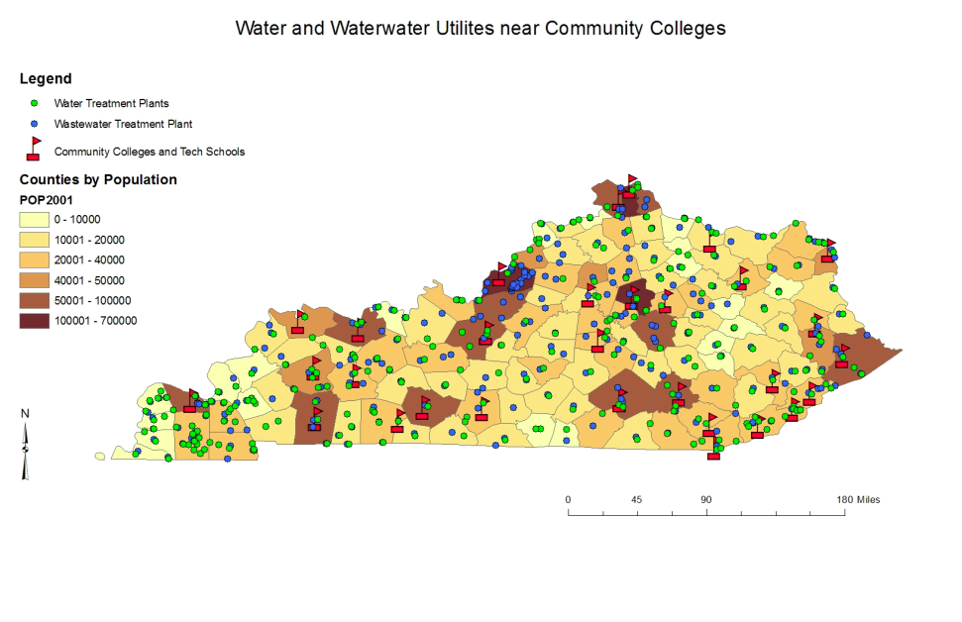
Diagram 1
Provided by Jana Fattic, Graduate Student Western Kentucky University
Compensation is another area nagging the water and wastewater management industry. The ability to recruit and retain qualified candidates in any industry depends, in part, on the industry’s ability to offer a competitive total compensation package. Additionally, individuals must weigh the opportunity costs associated with obtaining training and education in a given field verses the pay off. For example, the national average salary of water operators is $32,538 while electric linemen compare at $52,352 and heating and air conditioning technicians lead at $54,366. (www.CBSalary.com). To further add insult to injury, given the size of most water and wastewater utilities, there is little to no opportunity for advancement beyond the achievement of various state authorized water and wastewater operator certifications of which typically net pay increases of $2,000 or less per year.
As stated earlier by both Sam Wade and Gary Larimore, educating the populations being served is crucial to the development of the industry charged with safeguarding and delivering the resource not only essential for our comfort and well being, but necessary for our survival. It’s my opinion that making efforts to attract qualified talent is not enough. Educating the populous on the value of the industry is imperative. This involves the need to review and most likely increase rates. The politics of public utilities bears a tremendous amount of responsibility for the current state of affairs. Local mayors, commissioners and board members seeking re-election and reappointment must join the professional organizations and local educators to develop and initiate a responsible long-term plan that will foster the growth and sustainability of the water and wastewater industry. While electric providers are seeking cleaner, greener energy options, they have and continue to educate the end users regarding the need for rates that provide the capital necessary to deliver their services. No one argues with the heating and air conditioning industry when the temperatures are extreme, and the water industry must not be willing to compromise their stewardship of such a valuable resource in the interest of public opinion and popularity.
Conclusion
In conclusion, water and wastewater management organizations have and continue to grow and mature in answer to the ever increasing often overwhelming demands placed on their industry. Kentucky leads the industry in developing Total Quality Management initiatives, and yet there remains a tremendous disconnect in their ability to garner the recognition and support of the communities and public officials they serve. The question remains, who will accept the challenge to assist our water and wastewater providers in successfully marketing the value of the products and services we simply can’t live without?

BIBLIOGRAPHY

- Benjamin Franklin, (1706-1790), Poor Richards’ Almanac, 1746
- US Environment Protection Agency, http://www.epa.gov/agriculture/lcwa.htm
- US Geological survey, http://ga.water.usgs.gov
- Water Kentucky.org, www.waterky.org
- Water and Wastewater Utilities Near Community Colleges – Diagram by Fattic, Jana, WKU 2010)
- CB Salary.com - www.CBSalary.com
- Interview Correspondence – Mr. Sam Wade, Deputy CEO NRWA
- Interview Correspondence – Mr. Gary Larimore, Executive Director KRWA

