Title: “Protest Events of the Tea Party Movement and Senatorial Voting Behavior”  
Author: Yamato Hiromatsu (yhiroma@ilstu.edu)

Graduate Student, Department of Politics and Government at Illinois State University

This research addresses a question as to whether there is any relationship between citizens’ participation in protest events and senators’ legislative behavior, by studying Senatorial roll-call votes before and after the 2009 Tax Day rally of the Tea Party movement in the United States. Tea Party movement is a phenomenon in which local activist groups, national advocacy organizations, media, and members of the United States Congress were actively involved. Policy goals of the movement as a whole are understood as reducing tax, slashing public spending, and clearing away regulations on business. This research focuses on policy goals for citizen participants of the movement: they are comfortable middle-class, mainly Anglo-Saxon, and mostly senior citizens, and they are in many cases owners of small business. This research adopts a cross-sectional multivariate observational model and examines the change in senators’ voting tendency concerning roll-call votes on related issue areas. The results show that the 2009 Tax Day rally did not influence Senatorial voting behavior positively. Rather, there were some reactionary consequences that senators from states where rally size was large changed their voting behavior to the direction that Tea Partiers do not favor.

Table of Contents

1. INTRODUCTION: WHY THE TEA PARTY MATTERS? 3

2. WHAT IS THE TEA PARTY? 9

2.1. Nature and Goals of the Tea Party Movement 9

2.2. Tea Party as a Right-Wing Movement 12

3. LITERATURE REVIEW 13

3.1. Social Movement Theories and Outcomes 13

3.2. Outcomes of the Tea Party Movement 19

3.3. Sources of Legislative Behavior 22

3.4. Possible Paths of Influence 26

4. METHODS 27

4.1. Model and Hypotheses 27

4.2. Data 28

Dependent Variable: Selection of Roll-call Votes and Tea Party Score 28

Independent Variable: Protest Events Data 35

Change in the Ideological Orientation of Citizens and Senators 36

Other Control Variables 40

5. RESULTS 40

6. CONCLUSION 45

Appendix: Selected Roll-call Votes 50

References 59

# 1. INTRODUCTION: WHY THE TEA PARTY MATTERS?

According to the General Social Survey[1], the proportion of individuals who reported ever having attended a demonstration rose from 10.1 percent in 1973 to 18.8 percent in 2004 (Caren, Andrew, and Ribas 2011), and then to 21.8 percent in 2014. These figures can be interpreted as a sign that participation in such an activity is one of the practical means of political participation for citizens. Participants of such an activity --- demonstration, protest, march, and rally --- may believe that their participation is an effective tool to convey their political opinion to the government. Although some protesters may find other functions of protest events, the essential role of protest events, at least for ordinary citizen participants, seems to be understood as influencing policy making. This research is motivated by a question posed in response to such a situation: is such an activity truly an effective and rational means for citizens of democratic society to affect policy making? This research takes the case of the Tea Party movement for example and examines the political consequence of it, focusing on legislative behavior of senators. In the following part of this paper, activities such as demonstration, protest, march, and rally will be expressed as ‘protest events’ for the sake of convenience.

Indeed, protest events have played a crucial role in making or abolishing certain laws in the United States. For instance, the labor movement, which mobilized hundreds of thousands of people through big cities in March, 1930, prepared the Wagner Act of 1935 and the creation of the National Labor Relations Board; and the African American civil rights movement, which mobilized 250,000 people in Washington, D.C. on August 28, 1963, led the Civil Rights Act of 1964 and the Voting Rights Act of 1965 (Amenta et al. 2009). Such policy changes might have hardly occurred without protest movements, at least in the manner that they actually took place. Motivation for participating in current protest events may come from the lessons of these past ‘successful’ stories.

However, when it comes to a matter of how far the outcomes of protest events satisfy participant's expectation, the answer is not self-evident. Scholarship does not support the belief that social movements, most of which involve some form of protest events by the masses, always cause policy changes. Rather, social movements cause policy changes only when some extra conditions accompany (McAdam and Su 2002). After all, legislators are not always preoccupied by collective action of citizens. It is just only "the most ideal circumstances" that, "as elected officials, legislators see themselves as responsible to the will of the people" (Cornwall et al. 2007, p. 241).

Given the significant cost of participation in protest events, consequences of protest events are of pragmatic concern to any citizens of society where they have discretion on their behavior and participating in protests is a viable option. It may be particularly beneficial for politically active citizens to know how their participation in protest events matters. It is also an important element for a democratic regime to be stable. As Plato wrote about 2500 years ago, people are, by nature, easily instigated by demagogic rhetoric and resort to disruptive actions, which is not only sometimes detrimental to them but also threats minorities’ voice.[2] Notably, the United States Senate was designed to prevent or reduce such defects of democracy. Even in a situation where the House of Representatives is significantly driven by a populist trend, the Senate can make a deliberate judgment.

In assessing the case of the Tea Party movement, a notable characteristic is that the movement was fueled not only citizen participants but also by advocacy organizations and members of the United States Congress. This fact encourages this research to take into consideration a refined viewpoint to evaluate the efficiency of citizens’ participation in protest events: which group of people benefitted the most or the least from the participation of citizens in protest events, citizens themselves, advocacy organizations, or legislators?

Importantly, there is a significant difference between the means by which these groups of people can benefit from protest events. To put it simply, while citizens are benefitted mainly when their political preferences are realized in policy making, the other two actors have different ways to benefit from protests. For example, advocacy organizations can benefit from making themselves better known to the community and gaining new clients through protest events. Alternatively, electoral candidates can benefit if they increase the possibility of their winning elections through attending protest events or aligning themselves with the groups participating in the events. Accordingly, it may be said that, if the protest events did not influence policy making the citizens’ participation in the protest events ended up benefiting advocacy organizations and electoral candidates more than citizen activists themselves.

This research focuses on the policy goals of ordinary citizen participants. The concepts of benefit-seekers and office-seekers (Schlesinger 1975) help clarifying different motivations of people who participate in political activities where legislative parties play a role. The aspect of office-seekers, whose goal is office, is dominant in the depiction of electoral candidates. Any political action, including their participation in protest events, means almost nothing for them if it does not increase the chance of getting elected. Advocacy organizations would be understood as the first type of benefit-seekers in Aldrich (2011): those who are motivated by patronage dispersed by successful electoral candidates. To the contrary, the second type of benefit-seekers, which include citizen protesters, is motivated by their will to affect actual policy making. This perspective again backs up the direction of this research to link citizen participants and policy change and to be cognizant of different mechanisms of benefitting from protest events for different groups of people.

This research focuses, in particular, on roll-call votes of the United States senators. Scholars of political outcomes of social movements look at various stages of legislation, such as agenda setting, introduction of bills, actions of committees, floor debate and votes in two chambers, and law passage. These stages can be analyzed as dependent variables in comparative studies typically among state level legislatures (e.g. King, Cornwall and Dahlin 2005; Soule and Olzak 2004). Strength of this method, especially models that include initial stages, is that it can account for small impact of social movements that does not influence later stages of legislative process. However, this research does not adopt this various-stage model, but focuses on roll-call votes in the Senate, for three reasons. The first comes from the characteristic of the Tea Party movement. Since the movement is a nationwide phenomenon and its policy goals are mainly concerned with policies of the national government, behavior of legislators in Congress is the primary target of this research. Looking at initial stages and actions of committees to find anomalies caused by the movement is not right to the point.[3]

The second reason is subjective. This research intends to examine a question as to whether citizen participants of protest events are rewarded by implementation of policies that are preferable to them. Selection of roll-call votes to be examined in this research is driven by this standpoint.

Thirdly, this research intends to be a complement to extant research on the influence of the Tea Party movement on legislative behavior. While roll-call votes of House members have received some scholarly attention (Bailey, Mummolo and Noel 2012; Madestam et al. 2013), senators’ roll-call votes is a topic that has not been discussed extensively. That extant research often focuses on House members is not a compelling reason to dismiss the behavior of senators. First, senators were involved in the Tea Party movement like the members of the House of Representatives. There were senators who were endorsed by advocacy organizations and those who participated in the Tea Party Caucus, declaring that they agreed with the policy preferences of the Tea Party. Secondly, the role of the Senate in the United States Congress is consequential: they amend the bills and determine the passage of bills, just as House members’ behavior can.

Analyses of Senate members need a different standard, from those on House members, however. Although the assessment of senators’ roll-call votes will be simpler than that of the members of the House in terms of the number of members and the complexity of their electoral districts, distinctive characteristics of the Senate may come into play. The gist is that the Constitution deliberately insulates the U.S. Senators from public pressure. Their serving term is longer and the size of their electoral district is larger than those of House members. Constituents impose, therefore, less frequent electoral pressures on senators. For example, senators who were elected in the 2008 election are not running for reelection until 2014, which is a time when the Tea Party has already lost its thrust, and thus they probably had less incentive for behaving in a way that had been favored by citizen participants of Tea Party. Thus, explaining what factors influence senators’ legislative behavior and what kind of senators are likely to be influenced by these factors may be an important task of this research.

A methodological advantage of analyses on the outcomes of the Tea party movement is that, due to its relatively distinctive periods of emergence, a before-after comparison of the influence of protest events is possible.

Significance of research in general on the Tea Party movement is its potential to assess the influence of factors that cannot be simply explained by principles of the Democratic Party or the Republican Party or accompanying ideologies, on legislators’ decision making. While policy preferences of the Tea Party greatly overlap with those of the Republican Party, and observers of the movement argue that the movement shifted the center of gravity of the Republican Party to far-right (Formisano 2012; Skocpol and Williamson 2012), research based on survey data reports differences between the opinion of Tea Party supporters and other Republican supporters (Abramowitz 2012; Arceneaux and Nicholson 2012; Rapoport et al. 2013). Research based on interviews with local activists also report that their policy preference does not match policy goals of advocacy groups and libertarian legislators (Skocpol and Williamson 2012). Therefore, this research can provide insights on how legislators react to policy preferences of constituents that do not perfectly coincide with the principles of their legislative parties.

In summary, this research is an attempt to examine whether protest events influence the behavior of Senators, paying chief attention to the policy preferences of citizen participants. It will contribute to the academic knowledge about both the political outcomes of social movements and particularly the Tea Party movement, and also legislative behavior of the members of the United States Congress.

Section 2 will provide a brief summary of the characteristics of the Tea Party movement, focusing on necessary backgrounds for constructing the model of this research. Section 3 will review literature on social movements, the outcomes of the Tea Party movement, and legislative behavior. Section 4 will explain the model of this research, and Section 5 will report the results.

# 2. WHAT IS THE TEA PARTY?

## 2.1. Nature and Goals of the Tea Party Movement

This section briefly summarizes the nature and goals of the Tea Party movement: its emergence and decline, principles and policy goals, causes of citizens’ activism, organizational characteristics, endorsements of senators by advocacy organizations, and senators’ participation in the Tea Party Caucus. Basic understanding of the Party’s historical background is essential for making assumptions about the chronological changes of the effects of the Tea Party movement on policy making. Policy preferences of the Tea Party, in particular of citizen participants, will be a basis for the selection of the roll-call votes, which will be explained in detail in Section 4. Although the target of this research is not electoral results but legislative behavior, the electoral results are mentioned in this section as a part of the historical background of the movement.

The emergence of the Tea Party movement can be traced back to an anti-Porkulus protest in Seattle in early February 2009 (Skocpol and Williamson 2012). On February 19, CNBC commentator Rick Santelli made a widely televised speech at the Chicago Mercantile Exchange. Many books and articles mention to this as a monumental event at the dawn of the Tea Party. On February 27, small crowds gathered in dozens of cities across the country. Fox News took up the rally cry in March and early April, and triggered the rallies on the Tax Day, where hundreds of thousands rallied and reiterated anti-government messages. Estimated total numbers of the crowd of the day vary from 311,460 (Silver 2009) to 520,000–700,000+[4]. Rallies continued in the months that followed. Protesters gathered in August town hall events with local congressional representatives. On September 12, between 60,000 and 70,000 Tea Party protesters marched on Washington D.C. (Skocpol and Williamson 2012). Periodic rallies continued through 2010, which made it a pivotal year of the Tea Party movement. A report notes that the total crowd number of the Tax Day rally in 2010 was 57,845 (Messamore 2010). The Tea Party still exercised its influence in the 2012 elections. Citizens’ support or concern to the movement declined in 2013 and 2014, according to public opinion surveys[5].

The chief goal of the Tea Party is, in a nutshell, to downsize the federal government. ‘Tea’ in the name of the movement is said to be the acronym of ‘taxed enough already,’ and the ‘Tea Party’ symbolism was “a perfect rallying point since it brings to mind the original American colonial rebels opposing tyranny by tossing chests of tea into Boston Harbor” (Skocpol and Williamson 2012, p. 7). The speech made by Santelli spoke to adoration for freedom and patriotic sentiment of the U.S. citizens. Santelli exclaimed: “[h]ow many of you people want to pay for your neighbor’s mortgage that has an extra bathroom and can’t pay their bills?,” and “If you read our Founding Fathers, people like Benjamin Franklin and Jefferson, what we’re doing in this country now is making them roll over in their graves.” Such a narrative was seen in protest events with expressions such as ‘to take back the country.’ What the Tea Party wants is to downsize the federal government and to expand freedom of citizens.

The goals of the Tea Party include reducing taxes, slashing public spending, curbing public sector unions, and clearing away regulations on business. Participants in the movement also supported policing immigrants, safeguarding Second Amendment gun rights, and promoting pro-life and traditional family values. The American Recovery and Reinvestment Act, signed into law by President Obama on February 17, 2009, and the Affordable Care and Patient Protection Act, signed into law on March 23, 2010, were opposed by most Tea Party members (Skocpol and Williamson 2012). Zernike (2011) writes that the participants put more focus on economic issues than on social issues.

Although such policy goals overlap the policy preferences of the Republican Party, the Tea Party movement does not necessarily support the Republican Party. An example of policy where the preference of the Tea Party may deviate from that of the Republican Party is bailouts of banks, which was initiated by the administration of President George W. Bush and carried forward by the Obama administration. While the Tea Party manifested clear objection to this program, still some Republican legislators supported the bailouts.

According to observers of the movement, it was frustration with President Barack Obama and the Republican Party that caused citizens’ activism. Tea Party activists were irritated with the big-government principles of President Obama, which proposed health care reform and the costly bailouts of banks. Observers of the movement also note that activists held hostility against the personality of President Obama. Meanwhile, the Republican Party lacked its clear leader after President George W. Bush left and John McCain lost the 2008 presidential campaign. After the 2008 elections, pundits debated whether the Republican Party might be doomed to long-term decline (Skocpol and Williamson 2012). Citizens who felt frustration with both President Obama and Republicans formed local groups and started to hold meetings and protest events.

Tea Party participants held local meetings and made financial contributions to advocacy organizations and electoral candidates, as well as their participation in rallies. Local organizing of citizens groups was especially prominent during the period from spring to fall of 2009 and in 2010. Approximately 1000 local Tea Party groups were created, and their meetings were held regularly, usually once a month, but in some cases weekly (Skocpol and Williamson 2012). Strong regional networks of local Tea Party participants became a long-lasting characteristic of the Tea Party movement, and thus, were one of the chief causes of the mobilization of citizens in protest events. Madestam et al. (2013) show that protest events cause increases in the number of local organizers and the amount of financial contributions to Tea Party advocacy organizations. These three elements, such as rallies, local organizations and financial contributions, are expected to be mutually correlated, and any of them have potential to influence legislators’ behavior.

In summary, in the Tea Party movement, citizens formed local groups, and hundreds of thousands of people attended protest events. Advocacy organizations and members of Congress were the core part of the movement as well. It is already manifest that advocacy organizations and electoral candidate have received subjective returns from their participation in the movement: advocacy organizations publicized their name and attracted financial supports from citizens, and electoral candidates was either elected or defeated in elections (Karpowitz et al. 2011; Bailey, Mummolo and Noel 2012; Carson and Pettigrew 2013; Madestam et al. 2013). The remaining is the question of this research: whether the will of participants of protest events influenced policy making.

## 2.2. Tea Party as a Right-Wing Movement

A macro perspective gives a different explanation of the cause of the Tea Party movement. It is a viewpoint which regards the Tea Party movement as a right-wing movement. Parker and Barreto (2013) argue that the principle of small government and traditionalism were seen in the Ku Klux Klan of the 1920s and the John Birch Society around 1960s as well, and that what is common in participants of these three phenomena is a sentiment of fear. This understanding is consistent with the argument of Smelser (1962) that psychological conditions can be a reasonable cause of collective actions. These movements occurred as a reaction to the ongoing changes of the society.

If the Tea Party movement is simply a recent form of right-wing movement, findings in research on the Tea Party movements may be to some extent generalizable to other right-wing movements. Fortunately, being different from the cases of those two right-wing movements in the beginning or middle of the twentieth century, substantial data about protest events, activities of other actors, and other social and demographic information are available for the time when the Tea Party movement took place, and hence testability of research models.

Next section will review the literature on social movements, outcomes of the Tea Party movement, and legislative behavior. Literature on social movements provides theories to understand the mechanisms of social movement and tools to assess outcomes of social movements at large. Summary of extant research on outcomes of the Tea Party movement follows. Literature on legislative behavior reviews the incentives for legislators to act in specific ways in Congress, which is a theoretical basis for the causal mechanism of the model on the legislators’ side.

# 3. LITERATURE REVIEW

## 3.1. Social Movement Theories and Outcomes

Before conceptualizing the Tea Party movement as a social movement, the Tea Party movement must be seen as a phenomenon of collective action, not of individual action. Theories about the mechanisms of collective action at large assume that participants of collective actions are rational individuals. Citizens participate in collective actions in order to signal their policy preferences against policy makers (Lohmann 1993). Such individuals rationally choose whether they participate in a certain collective action or not, by calculating, not necessarily elaborately, the returns and incurring costs of the actions that they take (Olson 1971). Olson (1971) also notes that, apart from economic incentives, returns can be social benefits, such as reputation, or psychological rewards, such as pride. The reasons of participation and degree of commitment can vary depending on those unique individuals. This assumption is not an indispensable presumption of this research but can be a strong reasoning of its focus on policy change. If it is assumed that participants of the Tea Party movement, at least some of them, rationally aimed at policy change as a collective achievement through their action, which is very likely at minimum, policy change is an analytically important element of the movement, for it determines its success or failure.

Although success and failure for participants in the case of the Tea Party movement can be judged, chiefly, by assessing whether collective action caused implementation of preferable policies, success and failure of social movements in general is not always manifest. These two concepts can mean different consequences of a movement, depending on the person who judges. Therefore, there is a methodological necessity for scholars to always declare their own criteria of defining success and failure in their research or borrow definitions from other scholars. Gamson (1975) and Piven and Cloward (1977) took the initiative of this academic endeavor. They are common in pointing out that there are multiple events that can be considered as success, and thus, comprehensive and detailed evaluation is necessary for each social movement. They also coincide in opinions that success is rather relatively a rare case or the gains are at best moderate, and that disruptive protests are the most effective form of social protests. Success can be larger or smaller, thorough or partial, or at smaller or larger cost.

From the macro perspective, the range of success is wide across social movements. Success in a broad sense can include continuation of the movement, achievement of new members, disseminating the movement’s idea to the general public, strengthening internal ties, and so forth. In the most expanded sense of success, even a short term of existence of a social movement organization can technically be interpreted as success. In the narrowest sense, on the other hand, success would be defined as only radical policy changes in the institution targeted by challengers. The extreme end of the narrow sense of success can admit only a complete overturn of the regime.

In the case of the Tea Party movement, as described in section 2, participants of the movement aimed at policy changes in certain policy areas. Such policy changes are the ultimate success for the numerous participants in the protest events. As mentioned above, this ultimate success is not the only benefit for the participants of protest events. However, this research is primarily interested in whether the participants achieved the ultimate success, or not, because it is the appeal of such policy goals that mobilized so many people to the movement. Technically, this research extends the range of the scope of the ultimate success, from passage of specific bills to changing Senatorial voting behavior on roll-call votes with vote questions that are concerned with policy preferences of movement participants. This operation is necessary in order to assess the effect of protest events on Senatorial voting behavior. Method of the analysis will be explained in detail in section 4.

Also as described above, positive outcomes for the general citizen participants are different from those for national advocacy organizations and legislators. Gamson (1975) makes distinction between groups of movement participants by using the notion of beneficiary. Gamson writes that “[t]he target of *benefits* are those individuals or groups whom the challenging group hopes will be affected positively by the changes that it seeks from its antagonist” and that “I will call this target the group’s *beneficiary*” (p. 16). In the case of the Tea Party movement, advocacy organizations are direct beneficiary of publication of themselves and gaining new clients for them, but ordinary citizen protesters are not direct beneficiary of such consequences. Similarly, members of Congress are direct beneficiary of an increase in the possibility of winning elections, but ordinary citizen participants are not. Only policy changes can capture protest participants as beneficiaries. Thus, it is logical to couple policy changes and citizen participants, respectively as the definition of success of the movement and as the basis for giving this definition. Then, what must be considered is how the focused groups of movement participants and other actors relate to each other. In this regard, approaches of resource mobilization theory and political opportunity structure theory provide complementary perspectives.

The resource mobilization approach to explaining social movements focuses on “the dynamics and tactics of social movement growth, decline, and change” (McCarthy and Zald 1977, p. 1213). Scholars using this approach try to systematically understand what kind of resources there are and how various resources affect social movement organizations (Cress and Snow 1996; Oliver and Myers 1999; Edwards and McCarthy 2004; Tilly and Tarrow 2006; Caren, Ghoshal and Ribas 2011). In other words, this approach treats the whole figure of social movement organizations as the dependent variable and multiple social resources as independent variables. The interplay between main actors of social movements, which are in this perspective social movement organizations, and other actors is thus viewed as a phenomenon in which external institutions can be suppliers of resources to the main actors.

In the case of the Tea Party movement, advocacy organizations and legislators did little as suppliers of resources to citizen participants. If anything, they may have provided material resources for big events at national or regional level, or attention of mass media. Citizen engagement in local meetings was authentically grassroots: it was not supported by external institutions (Skocpol and Williamson 2012). Rather, citizens supplied resources to advocacy organizations and legislators in a form of donation or manpower.

The political opportunity structure perspective is an analytic tool to examine in what way social movements influence policy making, and vice versa (Lipsky 1970; Eisinger 1973; McAdam 1982; Giugni 1998, 2004, 2007; Burstein and Linton 2002; McAdam and Su 2002; Kriesi 2004; Meyer and Minkoff 2004; Cornwall et al. 2007; Johnson 2008; Amenta et al. 2010; Amenta, Caren and Stobaugh 2012; Gillion 2012). This approach pays major attention not only to internal variants such as size and publicity of social movement organizations but also to external variants such as public opinion, interest groups, legislative parties, and media, all of which mediate the influence of social movements on policy making. In other words, the political opportunity approach is a theoretical basis for research on policy outcomes of social movements. As movement outcomes, scholars look at various stages of policy making, such as a concession, hearings, agenda setting, roll-call votes, and law passage (e.g. King, Cornwall and Dahlin 2005). There is a variation in targeted institutions and issue areas. Targeted institutions of policy change are usually the federal government or state governments, depending on the scope of discussed social movements. Issue areas are, for example, the environment (Johnson 2008), women’s suffrage (King, Cornwall and Dahlin 2005), and antiwar protests (McAdam and Su 2002). Research on social movements that targets state governments has a methodological advantage. Social movement organizations and protest events on a single issue can be observed across the United States in many cases, where different environmental settings influence policy changes. Thus, by comparing state legislatures and statistically controlling various influential factors, research can analyze correlationship between policy changes and social movements.

In the case of the Tea Party movement, the targeted institution is chiefly the federal government because the goal of the movement concerns the state of the federal government. National advocacy organizations are the prominent external factor that is potential to intervene in the relationship between citizen participants and legislators. As was mentioned above, the Republican Party and mass media were substantially involved in the movement as well. The issue area might be a ‘right-wing movement.’

Among extant scholarly works, the research of Gillion (2012) is methodologically similar to this research. Gillion analyzes how roll-call votes of House members were influenced by protest events concerning racial and ethnic minority, and contends that the proposed ‘district-level protest hypothesis’ was supported: even though protest events do not affect law passage, they do influence legislative behavior of members of Congress.

Other three research is worth being cited here as closely related works. Johnson (2008) shows that the size of social movements on environmental issues, which are operationalized by the number of social movement organizations, matters on the stage of agenda setting but not on the stage of law passage. This research targets the federal government. King, Cornwall and Dahlin (2005) analyze state level outcomes of a social movement for women’s suffrage. They look at four legislative stages: introduction of bills, holding roll-call votes, passage at one house, and passage at two houses, and measure the number of suffrage organizations to operationalize the degree of mobilization. Their research shows that the effect of movement on legislative action is larger in earlier stages of the legislative process. They do not look at individual legislators’ voting behavior. McAdam and Su (2002) examine the relationship between antiwar protests between 1965 and 1973 and both agenda setting and roll-call votes. They measure roll-call votes in two ways: the frequency of relevant roll-calls and the proportion of legislative votes that supports the preferences of the protesters. Their findings include three claims: that the simple count of protest events does not show strong and consistent influence on the ratio of supportive roll-call votes; that more disruptive protest events predict a rise in the ratio of supportive roll-call votes; and that sizable demonstrations decreases the ratio of supportive roll-call votes.

Generalizability of findings of each study is strictly limited, in particular because of the difference in issue areas, geographical locations, historical periods, and other environmental factors. Thus, while extant research provides meaningful advice for designing research, it does not convincingly predict the outcomes of the Tea Party movement. The next section will review what has already been found about the political outcomes, in particular of legislative behavior, of the Tea Party movement.

## 3.2. Outcomes of the Tea Party Movement

There are a handful of recent articles that describe various political outcomes achieved by the Tea Party movement. Three articles discuss in particular legislative behavior. First, Madestam et al. (2013) employ an instrumental model with a rainfall variable to examine the correlationship between the Tax Day rallies held on April 15, 2009 and various political outcomes. The authors conclude that the rallies caused changes in subsequent movement strength, political beliefs in the population, and political outcomes, both in elections and in the legislature.

Second, research conducted by Bailey, Mummolo and Noel (2012) examines Republican vote share in elections and roll-call votes of Republican House members. They incorporate various measurements of the Tea Party movement, such as Tea Party endorsements, number of activists in electoral districts, support from the general public, and legislators’ self-identification with the movement. They also look at various time frames to make comparisons across elections and congressional terms. They conclude that the number of activists in the district and elite self-identification with the movement correlate to the Republican vote share in subsequent elections and roll-call votes of Republican House members. In their research, the authors do not incorporate the data of protest events, and do not look at senators.

Third, a project conducted by Carson and Pettigrew (2013) includes an analysis of the electoral results of the 2010 general election and roll-call votes of elected candidates in the House. They do not find statistically significant influence of Tea Party membership on House members’ roll-call votes on the American Recovery and Reinvestment Act of 2009 and the Patient and Protection and Affordable Care Act.

In addition to these three articles, a study of Karpowitz et al. (2011) is worth being mentioned. Karpowitz et al. do not study legislative behavior but includes a unique finding about the influence of the Tea Party movement on senators. The finding is that, in the 2010 Utah Republican Convention, strong and not-so-strong Republicans were less likely to vote for a Tea Party candidate than independent-leaning Republicans were.

These extant articles guide the methodology of this project. First, this project analyzes legislative behavior of senators because none of extant research has done that. Second, this project selects bills that are related specifically to the preferences of the Tea Party. This is a method adopted by McAdam and Su (2002). In other words, this project does not utilize scores made by conservative organizations as a measurement of the change in legislative behavior in relation with the Tea Party, which was a method used by Madestam et al. (2013). Although some scholars contend that policy preferences of the Tea Party overlap with those of the Republican Party or other political groups, the Tea Party movement has unique policy preferences (Abramowitz 2012; Arceneaux and Nicholson 2012; Rapoport et al. 2013). In addition, supporters of Republican candidates and Tea Party candidates can be different (Karpowitz et al. 2011). Third, this research focuses on legislative behavior of senators as success of the movement if the changes are made along with Tea Party preferences. This research does not focus on electoral results because it is not a direct benefit for protest participants.

The value of this project will be largely judged by the degree how precisely it can explain the variations in roll-call votes of senators. Conventional knowledge of social movement research informs about variables such as the size of protest events and mediation of legislative parties and interest groups, as was discussed in Section 3.1. Extant research on the Tea Party movement tells that the movement influenced electoral dynamics and some of the legislative behavior of House members. What needs to be accounted for before discussing the model of this research is a theoretical basis for an assumption that legislators react to the constituency. Also, in order to make a detailed explanation of Senatorial legislative vote choice, influential factors that are unique to the case of decision making of senators, or legislators in general, need to be clarified. For these purposes, the next section briefly reviews the literature on sources of legislative behavior, especially on the core nature of legislators as office seekers.

## 3.3. Sources of Legislative Behavior

In 1919, Max Weber made a speech on the nature of legislators in front of the students of Munich. According to Weber’s research, legislators are engaged in their business in order to satisfy both materialistic and spiritual desires, and they intend to remain in the job in order to keep satisfying such desires (Weber 1965). This is an argument logically deduced from the analysis on the development of political systems, and it is indeed convincing. A prevalent assumption that legislators are single-mindedly interested in reelection can be analogically inferred from this argument. This assumption does not exclude factors other than economic.

Anthony Downs’ seminal work *An Economic Theory of Democracy* (1957) is often cited as a monumental work that examined the mechanisms of how legislators, legislative parties, and voters act. In this book, Downs presents a theory that legislative parties determine behavior of legislators because it is legislative parties that provide job positions to legislators. Actually, legislators receive significant supports from their legislative parties, such as financial resources and shortcuts for their constituents to know about those legislators’ policy preferences. In the contemporary political context, legislative parties seem to be a significant source of legislative vote choice. A criticism, which is related to the case of the Tea Party movement, is that individual legislators receive significant amount of financial contributions from their citizen supporters as well as private advocacy organizations, in today’s political arena.

Another often cited work, David R. Mayhew’s *Congress: the Electoral Connection* (1974) sheds lights on the discretion of individual legislators. Mayhew argues that individual legislators have to make their individual efforts to gain votes from their constituents, through advertising, credit claiming, and position taking. Advertising is defined as any action to publicize legislators’ name among constituents. Credit claiming is to emphasize individual contribution to policy making, often by emphasizing individual legislators’ specific policy area of concern. Position taking means public enunciation of legislators’ policy preferences through, for example, roll-call votes. Legislators’ participation in the Tea Party movement can be understood as an effective tool of advertising. It can also be regarded as an action of credit claiming, if proposed policy goals are achieved. In other words, as was mentioned in Introduction, legislators have incentives to participate in the movement for their own sake.

Relatively recently, Cox and McCubbins (2005) made an addition to the assumption that most of the legislators are just single-minded office seekers. Cox and McCubbins write that “U.S. legislators seek not just reelection but also advancement in the internal hierarchy of posts within the House, good public policy, and majority status for their parties” (p. 32). This expanded interpretation of the motivations of legislators implies that legislators do not always take actions to maximize the probability of reelection.

The environment of legislators’ working place is unique, and it makes analyses on legislative behavior complicated. In the current political system of the United States, related entities include, for example, individual legislators, legislative parties, legislative committees, interest groups, mass media, electorates, and even institutions outside the United States. Influential factors in the system also include various phenomena, such as economic situations and ideological distribution of members in Congress. As a result of being influenced by numerous factors, legislators express their decisions in their legislative behavior, such as authoring bills, roll-call votes, and, in the case of Senate, filibustering[6]. The question to be examined is: does the list of influential factors on Senatorial decision making include protest events?

Extant research shows mixed results. There are empirical works that address that unconventional political participation of citizens significantly influences legislative behavior at large (Bartels 1991; Fording 1997; Steil and Vasi 2014). Burstein and Linton (2002) show that non-party organizational activities that provide legislators new information about political attitude of constituents are more likely to influence policy making, than such activities that are routine and constantly provide resources to legislators. Burstein and Linton (2002) explain that “[w]hat it takes to influence [politicians] is dramatic, attention-getting changes in the political environment, such as exponential increases in protest activity” (p. 387).

On the other hand, Burstein and Linton (2002) mention to the danger of selection bias and of arbitrary interpretation by researchers on substantial impact of the influence. According to Burstein and Linton (2002), while there are cases where non-party organizational activities influence policy making, there are also many cases where they do not. The former cases tend to be overly represented, and findings of non-existence of influence can be overlooked.

The case of the Tea Party movement seems to fall into the category of activities that provide new information to policy makers, and thus, it can be speculated that the movement was likely to have influenced Senators. However, there are other theories that are instructive to the situation of the Tea Party movement. For example, the roll-call ideological extremity theory (Canes-Wrone, Brady and Cogan 2002) is skeptical about the influence. This theory argues that legislators are likely to lose voters’ support if they take ideologically extreme positions; thus, legislators tend to take moderate, ambiguous position in order to gain support. The theoretical logic coincides with that of the median voter theorem. As mentioned above, policy preferences of participants of the Tea Party movement are extreme, rather than moderate. According to Rapoport et al. (2013), Tea Party supporters have extremely conservative opinion in some policy area, such as economic policy and social policy. Tea Party supporters are not median voters. Therefore, it is reasonable for legislators to ignore the Tea Party participants.

Another related argument is that vote share of legislators who run for a re-election is negatively correlated with the legislator’s party loyalty (Carson et al. 2010). In other words, if legislators have policy preference that is deviated from that of their legislative party and/or does not act with the principle of the party, their chance for getting reelected may rather increase. In the case of the Tea Party movement, legislators who acted in the Tea Party way were deviators from the Republican Party. This argument of party loyalty may or may not be applied to the situation of the Tea Party movement. If yes, it can be said that legislators had a good reason to jump on the bandwagon.

It has to be reminded that the models of Canes-Wrone, Brady and Cogan (2002) and Carson et al. (2010) are, as well as many other theories on legislative behavior, tested on the behavior of House members. Although both House and Senate members are elected officials and to some extent similarly got involved in the Tea Party movement, these are two distinct bodies of the legislature that are assigned distinct roles by the Constitution. Therefore, findings on House members have limited applicability to Senators.

Research specifically on Senatorial behavior is less profuse than that about House members. Here are two works that describe the unique culture of the Senate. Matthews (1960) calls normative conventions in the Senate ‘the folkways.’ For each member, it is a pressure for conformity to the main street culture of the Senate, and the folkways play a certain role in accomplishing their duties. Huitt (1969) describes a division between ‘insider’ and ‘outsider’ senators: some senators lie at the center of the thrust of the Senate to maintain the status quo, and others at the periphery to resolve social conflicts. Both researches are an observation and interview of senators and other people.

As sources of senatorial legislative behavior, these researches mention, for example, the seniority system, membership of committees, and prior political experience. Matthews also notes that there is a conflict between demands and expectations from outside the Senate (constituents) and the folkways of the Senate (legislative peers). These elements may suggest that it is difficult to find some universal tendencies in the behavior of senators.

These two studies were conducted on the senators around 1950s. Thus, current situation of the Senate might be different. Here is Matthews’ account on it.

Yet the trend in American Politics seems to be toward more competitive two-party politics; a greater political role for the mass media of communications and those skilled in their political use; larger, more urban constituencies. All these are factors which presently encourage departure from the norms of Senate behavior. In all likelihood, therefore, nonconformity to the folkways will increase in the future if the folkways remain as they are today. (1960, p. 117)

If this argument is correct, it can be said that there would now be more possibility that senators react to public opinion than a half century ago.

## 3.4. Possible Paths of Influence

Based on the discussions above, two possible paths through which Tea Party protests might influence Senatorial voting behavior are suggested: 1) protest events change constituent’s policy preference, and 2) protest events change senators’ ideological orientation. The first is a change concerning the chief element of electoral incentives for future election. Protest events are not only a manifestation of participants’ policy preferences but also potential to affect whole electorate’s policy preference (Madestam et al. 2013). Senators are supposed to observe protest events and estimate its impact on the whole constituent, and then change their behavior in order to gain more support of voters. The second is a change within individual senators. The assumption is that senators have their own beliefs on policies, which perhaps are related to their spiritual desires. Protest events may change their beliefs, and thus, roll-call votes.

These paths will be tested in the model of this research, together with the central concern on the influence of protest events. Next section explains the model.

# 4. METHODS

## 4.1. Model and Hypotheses

This research adopts a cross-sectional multivariate observational model. This is a method commonly used by scholars to analyze political outcomes of social movements (Giugni 2004, 2007; Meyer and Minkoff 2004; King, Cornwall and Dahlin 2005; Cornwall et al. 2007; Johnson 2008) or protest events/riots (McAdam and Su 2002; Collins and Margo 2004; Gillion 2012). While some scholars look at multiple stages of policy making (e.g. King, Cornwall and Dahlin 2005), the scope of this research is only roll-call votes (e.g. Gillion 2012). The former method is often, but not exclusively, adopted when a single specific bill is of concern to the research. The latter is more appropriate when multiple bills are concerned. This project adopts the latter because of the variety of policy goals of the Tea Party movement.

The unit of analysis of the model is each senator who served in the 110th Congress through the 113th Congress. This research creates an original score (Tea Party Score) that represents roll-call voting tendency of each senator for each congressional session. Chronological change in the Tea Party Score of each senator is the dependent variable of the model.

This research focuses, as the independent variable, the total crowd size of the Tax Day Rally on April 15, 2009, in each state. This model assesses direct and immediate influence of the 2009 Tax Day protests to Senatorial voting behavior. The previous section discussed two possible paths that might cause changes in Senatorial voting behavior. They are included in the model as covariates: 1) change in constituent’s policy preference; 2) change in senators’ ideology. Other socio-economic and demographic variables will be included in the model, in order to control the distinguishable characteristics of Tea Partiers.

To sum up, there are three main hypotheses concerning the effect of the rally on senatorial voting behavior:

*Hypothesis 1: The bigger the size of the 2009 Tax Day rally, the more Senatorial voting behavior changes towards Tea Party preferences.*

*Hypothesis 2: The bigger the size of the 2009 Tax Day rally, the more Senatorial voting behavior changes towards Tea Party preferences, provided that the protest events influenced constituent’s overall policy preferences.*

*Hypothesis 3: The bigger the size of the 2009 Tax Day rally, the more Senatorial voting behavior changes towards Tea Party preferences, provided that the protest events influenced senators’ overall policy preferences.*

*Hypothesis 4: Senators who run for reelection in 2010 were more susceptible to the influence of the 2009 Tax Day rally than other senators.*

## 4.2. Data

### Dependent Variable: Selection of Roll-call Votes and Tea Party Score

The data of roll-call votes of senators are retrieved from the Congressional Publications of *ProQuest* [7]. Roll-call votes, which will be a basis for calculating the Tea Party Score, were first screened by keyword-searching and then selected if the contents are substantially related to policy preferences of Tea Party protesters. The keywords are: tax, bailout, small business, family business, American business, deficit, debt, statutory limit, Federal Reserve, health care, social security, Medicare, environment, immigrant, immigration, abortion, marriage, patriot, and second amendment.

Both procedural roll-call votes and votes for final passage were picked up. Significance of individual roll-call votes may vary across the cases, and some may emphasize the significant distinction between procedural roll-call votes and final passage votes, mentioning to the public attention, and so forth. Notwithstanding such an argument, this research picked up both of them chiefly because, first, it is not viable to calculate and control the variation of different significance, and second, it is not easy to judge if a bill as a whole is supported by Tea Partiers or not. The result of keyword-searching is shown in Figure 1.

Figure . Selected Roll-Call votes from the 110th to the 113th Congress, by Keyword

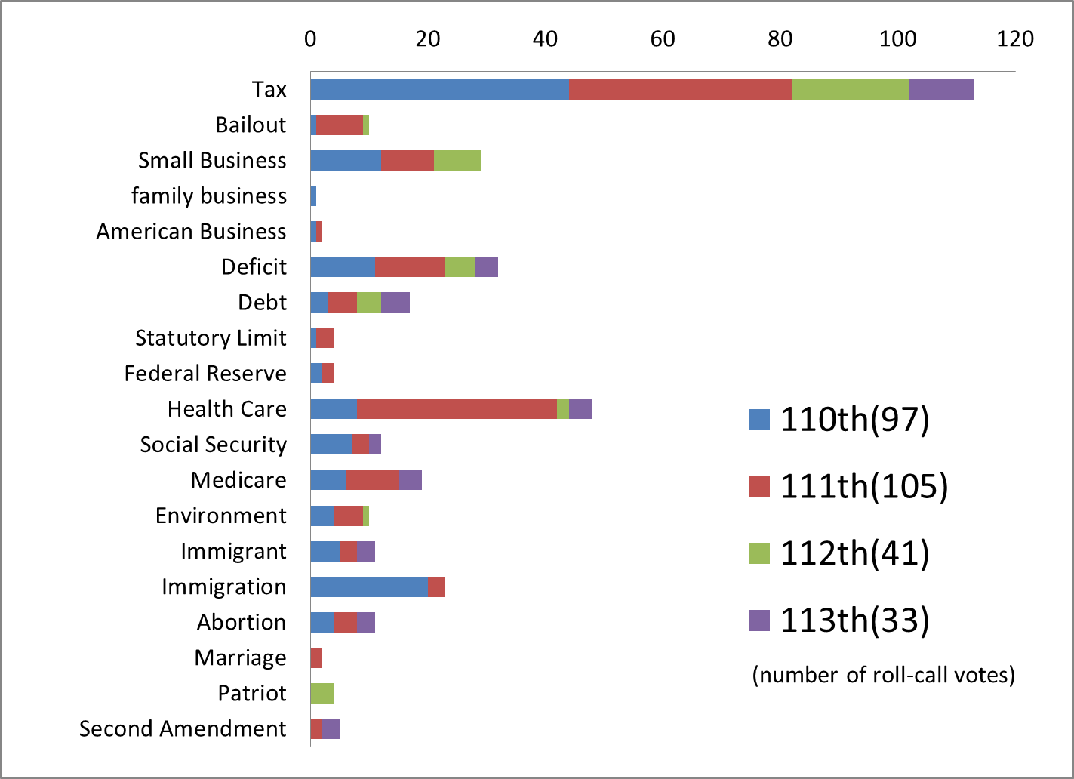

After selecting roll-call votes, this research determined which vote (Aye or Nay) is an ideal vote for citizen participants in protest events and local meetings, i.e. Tea Partiers[8]. The preferences of Tea Partiers and policy goals of so-called libertarian or ultra-conservative Republican senators in general do not always coincide. The discrepancy is prominent in policies concerned about, for example, Social Security and Medicare. Tea Partiers prefer to defend their benefits from such programs, while libertarian and ultra-conservative legislators tend to aim at abolishing those programs.

The discrepancy between Tea Partiers and other groups of people, ordinary Republican legislators and advocacy organizations in the case that follows, can be found in roll-call votes concerning taxation policy as well. Below is an example that was picked up with the keywords ‘tax’ and ‘family business.’ *ProQuest* summarizes the outcome of the roll-call vote this way: the Senate rejected the Landrieu Amendment No. 4378

to protect family businesses and farmers without increasing our nation's debt by providing for an estate tax that sets the exemption at $5 million and the rate at 35 percent, with the benefits of the exemption recaptured for estates over $100 million, paid for by closing tax loopholes that allow offshore deferral of compensation and transactions entered into solely for the purpose of avoiding taxation.

This is an amendment for a bill, 110 S.Con.Res.70, which is titled ‘Concurrent Resolution on the Budget for Fiscal Year 2009,’ on March 13, 2008. Regarding this amendment, difference between policy interests of Tea Partiers and that of advocacy organizations and ordinary Republican legislators is outstanding. In other words, the roll-call asked legislators to choose which to support, family business owners or strong advocacy organizations.

This roll-call vote was before the emergence of the Tea Party movement. In order to assess the change in the voting behavior of senators after protest events, this research calculated the Tea Party Score roll-call votes before 2009. In the case of this example, it can be imagined that citizen protesters would have supported votes for this amendment, while advocacy organizations would have been against this amendment. Actually, majority of both Republican and Democratic senators voted against the amendment. There were only three Republican Senators who voted for the amendment: Sen. Susan M. Collins (R-ME), Sen. Olympia J. Snowe (R-ME), and Sen. Kay Bailey Hutchison (R-TX).

Tea Party Score was calculated by the following equation:

*Tea Party Score* = $\frac{Number of ideal votes }{Total number of roll-call votes}$ (0 ≤ Tea Party Score ≤ 1)

For example, if Senator A voted in accordance with the preferences of the Tea Party for 10 of 20 roll-calls in the Xth Congress, the senator will be assigned a score of 0.5 for that congressional period (Tea Party score of Sen. A in the Xth Congress: 0.5). The score is bigger when a senator voted more frequently for the ideal vote choice. Chronological transition of the score of each senator is shown in figure2.

In addition, this research made four categories of roll-call votes and analyzed each of them respectively, in order mainly to analyze the difference in policy preferences of Tea Partiers and other groups of people. Categories are (1) bailout, (2) deficit, (3) health care, and (4) tax. Category (1) includes roll-call votes that were found by keywords such as bailout, small business, family business, and American business. Category (2) includes roll-call votes that were found by keywords such as deficit, debt, statutory limit, and Federal Reserve. Category (3) includes roll-call votes that were found by keywords such as health care, Social Security, and Medicare. Category (4) includes roll-call votes that were found by a keyword, tax. Figures 3 to 6 show the chronological transition of the Tea Party Score of each senator of each category. Roll-call votes across more than one congressional sessions or congressional terms are combined when the number of cases is outstandingly small or equal to zero.

Figure . Tea Party Score – All Roll-Call Votes

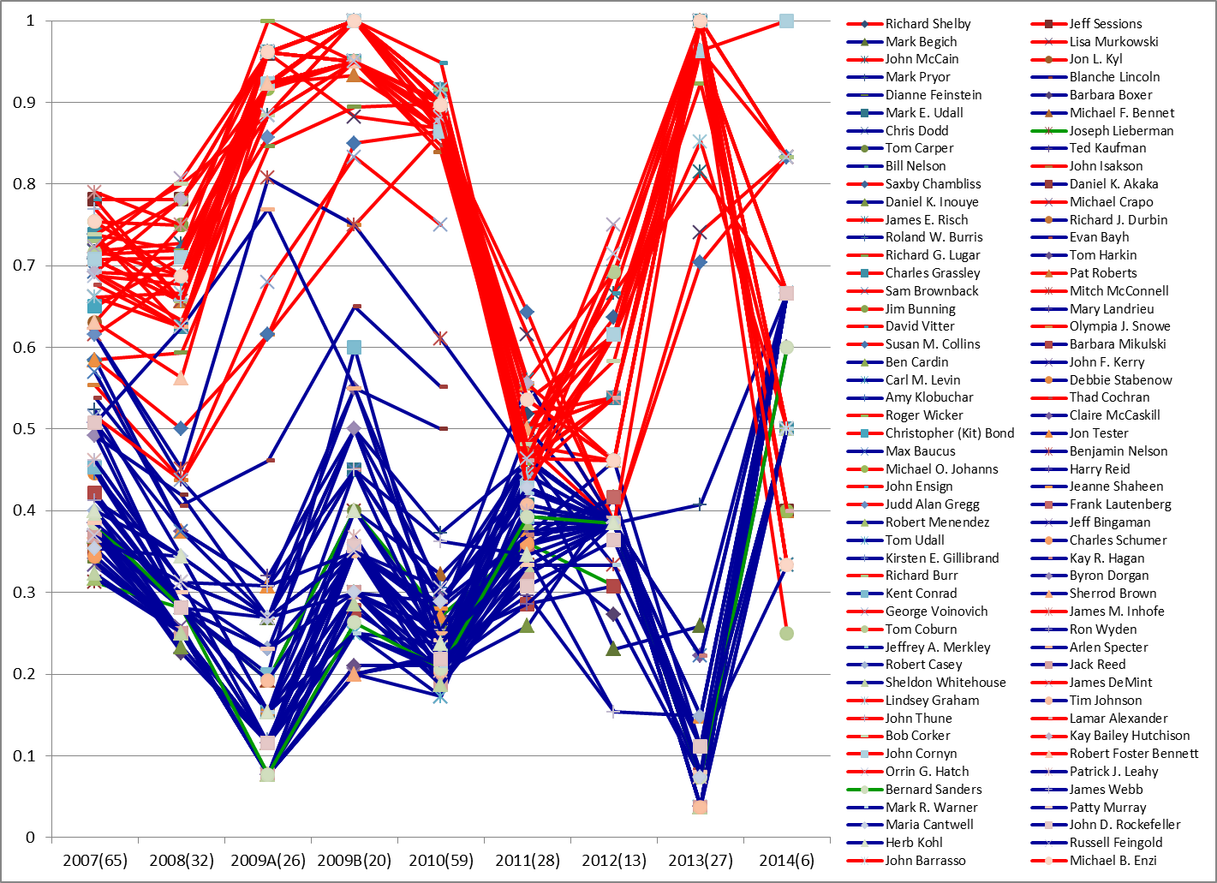

Figure . Tea Party Score – Category (1): Bailout

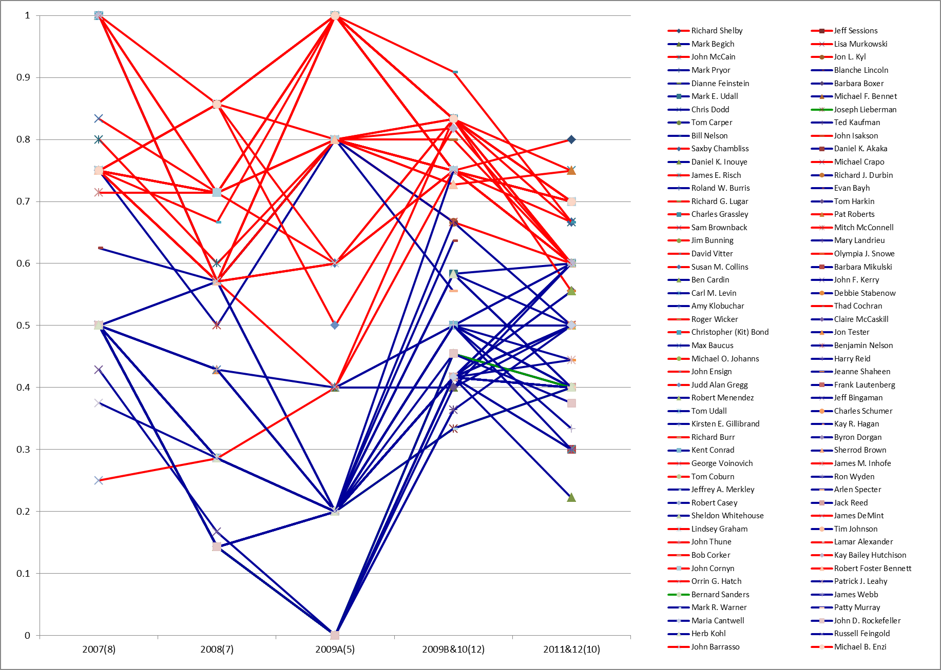

Figure . Tea Party Score – Category (2): Deficit

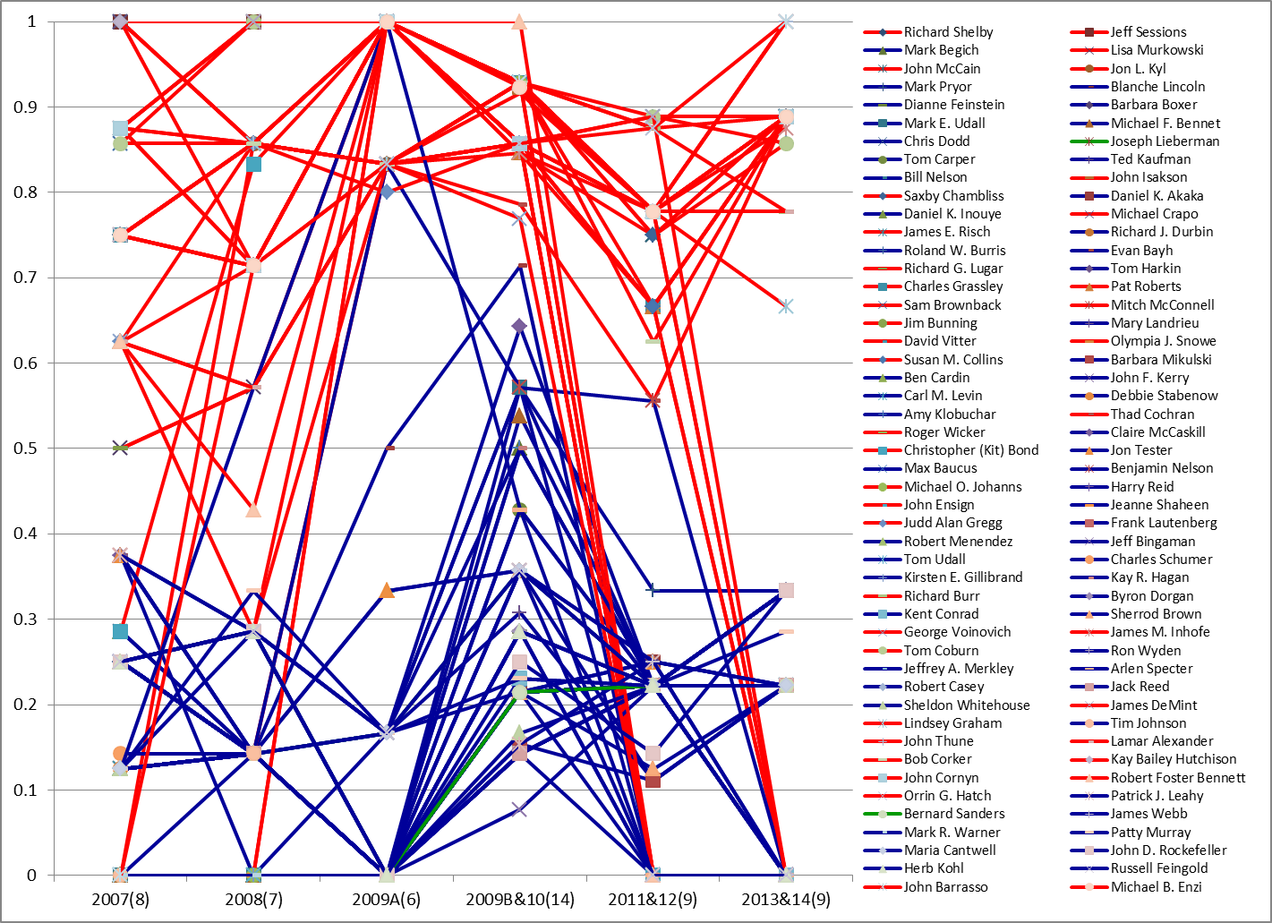

Figure . Tea Party Score - Category (3): Health Care

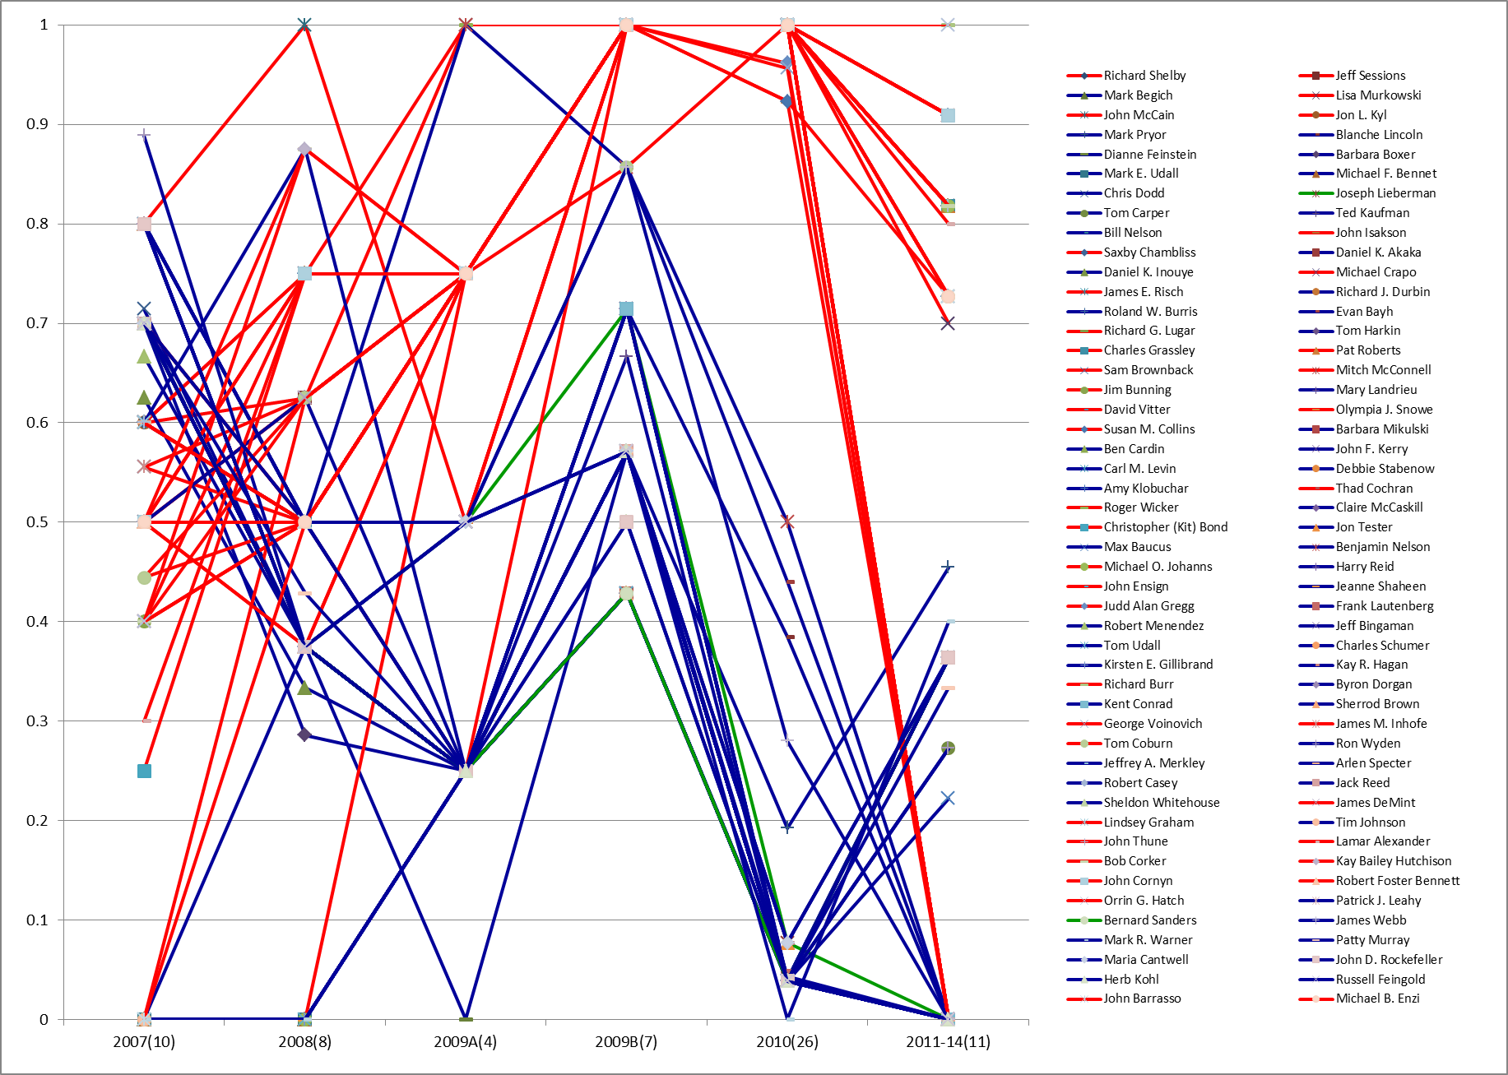

Figure . Tea Party Score - Category (4): Tax

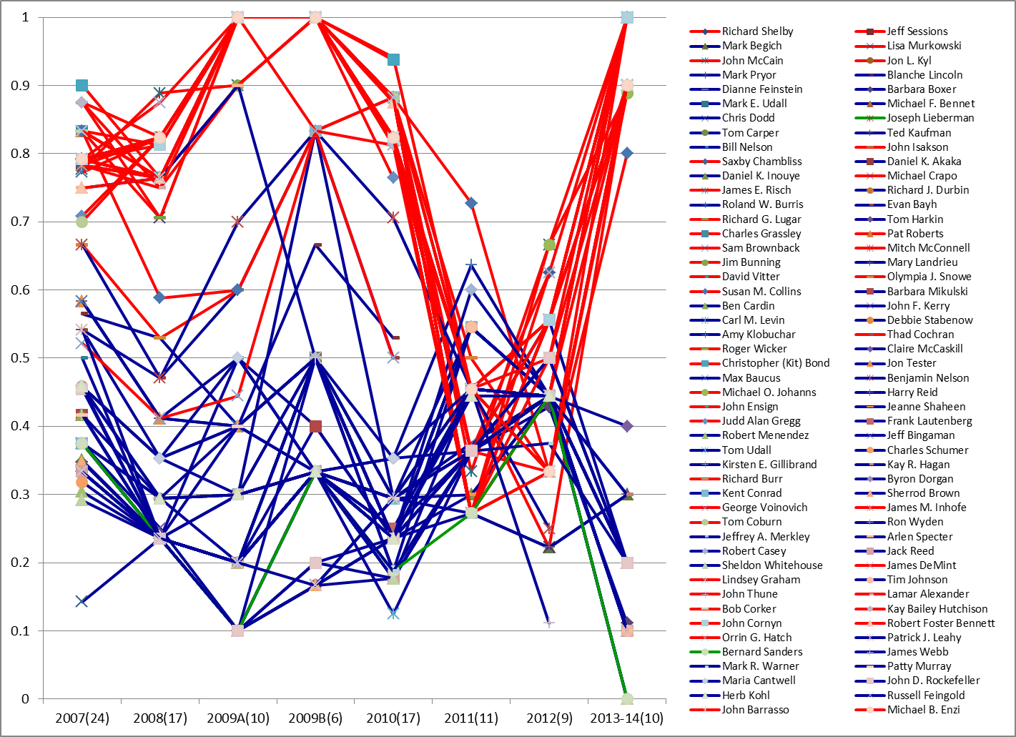

### Independent Variable: Protest Events Data

The data of crowd size of the Tax Day rally held on April 15, 2009, are retrieved from the webpages of FiveThirtyEight: Nate Silver’s Political Calculus[9] and SurgeUSA.org 2009[10]. The average of numbers reported by these two sources and the ratio of it to the population are shown in Figure 7. Crowd size per capita is used in the analysis.

Figure . Crowd Size of the 2009 Tax Day Rally

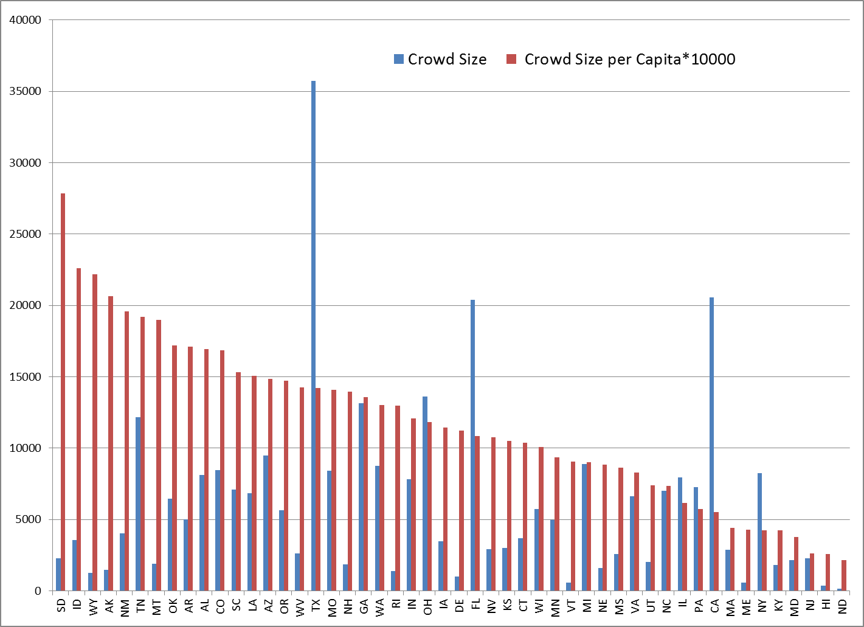

### Change in the Ideological Orientation of Citizens and Senators

As mentioned above, change in constituent’s policy preference and senators’ ideology may be correlated with the change in Senatorial voting behavior. One way to operationalize constituent’s policy preference is to measure liberal-conservative ideological orientation. This set of data was retrieved from *ANES 2008-2009 Panel Study* and *ANES 2010 Panel Recontact Study*[11]. Survey questions asked in November 2008 and June 2010 were selected, which were the most proximate data before and after the 2009 Tax Day Rally. *DW-NOMINATE Score*[12] was used in order to represent senators’ ideological orientation. These variables are incorporated in the model as covariates.

Figures 8 and 9 respectively show the relationship between the ideological orientation of citizens in November 2008 and June 2010 and the Tax Day rally in 2009. Figure 8 tells that the crowd size was larger in states where citizens were more conservative. Figure 9 tells that citizens’ ideological orientation shifted towards the liberal end, especially in states where the crowd size was large. Among states where turnout of the rally was high, Alaska outstandingly remains conservative. Figure 10 shows the relationship between the change between the two surveys and the rally. It tells that all the states more or less shifted towards the liberal end except Hawaii and that the larger the crowd size was, the more citizens’ ideological orientation shifted towards the liberal end.

Figure . Citizen Ideology in 2008 and Tax Day Rally in 2009



Figure . Citizen Ideology in 2010 and Tax Day Rally in 2009



Figure . Citizen Ideology Change between 2008 and 2010 and Tax Day Rally in 2009



Figure 11 shows the relationship between the DW-NOMINATE Score change between the 110th and 111th Congress and the 2009 Tax Day rally. Figure 12 shows the relationship between the change in DW-NOMINATE Score and the change in citizens’ ideological orientation. Compared with the citizen ideology, which shifted towards the liberal end through 2008 and 2010, DW-NOMINATE Score is stable for most of the senators.

Figure . DW-NOMINATE Score Change and the 2009 Tax Day Rally



Figure . DW-NOMINATE Score Change and Citizen Ideology Change



### Other Control Variables

Control variables for the model are median age, median income, percentage of Anglo-American population, and ratio of male to female. These variables represent the demographic characteristics of Tea Partiers: relatively senior, comfortably middle class, mainly white, and more male (Arceneaux and Nicholson 2012; Skocpol and Williamson 2012). Data were retrieved from *the United States Census 2010*[13].

# 5. RESULTS

This research constructed the model in order to examine whether the Tax Day Rally 2009 could be considered as a factor that influenced Senatorial voting behavior. Since the policy preferences of Tea Partiers do not completely coincide with those of the majority of right-wing citizens and legislators, this research sorted roll-call votes by category. Tables 1 to 5 respectively show the results of regression analysis: all roll-call votes, category (1) bailout, (2) deficit, (3) health care, and (4) tax.[14] Columns in the tables sort the category of senators: all senators, Republican senators, Democratic senators, senators who ran for reelection in 2010, Republican senators who ran for reelection in 2010, and Democratic senators who ran for reelection in 2010. Senators who did not vote either before or after April 15 are excluded from all the models. Independent senators are excluded from both models of Republican and Democratic senators.

Tables show that rally size negatively correlates with the score change of Republican senators for roll-call votes of category (2) deficit and (4) tax. The values of rally size are only occasionally positive, and they are statistically insignificant, e.g. Democratic senators for roll-call votes of category (3) health care. This means that where the rally size was big in their home state, Republican senators changed their voting behavior to be more contrary to the policy preferences of Tea Partiers on deficit and taxation issues: after the Tax Day rally in 2009, Republican senators from such states to a greater extent supported policies that increase federal deficit and expand federal programs and policies that raises more tax from citizens like Tea Partiers. In other words, mere number of participants of the 2009 Tax Day rally did not positively influence senatorial voting behavior.

Tables show that citizen ideology change negatively correlates with the score change of Democratic senator for roll-call votes of category (1) bailout, (3) health care, and (4) tax. This means that when citizens of their home state to a greater extent became more liberal in 2010 compared to in 2008, Democratic senators changed their voting behavior to be more contrary to the policy preferences of Tea Partiers on those issue areas: after the Tax Day rally in 2009, Democratic senators from such states to a greater extent supported policies that benefit enormous companies and slight Tea Partiers in regard of business policies, policies that curve Tea Partiers’ benefits from social welfare programs, and policies that raises more tax from citizens like Tea Partiers.

Given the negative correlation between the rally size and citizen ideology change that was shown in Figure 10, negative correlation between rally size and Tea Party Score change for roll-call votes of category (2) and (4) tax might be explained by the first possible path, which was mentioned in Section 3.4 --- protest events may influence Senatorial voting behavior by changing constituent’s policy preference. In the case of the 2009 Tax Day rally, rally size might have somehow negatively influenced the overall ideological orientation of citizens, and senators might have reacted to such a change. The result that change in citizen ideology correlated with Democratic senators’ voting behavior concerning policy areas in bailout, health care, and tax may support this interpretation.

Tables show that change in DW-NOMINATE scores positively correlates with the score change of Democratic senator for roll-call votes of category (1) bailout and (3) health care. This means that when overall and relative ideological orientation of Democratic senators to a greater extent became more conservative in 2010 compared to in 2008, they changed their voting behavior to be more supportive to the policy preferences of Tea Partiers on those issue areas: after the Tax Day rally in 2009, such Democratic senators to a greater extent supported policies that benefit Tea Partiers in regard of business policies and policies that preserve Tea Partiers’ benefits from social welfare programs.

The implication of the result about DW-NOMINATE scores is two-fold. First, given the non-correlation between rally size and DW-NOMINATE score change[15], it is false to contend that rallies influenced Senatorial voting behavior through changing the overall ideological orientation of senators. Thus, the second path that was mentioned in Section 3.4 --- protest events change senators’ ideological orientation --- is not supported. Instead, the result may suggest, from the perspective of political opportunity structure, that rallies are potential to influence Senatorial voting behavior if the rallies could somehow influence their overall ideological orientation. Second, since the positive correlation is observed concerning policy areas of bailout and health care, policy preferences of Tea Partiers in these policy areas were central concerns of Democratic senators, rather than of Republican senators.

Tables show that change in DW-NOMINATE Scores is also positively correlated with Tea Party Score change of senators who ran for reelection in 2010, in roll-call category (1) bailout and (4) tax. This means that the change in calculated overall ideological orientation of such senators might be mainly caused by changes in their vote choice discipline concerning these policy areas.

Table 1. Rally, Citizen Ideology, Senator Ideology, and Roll-call Votes

|  |  |  |  |  |  |  |
| --- | --- | --- | --- | --- | --- | --- |
|  | Tea Party Score Change for All Roll-call Votes | | | | | |
| Covariates | All Senators | Republican Senators | Democratic Senators | Reelection 2010 | Rep. Reelec. 2010 | Dem. Reelec. 2010 |
| Rally | -0.016 | -0.050** | 0.010 | 0.007 | -0.051 | 0.023 |
|  | (0.025) | (0.014) | (0.019) | (0.045) | (0.051) | (0.071) |
| Citizen Ideology | -0.099** | -0.029 | -0.057** | 0.027 | 0.014 | -0.015 |
|  | (0.022) | (0.015) | (0.015) | (0.036) | (0.031) | (0.034) |
| DW-NOMINATE | 0.229 | -0.285 | 0.147 | 0.765** | 0.606 | 0.692 |
|  | (0.195) | (0.294) | (0.097) | (0.243) | (0.429) | (0.182) |
| White-non-Hispanic | -0.001 | 0.0004 | -0.001 | 0.001 | 0.001 | -0.002 |
|  | (0.001) | (0.001) | (0.001) | (0.001) | (0.001) | (0.002) |
| Income | 0.001 | 0.003 | 0.004** | -0.010* | -0.005 | -0.006 |
|  | (0.002) | (0.002) | (0.002) | (0.004) | (0.006) | (0.004) |
| Age | -0.008 | 0.005 | -0.007 | -0.031** | -0.010 | -0.002 |
|  | (0.007) | (0.003) | (0.006) | (0.009) | (0.006) | (0.013) |
| Male | -0.002 | 0.0001 | -0.001 | 0.004 | 0.008 | -0.004 |
|  | (0.005) | (0.003) | (0.003) | (0.007) | (0.011) | (0.008) |
| R-squared | 0.34 | 0.54 | 0.52 | 0.78 | 0.84 | 0.97 |
| N | 81 | 36 | 44 | 22 | 12 | 10 |
| *Note.* The unit of analysis is a senator. The dependent variable is the difference between the Tea Party Score of two periods of time: (A) from January 3, 2007 to April 14, 2009, and (B) from April 16, 2009, to January 3, 2011. Standard errors in parenthesis. Significance: ** 1%, ** 5 %. | | | | | | |

Table 2. Rally, Citizen Ideology, Senator Ideology, and Roll-call Votes – Category (1) Bailout

|  |  |  |  |  |  |  |
| --- | --- | --- | --- | --- | --- | --- |
|  | Tea Party Score Change for Roll-call Votes in Category (1) Bailout | | | | | |
| Covariates | All Senators | Republican Senators | Democratic Senators | Reelection 2010 | Rep. Reelec. 2010 | Dem. Reelec. 2010 |
| Rally | -0.036 | -0.009 | 0.015 | -0.161 | 0.299 | -0.292* |
|  | (0.032) | (0.053) | (0.040) | (0.091) | (0.184) | (0.053) |
| Citizen Ideology | 0.012 | 0.008 | -0.057* | -0.075 | 0.221 | -0.100 |
|  | (0.027) | (0.059) | (0.028) | (0.071) | (0.111) | (0.026) |
| DW-NOMINATE | 0.818** | -0.881 | 0.893** | 1.456* | 1.279 | 1.917** |
|  | (0.292) | (1.250) | (0.216) | (0.490) | (1.536) | (0.138) |
| White-non-Hispanic | -0.001 | 0.001 | -0.002 | -0.001 | -0.004 | 0.004 |
|  | (0.001) | (0.002) | (0.001) | (0.002) | (0.004) | (0.001) |
| Income | 0.001 | -0.002 | 0.001 | 0.0001 | 0.010 | -0.001 |
|  | (0.002) | (0.006) | (0.003) | (0.008) | (0.023) | (0.003) |
| Age | 0.016 | 0.006 | 0.014 | 0.031 | -0.058 | 0.035 |
|  | (0.008) | (0.012) | (0.012) | (0.018) | (0.024) | (0.009) |
| Male | 0.008 | 0.009 | 0.006 | 0.028 | -0.046 | 0.040* |
|  | (0.007) | (0.015) | (0.006) | (0.016) | (0.038) | (0.006) |
| R-squared | 0.20 | 0.06 | 0.44 | 0.57 | 0.75 | 1.00 |
| N | 76 | 34 | 41 | 21 | 11 | 10 |
| *Note.* The unit of analysis is a senator. The dependent variable is the difference between the Tea Party Score of two periods of time: (A) from January 3, 2007 to April 14, 2009, and (B) from April 16, 2009, to January 3, 2011. Standard errors in parenthesis. Significance: ** 1%, ** 5 %. | | | | | | |

Table 3. Rally, Citizen Ideology, Senator Ideology, and Roll-call Votes – Category (2) Deficit

|  |  |  |  |  |  |  |
| --- | --- | --- | --- | --- | --- | --- |
|  | Tea Party Score Change for Roll-call Votes in Category (2) Deficit | | | | | |
| Covariates | All Senators | Republican Senators | Democratic Senators | Reelection 2010 | Rep. Reelec. 2010 | Dem. Reelec. 2010 |
| Rally | -0.063* | -0.112* | -0.019 | -0.154 | -0.001 | 0.031 |
|  | (0.030) | (0.041) | (0.036) | (0.086) | (0.209) | (0.190) |
| Citizen Ideology | -0.032 | -0.082 | -0.056 | 0.036 | 0.076 | 0.012 |
|  | (0.026) | (0.043) | (0.028) | (0.069) | (0.125) | (0.092) |
| DW-NOMINATE | 0.393 | -0.791 | 0.568 | 0.684 | 0.422 | 0.549 |
|  | (0.362) | (0.849) | (0.318) | (0.461) | (1.753) | (0.489) |
| White-non-Hispanic | 0.002 | 0.002 | 0.000 | 0.0037 | 0.002 | 0.001 |
|  | (0.001) | (0.002) | (0.001) | (0.0023) | (0.004) | (0.005) |
| Income | 0.003 | 0.004 | -0.001 | -0.005 | 0.007 | -0.009 |
|  | (0.002) | (0.004) | (0.003) | (0.008) | (0.025) | (0.011) |
| Age | 0.013 | 0.015 | -0.018 | -0.006 | -0.022 | -0.040 |
|  | (0.008) | (0.009) | (0.013) | (0.018) | (0.026) | (0.034) |
| Male | 0.003 | 0.008 | -0.009 | 0.020 | -0.005 | -0.005 |
|  | (0.006) | (0.009) | (0.007) | (0.014) | (0.043) | (0.020) |
| R-squared | 0.22 | 0.47 | 0.35 | 0.36 | 0.67 | 0.87 |
| N | 78 | 36 | 41 | 22 | 12 | 10 |
| *Note.* The unit of analysis is a senator. The dependent variable is the difference between the Tea Party Score of two periods of time: (A) from January 3, 2007 to April 14, 2009, and (B) from April 16, 2009, to January 3, 2011. Standard errors in parenthesis. Significance: ** 1%, ** 5 %. | | | | | | |

Table 4. Rally, Citizen Ideology, Senator Ideology, and Roll-call Votes – Category (3) Health Care

|  |  |  |  |  |  |  |
| --- | --- | --- | --- | --- | --- | --- |
|  | Tea Party Score Change for Roll-call Votes in Category (3) Health Care | | | | | |
| Covariates | All Senators | Republican Senators | Democratic Senators | Reelection 2010 | Rep. Reelec. 2010 | Dem. Reelec. 2010 |
| Rally | 0.028 | -0.012 | 0.035 | 0.211 | -0.167 | 0.266 |
|  | (0.071) | (0.019) | (0.027) | (0.191) | (0.138) | (0.117) |
| Citizen Ideology | -0.195** | 0.013 | -0.068** | 0.060 | -0.062 | -0.076 |
|  | (0.063) | (0.020) | (0.021) | (0.153) | (0.082) | (0.057) |
| DW-NOMINATE | 0.560 | 0.645 | 0.325* | 0.653 | 0.798 | 0.112 |
|  | (0.549) | (0.390) | (0.141) | (1.030) | (1.156) | (0.302) |
| White-non-Hispanic | -0.001 | 0.002* | -0.002 | 0.00004 | 0.004 | -0.009 |
|  | (0.003) | (0.001) | (0.001) | (0.005) | (0.003) | (0.003) |
| Income | -0.007 | -0.001 | 0.002 | -0.022 | -0.017 | -0.0005 |
|  | (0.006) | (0.002) | (0.002) | (0.018) | (0.016) | (0.007) |
| Age | -0.039* | -0.009* | 0.000 | -0.088* | 0.003 | 0.034 |
|  | (0.019) | (0.004) | (0.009) | (0.039) | (0.017) | (0.021) |
| Male | -0.008 | -0.006 | -0.002 | -0.017 | 0.022 | -0.027 |
|  | (0.014) | (0.004) | (0.005) | (0.031) | (0.029) | (0.012) |
| R-squared | 0.36 | 0.36 | 0.39 | 0.58 | 0.61 | 0.91 |
| N | 81 | 36 | 44 | 22 | 12 | 10 |
| *Note.* The unit of analysis is a senator. The dependent variable is the difference between the Tea Party Score of two periods of time: (A) from January 3, 2007 to April 14, 2009, and (B) from April 16, 2009, to January 3, 2011. Standard errors in parenthesis. Significance: ** 1%, ** 5 %. | | | | | | |

Table 5. Rally, Citizen Ideology, Senator Ideology, and Roll-call Votes – Category (4) Tax

|  |  |  |  |  |  |  |
| --- | --- | --- | --- | --- | --- | --- |
|  | Tea Party Score Change for Roll-call Votes in Category (4) Tax | | | | | |
| Covariates | All Senators | Republican Senators | Democratic Senators | Reelection 2010 | Rep. Reelec. 2010 | Dem. Reelec. 2010 |
| Rally | -0.044* | -0.055** | -0.020 | -0.002 | -0.008 | -0.026 |
|  | (0.021) | (0.017) | (0.029) | (0.032) | (0.094) | (0.024) |
| Citizen Ideology | -0.076** | -0.025 | -0.051* | 0.015 | 0.039 | -0.021 |
|  | (0.019) | (0.018) | (0.023) | (0.025) | (0.056) | (0.012) |
| DW-NOMINATE | 0.255 | -0.473 | 0.190 | 1.145** | -0.266 | 1.174** |
|  | (0.162) | (0.354) | (0.153) | (0.171) | (0.785) | (0.063) |
| White-non-Hispanic | 0.000 | 0.001 | 0.00004 | -0.001 | 0.002 | -0.002 |
|  | (0.001) | (0.001) | (0.001) | (0.001) | (0.002) | (0.001) |
| Income | 0.002 | -0.002 | 0.007** | -0.007* | -0.013 | -0.004 |
|  | (0.002) | (0.002) | (0.002) | (0.003) | (0.011) | (0.001) |
| Age | -0.005 | 0.005 | -0.016 | -0.021** | -0.020 | -0.016 |
|  | (0.006) | (0.004) | (0.010) | (0.007) | (0.012) | (0.004) |
| Male | -0.001 | 0.005 | 0.003 | 0.003 | 0.009 | -0.003 |
|  | (0.004) | (0.004) | (0.005) | (0.005) | (0.019) | (0.003) |
| R-squared | 0.29 | 0.42 | 0.47 | 0.88 | 0.58 | 1.00 |
| N | 81 | 36 | 44 | 22 | 12 | 10 |
| *Note.* The unit of analysis is a senator. The dependent variable is the difference between the Tea Party Score of two periods of time: (A) from January 3, 2007 to April 14, 2009, and (B) from April 16, 2009, to January 3, 2011. Standard errors in parenthesis. Significance: ** 1%, ** 5 %. | | | | | | |

# 6. CONCLUSION

This research provides the evidence on the absence of the direct influence of protest events to Senatorial voting behavior. The novel point of this research is its meticulous attention to the inconsistency of policy goals among multiple groups of people that composed of the Tea Party movement. In order to account for the discrepancy between those of citizen participants and those of legislators and advocacy groups, this research gathered the data of roll-call votes by category and analyzed them separately. The results show no evidence of legislators’ positive reaction to Tea Partiers as a consequence of the 2009 Tax Day rally, while negative influence on Republican senators has been observed in roll-call categories of (2) deficit and (4) tax.

Two alternative explanations were tested in the model as well. One is the change in citizen ideology, and this hypothesis is supported but in an opposite direction: rally size was negatively correlated with the change in citizens’ overall ideological orientation, and such a citizen ideology change concurred with the change in Democratic senators’ voting tendency in roll- call votes categories of (1) bailout, (3) health care, and (4) tax. Another is the change in overall ideological orientation of senators, and this hypothesis was not supported given the non-relationship between rally size and senators’ ideology.

Citizens’ participation in protest events of social movements has attracted scholarly attention for a long time, and recent empirical works showed some evidence on the relationship between protest events and political outcomes that were intended by protest groups, such as electoral results. However, extant research has not extensively examined Senatorial voting behavior or looked closely at various issue topics. This research compensates such lacks of literature and concludes that rally size does not influence Senatorial voting behavior in a direction that citizen participants prefer.

This conclusion is interpreted from the perspective of conventional understandings of political opportunity structure theory that Tea Partiers failed to achieve real powerful political allies, while they collaborated with legislators and advocacy organizations. The conclusion also supports the roll-call ideological extremity theory (Canes-Wrone, Brady and Cogan 2002): it was unlikely that senators changed their legislative behavior towards the Tea Party way because the policy preferences of Tea Partiers were not the central ideological core of either Republican or Democratic Party.

The rest of this section suggests directions of further development of the model, in six items. First, other protest events of the Tea Party movement should be examined as the independent variable. The model may be duplicated with the Tax Day rally in 2010. If data of other, probably smaller rallies are available, aggregated number of total crowd size of rallies during different periods of time may be analyzed.

Second, roll-call votes categorization may be improved. As mentioned above, the importance of roll-call votes vary, and the model did not distinguish it due to the methodological difficulty. One possible way to account for may be to pick up similar roll-call votes from different congressional sessions and compare vote choice of individual senators.

Roll-call votes may be categorized by the degree of discretion of individual senators on each roll-call votes. Scholars make a distinction between significant and insignificant bills because significant bills attract more party effects/party influence, compared with insignificant bills. Party influence may diminish the influence from other sources on senators’ on roll-call voting (Mayhew 2005; Howell et al. 2000; Ansolabehere 2001; Ansolabehere, Palmer, and Schneer 2014). Scholars also distinguish bills that received party unity votes from others in order to examine different degree of party influence (Binder, Lawrence and Maltzman 1999; Snyder and Groseclose 2000; Ansolabehere, Snyder and Stewart 2001; Carson et al. 2010). Categorization of roll-call votes by these categories will enhance the model.

Third, more detailed analysis on the covariates tested in the model is possible. For example, the measurement of citizen ideology change in the model did not account for different kinds of citizens. Although the aggregated score change was negative, it does not tell what kind of citizens changed their ideological orientation. Was that a change of originally Republican citizens towards the liberal side? Or, did the movement consolidate the liberal ideological orientation of originally Democratic citizens?

Fourth, more variety of time frame may be adopted. Given that the direct positive influence of protest events was not observed in the time frame adopted in the model --- comparison between two periods of time: (A) from January 3, 2007 to April 14, 2009, and (B) from April 16, 2009, to January 3, 2011 ---, time frames that examine the influence that is immediate and less durable may be tested, for example, ten days, a month, or three months after the Tax Day rally. Also, there is still a possibility that the influence occurred with a time-lag. This will be accounted for by adopting time frames such as a comparison between (C) before the 2009 Tax Day rally and (D) the 112th Congress.

Fifth, other covariates may be incorporated in the model. This research accounted for two alternative paths through which the rally might influence Senatorial voting behavior: change in citizens’ overall policy preference and change in senators’ overall ideological orientation. Other two possible paths to be taken into account are change in fund-raising pressure and change in the size of activist groups. Media attention may be incorporated as a covariate as well. In addition, there are possible factors concerning individual senators that may explain their behavior: age, length of career, membership in committees, among others.

Sixth, detailed investigation of electoral situations of individual senators may be necessary. Madestam et al. (2013) find that protest events are associated with the retirement of Democratic House members. In such cases, electoral strategy of candidates might change. Another probable element is electoral margins. According to Aldrich (2011), legislators who win the seat with narrow margin are constrained to reward their supporters. If the movement influences the winning margin, legislative behavior might be influenced as well. Other anomalous situations may influence individual senators’ behavior as well. For example, in the 2010 general election was an unopposed race for Sen. John Thune (R-SD). Such a status might have provided Sen. Thune less incentive to step closer to the Tea Party preference.

# Appendix: Selected Roll-call Votes

(1): Senate roll number  
(2): Tea Party position

|  |  |  |  |  |  |  |
| --- | --- | --- | --- | --- | --- | --- |
| (1) | Vote Date | Bill | Bill Title | Vote Question | (2) | Topics (Search Keywords) |
| 2007 | | | | | | |
| 26 | 25-Jan-07 | 110 H.R. 2 | FAIR MINIMUM WAGE ACT OF 2007 | Motion to waive | nay | health care |
| 27 | 25-Jan-07 | 110 H.R. 2 | FAIR MINIMUM WAGE ACT OF 2007 | Agree to the amendment | aye | tax, social security |
| 28 | 25-Jan-07 | 110 H.R. 2 | FAIR MINIMUM WAGE ACT OF 2007 | Motion to waive | nay | tax |
| 29 | 25-Jan-07 | 110 H.R. 2 | FAIR MINIMUM WAGE ACT OF 2007 | Agree to the amendment | aye | tax |
| 30 | 25-Jan-07 | 110 H.R. 2 | FAIR MINIMUM WAGE ACT OF 2007 | Motion to waive | aye | tax, deficit |
| 37 | 31-Jan-07 | 110 H.R. 2 | FAIR MINIMUM WAGE ACT OF 2007 | Motion to table | nay | small business |
| 82 | 21-Mar-07 | 110 S.Con.Res. 21 | FAIR MINIMUM WAGE ACT OF 2007 | Agree to the amendment | aye | tax, small business |
| 83 | 21-Mar-07 | 110 S.Con.Res. 21 | FAIR MINIMUM WAGE ACT OF 2007 | Agree to the amendment | aye | tax, small business |
| 84 | 21-Mar-07 | 110 S.Con.Res. 21 | FAIR MINIMUM WAGE ACT OF 2007 | Agree to the amendment | aye | tax |
| 85 | 21-Mar-07 | 110 S.Con.Res. 21 | FAIR MINIMUM WAGE ACT OF 2007 | Agree to the amendment | nay | tax |
| 89 | 22-Mar-07 | 110 S.Con.Res. 21 | FAIR MINIMUM WAGE ACT OF 2007 | Agree to the amendment | nay | social security |
| 90 | 22-Mar-07 | 110 S.Con.Res. 21 |  | Agree to the amendment | aye | debt |
| 92 | 22-Mar-07 | 110 S.Con.Res. 21 |  | Agree to the amendment | nay | deficit, medicare |
| 93 | 22-Mar-07 | 110 S.Con.Res. 21 |  | Agree to the amendment | nay | medicare |
| 94 | 22-Mar-07 | 110 S.Con.Res. 21 |  | Agree to the amendment | nay | tax |
| 95 | 22-Mar-07 | 110 S.Con.Res. 21 |  | Agree to the amendment | aye | small business |
| 99 | 23-Mar-07 | 110 S.Con.Res. 21 |  | Agree to the amendment | aye | deficit |
| 100 | 23-Mar-07 | 110 S.Con.Res. 21 |  | Agree to the amendment | aye | tax |
| 101 | 23-Mar-07 | 110 S.Con.Res. 21 |  | Agree to the amendment | aye | tax |
| 102 | 23-Mar-07 | 110 S.Con.Res. 21 |  | Agree to the amendment | aye | tax |
| 103 | 23-Mar-07 | 110 S.Con.Res. 21 |  | Agree to the amendment | aye | medicare |
| 104 | 23-Mar-07 | 110 S.Con.Res. 21 |  | Motion to waive | aye | debt |
| 107 | 23-Mar-07 | 110 S.Con.Res. 21 |  | Agree to the amendment | aye | tax, small business |
| 108 | 23-Mar-07 | 110 S.Con.Res. 21 |  | Agree to the amendment | aye | tax |
| 109 | 23-Mar-07 | 110 S.Con.Res. 21 |  | Agree to the amendment | aye | tax |
| 111 | 23-Mar-07 | 110 S.Con.Res. 21 |  | Agree to the amendment | aye | deficit |
| 113 | 23-Mar-07 | 110 S.Con.Res. 21 |  | Agree to the amendment | aye | tax |
| 138 | 24-Apr-07 | 110 S. 761 | AMERICA CREATING OPPORTUNITIES TO MEANINGFULLY PROMOTE EXCELLENCE IN TECHNOLOGY, EDUCATION, AND SCIENCE ACT | Agree to the amendment | aye | small business |
| 159 | 9-May-07 | 110 S.Con.Res. 21 |  | Motion to instruct | aye | tax |
| 174 | 22-May-07 | 110 S. 1348 | COMPREHENSIVE IMMIGRATION REFORM ACT OF 2007 | Agree to the amendment | aye | immigration |
| 175 | 23-May-07 | 110 S. 1348 | COMPREHENSIVE IMMIGRATION REFORM ACT OF 2007 | Agree to the amendment | aye | immigrant, immigration |
| 176 | 24-May-07 | 110 S. 1348 | COMPREHENSIVE IMMIGRATION REFORM ACT OF 2007 | Agree to the amendment | nay | immigrant, immigration |
| 177 | 24-May-07 | 110 S. 1348 | COMPREHENSIVE IMMIGRATION REFORM ACT OF 2007 | Agree to the amendment | aye | immigrant, immigration |
| 178 | 24-May-07 | 110 S. 1348 | COMPREHENSIVE IMMIGRATION REFORM ACT OF 2007 | Agree to the amendment | aye | immigration |
| 180 | 24-May-07 | 110 S. 1348 | COMPREHENSIVE IMMIGRATION REFORM ACT OF 2007 | Agree to the amendment | nay | immigration |
| 182 | 5-Jun-07 | 110 S. 1348 | COMPREHENSIVE IMMIGRATION REFORM ACT OF 2007 | Agree to the amendment | aye | immigration |
| 188 | 7-Jun-07 | 110 S. 1348 | COMPREHENSIVE IMMIGRATION REFORM ACT OF 2007 | Agree to the amendment | nay | health care |
| 189 | 6-Jun-07 | 110 S. 1348 | COMPREHENSIVE IMMIGRATION REFORM ACT OF 2007 | Agree to the amendment | nay | immigration |
| 192 | 6-Jun-07 | 110 S. 1348 | COMPREHENSIVE IMMIGRATION REFORM ACT OF 2007 | Agree to the amendment | aye | tax, immigration |
| 197 | 6-Jun-07 | 110 S. 1348 | COMPREHENSIVE IMMIGRATION REFORM ACT OF 2007 | Agree to the amendment | aye | immigration |
| 198 | 6-Jun-07 | 110 S. 1348 | COMPREHENSIVE IMMIGRATION REFORM ACT OF 2007 | Agree to the amendment | aye | immigration |
| 199 | 6-Jun-07 | 110 S. 1348 | COMPREHENSIVE IMMIGRATION REFORM ACT OF 2007 | Agree to the amendment | aye | immigration |
| 200 | 6-Jun-07 | 110 S. 1348 | COMPREHENSIVE IMMIGRATION REFORM ACT OF 2007 | Agree to the amendment | nay | immigrant |
| 201 | 6-Jun-07 | 110 S. 1348 | COMPREHENSIVE IMMIGRATION REFORM ACT OF 2007 | Agree to the amendment | aye | immigration |
| 202 | 7-Jun-07 | 110 S. 1348 | COMPREHENSIVE IMMIGRATION REFORM ACT OF 2007 | Agree to the amendment | aye | immigration |
| 219 | 20-Jun-07 | 110 H.R. 6 | Energy Independence and Security Act of 2007 | Agree to the amendment | nay | environment |
| 263 | 19-Jul-07 | 110 H.R. 2669 | COLLEGE COST REDUCTION ACT OF 2007 | Motion to waive | aye | social security |
| 277 | 25-Jul-07 | 110 H.R. 2638 | Consolidated Security, Disaster Assistance, and Continuing Appropriations Act, 2009 | Appeal the ruling of the chair | aye | immigration |
| 278 | 26-Jul-07 | 110 H.R. 2638 | Consolidated Security, Disaster Assistance, and Continuing Appropriations Act, 2009 | Agree to the amendment | aye | immigration |
| 289 | 1-Aug-07 | 110 H.R. 976 | CHILDREN'S HEALTH INSURANCE PROGRAM REAUTHORIZATION ACT OF 2007 | Agree to the amendment | aye | tax |
| 295 | 2-Aug-07 | 110 H.R. 976 | CHILDREN'S HEALTH INSURANCE PROGRAM REAUTHORIZATION ACT OF 2007 | Motion to waive | aye | tax |
| 307 | 2-Aug-07 | 110 H.R. 976 | CHILDREN'S HEALTH INSURANCE PROGRAM REAUTHORIZATION ACT OF 2007 | Final passage | aye | tax, small business |
| 318 | 6-Sep-07 | 110 H.R. 2764 | THE DEPARTMENT OF STATE, FOREIGN OPERATIONS AND RELATED PROGRAMS APPROPRIATIONS ACT, 2008 | Agree to the amendment | aye | abortion |
| 320 | 6-Sep-07 | 110 H.R. 2764 | THE DEPARTMENT OF STATE, FOREIGN OPERATIONS AND RELATED PROGRAMS APPROPRIATIONS ACT, 2008 | Agree to the amendment | nay | abortion |
| 321 | 6-Sep-07 | 110 H.R. 2764 | THE DEPARTMENT OF STATE, FOREIGN OPERATIONS AND RELATED PROGRAMS APPROPRIATIONS ACT, 2008 | Agree to the amendment | aye | tax |
| 323 | 6-Sep-07 | 110 H.R. 2764 | THE DEPARTMENT OF STATE, FOREIGN OPERATIONS AND RELATED PROGRAMS APPROPRIATIONS ACT, 2008 | Agree to the amendment | aye | environment |
| 353 | 27-Sep-07 | 110 H.R. 976 | CHILDREN'S HEALTH INSURANCE PROGRAM REAUTHORIZATION ACT OF 2007 | Concur in the House amendments | aye | tax, small business |
| 354 | 27-Sep-07 | 110 H.J.Res. 43 |  | Final passage | nay | debt, statutory |
| 369 | 16-Oct-07 | 110 H.R. 3093 | COMMERCE, JUSTICE, SCIENCE, AND RELATED AGENCIES APPROPRIATIONS BILL, 2008 R E P O R T | Motion to table the amendment | nay | immigration |
| 370 | 16-Oct-07 | 110 H.R. 3093 | COMMERCE, JUSTICE, SCIENCE, AND RELATED AGENCIES APPROPRIATIONS BILL, 2008 R E P | Motion to table the amendment | nay | immigrant, immigration |
| 379 | 18-Oct-07 | 110 H.R. 3043 | Departments of Labor, Health and Human Services, and Education, and Related Agencies Appropriations Act, 2008 | Agree to the amendment | aye | abortion |
| 403 | 1-Nov-07 | 110 H.R. 3963 | Children's Health Insurance Program Reauthorization Act of 2007 | Agree to the amendment | nay | social security |
| 415 | 6-Dec-07 | 110 H.R. 3996 | Temporary Tax Relief Act of 2007 | Final passage | aye | tax |
| 421 | 12-Dec-07 | 110 H.R. 2419 | Food, Conservation, and Energy Act of 2008 | Agree to the amendment | nay | health care |
| 426 | 13-Dec-07 | 110 H.R. 2419 | Food, Conservation, and Energy Act of 2008 | Agree to the amendment | nay | deficit |
| 2008 | | | | | | |
| 10 | 7-Feb-08 | 110 H.R. 5140 | Recovery Rebates and Economic Stimulus for the American People Act of 2008 | Final passage | nay | american business, bailout |
| 25 | 14-Feb-08 | 110 S. 1200 | Indian Health Care Improvement Act Amendments of 2008 | Agree to the amendment | aye | health care |
| 26 | 14-Feb-08 | 110 S. 1200 | Indian Health Care Improvement Act Amendments of 2008 | Agree to the amendment | nay | health care |
| 42 | 13-Mar-08 | 110 S.Con.Res. 70 | CONCURRENT RESOLUTION ON THE BUDGET FOR FISCAL YEAR 2009 | Agree to the amendment | aye | tax, small business |
| 43 | 13-Mar-08 | 110 S.Con.Res. 70 | CONCURRENT RESOLUTION ON THE BUDGET FOR FISCAL YEAR 2009 | Agree to the amendment | aye | tax, small business |
| 45 | 13-Mar-08 | 110 S.Con.Res. 70 | CONCURRENT RESOLUTION ON THE BUDGET FOR FISCAL YEAR 2009 | Agree to the amendment | aye | tax |
| 46 | 13-Mar-08 | 110 S.Con.Res. 70 | CONCURRENT RESOLUTION ON THE BUDGET FOR FISCAL YEAR 2009 | Motion to table | nay | tax |
| 49 | 13-Mar-08 | 110 S.Con.Res. 70 | CONCURRENT RESOLUTION ON THE BUDGET FOR FISCAL YEAR 2009 | Agree to the amendment | aye | tax |
| 50 | 13-Mar-08 | 110 S.Con.Res. 70 | CONCURRENT RESOLUTION ON THE BUDGET FOR FISCAL YEAR 2009 | Agree to the amendment | aye | tax, small business |
| 51 | 13-Mar-08 | 110 S.Con.Res. 70 | CONCURRENT RESOLUTION ON THE BUDGET FOR FISCAL YEAR 2009 | Agree to the amendment | nay | social security, tax, deficit |
| 52 | 13-Mar-08 | 110 S.Con.Res. 70 | CONCURRENT RESOLUTION ON THE BUDGET FOR FISCAL YEAR 2009 | Agree to the amendment | aye | social security, tax |
| 60 | 13-Mar-08 | 110 S.Con.Res. 70 | CONCURRENT RESOLUTION ON THE BUDGET FOR FISCAL YEAR 2009 | Agree to the amendment | aye | immigration, deficit |
| 61 | 13-Mar-08 | 110 S.Con.Res. 70 | CONCURRENT RESOLUTION ON THE BUDGET FOR FISCAL YEAR 2009 | Motion to waive | aye | tax |
| 62 | 13-Mar-08 | 110 S.Con.Res. 70 | CONCURRENT RESOLUTION ON THE BUDGET FOR FISCAL YEAR 2009 | Agree to the amendment | nay | tax |
| 63 | 13-Mar-08 | 110 S.Con.Res. 70 | CONCURRENT RESOLUTION ON THE BUDGET FOR FISCAL YEAR 2009 | Agree to the amendment | nay | medicare |
| 64 | 13-Mar-08 | 110 S.Con.Res. 70 | CONCURRENT RESOLUTION ON THE BUDGET FOR FISCAL YEAR 2009 | Agree to the amendment | nay | tax, deficit |
| 65 | 13-Mar-08 | 110 S.Con.Res. 70 | CONCURRENT RESOLUTION ON THE BUDGET FOR FISCAL YEAR 2009 | Agree to the amendment | aye | social security, deficit |
| 66 | 13-Mar-08 | 110 S.Con.Res. 70 | CONCURRENT RESOLUTION ON THE BUDGET FOR FISCAL YEAR 2009 | Agree to the amendment | aye | debt |
| 68 | 13-Mar-08 | 110 S.Con.Res. 70 | CONCURRENT RESOLUTION ON THE BUDGET FOR FISCAL YEAR 2009 | Agree to the amendment | nay | deficit |
| 69 | 13-Mar-08 | 110 S.Con.Res. 70 | CONCURRENT RESOLUTION ON THE BUDGET FOR FISCAL YEAR 2009 | Motion to table | nay | immigration, federal reserve |
| 71 | 13-Mar-08 | 110 S.Con.Res. 70 | CONCURRENT RESOLUTION ON THE BUDGET FOR FISCAL YEAR 2009 | Agree to the amendment | aye | abortion |
| 74 | 13-Mar-08 | 110 S.Con.Res. 70 |  | Agree to the amendment | nay | tax, environment |
| 76 | 13-Mar-08 | 110 S.Con.Res. 70 | CONCURRENT RESOLUTION ON THE BUDGET FOR FISCAL YEAR 2009 | Agree to the amendment | aye | family business, tax |
| 77 | 13-Mar-08 | 110 S.Con.Res. 70 | CONCURRENT RESOLUTION ON THE BUDGET FOR FISCAL YEAR 2009 | Agree to the amendment | aye | tax, small business |
| 78 | 13-Mar-08 | 110 S.Con.Res. 70 | CONCURRENT RESOLUTION ON THE BUDGET FOR FISCAL YEAR 2009 | Agree to the amendment | aye | tax |
| 82 | 14-Mar-08 | 110 S.Con.Res. 70 | CONCURRENT RESOLUTION ON THE BUDGET FOR FISCAL YEAR 2009 |  | aye | deficit, federal reserve |
| 104 | 16-Apr-08 | 110 H.R. 1195 | Highway Technical Corrections Act of 2007 | Motion to instruct | nay |  |
| 131 | 15-May-08 | 110 S.Con.Res. 70 | CONCURRENT RESOLUTION ON THE BUDGET FOR FISCAL YEAR 2009 | Motion to instruct | aye | tax |
| 133 | 15-May-08 | 110 S.Con.Res. 70 | CONCURRENT RESOLUTION ON THE BUDGET FOR FISCAL YEAR 2009 | Motion to instruct | aye | environment |
| 169 | 9-Jul-08 | 110 H.R. 6331 | Medicare Improvements for Patients and Providers Act of 2008 | Motion for cloture | aye | health care, medicare |
| 177 | 15-Jul-08 | 110 H.R. 6331 | Medicare Improvements for Patients and Providers Act of 2008 | Agree to override the President's veto | aye | health care, medicare |
| 203 | 23-Sep-08 | 110 H.R. 6049 | Renewable Energy and Job Creation Act of 2008 | Agree to the amendment | aye | tax |
| 2009 | | | | | | |
| 19 | 28-Jan-09 | 111 H.R. 2 | Children's Health Insurance Program Reauthorization Act of 2009 | Agree to the amendment | aye | abortion |
| 27 | 29-Jan-09 | 111 H.R. 2 | Children's Health Insurance Program Reauthorization Act of 2009 | Agree to the amendment | aye | tax, health care |
| 40 | 4-Feb-09 | 111 H.R. 1 | American Recovery and Reinvestment Act of 2009 | Motion to waive | aye | deficit |
| 42 | 4-Feb-09 | 111 H.R. 1 | American Recovery and Reinvestment Act of 2009 | Motion to waive | aye | tax |
| 43 | 4-Feb-09 | 111 H.R. 1 | American Recovery and Reinvestment Act of 2009 | Motion to waive | aye | tax |
| 58 | 6-Feb-09 | 111 H.R. 1 | American Recovery and Reinvestment Act of 2009 | Motion to waive | aye | tax |
| 61 | 10-Feb-09 | 111 H.R. 1 | American Recovery and Reinvestment Act of 2009 | Final passage | nay | stimulus bill, bailout |
| 72 | 26-Feb-09 | 111 S. 160 | District of Columbia House Voting Rights Act of 2009 | Agree to the amendment | aye | second amendment |
| 81 | 5-Mar-09 | 111 H.R. 1105 | Omnibus Appropriations Act, 2009 | Agree to the amendment | aye | abortion |
| 93 | 10-Mar-09 | 111 H.R. 1105 | Omnibus Appropriations Act, 2009 | Motion to table | nay | immigration, immigrant |
| 118 | 31-Mar-09 | 111 S.Con.Res. 13 | CONCURRENT RESOLUTION ON THE BUDGET FOR FISCAL YEAR 2010 | Agree to the amendment | aye | debt |
| 119 | 1-Apr-09 | 111 S.Con.Res. 13 | CONCURRENT RESOLUTION ON THE BUDGET FOR FISCAL YEAR 2010 | Agree to the amendment | aye | debt |
| 121 | 1-Apr-09 | 111 S.Con.Res. 13 | CONCURRENT RESOLUTION ON THE BUDGET FOR FISCAL YEAR 2010 | Agree to the amendment | aye | tax |
| 122 | 1-Apr-09 | 111 S.Con.Res. 13 | CONCURRENT RESOLUTION ON THE BUDGET FOR FISCAL YEAR 2010 | Agree to the amendment | aye | tax, small business |
| 124 | 1-Apr-09 | 111 S.Con.Res. 13 | CONCURRENT RESOLUTION ON THE BUDGET FOR FISCAL YEAR 2010 | Agree to the amendment | aye | debt |
| 125 | 1-Apr-09 | 111 S.Con.Res. 13 | CONCURRENT RESOLUTION ON THE BUDGET FOR FISCAL YEAR 2010 | Motion to waive | nay | environment |
| 127 | 1-Apr-09 | 111 S.Con.Res. 13 | CONCURRENT RESOLUTION ON THE BUDGET FOR FISCAL YEAR 2010 | Agree to the amendment | aye | health care |
| 128 | 2-Apr-09 | 111 S.Con.Res. 13 | CONCURRENT RESOLUTION ON THE BUDGET FOR FISCAL YEAR 2010 | Agree to the amendment | nay | medicare |
| 131 | 2-Apr-09 | 111 S.Con.Res. 13 | CONCURRENT RESOLUTION ON THE BUDGET FOR FISCAL YEAR 2010 | Agree to the amendment | aye | federal reserve |
| 134 | 2-Apr-09 | 111 S.Con.Res. 13 | CONCURRENT RESOLUTION ON THE BUDGET FOR FISCAL YEAR 2010 | Agree to the amendment | aye | bailout, debt, deficit |
| 135 | 2-Apr-09 | 111 S.Con.Res. 13 | CONCURRENT RESOLUTION ON THE BUDGET FOR FISCAL YEAR 2010 | Agree to the amendment | aye | tax |
| 139 | 2-Apr-09 | 111 S.Con.Res. 13 | CONCURRENT RESOLUTION ON THE BUDGET FOR FISCAL YEAR 2010 | Agree to the amendment | aye | tax |
| 146 | 2-Apr-09 | 111 S.Con.Res. 13 | CONCURRENT RESOLUTION ON THE BUDGET FOR FISCAL YEAR 2010 | Agree to the amendment | aye | tax, deficit |
| 147 | 2-Apr-09 | 111 S.Con.Res. 13 | CONCURRENT RESOLUTION ON THE BUDGET FOR FISCAL YEAR 2010 | Agree to the amendment | nay | tax |
| 148 | 2-Apr-09 | 111 S.Con.Res. 13 | CONCURRENT RESOLUTION ON THE BUDGET FOR FISCAL YEAR 2010 | Agree to the amendment | aye | bailout |
| 151 | 2-Apr-09 | 111 S.Con.Res. 13 | CONCURRENT RESOLUTION ON THE BUDGET FOR FISCAL YEAR 2010 | Agree to the amendment | aye | small business |
| 152 | 2-Apr-09 | 111 S.Con.Res. 13 | CONCURRENT RESOLUTION ON THE BUDGET FOR FISCAL YEAR 2010 | Agree to the amendment | aye | health care |
| **Tax Day** | | | | | | |
| 163 | 23-Apr-09 | 111 S.Con.Res. 13 | CONCURRENT RESOLUTION ON THE BUDGET FOR FISCAL YEAR 2010 | Motion to instruct | nay | environment |
| 165 | 23-Apr-09 | 111 S.Con.Res. 13 | CONCURRENT RESOLUTION ON THE BUDGET FOR FISCAL YEAR 2010 | Motion to instruct | aye | debt |
| 167 | 23-Apr-09 | 111 S.Con.Res. 13 | CONCURRENT RESOLUTION ON THE BUDGET FOR FISCAL YEAR 2010 | Motion to instruct | aye | tax |
| 168 | 23-Apr-09 | 111 S.Con.Res. 13 | CONCURRENT RESOLUTION ON THE BUDGET FOR FISCAL YEAR 2010 | Motion to instruct | aye | health care |
| 169 | 23-Apr-09 | 111 S.Con.Res. 13 | CONCURRENT RESOLUTION ON THE BUDGET FOR FISCAL YEAR 2010 | Motion to instruct | aye | environment, american business |
| 192 | 13-May-09 | 111 H.R. 627 | Credit Cardholders' Bill of Rights Act of 2009 | Motion to waive | aye | debt |
| 219 | 8-Jul-09 | 111 H.R. 2892 | Department of Homeland Security Appropriations Act, 2010 | Motion to table | nay | immigration |
| 268 | 6-Aug-09 | 111 H.R. 3435 |  | Motion to waive | aye | tax |
| 295 | 24-Sep-09 | 111 H.R. 2996 | Department of the Interior, Environment, and Related Agencies Appropriations Act, 2010 | Motion to table | nay | environment |
| 298 | 24-Sep-09 | 111 H.R. 2996 | Department of the Interior, Environment, and Related Agencies Appropriations Act, 2010 | Final passage | nay | environment |
| 316 | 7-Oct-09 | 111 H.R. 2847 | Commerce, Justice, Science, and Related Agencies Appropriations Act, 2010 | Motion to table | nay | immigration, immigrant |
| 356 | 3-Dec-09 | 111 H.R. 3590 | Service Members Home Ownership Tax Act of 2009 | Agree to the amendment | aye | tax |
| 357 | 3-Dec-09 | 111 H.R. 3590 | Service Members Home Ownership Tax Act of 2009 | Agree to the amendment | aye | medicare |
| 359 | 4-Dec-09 | 111 H.R. 3590 | Service Members Home Ownership Tax Act of 2009 | Agree to the amendment | aye | social security |
| 360 | 4-Dec-09 | 111 H.R. 3590 | Service Members Home Ownership Tax Act of 2009 | Agree to the amendment | aye | health care, tax |
| 361 | 4-Dec-09 | 111 H.R. 3590 | Service Members Home Ownership Tax Act of 2009 | Agree to the amendment | aye | medicare |
| 368 | 7-Dec-09 | 111 H.R. 3590 | Service Members Home Ownership Tax Act of 2009 | Agree to the amendment | aye | medicare |
| 369 | 8-Dec-09 | 111 H.R. 3590 | Service Members Home Ownership Tax Act of 2009 | Motion to table | nay | abortion, tax |
| 375 | 15-Dec-09 | 111 H.R. 3590 | Service Members Home Ownership Tax Act of 2009 | Agree to the amendment | aye | tax |
| 396 | 24-Dec-09 | 111 H.R. 3590 | Service Members Home Ownership Tax Act of 2009 | final passage | nay | Patient Protection and Affordable Care Act, health care |
| 2010 | | | | | | |
| 4 | 26-Jan-10 | 111 H.J.Res. 45 |  | Agree to the amendment | aye | social security |
| 11 | 28-Jan-10 | 111 H.J.Res. 45 |  | Agree to the amendment | aye | deficit |
| 14 | 28-Jan-10 | 111 H.J.Res. 45 |  | Final passage | nay | debt, statutory |
| 33 | 3-Mar-10 | 111 H.R. 4213 | Unemployment Compensation Extension Act of 2010 | Motion to waive | aye | tax |
| 40 | 4-Mar-10 | 111 H.R. 4213 | Unemployment Compensation Extension Act of 2010 | Motion to waive | aye | tax |
| 41 | 4-Mar-10 | 111 H.R. 4213 | Unemployment Compensation Extension Act of 2010 | Motion to waive | aye | tax |
| 42 | 4-Mar-10 | 111 H.R. 4213 | Unemployment Compensation Extension Act of 2010 | Motion to waive | aye | statutory, deficit |
| 48 | 4-Mar-10 | 111 H.R. 4213 | Unemployment Compensation Extension Act of 2010 | Final passage | aye | tax |
| 57 | 18-Mar-10 | 111 H.R. 1586 | FAA Air Transportation Modernization and Safety Improvement Act |  | aye | deficit |
| 58 | 18-Mar-10 | 111 H.R. 1586 | FAA Air Transportation Modernization and Safety Improvement Act | Motion to waive | aye | deficit |
| 59 | 18-Mar-10 | 111 H.R. 1586 | FAA Air Transportation Modernization and Safety Improvement Act | Motion to waive | aye | deficit |
| 60 | 18-Mar-10 | 111 H.R. 1586 | FAA Air Transportation Modernization and Safety Improvement Act | Agree to the amendment | aye | deficit |
| 61 | 22-Mar-10 | 111 H.R. 1586 | FAA Air Transportation Modernization and Safety Improvement Act | Final passage | aye | tax |
| 64 | 24-Mar-10 | 111 H.R. 4872 | Health Care and Education Reconciliation Act of 2010 | Motion to table | nay | health care, medicare |
| 65 | 24-Mar-10 | 111 H.R. 4872 | Health Care and Education Reconciliation Act of 2010 | Motion to table | nay | health care |
| 68 | 24-Mar-10 | 111 H.R. 4872 | Health Care and Education Reconciliation Act of 2010 | Motion to table | nay | health care |
| 73 | 24-Mar-10 | 111 H.R. 4872 | Health Care and Education Reconciliation Act of 2010 | Motion to table | nay | abortion |
| 74 | 24-Mar-10 | 111 H.R. 4872 | Health Care and Education Reconciliation Act of 2010 | Motion to table | nay | health care |
| 77 | 24-Mar-10 | 111 H.R. 4872 | Health Care and Education Reconciliation Act of 2010 | Motion to table | aye | health care |
| 79 | 24-Mar-10 | 111 H.R. 4872 | Health Care and Education Reconciliation Act of 2010 | Motion to table | nay | tax, health care |
| 80 | 24-Mar-10 | 111 H.R. 4872 | Health Care and Education Reconciliation Act of 2010 | Motion to table | nay | tax |
| 82 | 24-Mar-10 | 111 H.R. 4872 | Health Care and Education Reconciliation Act of 2010 | Motion to waive | aye | health care, medicare |
| 83 | 24-Mar-10 | 111 H.R. 4872 | Health Care and Education Reconciliation Act of 2010 | Motion to Table | nay | health care |
| 84 | 24-Mar-10 | 111 H.R. 4872 | Health Care and Education Reconciliation Act of 2010 | Motion to table | nay | health care |
| 85 | 24-Mar-10 | 111 H.R. 4872 | Health Care and Education Reconciliation Act of 2010 | Motion to waive | aye | health care, medicare |
| 87 | 25-Mar-10 | 111 H.R. 4872 | Health Care and Education Reconciliation Act of 2010 | Motion to table | nay | health care, medicare |
| 89 | 25-Mar-10 | 111 H.R. 4872 | Health Care and Education Reconciliation Act of 2010 | Motion to waive | aye | health care, marriage |
| 90 | 25-Mar-10 | 111 H.R. 4872 | Health Care and Education Reconciliation Act of 2010 | Motion to table | nay | health care |
| 91 | 25-Mar-10 | 111 H.R. 4872 | Health Care and Education Reconciliation Act of 2010 | Motion to waive | aye | health care, tax, marriage |
| 94 | 25-Mar-10 | 111 H.R. 4872 | Health Care and Education Reconciliation Act of 2010 | Motion to waive | aye | second amendment, health care |
| 95 | 25-Mar-10 | 111 H.R. 4872 | Health Care and Education Reconciliation Act of 2010 | Motion to table | nay | immigrant, deficit |
| 96 | 25-Mar-10 | 111 H.R. 4872 | Health Care and Education Reconciliation Act of 2010 | Motion to table | nay | health care, small business |
| 97 | 25-Mar-10 | 111 H.R. 4872 | Health Care and Education Reconciliation Act of 2010 | Motion to table | nay | health care, social security, medicare |
| 98 | 25-Mar-10 | 111 H.R. 4872 | Health Care and Education Reconciliation Act of 2010 | Motion to table | nay | health care, tax |
| 99 | 25-Mar-10 | 111 H.R. 4872 | Health Care and Education Reconciliation Act of 2010 | Motion to waive | aye | health care, deficit |
| 101 | 25-Mar-10 | 111 H.R. 4872 | Health Care and Education Reconciliation Act of 2010 | Motion to table | nay | health care |
| 102 | 25-Mar-10 | 111 H.R. 4872 | Health Care and Education Reconciliation Act of 2010 | Motion to waive | aye | health care |
| 103 | 25-Mar-10 | 111 H.R. 4872 | Health Care and Education Reconciliation Act of 2010 | Motion to table | nay | health care, tax, small business |
| 104 | 25-Mar-10 | 111 H.R. 4872 | Health Care and Education Reconciliation Act of 2010 | Motion to table | nay | health care |
| 105 | 25-Mar-10 | 111 H.R. 4872 | Health Care and Education Reconciliation Act of 2010 | Final passage | nay | health care |
| 115 | 15-Apr-10 | 111 H.R. 4851 | Continuing Extension Act of 2010 | Agree to the amendment | aye | tax |
| 130 | 5-May-10 | 111 S. 3217 | Restoring American Financial Stability Act of 2010 | Agree to the amendment | aye | bailout |
| 137 | 11-May-10 | 111 S. 3217 | Restoring American Financial Stability Act of 2010 | Agree to the amendment | aye | federal reserve |
| 147 | 13-May-10 | 111 S. 3217 | Restoring American Financial Stability Act of 2010 | Agree to the amendment | aye | statutory |
| 148 | 13-May-10 | 111 S. 3217 | Restoring American Financial Stability Act of 2010 | Agree to the amendment | aye | bailout |
| 149 | 13-May-10 | 111 S. 3217 | Restoring American Financial Stability Act of 2010 | Agree to the amendment | aye | small business |
| 151 | 17-May-10 | 111 S. 3217 | Restoring American Financial Stability Act of 2010 | Motion to waive | aye | bailout |
| 152 | 17-May-10 | 111 S. 3217 | Restoring American Financial Stability Act of 2010 | Agree to the amendment | aye | bailout |
| 153 | 18-May-10 | 111 S. 3217 | Restoring American Financial Stability Act of 2010 | Agree to the amendment | aye | bailout |
| 180 | 9-Jun-10 | 111 H.R. 4213 | Unemployment Compensation Extension Act of 2010 | Motion to table | nay | tax |
| 182 | 9-Jun-10 | 111 H.R. 4213 | Unemployment Compensation Extension Act of 2010 | Agree to the amendment | aye | tax |
| 183 | 9-Jun-10 | 111 H.R. 4213 | Unemployment Compensation Extension Act of 2010 | Motion to table | nay | tax |
| 187 | 15-Jun-10 | 111 H.R. 4213 | Unemployment Compensation Extension Act of 2010 | Agree to the amendment | aye | tax, deficit |
| 226 | 5-Aug-10 | 111 H.R. 1586 | FAA Air Transportation Modernization and Safety Improvement Act | Motion to suspend | aye | tax |
| 227 | 5-Aug-10 | 111 H.R. 1586 | FAA Air Transportation Modernization and Safety Improvement Act | Motion to suspend | aye | tax, small business |
| 232 | 14-Sep-10 | 111 H.R. 5297 | Small Business Lending Fund Act of 2010 | Motion for cloture | aye | small business |
| 237 | 16-Sep-10 | 111 H.R. 5297 | Small Business Lending Fund Act of 2010 | Final passage | aye | small business |
| 244 | 29-Sep-10 | 111 S.J.Res. 39 |  | Motion to Proceed | aye | health care |
| 274 | 15-Dec-10 | 111 H.R. 4853 | Tax Relief, Unemployment Insurance Reauthorization, and Job Creation Act of 2010 | Motion to suspend | aye | tax |
| 2011 | | | | | | |
| 9 | 2-Feb-11 | 112 S. 223 | FAA Air Transportation Modernization and Safety Improvement Act | Motion to waive | aye | health care |
| 19 | 15-Feb-11 | 112 H.R. 514 | FISA Sunsets Extension Act of 2011 | Final passage | nay | patriot |
| 28 | 1-Mar-11 | 112 S. 23 | Patent Reform Act of 2011 | Motion to table | nay | debt |
| 43 | 16-Mar-11 | 112 S. 493 | SBIR/STTR Reauthorization Act of 2011 | Agree to the amendment | aye | small business |
| 48 | 5-Apr-11 | 112 H.R. 4 | Small Business Paperwork Mandate Elimination Act of 2011 | Agree to the amendment | aye | small business |
| 49 | 5-Apr-11 | 112 S. 990 | Small Business Paperwork Mandate Elimination Act of 2011 | Final passage | aye | small business |
| 52 | 6-Apr-11 | 112 S. 493 | SBIR/STTR Reauthorization Act of 2011 | Agree to the amendment | aye | tax, environment |
| 72 | 17-May-11 | 112 S. 940 | Close Big Oil Tax Loopholes Act | Motion to proceed | aye | tax |
| 75 | 23-May-11 | 112 S. 1038 | PATRIOT Sunsets Extension Act of 2011 | Motion for cloture | nay | patriot |
| 76 | 24-May-11 | 112 S. 1038 | PATRIOT Sunsets Extension Act of 2011 | Motion to table | nay | patriot |
| 82 | 26-May-11 | 112 S. 990 | Small Business Additional Temporary Extension Act of 2011 | Motion to table | nay | small business, patriot act |
| 84 | 26-May-11 | 112 S. 990 | Small Business Additional Temporary Extension Act of 2011 | Agree to the House amendments | nay | small business |
| 87 | 9-Jun-11 | 112 S. 782 | Economic Development Revitalization Act of 2011 | Agree to the amendment | aye | small business |
| 89 | 14-Jun-11 | 112 S. 782 | Economic Development Revitalization Act of 2011 | Motion for cloture | aye | tax |
| 90 | 16-Jun-11 | 112 S. 782 | Economic Development Revitalization Act of 2011 | Agree to the amendment | nay | tax |
| 106 | 7-Jul-11 | 112 S. 1323 |  | Motion to cloture | nay | deficit |
| 107 | 11-Jul-11 | 112 S. 1323 |  | Motion to proceed | aye | deficit |
| 108 | 13-Jul-11 | 112 S. 1323 |  | Motion to cloture | nay | deficit |
| 130 | 8-Sep-11 | 112 S.J.Res. 25 |  | Motion to proceed | aye | debt |
| 178 | 20-Oct-11 | 112 S. 1726 | Withholding Tax Relief Act of 2011 | Motion for cloture | aye | tax |
| 185 | 21-Oct-11 | 112 H.R. 2112 | Agriculture, Rural Development, Food and Drug Administration, and Related Agencies Appropriations Act, 2012 | Agree to the amendment | aye | bailout |
| 203 | 10-Nov-11 | 112 H.R. 674 | REPEAL OF IMPOSITION OF 3 PERCENT WITHHOLDING ON CERTAIN PAYMENTS MADE TO VENDORS BY GOVERNMENT ENTITIES | Agree to the amendment | aye | tax |
| 219 | 1-Dec-11 | 112 S. 1917 | Middle Class Tax Cut Act of 2011 | Motion to proceed | aye | tax |
| 220 | 1-Dec-11 | 112 S. 1931 |  | Motion to proceed | aye | tax |
| 224 | 8-Dec-11 | 112 S. 1944 | Middle Class Tax Cut Act of 2011 | Motion to proceed | aye | tax |
| 225 | 8-Dec-11 | 112 S. 1931 | Temporary Tax Holiday and Government Reduction Act | Motion to proceed | aye | tax |
| 232 | 17-Dec-11 | 112 H.R. 3630 | Temporary Payroll Tax Cut Continuation Act of 2011 | Agree to the amendment | nay | tax, unemployment |
| 2012 | | | | | | |
| 2 | 26-Jan-12 | 112 H.J.Res. 98 |  | Motion to Proceed | aye | debt |
| 39 | 13-Mar-12 | 112 S. 1813 | MAP-21 | Agree to the amendment | aye | tax |
| 40 | 13-Mar-12 | 112 S. 1813 | MAP-21 | Agree to the amendment | aye | tax |
| 43 | 13-Mar-12 | 112 S. 1813 | MAP-21 | Agree to the amendment | aye | tax |
| 44 | 13-Mar-12 | 112 S. 1813 | MAP-21 | Motion to waive | aye | deficit |
| 59 | 26-Mar-12 | 112 S. 2204 | Repeal Big Oil Tax Subsidies Act | Motion for cloture | aye | tax |
| 63 | 29-Mar-12 | 112 S. 2204 | Repeal Big Oil Tax Subsidies Act | Motion for cloture | aye | tax |
| 92 | 15-May-12 | 112 H.R. 2072 | Export-Import Bank Reauthorization Act of 2012 | Agree to the amendment | aye | debt |
| 105 | 24-May-12 | 112 S. 3187 | Food and Drug Administration Safety and Innovation Act |  | aye | health care |
| 162 | 21-Jun-12 | 112 S. 3240 | Agriculture Reform, Food, and Jobs Act of 2012 | Agree to the amendment | aye | deficit |
| 174 | 10-Jul-12 | 112 S. 2237 | Small Business Jobs and Tax Relief Act | Motion for cloture | nay | tax, small business |
| 177 | 10-Jul-12 | 112 S. 2237 | Small Business Jobs and Tax Relief Act | Motion for cloture | nay | tax, small business |
| 184 | 25-Jul-12 | 112 S. 3412 | Middle Class Tax Cut Act | final passage | aye | tax |
| 240 | 28-Dec-12 | 112 H.R. 1 | Full-Year Continuing Appropriations Act, 2011 | Agree to the amendment | aye | tax |
| 2013 | | | | | | |
| 6 | 31-Jan-13 | 113 H.R. 325 | No Budget, No Pay Act of 2013 | Motion to table | nay | debt |
| 8 | 31-Jan-13 | 113 H.R. 325 | No Budget, No Pay Act of 2013 | Motion to table | nay | debt, social security |
| 48 | 21-Mar-13 | 113 S.Con.Res. 8 |  | Agree to the amendment | aye | deficit, medicare |
| 49 | 21-Mar-13 | 113 S.Con.Res. 8 |  | Agree to the amendment | aye | tax |
| 51 | 22-Mar-13 | 113 S.Con.Res. 8 |  | Agree to the amendment | aye | health care |
| 53 | 22-Mar-13 | 113 S.Con.Res. 8 |  | Agree to the amendment | aye | tax |
| 54 | 22-Mar-13 | 113 S.Con.Res. 8 |  | Agree to the amendment | nay | health care, birth control, abortion |
| 55 | 22-Mar-13 | 113 S.Con.Res. 8 |  | Agree to the amendment | aye | health care |
| 57 | 22-Mar-13 | 113 S.Con.Res. 8 |  | Agree to the amendment | aye | deficit |
| 59 | 22-Mar-13 | 113 S.Con.Res. 8 |  | Motion to waive | aye | tax |
| 64 | 22-Mar-13 | 113 S.Con.Res. 8 |  | Motion to waive | aye | abortion |
| 66 | 22-Mar-13 | 113 S.Con.Res. 8 |  | Agree to the amendment | aye | tax |
| 67 | 22-Mar-13 | 113 S.Con.Res. 8 |  | Agree to the amendment | aye | tax |
| 68 | 22-Mar-13 | 113 S.Con.Res. 8 |  | Motion to waive | aye | tax |
| 71 | 22-Mar-13 | 113 S.Con.Res. 8 |  | Agree to the amendment | aye | tax |
| 74 | 22-Mar-13 | 113 S.Con.Res. 8 |  | Agree to the amendment | aye | social security, medicare |
| 77 | 23-Mar-13 | 113 S.Con.Res. 8 |  | Agree to the amendment | aye | health care, immigrant |
| 78 | 23-Mar-13 | 113 S.Con.Res. 8 |  | Agree to the amendment | aye | deficit |
| 82 | 23-Mar-13 | 113 S.Con.Res. 8 |  | Agree to the amendment | aye | deficit |
| 86 | 23-Mar-13 | 113 S.Con.Res. 8 |  | Agree to the amendment | aye | abortion |
| 90 | 23-Mar-13 | 113 S.Con.Res. 8 |  | Agree to the amendment | aye | tax |
| 91 | 23-Mar-13 | 113 S.Con.Res. 8 |  | Agree to the amendment | aye | second amendment |
| 97 | 17-Apr-13 | 113 S. 649 | Safe Communities, Safe Schools Act of 2013 | Agree to the amendment | nay | second amendment |
| 102 | 17-Apr-13 | 113 S. 649 | Safe Communities, Safe Schools Act of 2013 | Agree to the amendment | aye | second amendment |
| 148 | 13-Jun-13 | 113 S. 744 | Border Security, Economic Opportunity, and Immigration Modernization Act | Motion to table | nay | immigrant |
| 151 | 18-Jun-13 | 113 S. 744 | Border Security, Economic Opportunity, and Immigration Modernization Act | Agree to the amendment | aye | immigrant |
| 220 | 29-Oct-13 | 113 S.J.Res. 26 |  | Motion to Proceed | aye | debt |
| 2014 | | | | | | |
| 33 | 12-Feb-14 | 113 S. 540 | Temporary Debt Limit Extension Act | Motion for cloture | aye | debt |
| 34 | 12-Feb-14 | 113 S. 540 | Temporary Debt Limit Extension Act | Agree to the House amendment | nay | debt |
| 92 | 31-Mar-14 | 113 H.R. 4302 | Protecting Access to Medicare Act of 2014 | Motion to waive | aye | medicare |
| 93 | 31-Mar-14 | 113 H.R. 4302 | Protecting Access to Medicare Act of 2014 | Final passage | aye | medicare |
| 246 | 29-Jul-14 | 113 H.R. 5021 | Highway and Transportation Funding Act of 2014 | Agree to the amendment | aye | tax |
| 364 | 16-Dec-14 | 113 H.R. 5771 | Tax Increase Prevention Act of 2014 | Final passage | aye | tax |

# References

Abramowitz, Alan I. 2012. "Grand Old Tea Party: Partisan Polarization and the Rise of the Tea Party Movement." In *Steep: the Precipitous Rise of the Tea Party*, ed. Lawrence Rosenthal and Christine Trost. Berkeley: University of California Press, 195-211.

Aldrich, John H. 2011. *Why Parties?: A Second Look.* Chicago: University of Chicago Press.

Amenta, Edwin, Neal Caren, Elizabeth Chiarello, and Yang Su. 2010. "The Political Consequences of Social Movements." *Annual Review of Sociology* 36 (1): 287-307.

Amenta, Edwin, Neal Caren, Sheera Joy Olasky, and James E. Stobaugh. 2009. "All the Movements Fit to Print: Who, what, when, Where, and Why SMO Families Appeared in the New York Times in the Twentieth Century." *American Sociological Review* 74 (4): 636-56.

Amenta, Edwin, Neal Caren, and James E. Stobaugh. 2012. "Political Reform and the Historical Trajectories of U.S. Social Movements in the Twentieth Century." *Social Forces* 90 (4): 1073-100.

Ansolabehere, Stephen, Maxwell Palmer, and Benjamin Schneer. 2013. *What Has Congress Done?* Unpublished Working Paper.

Ansolabehere, Stephen, Snyder James M., and Charles Stewart. 2001. "The Effects of Party and Preferences on Congressional Roll-Call Voting." *Legislative Studies Quarterly* 26 (4): 533-72.

Arceneaux, Kevin, and Stephen P. Nicholson. 2012. "Who Wants to have a Tea Party? the Who, what, and Why of the Tea Party Movement." *PS: Political Science & Politics* 45 (4): 700-10.

Bailey, Michael A., Jonathan Mummolo, and Hans Noel. 2012. "Tea Party Influence: A Story of Activists and Elites." *American Politics Research* 40 (5): 769-804.

Bartels, Larry M. 1991. "Constituency Opinion and Congressional Policy Making: The Reagan Defense Build Up." *The American Political Science Review* 85 (2): 457-74.

Binder, Sarah A., Eric D. Lawrence, and Forrest Maltzman. 1999. "Uncovering the Hidden Effect of Party." *The Journal of Politics* 61 (3): 815-31.

Burstein, Paul, and April Linton. 2002. "The Impact of Political Parties, Interest Groups, and Social Movement Organizations on Public Policy: Some Recent Evidence and Theoretical Concerns." *Social Forces* 81 (2): 381-408.

Canes-Wrone, Brandice, David W. Brady, and John F. Cogan. 2002. "Out of Step, Out of Office: Electoral Accountability and House Members' Voting." *The American Political Science Review* 96 (1): 127-40.

Caren, Neal, Raj Andrew Ghoshal, and Vanesa Ribas. 2011. "A Social Movement Generation: Cohort and Period Trends in Protest Attendance and Petition Signing." *American Sociological Review* 76 (1): 125-51.

Carson, Jamie L., Gregory Koger, Matthew J. Lebo, and Everett Young. 2010. "The Electoral Costs of Party Loyalty in Congress." *American Journal of Political Science* 54 (3): 598-616.

Carson, Jamie L., and Stephan Pettigrew. 2013. "Strategic Politicians, Partisan Roll Calls, and the Tea Party: Evaluating the 2010 Midterm Elections." *Electoral Studies* 32 (1): 26-36.

Collins, William J., and Robert A. Margo. 2004. "The Labor Market Effects of the 1960s Riots." In *Papers on Urban Affairs 2004*, ed. William G. Gale and Janet Rothenberg Pack. Washington, DC: The Brookings Institution, 1-54.

Cornwall, Marie, Brayden King, Elizabeth Legerski, Eric Dahlin, and Kendra Schiffman. 2007. "Signals Or Mixed Signals: Why Opportunities for Mobilization are Not Opportunities for Policy Reform." *Mobilization: An International Quarterly* 12 (3): 239-54.

Cox, Gary W., and Mathew D. McCubbins. 2005. *Setting the Agenda: Responsible Party Government in the U.S. House of Representatives.* Cambridge: Cambridge University Press.

Cress, Daniel M., and David A. Snow. 1996. "Mobilization at the Margins: Resources, Benefactors, and the Viability of Homeless Social Movement Organizations." *American Sociological Review* 61 (6): 1089-109.

Downs, Anthony. 1957. *An Economic Theory of Democracy.* New York: Harper & Row.

Edwards, Bob, and John D. McCarthy. 2004. "Resources and Social Movement Mobilization." In *The Blackwell Companion to Social Movements*, ed. David A. Snow, Sarah A. Soule and Hanspeter Kriesi. Malden, MA: Blackwell Publishing Ltd, 116-152.

Eisinger, Peter K. 1973. "The Conditions of Protest Behavior in American Cities." *The American Political Science Review* 67 (1): 11-28.

Fording, Richard C. 1997. "The Conditional Effect of Violence as a Political Tactic: Mass Insurgency, Welfare Generosity, and Electoral Context in the American States." *American Journal of Political Science* 41 (1): 1-29.

Formisano, Ronald P. 2012. *The Tea Party: A Brief History.* Baltimore: Johns Hopkins University Press.

Gamson, William A. 1975. *The Strategy of Social Protest.* Homewood, IL: Dorsey Press.

Gamson, William A. 1990. *The Strategy of Social Protest.* 2nd ed. ed. Belmont, CA: Wadsworth.

Gillion, Daniel Q. 2012. "Protest and Congressional Behavior: Assessing Racial and Ethnic Minority Protests in the District." *Journal of Politics* 74 (4): 950-62.

Giugni, Marco. 2004. *Social Protest and Policy Change: Ecology, Antinuclear, and Peace Movements in Comparative Perspective.* Lanham, MD: Rowman & Littlefield.

Giugni, Marco. 2007. "Useless Protest? A Time Series Analysis of the Policy Outcomes of Ecology, Antinuclear, and Peace Movements in the United States, 1977-1995." *Mobilization: An International Quarterly* 12 (1): 53-77.

Giugni, Marco. 2007. "Useless Protest? A Time-Series Analysis of the Policy Outcomes of Ecology, Antinuclear, and Peace Movements in the United States, 1977-1995." *Mobilization: An International Quarterly* 12 (1): 53-77.

Giugni, Marco. 1998. "Was it Worth the Effort? the Outcomes and Consequences of Social Movements." *Annual Review of Sociology* 24: 371-93.

Howell, William, Scott Adler, Charles Cameron, and Charles Riemann. 2000. "Divided Government and the Legislative Productivity of Congress, 1945-94." *Legislative Studies Quarterly* 25 (2): 285-312.

Huitt, Ralph K. 1969. "The Outsider in the Senate: An Alternative Role." In *Congress: Two Decades of Analysis*, ed. Ralph K. Huitt and Robert L. Peabody. New York: Harper & Row, 159-178.

Johnson, Erik W. 2008. "Social Movement Size, Organizational Diversity and the Making of Federal Law." *Social Forces* 86 (3): 967-93.

Karpowitz, Christopher F., J. Quin Monson, Kelly D. Patterson, and Jeremy C. Pope. 2011. "Tea Time in America? the Impact of the Tea Party Movement on the 2010 Midterm Elections." *PS: Political Science & Politics* 44 (2): 303-9.

King, Brayden G., Marie Cornwall, and Eric C. Dahlin. 2005. "Winning Woman Suffrage One Step at a Time: Social Movements and the Logic of the Legislative Process." *Social Forces* 83 (3): 1211-34.

Kriesi, Hanspeter. 2004. "Political Context and Opportunity." In *The Blackwell Companion to Social Movements*, ed. David A. Snow, Sarah A. Soule and Hanspeter Kriesi. Malden, MA: Blackwell Publishing Ltd, 67-90.

Lipsky, Michael. 1970. *Protest in City Politics: Rent Strikes, Housing and the Power of the Poor.* Chicago: Rand McNally & Company.

Lohmann, Susanne. 1993. "A Signaling Model of Informative and Manipulative Political Action." *The American Political Science Review* 87 (2): 319-33.

Madestam, Andreas, Daniel Shoag, Stan Veuger, and David Yanagizawa-Drott. 2013. "Do Political Protests Matter? Evidence from the Tea Party Movement." *The Quarterly Journal of Economics* 128 (4): 1633-85.

Mayhew, David R. 1974. *Congress: The Electoral Connection.* New Haven: Yale University Press.

Mayhew, David R. 2005. *Divided We Govern: Party Control, Lawmaking, and Investigations, 1946-2002.* Second ed. New Haven: Yale University Press.

McAdam, Doug. 1982. *Political Process and the Development of Black Insurgency, 1930-1970.* Chicago: University of Chicago Press.

McAdam, Doug, and Yang Su. 2002. "The War at Home: Antiwar Protests and Congressional Voting, 1965 to 1973." *American Sociological Review* 67 (5): 696-721.

McCarthy, John D., and Mayer N. Zald. 1977. "Resource Mobilization and Social Movements: A Partial Theory." *American Journal of Sociology* 82 (6): 1212-41.

Messamore, W. E. 2010. "How Many People Were In Attendance At The Tax Day Tea Party Protests?" <http://www.humblelibertarian.com/2010/04/how-many-people-were-in-attendance-at.html> (02/18/2015).

Meyer, David S., and Debra C. Minkoff. 2004. "Conceptualizing Political Opportunity." *Social Forces* 82 (4): 1457-92.

Oliver, Pamela E., and Daniel J. Myers. 1999. "How Events Enter the Public Sphere: Conflict, Location and Sponsorship in Local Newspaper Coverage of Public Events." *American Journal of Sociology* 105 (1): 38-87.

Olson, Mancur. 1971. *The Logic of Collective Action: Public Goods and the Theory of Groups.* Cambridge, Mass.: Harvard University Press.

Parker, Christopher S., and Matt A. Barreto. 2013. *Change They Can't Believe In: The Tea Party and Reactionary Politics in America.* Princeton: Princeton University Press.

Perrin, Andrew J., Steven J. Tepper, Neal Caren, and Sally Morris. 2014. "Political and Cultural Dimensions of Tea Party Support, 2009-2012." *The Sociological Quarterly* 55 (4): 625-52.

Piven, Frances Fox, and Richard A. Cloward. 1977. *Poor People's Movements: Why They Succeed, How They Fail.* New York: Pantheon Books.

Rapoport, Ronald B., Meredith Dost, Ani-Rae Lovell, and Walter J. Stone. 2013. *Republican Factionalism and Tea Party Activists    .* Chicago, IL ed.

Schlesinger, Joseph A. 1975. "The Primary Goals of Political Parties: A Clarification of Positive Theory." *The American Political Science Review* 69 (3): 840-9.

Silver, Nate. 2009. "Tea Party Nonpartisan Attendance Estimates: Now 300,000+." <http://fivethirtyeight.com/features/tea-party-nonpartisan-attendance/> (02/17/2015).

Skocpol, Theda, and Vanessa Williamson. 2012. *The Tea Party and the Remaking of Republican Conservatism.* New York: Oxford University Press.

Smelser, Neil J. 1963. *Theory of Collective Behavior.* New York: Free Press.

Snow, David A., and Sarah A. Soule. 2010. *A Primer on Social Movements.* London: W. W. Norton & Company, Inc.

Snyder Jr., James M., and Tim Groseclose. 2000. "Estimating Party Influence in Congressional Roll-Call Voting." *American Journal of Political Science* 44 (2): 193-211.

Soule, Sarah A., and Susan Olzak. 2004. "When do Movements Matter? the Politics of Contingency and the Equal Rights Amendment." *American Sociological Review* 69 (4): 473-97.

Steil, Justin Peter, and Ion Bogdan Vasi. 2014. "The New Immigration Contestation: Social Movements and Local Immigration Policy Making in the United States, 2000–2011." *American Journal of Sociology* 119 (4): 1104-55.

Tilly, Charles, and Sidney Tarrow. *Contentious Politics.* Boulder, CO: Paradigm Publishers.

Weber, Max, Charles Wright Mills, and Hans Heinrich Gerth. 1965. *Politics as a Vocation.* Philadelphia, PA: Fortress Press.

Zernike, Kate. 2011. *Boiling Mad: Behind the Lines in Tea Party America.* New York: St. Martin's Griffin.

1. http://www3.norc.org/GSS+Website/
2. For example, in *Apology of Socrates*, Plato describes the state of affairs where people tend to believe in alleged claims against targeted person, and the voice of accused person can be powerless in a democratic social system.
3. Selection bias is a potential methodological fraud of the model focusing on only floor votes: the Tea Party movement might have influenced the behavior of legislators in the initial stages of the legislature and selections of bills that reached the floor and amendments for them. As a consequence, roll-call votes of senators might not have reflected the influence of the movement in a measurable way. Although this bias is outside of the scope of this project, it should be controlled in a more comprehensive research.
4. SurgeUSA.org: <http://www.surgeusa.org/actions/teapartycrowds.htm>
5. Pew Research Center. 2013. "Tea Party’s Image Turns More Negative: Ted Cruz’s Popularity Soars among Tea Party Republicans." http://www.people-press.org/2013/10/16/tea-partys-image-turns-more-negative/ (02/18/2015).

   Gallup. 2014. "Tea Party Movement." http://www.gallup.com/poll/147635/tea-party-movement.aspx (02/18/2015).
6. Senator Ted Cruz (R-TX) filibustered against so called Obamacare on September 24-25, 2013. (http://www.washingtonpost.com/sf/national/2013/09/25/transcript-sen-ted-cruzs-filibuster-against-obamacare/)
7. http://congressional.proquest.com/congressional/search/basic/basicsearch
8. As a source of the information about the preference of Tea Partiers, this research chiefly relies on the chapter 2 of Skocpol and Williamson (2012).
9. <http://fivethirtyeight.com/features/tea-party-nonpartisan-attendance/>
10. <http://www.surgeusa.org/actions/teapartycrowds.htm>
11. http://www.electionstudies.org/studypages/download/datacenter_special_NoData.htm
12. http://voteview.com/dwnomin.htm
13. http://www.census.gov/
14. Category (1) includes roll-call votes that were found by keywords such as bailout, small business, family business, and American business. Category (2) includes roll-call votes that were found by keywords such as deficit, debt, statutory limit, and Federal Reserve. Category (3) includes roll-call votes that were found by keywords such as health care, Social Security, and Medicare. Category (4) includes roll-call votes that were found by a keyword, tax
15. The result of a simple bivariate regression model of rally size (IV) and DW-NOMINATE Score (DV) is that coefficient is -0.019, standard error is 0.034, and p-value is 0.583.