Investment Behavior in the Wake of the 2008 Recession
Trevor J. Hurd
Wartburg College

ABSTRACT
The 2008 recession had a significant impact on the world economic order, resulting in a sharp decline in global foreign direct investment (FDI) flows by 1 trillion dollars from 2008 to 2010. However, the recession did not stop multinational corporations (MNCs) from investing. Rather, the MNC became more cautious as a result of economic instability. This research has sought to decipher what factors influenced MNC investment behavior following the 2008 recession. To measure investment behavior, FDI as a percentage of gross domestic product (GDP) has been collected for the years 2008 and 2015. The independent variables include: level of economic development, level of political stability, level of globalization, level of capital availability, and economic freedom. All of which have been collected from the year 2008. Synchronic and diachronic regression models have been produced to examine their immediate and latent impact on recessionary FDI behavior. This study has failed to reject the null hypotheses for each individual variable. However, while no singular independent variable was significant, the final synchronic regression model did attain significance. This may provide evidence to the notion that MNCs had greater scrutiny towards particular factors in their investment behavior following the 2008 recession.

The cultures, businesses, religions, conflicts, innovations, and ideas of individual nations and regions have expanded outside of their original domains. In doing so, the world has been brought closer together––for better, or for worse. In Friedman’s (2005) book, The World is Flat, he argues that the ever-present process of globalization has eliminated many of the challenges associated with the past, and has thus reduced the world to a level playing field––allowing us to communicate and expand our interests like no other time in history. Friedman emphasizes the 21st century’s global development, noting that change has occurred at “warp speed” and it is the responsibility of business’ and countries alike to adapt and absorb this global revolution if they intend to benefit from it (pp. 46-7).
Perhaps Friedman is right. The restrictions of the past have been reduced, making the ability to adapt to globalization just as valuable and powerful as wealth and military prowess. Yet there are still a multitude of factors that can influence the manner in which nations interact. This fact becomes all the more apparent when viewing the investment trends of multinational corporations (MNCs). The extension of foreign direct investment (FDI) to seemingly all corners of the globe appears to be a beneficial practice for both the recipient and the investor. Yet we must also note that as capital continues to flow and international investment increases, the world’s financial system becomes increasingly interdependent, in which one nation’s economic downturn may impact an entire region, or perhaps even effect the global system.
The crash of the U.S. housing market and the subsequent recession resulted in a sharp 16% decline in FDI for 2008. In 2009, this decline would increase by another 40%. By 2010 FDI flows had dropped by nearly one-trillion dollars (Poulsen et. al., 2011, pp. 19-20). Since then FDI flows have remained sluggish in comparison to other––albeit lesser––recessions of the past. MNCs have continued to become more cautious as emerging economies have failed to attain stability in the wake of the recession (Poulsen et. al., 2011, p. 21). It is from this apparent pattern of reduced FDI flows that this paper’s research inquiry is derived. As MNCs have become more cautious in their investment decisions, fewer countries have reaped the benefits of FDI. We must then consider what factors stand out as attractive and inviting to the rational minded MNC. If this can be done, we can begin to devise an investment model that FDI-deprived nations may incorporate in the wake of global economic downturns.
Literature Review
Literature regarding MNCs is broad in scope and abundant in quantity. Careful selection of pertinent literature focused on the behavior of MNCs has ensured a strong foundation for the following research. Yet, it is essential to include broader, more explanatory literature as well. Consequently, the following review initially takes a broad approach to the subject matter and progressively narrows in focus.
MNCs have become increasingly important actors in the international system. The growth of economic markets, particularly in the 1970’s, provided opportunities for large corporations to expand via FDI, to other countries (Shiraev & Zubok, 2016, p. 249). Market expansion on a global scale has required the MNCs to become calculating in their investment decisions––analyzing countless factors and potential outcomes. As expected, the growth of FDI flows to less developed countries has provoked varying national attitudes towards MNCs. These attitudes are reflected within varying theoretical foundations (i.e., modernization theory, dependencia theory).
Modernization theorists have posited that FDI is beneficial to short-term growth in emerging/developing economies, as it provides capital to otherwise capital-starved economies (Jensen, 2003). However, some conceive of FDI as detrimental to long term growth, as it is presumed that MNC penetration results in “technological dependency” for host countries (Senghaas, 1975, p. 266). Over time, awareness of dependency in the host country can result in a split between the periphery––that is nation’s yet to be effectively incorporated into the world system––and core countries, as a result of the discontent felt in the periphery. Advocates of dependency theory argue that dissatisfaction is understandable and warranted, as many less-developed countries do not benefit from MNC penetration (Onimode, 1978). Furthermore, a country’s adherence to these negative assumptions can influence the domestic investment structure to become less cooperative toward MNCs (i.e., poor investment climate) (Bornschier & Hoby, 1981, pp. 365-6). Therefore, factors such as national attitude and domestic investment structures––which includes capital availability––are key considerations within the complex interplay of variables that determine MNC investment decisions (Singh, 2012, pp. 401-2).
Additional research has argued that countries with developing liberalized economies and democratic governance become more attractive to MNCs as a result of the “lower country risk” associated with democratic mode of behavior. Jensen (2003) concludes that “democratic regimes attract as much as 70 percent more FDI as a percentage of GDP than do authoritarian regimes” (p. 612). This argument displays authoritarian regimes that practice political repression as having a negative reputation, and thus is likely to negatively impact the MNC. This in turn may result in “pressure by international public opinion and morality concerns to either divest or disinvest” (Billet, 1991, p. 33). Thus the underlying assumption is that MNCs have a moral compass guiding their investment decisions towards countries progressively moving towards equality. The “International Morality” argument has been drawn into question by the argument that the MNC’ goal of profit is of tantamount importance. Considerations related to political repression and human rights violations are reduced to secondary considerations at best (Vernon, 1978, pp. 128-31; Billet, 1991, p. 35). Moreover, research has found that authoritarian regimes face less pressure from subordinate groups in society and can produce low wages by suppressing labor unions––which results in a more favorable business climate (Jensen 2003, p. 593). Singh (2012) ultimately discerns that MNCs are indeed profit driven and are either “natural resource seeking, market seeking, efficiency seeking and strategic asset or capability seeking.” These motives, however, are evaluated by MNCs in accordance with “sub-national variations” present within host countries. Therefore, MNCs do not operate off of solely economic factors, but rather interpret economic factors in the context of greater regional trends (p. 403).
Further research has emphasized the political impact on investment decisions. Notably, Harrison et al. (2014) posit that MNCs must consider a host of factors regarding key political actors and fractionalization during critical elections to enhance the MNC’s understanding of the “institutional landscape” (pp. 43-44). More recent research has sought to add to the apparent list of political and economic factors by examining the role that history plays in FDI decision-making. Proponents of the historical measure argue that many factors used to assess MNC behavior are static and lack the necessary means to explain FDI decisions. This “country-specific” approach has emphasized the importance of historical-ties between nations, and suggests that countries with shared histories and similar values are likely to develop stronger investment relations (Makino & Tsang, 2011, p. 546). Shroff et al. (2014) have added to this argument by suggesting that countries sharing similar values and languages provide a more effective information environment in which the MNC may operate. These factors may include similarities in “corporate culture,” language, and judicial systems (p. 7).
The aforementioned literature suggests a plethora of factors that influence the FDI decisions of MNCs. From this we may discern that political, economic, cultural, and structural factors all influence MNC behavior. Additionally, global financial stability has increased in importance as world markets become more interdependent and susceptible to international crisis.
The great majority of post-recession research has focused in particular on the 1 trillion-dollar decline of FDI between 2008 and 2010 (Costică, 2012; Sauvant, 2009; Poulsen et al., 2011). However, explanations for this decline vary. It is generally accepted that post-recession FDI requires greater risk assessment by MNCs for simple reasons. Economic and financial instability demands greater caution and is likely to lead to less generous FDI flows. Recessions are likely to hinder short-term economic growth and long-term economic development (Poulsen, et al., 2011 p. 19). Other research has sought to explain sluggish FDI growth as a result of strong emerging economies challenging previously dominant economies. This has required MNCs to examine a greater number of countries to determine their potential profitability (Costică, 2012, p. 125). Some have posited that MNCs have begun to adopt “long-term” investment plans. Thus, the MNC must attain a greater understanding of the current, but also future, investment climate offered within a country (Sauvant, 2009, p. 3). Some see the continued liberalization of the FDI framework as the necessary measures to combat recession and FDI declines. Authukorala (2003) Sauvant (2009, p. 2) maintain that historically a friendlier and more inviting FDI climate is produced when FDI regulation is limited; thus providing a greater opportunity of success for the MNC. Moreover, the underlying assumption purported in the literature suggests that less stable investment climates require heightened analysis and scrutiny to ensure profitability. Thus, economic freedom remains a critical consideration for FDI behavior of MNCs.
In sum, this brief literature review has provids a foundation for the following research. By providing several potential factors that may influence FDI behavior, we have attained a greater understanding of what causal factors are important to the following research.
Theoretical Overview
The following study seeks to understand how MNCs make decisions in the wake of economic and financial instability. Theoretically, we may examine this behavior through the parallel lens of personal investment theory. Briefly stated, investment theory posits that investors (i.e., MNCs) are inclined to invest in the most stable and promising outcome when balanced with perceived risk. The primary goal of the investor is capital gain (i.e., profit). It must be noted that investment theory has been developed with the considerations of the individual investor in mind, rather than MNCs. Yet still, the ultimate motivation for investors of all sorts is profitability. As Markowitz (1991) has noted, however, increased capital gain is often times accompanied by the accumulation of risk. That is to say that where there is a greater potential for profit, there is also a greater potential for unsustainable loss (p. 470). In accordance to theory, it is the duty of the investor to invest in an efficient manner; one that minimizes risk while expanding the potential for greater returns (Peterson, 2012, p. 97). The theory will drive the examination of what factors are significant determinants of post-recession FDI flows. If any variables are significant, we may discern that the investor (i.e., MNC) is concerned with that factor/variable as a result of its impact on their desired goal of profitability. Naturally, MNCs must evaluate a host of variables––both domestic and international––that can influence their FDI decision and outcome. It may also be discerned that because MNCs desire profitability, they are constantly striving to ensure returns and therefore seeking the most efficient investment decisions. This study supposes statistical support for particular factors that stand out as favorable to MNC investment. However, Pistorius (2014) has noted that investment theory can be researched through proper handling of statistical analysis accompanied by an understanding of how judgements are made in accordance to theory. Yet still we must be wary of statistical indicators, as they are not conclusive but rather supportive of investment theory (pp. 727-730). Nonetheless, by observing relationships between certain variables and recessionary FDI flows we can gain a better understanding of what drives MNC behavior.
Methodology
In accordance with investment theory, this study presumes that during times of economic and financial instability (i.e., recessions), MNCs must become more cautious in their investment behavior in order to retain profitability. Data has been collected for the years 2008 and 2015 with the intention of discovering the causal factors that are considered important to MNCs during recessionary periods. Because economic and financial instability affects the potential for profitability, this study assumes that the independent variables will have greater significance in 2008 when compared to 2015.
Dependent Variable
The dependent variable is MNC investment behavior and is measured by FDI flows as a percentage of gross domestic product (GDP). By gathering statistics as a percentage of GDP we may attain data that accounts for the varying size of the economies being studied. This is measured for 2008 and 2015 from the World Bank database. A synchronic regression model will be produced with the intention of exploring the immediate impact of the 2008 independent variables on FDI behavior. A diachronic regression model is also produced to examine potential latent effects. As mentioned above, this study presumes that the 2008 model will have greater significance than the 2015 model because MNCs are required to become more cautious during periods of economic instability if they wish to maximize profitability.

Independent Variables
Five independent variables are included in this study and are measured for 2008. This year was selected because it represents the initial period of the global economic and financial recession. These variables include:
- Level of Economic Development
- Level Domestic Economic Freedom
- Level of Globalization
- Level of Capital Availability
- Level of Political Stability
The independent variables are measured by: gross domestic product per capita (GDPPC), economic freedom scores (Fraser Institute), KOF globalization Index scores, gross capital formation (GCF), and the sub-measurement of political effectiveness found within the State Fragility Index (SFI). GDPPC will measure the general economic development within a country. Political effectiveness scores are representative of the political environment within a given country, as it rates a nation’s political stability in accordance with the consecutive years of stable regime turnover (Marshall, Elzinga-Marshall, 2016, p. 8). Therefore, it will measure the political stability within a country. The Economic Freedom Index scores countries in accordance to their governments expenditures, taxes, and enterprises. As well as the legal structures and property rights of a country, the soundness of the national currency, foreign trade freedom, and business regulation (Gwartney et al. 2017, p. 4); thus acting as a measure of the economic freedom variable. Globalization Index scores act as a proxy measurement of a country’s inclusion into the world economy, or level of globalization. Gross capital formation as a percentage of GDP is used as a measurement of the of the level of capital availability within a given country. This has been selected because it measures the acquisition of new assets in addition to prior existing assets within an economy. Therefore, it may act as a measurement of capital producing mechanisms within a given economy.
The level of analysis is the nation-state, however, the research results are intended to discover potential trends that may be applicable on a larger scale. The countries under review derive from three regional groups: Latin America, Sub-Saharan Africa, and East Asia. In total there are 110 countries being examined. The regression analysis that follows does not separate the data by region, but rather evaluates the data holistically. The research hypotheses generated for this study are that level of economic development, level of economic freedom, level of globalization, level of capital availability, and political effectiveness influence the post-recession FDI behavior of MNCs. The null hypotheses for this research suggests that none of these variables influence post-recession FDI.
Individual Hypotheses
Countries with strong economic growth are large recipients of FDI. However, as recessions hinder economic growth, MNCs may turn to proven economies with greater economic development to invest in (Poulsen et al. 2011, p. 22; Sauvant, 2009, p. 3). This study assumes that economic development will be less susceptible to economic volatility and therefore provide the surest potential for profitability to the MNC. This study hypothesizes that the 2008 recession has caused MNCs to focus on economic development and will therefore result in a positive relationship between FDI and GDPPC as noted in the following hypothesis.
H₁: There is a positive relationship between the level of economic development and the FDI behavior of MNCs.
H₀: There is no relationship between economic development and post-recession FDI.
Economic liberalization, or the reduction of government regulation within a country, has been assumed to produce greater potential for investment (Haller, 2011, pp. 661-2; Giannone, 2011, p. 112). This study maintains that FDI behavior will focus on countries with greater economic freedom as it will increase the potential for profitability. Therefore, the following hypothesis encapsulates the impact of economic freedom on FDI behavior.
H₂: There is a positive relationship between the level of economic freedom and FDI behavior of MNCs.
H₀: There is no relationship between the level of economic freedom and FDI behavior of MNCs
The global liberal economic order of the 20th century has produced a more interdependent global economic system as a result of greater economic openness between countries (Giannone, 2011). Because of this, this study examines levels of globalization with the KOF globalization index as a measurement. This study maintains that countries with higher levels of globalization will also be more open to post-recession FDI flows. It is also assumed that greater country openness may provide potential for MNC penetration and greater profitability. This leads to the following hypothesis.
H₃: There is a positive relationship between the level of globalization FDI behavior of MNCs.
H₀: There is no relationship between the level of globalization and FDI behavior of MNCs.
The 2008 recession has limited the degree to which banks are willing to lend capital, particularly to MNCs (Poulsen, 2011, pp. 20-23). Naturally being driven by profit, MNCs focus their investments in countries that may offer simpler means to attain “strategic assets” and capital (Singh, 2012, p. 403). Therefore, this study has sought to include the level of capital availability as a potentially significant factor impacting FDI behavior during the recessionary periods. The following hypothesis is conveys this.
H₄: There is a positive relationship between the level of capital availability and FDI behavior of MNCs.
H₀: There is no relationship between the level of capital availability and FDI behavior of MNCs.
Political stability impact the ability of MNCs to predict a host country’s economic and financial environment (Harrison et al. 2014, p. 39). To measure political stability, this study uses the political effectiveness statistic collected in the more holistic Social Fragility Index (SFI). This study maintains that a more stable political environment reduces market volatility and is therefore more attractive to MNCs. Political effectiveness scores rank countries from 0-3, with zero indicating high political stability and three indicating instability. Therefore, this study hypothesizes that political effectiveness scores will form a negative relationship with post-recession FDI.
H₅: There is a negative relationship between the level of political stability and FDI behavior of MNCs.
H₀: There is no relationship between the level of political stability and FDI behavior of MNCs.

Statistical Results and Analysis
Correlation and linear regression analysis were performed via SPSS Statistic 24. Initially descriptive statistics and histograms were produced to determine the distribution of the data. FDI as a percentage of GDP for the years 2008 and 2015 and GDPPC for the year 2008 displayed distributions that were not normal; as each measurement fell outside of the acceptable standard deviation range of -3 and 3 (Appendix: Figure 1). In order to normalized the distribution of this data the natural log function (ln) was executed. By doing so, the data’s quality would increase and its distribution would attain acceptable levels (Appendix: Figure 2). Additional scatter-plots were constructed for each of the data measurements to determine if any non-linear patterns existed within the data; no non-linear patterns appeared.
Before producing regression models, a correlation matrix was created to determine if any significant correlations occurred between the independent and dependent variables. The results are below:
Correlations
 |  | LNGDPPC2008 | Poleff2008 | Econ.Fr.2008 | KOFIndex2008
LNGDPPC2008 | Pearson Correlation | 1 | -.555** | .583** | .537**
 | Sig. (2-tailed) |  | .000 | .000 | .000
 | N | 109 | 89 | 83 | 105
Poleff2008 | Pearson Correlation | -.555** | 1 | -.483** | -.542**
 | Sig. (2-tailed) | .000 |  | .000 | .000
 | N | 89 | 90 | 80 | 87
Econ.Fr.2008 | Pearson Correlation | .583** | -.483** | 1 | .680**
 | Sig. (2-tailed) | .000 | .000 |  | .000
 | N | 83 | 80 | 84 | 81
KOFIndex2008 | Pearson Correlation | .537** | -.542** | .680** | 1
 | Sig. (2-tailed) | .000 | .000 | .000
 | N | 105 | 87 | 81 | 105
GCF%GDP2008 | Pearson Correlation | .068 | -.351** | .243* | .079
 | Sig. (2-tailed) | .522 | .001 | .029 | .458
 | N | 92 | 84 | 81 | 90
LNFDIGDP2008 | Pearson Correlation | .295** | -.211 | .368** | .135
 | Sig. (2-tailed) | .003 | .054 | .001 | .183
 | N | 102 | 84 | 80 | 99
LNFDIGDP2015 | Pearson Correlation | .050 | -.013 | .090 | .091
 | Sig. (2-tailed) | .610 | .906 | .425 | .366
 | N | 105 | 85 | 80 | 101

 |  | GCF%GDP2008 | LNFDIGDP2008 | LNFDIGDP2015
LNGDPPC2008 | Pearson Correlation | .068 | .295** | .050
 | Sig. (2-tailed) | .522 | .003 | .610
 | N | 92 | 102 | 105
Poleff2008 | Pearson Correlation | -.351** | -.211 | -.013
 | Sig. (2-tailed) | .001 | .054 | .906
 | N | 84 | 84 | 85
Econ.Fr.2008 | Pearson Correlation | .243* | .368** | .090
 | Sig. (2-tailed) | .029 | .001 | .425
 | N | 81 | 80 | 80
KOFIndex2008 | Pearson Correlation | .079 | .135 | .091
 | Sig. (2-tailed) | .458 | .183 | .366
 | N | 90 | 99 | 101
GCF%GDP2008 | Pearson Correlation | 1 | .131 | -.091
 | Sig. (2-tailed) |  | .220 | .401
 | N | 92 | 89 | 88
LNFDIGDP2008 | Pearson Correlation | .131 | 1 | .542**
 | Sig. (2-tailed) | .220 |  | .000
 | N | 89 | 102 | 99
LNFDIGDP2015 | Pearson Correlation | -.091 | .542** | 1
 | Sig. (2-tailed) | .401 | .000
 | N | 88 | 99 | 105

**. Correlation is significant at the 0.01 level (2-tailed).
*. Correlation is significant at the 0.05 level (2-tailed).

FDI behavior in 2008 and 2015 were significantly correlated at the 0.01 level. Additionally, 2008 Economic development and 2008 economic freedom were both significantly correlated at the 0.01 level to FDI behavior for 2008 but not for 2015. Significant correlations at the 0.01 level occurred between economic development and all other measures except capital availability and FDI behavior for 2015. Political stability would form negative significant correlations at the 0.01 level with all measures except FDI behavior for 2008 and 2015. The level of globalization would correlate significantly at the 0.01 levels with all measures except capital availability for 2008 and FDI behavior for 2008 and 2015. Capital availability correlated significantly with economic freedom at the 0.05 level.
After analyzing the correlation matrix, a synchronic regression model was created to determine if any of the independent measurements were significantly related to LnFDI%GDP in 2008. The initial model located in Table 1 performed poorly, having no statistical significance and an R–squared score of 0.119. The adjusted R–square was 0.054, indicating that the first model only explained 5.4% of the variations present in LnFDI%GDP for 2008. The 72 cases an insignificant F-score of 1.815. After running collinearity diagnostics, it became evident that KOF Globalization index scores was highly correlated to other measurements with a VIF score of 4.134. No other measurements had VIF scores over 4.0, but LnGDPPC and globalization had 61% and 59% of their variation landing on the same dimension.
A second iteration of the model was insignificant, with 73 cases, and an F-score of 2.323 (C.I.=93.5%). An increase in the adjusted R-square to 0.068 indicates that the second model now explained 6.8% of the variation in LnFDI%GDP in 2008. The VIF scores for the independent variables in this model were below 4.0, an acceptable level of collinearity. However, further collinearity diagnostics indicated that LnGDPPC and Economic Freedom respectively accounted for 55% and 87% of their variation on the same dimension. After further examination the decision to remove LnGDPPC was executed despite Economic Freedom accounting for a greater percentage in the 4th dimension. This decision was based on the fact that Economic Freedom held a greater t-score (0.745) than LnGDPPC (.544). These scores are low; yet they show that Economic Freedom had performed better within the model.
The third regression model for the synchronic analysis was run without globalization scores or LnGDPPC and 73 cases produced a significant model at the 0.05 level (F=3.209; 96.5% C.I.). The adjusted R-square increase accounted for 7.7% of the variation in LnFDI%GDP in 2008. No collinearity was present, with each independent variable measure having insignificant VIF scores (below 4.0). The individual t-scores and significance for each measure within the first, second, and third regression models are listed in Table 1:
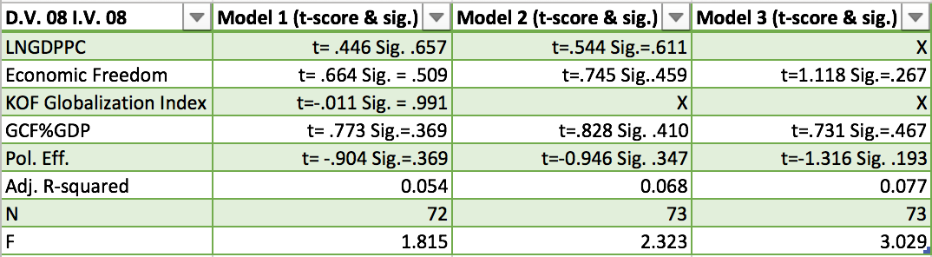
(Table 1: Synchronic Regression Models)

Diachronic regression models to examined the latent effects between the 2008 independent variables and the 2015 dependent variable. In relation to theory, this portion of the study is critical. Investment theory suggests that the primary goal of investors is to increase profitability. In the case of economic recession, profitability becomes less assured/predictable. By examining both 2008 and 2015 LnFDI%GDP we can observe if any variables increased or decreased in significance as the recessionary becomes less.
The first regression model with LnFDI%GDP from 2015 was disappointing, producing an F-score of 0.304 at a 9.1% confidence interval based off of 72 cases. The adjusted R-squared was -.051. No measures within the model exceeded acceptable VIF scores, however, to improve the model economic freedom was removed. This was done because 65% of the variation in Economic Freedom and 43% of the variation of KOF Globalization Index fell on the same dimension, indicating a good deal of collinearity between the measures.
The second regression model remained insignificant, incorporating 78 cases with an F-score of 0.739 and a confidence interval of 46.7%. The adjusted R–square was -0.011, showing that the model explained no portion of the variance within LnFDI%GDP for 2015. Intending to improve the model, LnGDPPC was removed from the model. Again, each VIF score fell under 4.0. The collinearity diagnostics showed that the variance in LnGDPPC and political effectiveness were at their highest in the sixth dimension (LnGDPPC=76%, Pol. Eff.=40%). This led to the removal of LnGDPPC, as it held the highest variance proportion.
The third regression model contained 78 cases and retained an F-score of 0.914. The model’s confidence interval was 56.2% with an adjusted R-square of -0.03. The model’s individual measurements each held VIF scores below four, however the collinearity diagnostics indicated that KOF index scores and Political Effectiveness each had their largest variations in the fourth dimension (KOF index= 88%, Pol. Eff.=53%). Because the KOF index scores held the highest percentage, it was removed and another regression was produced.
The fourth regression incorporated 79 cases, yet again failed to produce any significant results with an F-score of 0.866 and a 58.4% confidence interval. The adjusted R-square remained the same at -0.033, indicating the model still accounted for no explanation in the variance of LnFDI%GDP in 2015. The two remaining variables produced the same VIF score of 1.148 and the large majority of each measures variance proportions fell on different dimension in the collinearity diagnostics. Thus no further variable reduction was necessary. The individual t-scores and significances for each measure within the four models is listed below in Table 2:
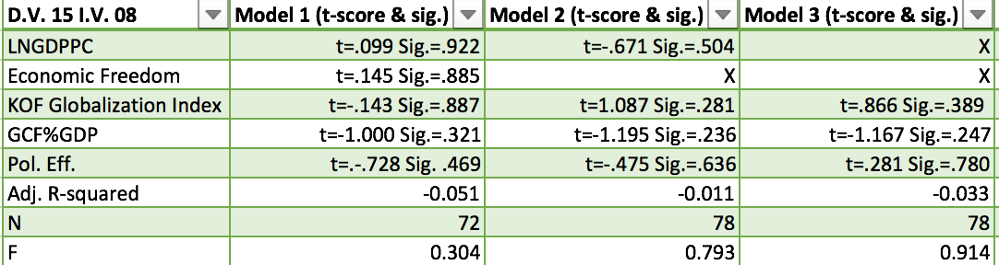
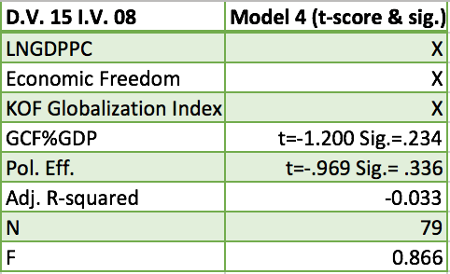
(Table 2: Diachronic Regression Models)

Discussion of Results
The intended goal of this study was to determine the significant factors behind the FDI behavior of MNCs following the 2008 recessionary period. As mentioned earlier, this study presumed that the synchronic regression model would produce more significance than the diachronic model. This is in part true, as the final model containing all 2008 measures was significant at the 0.05 level with an F-score of 3.209. In comparison, the model containing LnFDI%GDP from 2015 and independent measures from 2008 failed to attain any significance and achieved a final F-score of 0.866. However, the adjusted R-square reveals that the synchronic model (Table 1), although significant, only accounts for a small portion of the variance in 2008 FDI behavior. Interestingly, the final synchronic model showed that the constant was insignificant, with a t-score of -.254 and a confidence interval of 19.9%. This indicates that the model, despite having a small adjusted R-square, was not necessarily missing any significant variables. This result is perplexing and requires further research. Moreover, this models significance can partially be explained through investment theory. The initial period following the recession resulted in great economic instability on a global scale. During that period of time, economic growth was hindered severely, leaving MNCs to become more cautious in their FDI behavior (Poulsen, 2011, pp. 19-22). Therefore, the synchronic model attained 0.05 significance because MNCs––in order to attain profitability––were required to have greater scrutiny than in 2015. Though the synchronic model only explained 7.7% of the variation in 2008 LnFDI%GDP, it does indicate that economic freedom, capital availability, and political stability had an immediate impact on MNC behavior in 2008 and no latent impact in 2015. Because of this, we may recognize that there is plausible evidence to support the notion that MNCs consider additional factors during heightened recessionary periods in order to attain profitability. This may include the political atmosphere/stability in a country, the amount of economic regulation, and/or the amount of available capital in a country. It must be noted that no individual measurement attained significance in either model. However, the final diachronic model’s constant did have a t-score of 3.674 and 99.99% confidence interval, indicating that the model was missing a significant variable.
Aside from this finding, little more can be deciphered from the results; this is problematic. The literature review from this study indicated that political, economic, social, and cultural factors all influence MNC behavior. Examining these factors in a quantitative study requires measurements that accurately reflect these variables. Failure to collect valid measurements for the selected variables may be one potential explanation for the poor regression model performance.
For example, the decision to use the holistic KOF globalization index as a measurement for the level of globalization may have been more useful if a sub-category of the index was used (e.g., cultural globalization, social globalization, economic globalization). By doing so, collinearity within the model may have been reduced. The holistic measurement includes a number of cultural and social sub-measurements that were initially perceived to be beneficial to the study. In hind-sight, the KOF index’s inclusion of various sub-measurements may have limited its performance in the model. This becomes apparent when viewing the individual t-scores for the variable. In the synchronic model (Table 1), the measurement was removed after one regression test, as it produced a t-score of -0.001, a confidence interval of 0.9%, and a VIF score of 4.134. In the diachronic model (Table 2), t-scores improved, with the highest score at 1.087 (confidence interval 71.9%). Yet the variable never attained significance. Therefore, this study fails to reject the null hypothesis for the relationship between levels of globalization and recessionary FDI.
LnGDPPC, as a measurement of economic development is credible (Encyclopædia Britannica, 2018). However, the measurement never attained significance in either model, producing t-scores well below, or above, the acceptable 2.0 or -2.0 score. Additionally, the confidence interval never exceeded 56%. In turn, this study has failed to reject the null hypothesis for economic development, indicating that it is has no positive significant relationship with FDI behavior during recessionary periods. Additionally, it may have been more useful to collect data for the annual percent change in GDPPC. This may have better portrayed the impact of the recession on economic development, as it is reflective of annual change. Whereas LnGDPPC in constant US$ is a static measurement. Furthermore, the inclusion of economic growth, measured by percentage change in GDP, could have been useful, as it is the primary attractant of FDI during stable economic periods (Poulsen, 2011, p. 20). The lack of significance produced by LnGDPPC is perplexing, as the measure did produce a significant relationship with 2008 LnFDI%GDP at the 0.01 level.
The use of the political effectiveness measurement within the State Fragility Index interprets stability in accordance to how long a particular country’s government has peacefully maintained regime turnover. This is likely to accurately portray stability, however it does not necessarily indicate the type of government (e.g., democracy, authoritarian). According to Jensen (2003), government style, along with stability, are important factors that may determine FDI. Thus, the measurement may have been flawed, as it does not necessarily incorporate the type of government. The variable never attained significance in the regression tests, producing only one t-score below -1 (-1.316). Therefore, this study has failed to reject the null hypothesis regarding the negative relationship between recessionary FDI and political effectiveness. Moreover, the variable was included in the final synchronic model (Table 1), indicating it does have a function in explaining part of the variance of FDI when acting in conjunction to other variables. It may be a useful measurement in future regression analysis.
The inclusion of capital availability as a variable is warranted (Poulsen, 2011; Singh, 2012). However, the use of Gross Capital Formation as a percentage of GDP may have failed to capture the conceptual idea of validity. As mention previously, using percentage of GDP does not account for the change of size in the economy. Furthermore, GCF is a holistic measure of capital availability and does not discriminate data according to the origins of the capital. Thus meaning that it includes capital deriving from a number of different financial channels (i.e., local banks, foreign aid, etc.). Because of this, it may not have accurately reflected the specific types of capital that are of interest to MNCs. GCF%GDP failed to attain significance in either of the models. Therefore, this study has failed to reject the null hypothesis for the relationship between levels of capital availability and post-recession FDI. It must be noted that in the final synchronic regression (Table 1) the variable––in conjunction with political effectiveness and economic freedom––did contribute to a significant model. The individual t-score of 0.731 does indicate that the variable, in comparison to the others included in the final model in Table 1, contributed less to the model. Perhaps, future research may remove the variable with the intention of discovering if a greater level of explanation can be procured.
The use of the Fraser institutes measurement of Economic Freedom is likely to have accurately reflected economic freedom levels (Gwartney, 2010, p. 7). Yet, the variable never attained any significance in either model, producing its highest t-score (1.118) in the final model of the synchronic analysis (Table 1). Because this model is significant we may conclude that the variable, when in conjunction to other variables, adds to a significant model. Nevertheless, this study has failed to reject the null hypothesis for the level of economic freedom and post-recession FDI. However, it is puzzling that no significant relationship was formed, as the correlation matrix showed the measure attaining 0.01 significance with 2008 LnFDI%GDP.
Another potential explanation derives from the research’s incorporation of three regional groups into one general study. This may have resulted in a masking effect. Additionally, the use of single-year measurements may have become misleading as there is potential for idiosyncrasies (Billet, 1991, p. 20). To overcome this issue in future research, the integration of measurements that include percentage changes over two, or perhaps three years, may be useful.
Finally, another area the study that may have contributed to poor regression performance resides within the measurement of the dependent variable. As with all measurements that use percentage of GDP, it does not account for the relative change in the size of the economy. Thus, the measurements from 2008 and 2015 may have been misleading, as it only accounted for FDI as a percentage of GDP without including the actual change in the size of the economy. This may be overcome by examining percentage change in FDI flows. Additionally, the unit of comparison (i.e., GDP) could have been altered to percentage of the workforce, rather than percentage of GDP. This may be a useful consideration in future research. Notably, this study did produce a significant model that explained 7.7% of the variation in LnFDI%GDP in 2008 (Table 1). Though this is small, it appears to––in-part––confirm investment theory. To further support this claim, it may be useful to perform another synchronic regression analysis between the dependent variable (LnFDI%GDP) and the independent variables for the year 2015. If a significant model were produced, we may conclude that MNCs are less concerned with the latent effects of recessions as the global economy becomes more stable.
Conclusion
Deciphering what factors influence the FDI behavior of MNCs remains an important area of study. The growing interdependence of countries continues to bring us closer. Ultimately this is a beneficial process, yet we must consider that economic recessions are less likely to remain isolated, but rather have the ability to negatively impact more countries. Though this study has failed to produce any largely significant results, we must continue to work towards a better understanding of how nations can obtain FDI despite recessionary periods. Future research may give greater consideration to what measurements should be used in order to more accurately reflect the particular variables being incorporated. Nonetheless, the role of the MNC will continue to grow, and thus understanding their behavior can only benefit those seeking to comprehend the complexities of international relations.

References:
Authukorala, P. (2003). “FDI in crisis and recovery: Lessons from the 1997-98 Asian crisis”, Australian Economic History Review, 43, 197-214.
Billet, B. (1991). Investment behavior of multinational corporations in developing areas:
Comparing the Development Assistance Committee, Japanese, and American
corporations. New Brunswick, N.J., U.S.A.: Transaction.
Bornschier, V., & Hoby, J. (1981). Economic policy and multinational corporations in development: The measurable impacts in cross-national perspective. Social Problems, 28(4), 363-377. doi:10.2307/800050
Costică Mihai. (2012). The context and new trends of foreign direct investment flows. USV Annals of Economics and Public Administration, 12(1), 121-129.
C V Haley, U., & M Boje, D. (2014). Storytelling the internationalization of the multinational
enterprise. Journal of International Business Studies, 45(9), 1115-1132.
Economic development. (2018). In Encyclopædia Britannica. Retrieved
from https://academic.eb.com/levels/collegiate/article/economic-development/106199
Friedman, T. L. (2005). The world is flat: A brief history of the twenty-first century. 1st ed., Farrar, Straus and Giroux.

Giannone, D., et al. (2011). "Market freedom and the global recession." IMF Economic Review, p. 111+. Academic OneFile, http://link.galegroup.com/apps/doc/ A2549 59529/AONE?u=wartburgcoll&sid=AONE&xid=221722ea. Accessed 19 Nov. 2018.

Goetzmann, W. N. (1996). "An introduction to investment theory". Retrieved from http://viking.som.yale.edu/will/finman540/classnotes/notes.html

Gwartney J., Lawson, R., & Hall, J. “Economic Freedom of the World: 2017 Annual Report” Heritage Foundation. Retreived from https://www.fraserinstitute.org/sites/default/ files/economic-freedom-of-the-world-2017.pdf

Harrison, C., & Elaydi, R. (2014). "Exploring the benefits of MNC investment in foreign
countries during significant political elections." Journal of International Business
Research 13, no. (2): 38-49.

Haller, A. (2011). Economic freedom and human development in the knowledge
society. Economics, Management and Financial Markets, 6(1), 661-670. Retrieved from
http://ezproxy.wartburg.edu/login?url=https://search.proquest.com/docview/869529790?a ccountid=37903
Jensen, N. (2003). Democratic governance and multinational corporations: Political regimes and inflows of foreign direct investment. International Organization, 57(3), 587-616. Retrieved from http://www.jstor.org/stable/3594838

“KOF Globalization Index”. (2017). KOF Swiss Economic Institute. Retreived from: https://www.kof.ethz.ch/en/forecasts-and-indicators/indicators/kof-globalisation- index.html
Makino, S., & Tsang, E. (2011). Historical ties and foreign direct investment: An exploratory study. Journal of International Business Studies, 42(4), 545-557. Retrieved from http://www.jstor.org/stable/29789440
Onimode, B. (1978). Imperialism and multinational corporations: A case study of Nigeria.
Journal of Black Studies, 9(2), 207-232. Retrieved from http://www.jstor.org /stable/2783836
Peterson, S. (2012). Investment theory and risk management website (Wiley finance series). Hoboken, N.J.: Wiley.
Pistorius, T. (2014). Beyond statistics: A new rhetoric for investment theory. Journal of Organizational Change Management, 27(5), 722-731.
Poulsen, L. S., & Hufbauer, G. C. (2011). Foreign direct investment in
times of crisis. Transnational Corporations, 20(1), 19-37.
Sauvant, K. (2009). Columbia foreign direct investment perspectives: The FDI recession has
begun. Transnational Corporations Review, 1(1), 1-3.
Senghaas, D. (1975). Multinational corporations and the Third World. On the problem of the further integration of peripheries into the given structure of the international economic system. Journal of Peace Research, 12(4), 257-274.
Shiraev, E., & Zubok, V. (2016) International relations. New York: Oxford University Press.
Singh, D. (2012). Emerging economies and multinational corporations. International Journal of Emerging Markets, 7(4), 397-410. doi:http://dx.doi.org/10.1108/174 68801211264315
Shroff, N., Verdi, R., & Yu, G. (2014). Information environment and the investment decisions of multinational corporations. Accounting Review, 89, no. (2).
Marshall, M. G., Elzinga-Marshall, G. (2016). State Fragility Index. Center for Systemic Peace. Retrieved from: http://www.systemicpeace.org/inscr/SFImatrix2016c.pdf
Vernon, R. (1978). The multinationals: No strings attached. Foreign Policy, (33), 121-134. doi:10.2307/1148464
World Bank. (2018). World Bank Open Data. Retrieved from https://data.worldbank.org/

Appendix:
Figure 1 (Skewed Data)
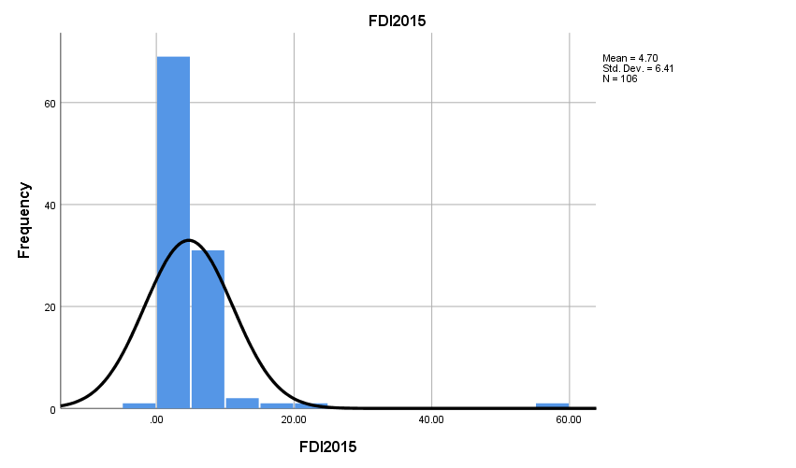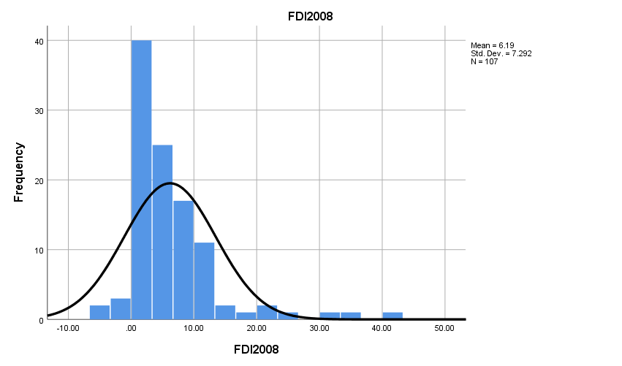
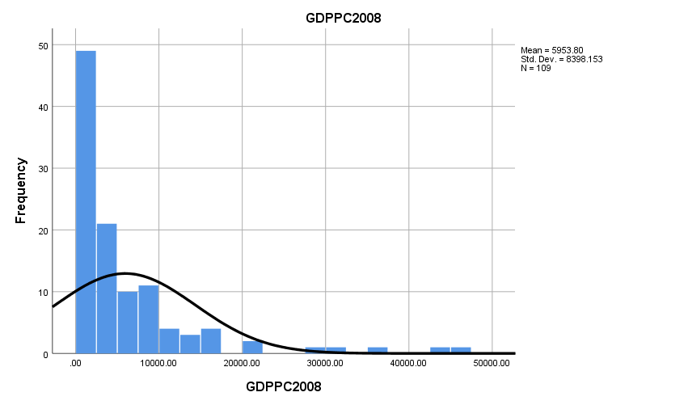
Figure 2 (Data after natural log function) 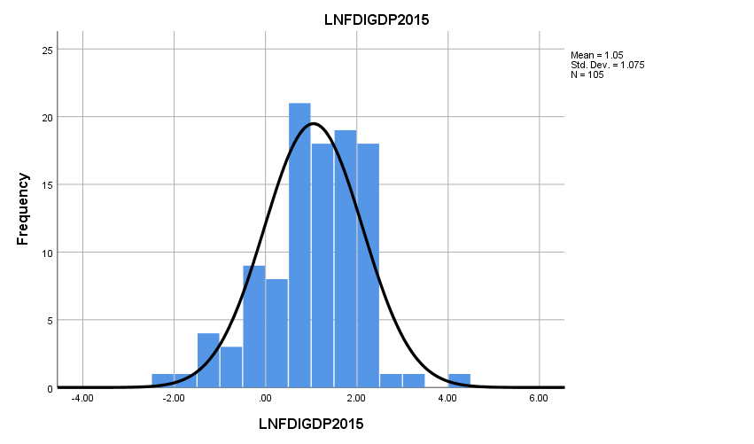
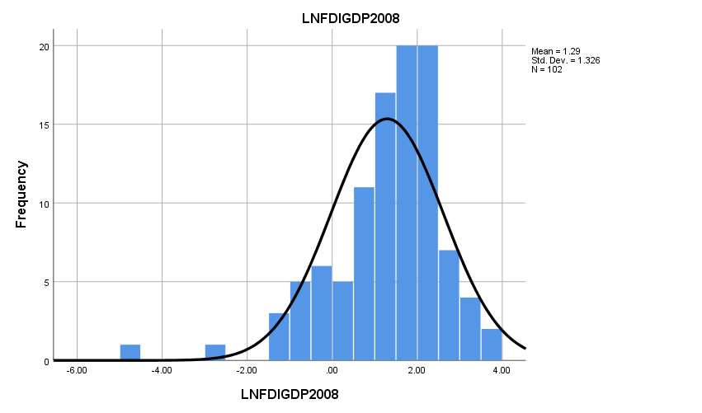

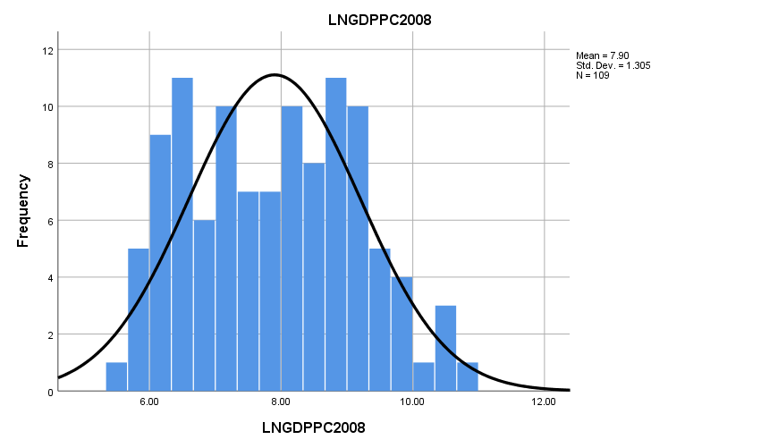

It must be noted that the decision to use the sub-measurement was made only after poor regression performance of the holistic SFI measure occurred in preliminary regression models.
This study hypothesizes that a negative correlation will occur as a result of the method in which the measurement displays political stability. In essences, a negative correlation is equivalent to a positive relationship.
The VIF score is used as a measurement of

