Adam Johnson
Senior Seminar
Nathan Kalmoe
23rd February 2016

A lesson of Proxies: Case Studies of Hezbollah and Boko Haram

Abstract:
Proxy warfare has made a comeback in the arsenal of many states, particularly within volatile regions. Thought to be tool used by the United States and Soviet Union to avoid direct conflict, proxy warfare has evolved into a cheap method of undermining and weakening potential adversaries. Unless political and military leaders can learn and incorporate lessons from this resurgence, conventional power will be impotent in the face of foes that won’t fight openly and enjoy the support of patron states. Case studies combined with video analysis of Hezbollah and Boko Haram will analyze their similarities, differences, and determine if there is anything to be learned from the resurgence of proxies.
With the collapse of the bipolar world, proxy warfare between major powers has declined dramatically (Mumford 2013). This decline among major powers has been mirrored by the rise of proxy warfare between middle, or regional powers (Groh 2010). Middle or Regional powers are states that influence their respective regions through political, economic, and military influence, but are usually impotent outside their region. These powers lack the economic, political and especially military influence to dominate their neighbors, and usually have state organized proxies or provide supplies to respective groups willing to fight. That distinction is meaningful, as Hezbollah is a state sponsored proxy receiving support from Iran, often having military objectives determined by Tehran, while the tactic support of the Pakistani Inter-Services Intelligence (ISI) for extremist Islamist groups relegates the proxy-patron relationship tenuous at best (Roberts 2007). This is relevant to my analysis of Boko Haram, as one of the group’s most prominent features is that they have no discernible patron state. Numerous tribal militias, gangs, and separatist groups have been funded in Sub Saharan Africa (McFarland 2009), what makes Boko Haram any different from these groups? How does Hezbollah compare to its opposite? For the purposes of this paper I will not cover states motivations or the cost and benefits of proxy warfare, Tyrone Groh provides in depth research on these topics from his doctoral thesis War on the Cheap? Assessing the Costs and Benefits of Proxy War.
Literature Review:
Published material on proxy warfare primarily falls along three paths of thought. The first focuses on the historical use of proxy groups as a Cold War tool by Western nations and Communist nations to fight each other (Mumford 2013). The Cold War era proxy is typified as freedom fighters, a faction within a civil war, or groups inspired for their respective reasons to fight for a cause. From economic to religious motivations, the external support for these groups was primarily divided between the “West” or NATO member nations, and the “East” or Communist Bloc nations. This dichotomy was a useful framework for the contemporary times, though it never captured the nuance or use of the superpowers by regional powers to further their own goals.
The second path of thought, primarily within Military and Defense orientated publications and institutions, has come to be dominated Hybrid Warfare, a catchall term that has come to encapsulate a combination of conventional, unconventional, and cyber warfare, even this cannot be agreed upon by those in the field (Puyvelde 2015). This catch all term is vague, and lacks the context or nuance necessary to determine relevant policy and actions towards those that use this “new” type of warfare. This is further complicated by the reliance on the framework of “tribal” militias, or proxy groups that fit the stereotype of support by a financially strapped African nation that supplies them through small arms and trafficking of people and materials (McFarland 2009). The use of high end weaponry and greater support for proxy groups has mostly gone unnoticed, with reliance on previous frameworks contributing to inaccurate analysis and policy recommendations.
Finally, the proliferation and saturation of certain geographical regions with small arms, namely the Middle East and Africa, has created an environment for the potential ability of even the weakest state to supply and maintain its own proxy forces (Pytak 2010). Aside from specialized organizations like the Small Arms Survey and other defense oriented think tanks, this has been studied as a primarily humanitarian issue, and hasn’t been attributed as a possible cause that contributes to the formation of potential proxy groups or their being supplied due to the flooded market.
Methodology:
Open Source Intelligence (OSINT) is the use of nonclassified government information, information published by nongovernmental organizations (NGO’s), and any public information from diverse sources (Norton 2011). This methodology emphasizes a synthesis of any form of relevant information into an overarching picture, combining the analytical aspects of the intelligence specialties. Open Source information from humanitarian non profits, companies, academic sources, military sources, and government sources, just to name a few, are all treated as accurate and relevant, each having its specific information relevant to the intended audience. This is combined and analyzed to create a holistic understanding of the issue.
Open Source Intelligence has yielded little concrete information on most groups from the usual sources due to their nature, most don’t publish material, but GoPro™ combat footage has proved an usual source of first hand information. The availability of digital recording has uncovered material that would have been previously unavailable, and allows the rapid dissemination of information and events from the place of their occurrence. In the case of the Syrian Civil War, amateur footage makes major events and finds on the battlefield available online within the week and sometimes within hours of their recording. This will be combined with video and military analysis to determine if any useful information can be found.
Why is this important?
The Iranian Guards Revolutionary Corps (IRGC), the primary patron of Hezbollah, has under extreme economic duress proven the foremost institutional practitioner of proxy warfare (Robin 2011). This is a worrying trend as the Iranian economy will grow as sanctions are removed, and the IRGC will be able to expand of use politically and economically cheap proxies to further its goals. This trend is exptrapolateable to many developing nations who are experiencing rapid economic growth (Regional Economic Outlook, Sub-Saharan Africa 2015). This dramatic economic growth of developing countries (Sy 2014), coupled with the relative decline of western power, has allowed formerly weak states to employ the type of large scale proxy warfare formerly employed by western nations. The rough criminal group sponsored through small arms and drug sales of the Cold War has been replaced by politically and economically supported proxies, some enjoying the almost open support of their patron state. This trend has gone unnoticed among policymakers who focus on the traditional proxy group, directed by a powerful adversary, instead of regional powers or even weak nations with poor institutional development and tenuous control over its territory.
One often overlooked aspect of these cheap militia-esque proxies is their inability to be controlled by their patrons. The leadership of Hezbollah can be counted upon, within reason, to not take drastic measures without first consulting Tehran. Boko Haram seems to have no rational thought within the group for self preservation or continuity of existence, nor minimizing potential adversaries. This sets a dangerous precedent in the age of major attacks on civilians, with no single entity able to be held accountable for the actions of these groups. Unless political and military leaders can understand and learn from this resurgence, conventional power will be impotent in the face of foes that won’t fight openly, and enjoy the support of hostile nations.
Hezbollah is the pinnacle of the proxy, self sustaining in recruitment and gaining advanced combat experience in modern warfare within Syria. As developing nations continue to grow, their newfound economic growth with allow for almost any nation with the will to afford proxies, exploding in a conflagration of state sponsored violence, particularly in the authoritarian nations of the Middle East and Sub Saharan Africa. This trend is ominous for policy makers, as the democratic nature of most nation states make the use of proxy warfare unethical, expensive, and most importantly something that cannot be countered with traditional hard power (Thompson 2002).
What is proxy warfare?
In his book Proxy Warfare Andrew Mumford defines proxy warfare as:

“The indirect engagement in a conflict by third parties wishing to influence its strategic outcome. They are constitutive of a relationship between a benefactor, who is a state or non- state actor external to the dynamic of an existing conflict, and their chosen proxies who are the conduit for weapons, training and funding from the benefactor. Such arms length interventions are undertaken ostensibly for reasons of maximizing interest, while at the same time minimizing risk. In short, proxy wars are the logical replacement for states seeking to further their own strategic goals yet at the same time avoid engaging in direct, costly and bloody warfare.”

Proxy warfare has gone through many iterations and periods of use, especially during the Cold War (Groh 2010). From primarily American or Soviet sponsored political-religious groups like the Mujahedeen and Red Faction Brigade, these traditional proxies have been replaced or superseded by separatist and extremist religious groups that hold their patron at arms lengths while pursuing their own goals. One incorrect idea about proxy groups is that the patron state exercises direct control over the proxy. That is inaccurate and the exception, as most proxies are self directing and have complex relationships with their patron state. Proxies almost always have their own objectives to carry out: regime change, political goals, economic goals, ethnically or religiously based objectives; these are some of the common reasons. The most important distinction for proxy groups is that they fit into other types of groups. An insurgency group can be a proxy group, as can a large organized crime syndicate. A faction within a civil war can be a proxy group, as can other nations as third parties. The definition is flexible and captures many groups today who receive support from both nation states and NGO’s.
Criteria
The growing prevalence of proxy groups, especially within the Middle East and Sub Saharan Africa, is being driven by a four pivotal factors that determine the success of proxy groups. The factors are as following:
Political Support: Does the proxy have the political backing of a patron state? The Novorossiya Confederacy, Hezbollah, Taliban, and Breakaway states of the Caucasus region have the nominal support of their respective patron states, often not subtly (Thomas 2015). This can be difficult to track, as some patron states keep traceable involvement to a minimum, while others openly support their proxy group. Formalized agreements between the proxy and 3rd party nations are one sign of extensive and prolonged political support.
Sustainability: Can the proxy sustain itself in any meaningful way? Membership, financial support, political power, and ability to gather sustainment materials independently are one hallmark of a successful proxy (Butler 2011). Total dependence on a patron state for material, members and funding leaves the proxy in a bind if the patron state decides to terminate support.
Material Support: Does the proxy have access to moderately advanced munitions and weapons systems? Being limited to vintage weapons systems limits the proxy’s combat effectiveness and ability to fulfill political goals, while proxies armed with cutting edge munitions and in some cases with advanced military training and organization can become surrogate armies for their patron state (Jenzen-Jones, Lyamin, and Wright 2014). A small group of fighters armed with bolt action rifles will be hard pressed to take on even the most inept security force, while an organized, trained, and heavily armed group with anti vehicle weapons and indirect fire support can ravish even the most combat hardened force.
Viability of potential Proxy: Does the proxy have a reasonable chance of fulfilling its goal? Establishing proxy groups within moderate political regions is difficult, while volatile regions that lack governance often have the highest chances of success (Paffenroth 2014). Establishing a proxy group within a nation with strong institutions like Canada will be significantly harder, and have a much greater chance of failure, than convincing Chechnyan separatists to fight against Russian security forces.
As defined above, very few proxy groups fit all the criteria and often exist for small periods of time. Two groups that have defied the usual lifespan of a proxy group, Hezbollah and Boko Haram, represent the opposite potentials of a proxy group. A case study of both groups, coupled with my own analysis of propaganda and combat videos, will discuss the proxies and the patterns that can be learned from analyzing them.
Hezbollah
Hezbollah has captured the attention of western policymakers, and has been designated a terrorist organization by the US Department of State (Levitt 2005). A Shia militant organization that grew out of the Lebanese Civil War and Israeli occupation of Southern Lebanon, the organization has developed into the perfect example of a state sponsored proxy that acts as an almost branch of the IRGC (Schiesz 2014). Growing from its origins as a light infantry guerrilla force, barely able to stand up in fights with the Israeli Defense Force (IDF), it has grown into an organization that has active and reserve combat components, an able currency generating apparatus, and has woven itself into the political and social fabric of Lebanon (Mumford 2013). In particular the 2006 Lebanon War showed the growth in what military circles define as “Operational and Tactical capabilities (Johnson 2010)”.
For the purposes of this paper, Operational capabilities are defined as the ability to coordinate and effectively use military units larger than companies. This is emphasized especially as the size of military units get larger, at the battalion and regimental level. Tactical capabilities are the physical command and effectiveness of soldiers or combatants at or below the company level and emphasize training, equipment, and professional leadership. These capabilities cost time, money, and expertise to acquire and often take decades of practice combined with real world usage in warfare. A proxy group with these capabilities is powerful, and able to compete militarily with smaller nation state armies.
Hezbollah grew from its original role as a light infantry based force capable of firefights involving dozens of combatants at best, into a large thousand man force capable of sustaining a prolonged offensive effort outside of its own territory. Heavily involved in the Syrian Civil War, Hezbollah at the behest of Iranian influence has entered into the war as a major combatant, and has been seen as responsible for the SSA retaking ground from extremist and moderate groups. Does Hezbollah satisfy the aforementioned criteria, and does it bring anything unique that can be learned from?
Political Support: Hezbollah enjoys the extensive political support of a regional power, Iran, the largest Shia majority state in the Middle East. Frequent sermons from the Ayatollah are featured in Hezbollah propaganda and recruitment videos, along with not so subtle featuring of IRGC symbols in some videos released. While internationally branded as a terrorist organization, Hezbollah enjoys training in Iran by IGRC personnel and often can be found fighting with Iranian advisors (Sullivan 2014).
Sustainability: Hezbollah receives millions of dollars in donations from the Lebanese Diaspora, and routinely generates tens of millions of dollars in revenue from activities in Lebanon (Levitt 2005). Hezbollah recruiting policies allow for most members to retain their civilian lives, a method not dissimilar from the US. Army Reserves, while still receiving training and benefits for being on call (Butler 2011). This rotation of active fighters, coupled with an extensive and effective reserve system that sustains combat forces, creates a combat tested core of experienced soldiers. While most advanced equipment is supplied by the IRGC, Hezbollah has proven itself capable of acquiring small arms, particularly Soviet pattern weapons system (Butler 2011).
Material Support: Hezbollah enjoys some of the most advanced weapons systems, logistics networks, and institutional development ever seen by a proxy group. From its humble origins as a light infantry based force that skirmished with Israeli forces, Hezbollah has evolved into a proxy group capable of small unit fighting, something that can be difficult even for contemporary nations. Small Arms, Anti Personnel Weapons, Anti Tank and even Anti Aircraft weapons have been observed in use by Hezbollah, giving pause to even combat tested national armies (Johnson 2010). Hezbollah has even acquired advanced missile capabilities from its patron state, the Iranian produced Falaq surface to surface missile (Jenzen-Jones, Lyamin, and Wright 2014). In the material department, Hezbollah is arguably the most lavishly supplied proxy group to currently exist.
Viability: Hezbollah is virtually impossible to destroy in a conventional sense, as it has woven itself into the structure of the Lebanese nation, forming an almost dual structure of government that provides essential services to its members, their families, and citizens of Lebanon. The Lebanese Army is unable to remove or destroy Hezbollah in a very real fear of starting a civil war, essentially insulating Hezbollah from foreign involvement. Withholding dramatic changes in Lebanon, Hezbollah is safe from both nation state armies and other proxy groups within its stronghold, and can begin operations against adversaries at will or direction from Tehran.
Discussion
As defined above, Hezbollah is the quintessential example of a proxy that enjoys unparalled support from its patron state, unique in that the patron state has been under economic sanctions from the West since the Iranian revolution, and was hit hard economically by the additional Comprehensive Iran Sanctions, Accountability, and Divestment Act of 2010 (Berman 2010). Within the Islamic Republic of Iran, the IRGC has been responsible for the political and material support of Hezbollah, and has been able to continue support even under sanctions due to its dominant role within the Iranian economy (Robin 2011). Prominent in the Syrian Civil War, Hezbollah hasn’t hesitated to show off its advanced and growing strength on the battlefield, coupled with the extensive support of its patron state.
Hezbollah Analysis Rationale: Analyzing the traditional signs of patron support, small arms and portable weapons systems, is difficult with Hezbollah due to its geographical situation. Geographically the region that Hezbollah operates in is awash with small arms, often extremely difficult to trace (Diehl and Jenzen-Jones 2014). Analyzing the multitude of small arms used by Hezbollah is difficult, with propaganda videos and combat videos presenting two different situations. The first, in which arms stocks are nearby and operations are confined to exercises, presents a uniform and strong appearance that is prominently displayed. The second, combat footage from Syria, presents the opposite in that deployed forces often become worn down and ad hoc as they fight. Obtaining weapons from the battlefield is relatively easy and free, but presents an uneven and ragtag appearance among fighters.
With this in mind, analysis will be kept to Propaganda videos released online, with a focus on heavy weapons systems. For the purposes of this paper heavy weapons systems are defined as weapons that aren’t capable of being carried, or weapons that require either two people to use, or a vehicle to carry. These are harder to sustain and employ by proxy groups due to their complicated and expensive nature, and represent the easiest way to determine a patron state as Soviet-Russian and American weapons systems dominate the export market.
Analysis #1: (ElectronicResistance)
Retrieved from YouTube, this two part propaganda video shows a Hezbollah small unit practicing fire and maneuver in an open field and heavy weapons being used in the field:
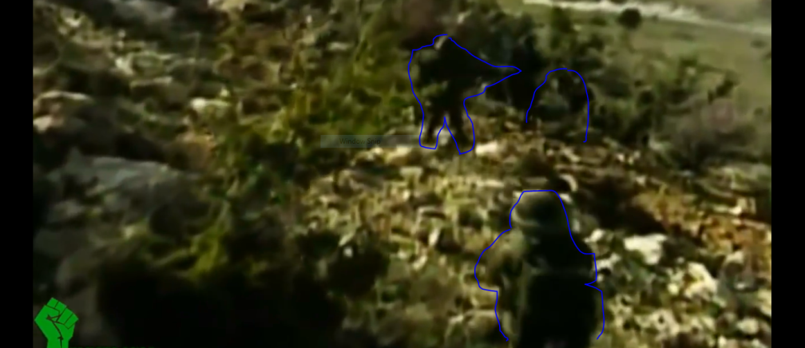
Highlighted in blue, the small unit shares standardized equipment, something unusual and prohibitively expensive for most proxy groups, who commonly have a ragtag appearance even in propaganda videos. This denotes a safe area that is used for training, exercises, and possibly even live fire exercises. Large enough to accommodate both crews working the weapons and a camera crew, the video was likely filmed within Lebanon, Syria, or IRGC facilities within Iran.
Continuing from there, of significant notice is what equipment is shown in the video, notably the mortar system:
This unnamed mortar, edited in with a series of explosions, bares a glaring resemblance to the Iranian produced Razm system, a 120mm mortar that is too heavy to be infantry mobile, and has to be transported by truck:
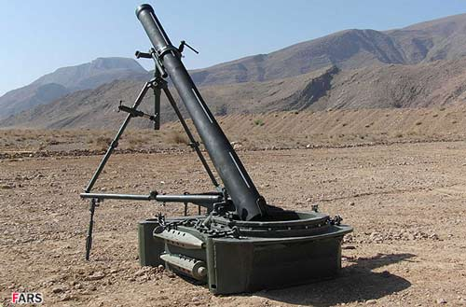
It bears no resemblance to any American made mortar systems, which all lack the notch on the right side of the barrel and lack the counterweight on the bottom used to stabilize the mortar. While not definitive, the system is most likely the Iranian produced Razn.
Another interesting display of equipment, a bit harder to place, is the Antitank Guided Munition (ATGM) being quickly assembled in the field:
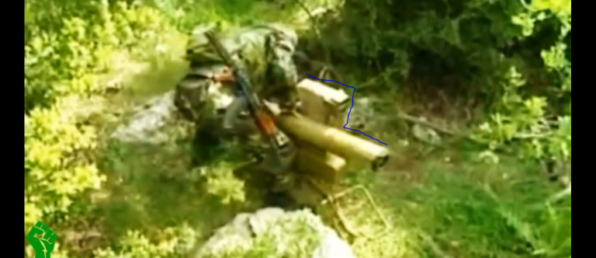
The silhouette of the launcher highlighted in blue bears a resemblance to the originally Russian produced 9M113 Konkurs, which is locally produced in Iran under the name Torsan, which is completely interchangeable with the Russian production model. The following photo is of an Israeli captured Russian variant:
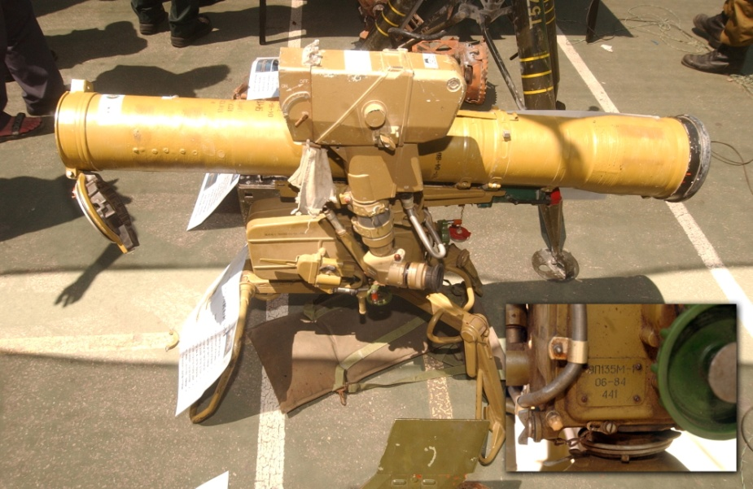
This seems conclusive, but stocks of ammunition for the system were in Syrian Arab Army (SAA) arsenals prior to the outbreak of the Syrian Civil War, and is possibly stocks given to Hezbollah by the Assad Regime, though the persistence of such munitions four years into the war, coupled with frequent use as anti infantry weapons, lends credence to the idea of Iranian supplies. The ammunition for the system ranges in the tens of thousands of dollars, while the complexity of producing the ammunition is only capable by advanced munitions industries, point to three conclusions.
- The Russian entry into the Syrian Civil War may have induced the Russian government to supply Hezbollah on the ground with munitions. The ammunition is interchangeable, and Russia is the only former soviet country capable of producing the missile system. (Ukrainian production is still active, but unlikely to wind up in Syria)
- Hezbollah is actively supported by the IRGC. The Iranian Defence Industries Organization (DIO) is a conglomerate of Iranian state companies responsible for producing systems like the Torsan. This is coupled with knowledge of Iranian advisors and IRGC personnel on the ground fighting with the SAA.
- Hezbollah found an extremely large cache of ammunition for the Torsan that had been abandoned by the SAA during the start of the Syrian Civil War. The system was already in army stocks, and is it possible that the SAA stockpiled them. This is unlikely, as the cost and need for the system was unlikely given Syria’s situation before the war. Unlikely, but remotely possible.
Summary
Hezbollah has transformed what it means to be a proxy group. From its humble origins it now enjoys a position of political insulation, lavish material support, military capabilities beyond some nation states, and is safe from destruction for the foreseeable future. As the Syrian Civil War winds down combat hardened fighters will return home in large numbers, and upset the delicate within Lebanon, and with the Israelis. This is a worrying possibility, as states come to the conclusion that Hezbollah can serve as a template for how they seek to use their proxies. A world full of potential Hezbollah’s, each with varying political goals, but with the strength to attempt its goals is a world full of long and bloody conflicts and possibly even capable of starting regional wars. Especially worrying is the precedent set of IRGC support for Hezbollah, as it acts unilaterally and without unity of government. Various factions with governments supporting their own proxies is a worrying development, especially as regional powers become the centers of power within their regions.
Boko Haram
Jama’atu Ahlus-Sunnah Lidda’Awati Wal Jihad or as it’s known in the West, Boko Haram has exploded onto the world scene with its horrific behavior, commonly committing acts that seem part of a bygone era. Decapitation, mutilation, forced religious conversion and systemic use of sexual assault are only some of the many acts the group has proudly broadcast to the world. Made notorious for the 2014 Chibok Kidnappings and the #BringBackOurGirls campaign through online media, Boko Haram’s members and leadership have been active within West Africa, especially within Nigeria, for over a decade.
An extension of Nigeria’s troubled past with religious violence; Boko Haram’s beginning can be traced to the Muslim North of Nigeria, which has vastly different cultural, linguistic, political and religious dimensions than the South (Walker 2012). Boko Haram is the manifestation of internal tension and unrest and has achieved dramatic victories against Nigerian and other West African security forces. What is driving Boko Haram’s success, and is there any chance of external support? Boko Haram got its start in Northern Nigeria at the Alhajj Muhammadu Ndimi Mosque in the early 2000’s, where an offshoot of young male worshippers there declared the city and Islamic establishment corrupt. A call went out to move to Yobe state near the border with Niger to establish true Sharia law, but was cut short when the early group’s adherents came into conflict with Nigerian police. Referred to as the Nigerian Taliban by some in the region, the embryonic Boko Haram was composed of primarily wealthy and influential Northern Nigerians sons, many of whom were college educated and wealthy (Walker 2012).
Boko Haram’s complicated relationship with Nigeria frustrates attempts at cooperation with other West African security forces, notably Niger, Cameroon and Chad who have had to accommodate more than 60,000 refugees into crowded camps along their borders (Blanchard 2014). With a casualty count in the tens of thousands, erosion of Nigerian control over the north, and inflaming of religious tensions among Christians and Muslims, Boko Haram presents a challenge to the Nigerian government. On the other hand, use of militias and insurgent groups to fight neighbors or separatist groups is nothing new on the Africa continent (McFarland 2009). Especially prevalent among the Democratic People’s Republic of the Congo (DRC), Ethiopia, and Sudan, militias like the Janjaweed, a militia group that operates around central and southern Sudan and were instrumental in combating south Sudanese separatists, are legitimate tools among the various African regimes (Flint 2009).
What makes Boko Haram so different from other groups are its dramatic battlefield successes, seemingly lavish supplies of small arms, and use of the porous borders between Nigeria’s neighbors as a sanctuary, and most importantly its lack of a patron state. No single nation state seems likely or able to support Boko Haram, especially those who have been on the receiving end of bombings and raids by its fighters. Who then is supporting Boko Haram? How are they doing so? And is there anything to be learned from it?
Political Support: Boko Haram lacks discernible support from any single state, and has been the subject international of cooperation in the fight against Islamic extremism (Campbell 2014). Domestically Boko Haram had received support from disaffected northern Nigerians in its early years, and was thought to have received support from northern politicians unhappy with the policies of the Nigerian federal government (Pate 2015). This support has for the most part disappeared in the wake of Boko Haram killing and kidnapping northern Muslims, though some continue to support it. Overwhelmingly Boko Haram has little or no political support in the territory it controls, and from both Nigeria and the neighboring nations.
Sustainability: Boko Haram has been the wildfire to Hezbollah’s flame, rapidly growing and expanding in territory and capabilities. That expansion doesn’t necessarily translate into sustainability, as Boko Haram’s main method of recruitment and sustainment has been conscription and use of kidnappings and hostages as fund generation (Pate 2015). This has alienated what little support the group has retained, and has been pivotal in depopulating the Sambisa forsest, its preferred hiding place. Boko Haram will be increasingly hard pressed to sustain its current level of activity, and has slowly begun to embrace bombings instead of frontal attacks on security forces as its preferred method of destruction. This is cheaper for the group and allows it to maximize violence against civilians while minimizing its own losses.
Material Support: Boko Haram employs a dizzying array of small arms, something not unusual due to the porous borders of many African nations(Diehl and Jenzen-Jones 2014). American, Soviet-Russian, and European type small arms have been found strewn across the battlefields of northern Nigeria. The Nigerian military itself is reliant upon imports for many of its own needs, fueling a vicious cycle in which Boko Haram is able to replenish its stocks of ammunition and gather weapons from killed security forces. Of particular interest is the heavy weapons used by Boko Haram, many of which are extraordinarily to service and supply in the forests and austere battlefields Boko Haram is accustomed to fighting on. West African security forces have used infantry for the most part, limiting the theory of these systems being taken from them. The analysis of the weapons systems in use could give some clues into where the weapons are from, and who possibly supplies them.
Viability of Proxy: Boko Haram’s long term prospects look bleak at best. For the foreseeable future it has succeeded in alienating and antagonizing most of West Africa, and made one time enemies cooperate in an effort to snuff the group out. Under the over arching umbrella of combating Islamic extremist, though it barely fits into that criteria, Boko Haram has drawn western support to Nigeria. International support for Nigeria, combined with potent regional support from fellow African nations, makes Boko Haram powerless to protect itself in any political manner. In its current iteration Boko Haram is unlikely to make it through the decade intact, let alone in its current form. Crushing the group will not erase the conditions that gave rise to the group, and many of its current members will likely plague northern Nigeria for years to come as a low level insurgency. In the end, Boko Haram represents the opposite of Hezbollah, a wildfire that has burned quickly and brightly but will fizzle out over time.
Discussion
Compared to Hezbollah, Boko Haram represents a homegrown reaction to ethnic, religious, economic, and political differences between northern and southern Nigerians. Imposing its interpretation of Sharia law upon northern Nigeria remains its political goal but is intractable considering the group’s main obstacle, the Nigerian government and the sizable Christian population. Boko Haram sets a worrying precedent of militias and separatist groups attacking and devastating the already overburdened nations of West and Central Africa, not to mention the Horn of Africa. While democracies would find supporting such groups amoral and unpalatable, authoritarian regimes could possibly see such groups as a method of weakening potential adversaries and support them with material and sanctuary.
Boko Haram Analysis Rationale
(DISCLAIMER: The video I will be using for the analysis is graphic and displays the bodies of Nigerian security forces along with the beheading of a Nigerian soldier. The footage is gratuitous and grotesque, but the original video will be included in works cited)
Analysis #2
The analysis of this video will lean heavily towards analysis of ammunition for heavy weapons systems and what few heavy systems there are. This is for two reasons: First is the availability of ammunition for small arms within the region. Ammunition can be used for whatever type of weapon so long as it uses the correct caliber, and the most common types of calibers in the world are the 5.56 x 45mm NATO and Russian-Soviet 7.62 x 39mm. Tracking individual cartridges, especially in a poor quality video, is almost impossible. Boko Haram is seen in the video with access to a heavy weapons system that seems to still be functioning, unusual to be able to service and supply the weapon in its hideouts along the border. Since these are often more definitive on signs of external support, I will focus on them.
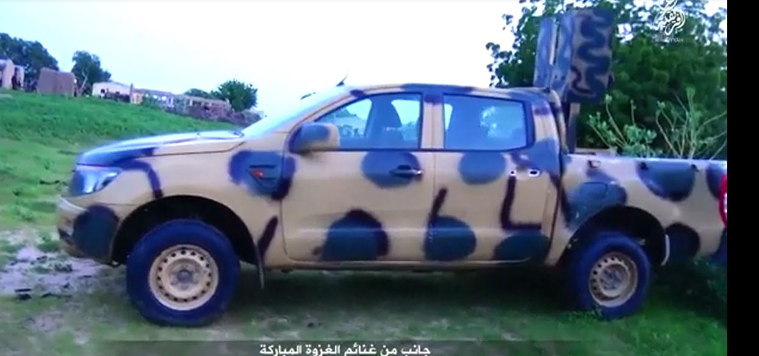
The above is what is referred to as a technical. Technicals are ordinarily civilian vehicles that usually have some sort of basic armor or combat modifications made to them, and are often used by groups that cannot afford or obtain professionally designed armored fighting vehicles (AFV). A common type of AFV in civil wars, insurgencies, and other low level conflicts, their availability and cost are affordable by even the most cash strapped group, who simply wield weapons onto the vehicle and give it a coat of paint. Two distinguishing features confirm this as being used by Boko Haram in a combat capacity.
First, the logo barely visible on the front of the vehicle looks similar to the standard ford logo:
A cursory overview of the Ford Sub Saharan Africa website reveals only two trucks for sale on the Nigerian market from ford: The F-150 and Ford Ranger
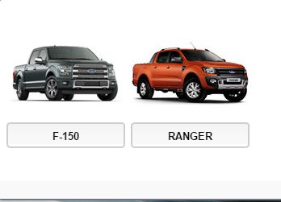
Second, while not conclusive, the truck features a mounted hard point on the rear to fire heavy weapons from:
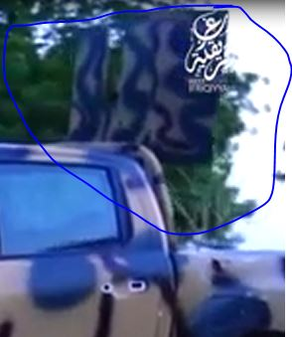
The hard point is meant to shield the operator from fire while allowing the truck to serve as a mobile weapons platform, something useful for hit and run tactics. This would be an unnecessary modification for the Nigerian military, as they possess AFV’s, meaning this was likely a civilian truck taken by Boko Haram and repurposed. Where the AFV came from is unknown, but considering the lack of signs of aging on the vehicle, and the seemingly new appearance of it, this lends credence to the theory that the vehicle was either stolen or donated from a source able to afford the essentially brand new vehicle. Who or what is capable of affording the vehicle, if donated, could point to sponsorship from someone or a group that’s finically secure within Nigeria.
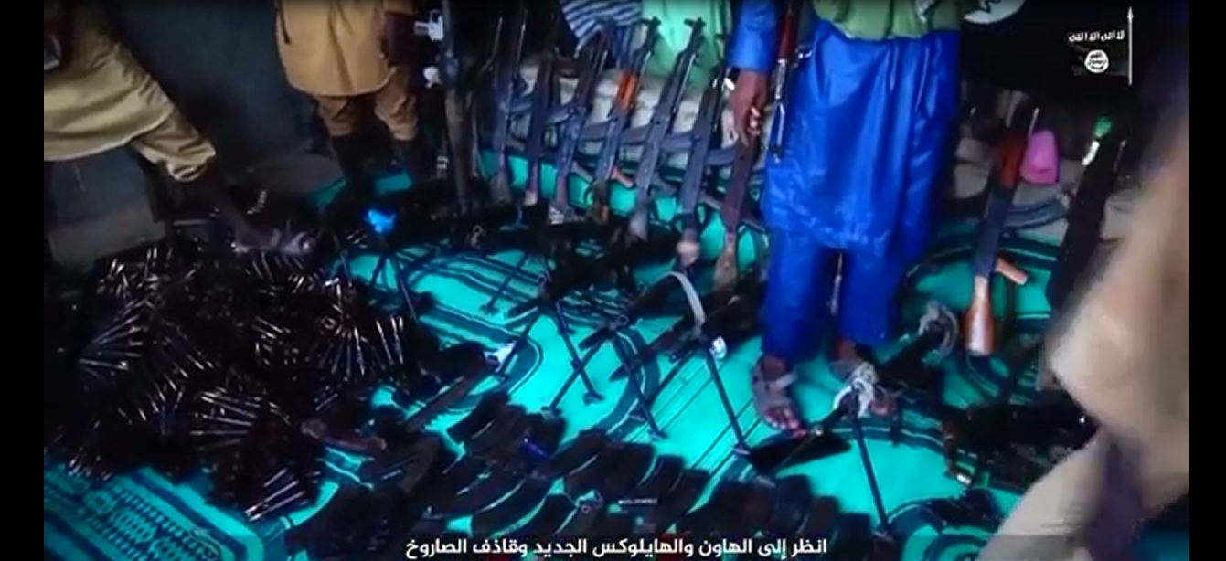
The above is the arms cache featured in the video, with dozens of rifles and magazines scattered everywhere. Of particular importance is the bundle of ammunition in the bottom left, which is too large, heavy, and numerous to be something used for small arms. It likely belongs to the heavy gun mounted on the technical, which uses the same caliber that the bundle appears to be.
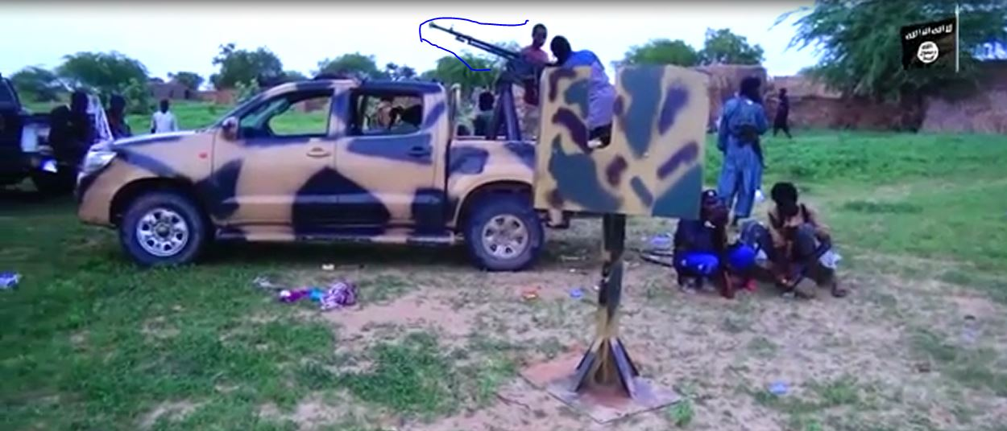
This is unlikely to have originated with the Nigerian security forces, they have more modern systems, and brings into question who could’ve supplied it. The possibility of private actors supplying Boko Haram is plausible, as cutting the funding to Boko Haram has proved extremely difficult (Blanchard 2014). Support for Boko Haram, though severely shrunken form its heyday, still does exist in the north, and is possibly still being financially supported by wealthy patrons. The direct link between funds and arms will likely not be discovered for a long time.
Conclusion: Boko Haram represents the untrained, uncoordinated proxy that has an at best tenuous relationship with its patron or patrons. Boko Haram lacks the systemic organization, planning, and institutional development that Hezbollah has honed over its existence. That said, Boko Haram has proved that it can be just as deadly and frustrating to deal with, and has proven that it doesn’t need to match firepower with firepower, only causing enough damage to make the Nigerian government seem impotent and causing ethnic and religious strife wherever it attacks. Boko Haram will not likely be around for the long term, but groups similar to Boko Haram will. Boko Haram serves as the template for a disposable proxy, a dog let off the leash to cause as much destruction and chaos as possible before it’s put down. That’s a template for states that have authoritarian regimes and are either insulated from the result, or deem them useful enough to accept the consequences. Especially important is the lack of control over Boko Haram, as independent actors, factions, and organizations support the group for various reasons. The lack of a centralized authority that attempts to regulate the behavior of its proxy leaves all decision making in the hands of the proxy, and in the case of Boko Haram a proxy that acts without regard for international norms of behavior or conduct of warfare.
Boko Haram and Hezbollah represent the opposite spectrums of proxy groups, one stable and heavily involved as a surrogate army for its patron state, the other hiding in a forest while it attacks anything and everything destabilizing an already tense political situation. Groups similar to both will come into existence for various reasons, but their patron’s state ability to supply and protect them will increase as more nations learn from these groups. The cost of nation states fighting their neighbors in conventional wars will be enormous compared to the cost of supplying and sometimes training proxy forces to carry out objectives. This trend in proxy development is a permanent one and likely to increase as more lessons and examples are drawn from the battlefields of Syria, Nigeria, Lebanon and Yemen. Proxies are here to stay, and they are getting deadlier.

Works Cited
Berman, Howard. “H.R.2194 - 111th Congress (2009-2010): Comprehensive Iran Sanctions, Accountability, and Divestment Act of 2010.” legislation. N.p., 1 July 2010. Web. 26 Feb. 2016.
Blanchard, Lauren Ploch. “Nigeria’s Boko Haram: Frequently Asked Questions*.” Current Politics and Economics of Africa 7.2 (2014): 143. Print.
Butler, Leroy B. Hezbollah: The Dynamics of Recruitment. DTIC Document, 2011. Google Scholar. Web. 24 Feb. 2016.
Campbell, John. “Boko Haram: Origins, Challenges and Responses.” NOREF Policy Brief (2014): n. pag. Google Scholar. Web. 21 Mar. 2016.
Diehl, Alexnader, and N. R. Jenzen-Jones. Small Arms Survey Feeding The Fire. Graduate Institute of International and Development Studies,Geneva, 2014. Print. Small Arms Survey.
ElectronicResistance. Hezbollah Training & Combat Footage. N.p. Film.
Flint, Julie. Beyond “Janjaweed”: Understanding the Militias of Darfur. Geneva: Small Arms Survey, Graduate Institute of International Studies, 2009. Print.
Groh, Tyrone Lee. “War on the Cheap?: Assessing the Costs and Benefits of Proxy War.” Generic (2010): n. pag. Web.
Jenzen-Jones, N. R., Yuri Lyamin, and Galen Wright. Iranian Falaq-1 and Falaq-2 Rockets in Syria. Armament Research Services Pty. Ltd., 2014. Google Scholar. Web. 24 Feb. 2016.
Johnson, David E. Military Capabilities for Hybrid War: Insights from the Israel Defense Forces in Lebanon and Gaza. Santa Monica, CA: RAND, 2010. Print.
Levitt, Matthew. “Hezbollah: Financing Terror through Criminal Enterprise.” Testimony Before the Committee on Homeland Security and Governmental Affairs, Us Senate 25 (2005): n. pag. Google Scholar. Web. 23 Feb. 2016.
McFarland, Sherri. “The Usage of Proxy Militias in the Horn of Africa and the Democratic Republic of Congo.” New Balkan Politics 11 (2009): N_A. Print.
Mumford, Andrew. Proxy Warfare. Cambridge: Polity Press, 2013. Print. War and Conflict in the Modern World.
Norton, R.A. “Guide to Open Source Intelligence: A Growing Window into the World.” Intelligencer: Journal of U.S. Intelligence Studies 18.Winter/Spring 2011 (2011): 65–67. Print.
Paffenroth, Adam. “Outsourcing Conflict: An Analysis of the Strategic Underpinnings of Proxy Warfare.” Johns Hopkins University, 2014. Google Scholar. Web. 9 Dec. 2015.
Pate, Amy. Boko Haram: An Assessment of Strengths, Vulnerabilities, and Policy Options. National Consortium for the Study of Terrorism and Responses to Terrorism (START), 2015. Web. 25 Mar. 2016.
Puyvelde, Damien Van. “Hybrid War – Does It Even Exist?” NATO Review. N.p., 2015. Web. 5 Apr. 2016.
Pytak, Allison. Small Arms and Light Weapons: Africa. 777 United Nations Plaza, 9th Floor New York, NY 10017: Religions for Peace: African Council of Religious Leaders, 2010. Print.
Regional Economic Outlook, Sub-Saharan Africa. Washington, DC: International Monetary Fund, 2015. Print.
Roberts, Robert J. Pakistan’s Inter-Services Intelligence Directorate: A State within a State? Washington, D.C.: Potomac Books : National Defense University Press, 2007. Open WorldCat. Web. 1 Apr. 2016.
Robin, Matthew Douglas. “Explaning the Economic Control of Iran by the Irgc.” University of Central Florida Orlando, Florida, 2011. Google Scholar. Web. 1 Apr. 2016.
Schiesz, Sarah. Hezbollah: Before and After the Syrian War. Rochester, NY: Social Science Research Network, 2014. papers.ssrn.com. Web. 9 Dec. 2015.
Sullivan, Marisa. Hezbollah in Syria. N.p., 2014. Web. 23 Feb. 2016.
Sy, Amadou. “Five Questions Answered on Africa’s Rising Economic Growth.” The Brookings Institution. N.p., 3 Feb. 2014. Web. 23 Feb. 2016.
Thomas, Timothy. “Russia’s Military Strategy and Ukraine: Indirect, Asymmetric—and Putin-Led.” The Journal of Slavic Military Studies 28.3 (2015): 445–461. CrossRef. Web.
Thompson, Brian L. Surrogate Armies: Redefining the Ground Force. DTIC Document, 2002. Google Scholar. Web. 9 Dec. 2015.
Walker, Andrew. What Is Boko Haram? US Institute of Peace, 2012. Google Scholar. Web. 21 Mar. 2016.

