“Candidate Rhetoric and Political Correctness”

Dakota Carman
Illinois State University
Undergraduate
ddcarm1@ilstu.edu

Jason Kokkat
Illinois State University
Undergraduate
jjkokka@ilstu.edu

Abstract

This paper examines candidate rhetoric. We explore whether candidates can invoke a framework of political correctness to avoid public scrutiny over “offensive” rhetoric. There is a growing literature to suggest that political correctness is an emerging proxy for symbolic racism. Using a survey experiment conducted at multiple U.S. universities in March 2017, we examine how individuals respond to hypothetical candidate tweets. We find evidence that when candidates frame their rhetoric around political correctness, they are less likely to be penalized for being “offensive” than candidates that do not reference political correctness. Our results suggest that candidates can preempt public backlash against inflammatory rhetoric by framing the discussion around the problem of “PC culture.”

The 2016 national election will potentially to go down as one of the most bewildering electoral cycles in United States history. Multiple candidates rose to the challenge of receiving their party’s nomination. But in the end, voters chose two very different candidates to lead their respected parties. As 2016 inched closer to November, voters watched as one candidate rose above the rest by using aggressive language, alienating several key voting blocs, and utilizing his own informal brand of campaigning to secure the Oval Office. Donald Trump came to power breaking nearly every rule ever crafted for political campaigns. He successfully overcame virtually all attempts to discredit him, whether it came from his opponent, Hillary Clinton, his own party, or the media - all the while saying what he wanted no matter who it offended, a seemingly unconscionable electoral strategy.
From the moment Trump announced his candidacy for President, the media has been following his every move and has dissected nearly every uttered word. Trump took this free publicity and capitalized on it. He was never far from the media’s top story for the day and he constantly made sure to stay there. He could say what he wanted and they will spend the next day critiquing his rhetoric. Often, it has been overlooked that Trump, on several occasions, invoked political correctness as a problem plaguing American society (Swaim 2016). Why is this framing of political correctness so alienating and polarizing? Why do some voters punish candidates who refuse to choose their words carefully?
In this paper, we examine how candidates can use a frame of political correctness to offset public outrage at offensive or inflammatory language. Using a survey experiment conducted at multiple U.S. universities in March 2017, we find evidence that when candidates frame their rhetoric around political correctness, they are less likely to be penalized for being “offensive” than candidates that do not reference political correctness. Our results suggest that candidates can preempt public backlash against inflammatory rhetoric by framing the discussion around the problem of “PC culture.”
Theory and Hypotheses
This paper seeks to address the phenomenon of political correctness as a campaign tool. We believe political correctness (PC) can be used by candidates as a framing instrument to deflect scrutiny caused by inflammatory or divisive rhetoric. Previous literature states that PC is used as a tool that pre-empts offensive remarks and projects an acceptable manifestation of communication; PC is particularly useful for conservative campaigns and can be used to prime voters about candidate ideology and highlight a perceived hypocrisy in liberal ideology, such as the belief that liberal individuals seek to restrict freedom of speech (Wikstrom 2016).
In short, we propose that candidates can use political correctness as a tool to frame their campaign communication that enables them to circumvent adverse public reactions to ideologically charged rhetoric. In other words, a candidate can make offensive or inflammatory statements and get away with it, so long as the candidate frames his or her rhetoric around the “problem” of political correctness. There is evidence that the relationship between ideological candidate rhetoric and public reaction to that rhetoric is tempered by the frame within which the rhetoric is delivered (Kam and Simas 2010; Milita et al. 2017; Stone and Simas 2010).
Candidate strategy and clear position statements are largely dependent on salience and the ideological compatibility between the candidate and his or her prospective constituency. If a particular subject matter is controversial or divisive within the district, a candidate will tend to make vague and ambiguous statements about the issue (Milita, Ryan and Simas 2014). Since offensive remarks are controversial and potentially damaging for a candidate’s campaign, this study predicts that it is in a candidate’s best interest to remain ambiguous and change the subject to a dimension on which he or she can win in the aftermath of an offensive statement (Milita, Ryan, and Simas 2014).
Before observing political correctness as an issue framing mechanism, it is useful to understand it as an electoral issue. Scholars who have studied political issue framing have found that framing affects are more successful when the frame has policy implications (Luttig and Lavine 2016). So, then what are the policy implications of using a frame of political correctness? Globally, people running for public office have accompanied promises of stronger immigration policy with a PC frame (Weinman 2016). In the US, candidates and elected officials have invoked political correctness while taking clear issue stances. For instance, on the issue of drug abuse, Ben Carson, during his 2016 presidential run, suggested that America’s “opioid crisis” is due to the problematic culture of political correctness. Carson asserted that Americans are “throwing away all our values and principles for the sake of political correctness” (Weinman 2016). Other authors who observe the use of political correctness in politics as a framing tool link its use to issue stances concerning higher education, and hiring practices (Scott 1991). The use of PC framing has been linked to anti-affirmative action policy stances (Scott 1991). In sum, as policy implications emerge with PC rhetoric this study asserts that political correctness is a strong and useful frame with which candidates can increase the public appeal of highly ideological rhetoric.
As noted earlier we expect that political correctness, as a rhetorical frame, can be a successful tool to deflect public criticism of controversial campaign statements. Take the Ben Carson quote from above as an example. When asked about the drug abuse problem in the US, Carson did not address drugs, poverty, education, political economy, or policy prescriptions, but instead offered that PC culture was damaging American morals (Weinman 2016). There are a couple different explanations for this behavior. First, candidates will not articulate clear issue stances or policy goals if they do not have a strong ideological congruence with their constituency (Milita, Ryan, and Simas 2014). Second, there is a growing trend of anti-intellectualism in America; many scholars note a resistance and distrust of intellectualism by the conservative electorate (Hofstadter 1963). Therefore, conservative candidates like Carson can use a frame of political correctness to reduce the dimensionality and complexity of an issue, which helps to avoid fatigue in potential voters (Scott 1991).
In short, our example shows that by adding the frame of political correctness to the drug abuse issue, candidates will work in their best interest by ignoring the issue’s complexity and deflecting the discourse to political correctness. Doing so reduces the dimensionality of an issue, making the issue much more simplified and easy for the electorate to digest. This poses considerably less electoral risk for a candidate. How about for issues of prejudice? Can a PC frame be used to deflect offensive acts of prejudice? Researchers who study political correctness and its relationship to sexist dialogue say yes. For instance, studies separate traditional forms of sexism with more PC variations of sexism and show that newer forms of sexism are more acceptable and less detectable (Barreto and Ellemers 2005). Studies that define political correctness as “the conditions under which people refrain from expressing more blatant forms of prejudice” show evidence that people who are victims of “offensive” language are less likely to point out the prejudice when it is projected via a PC frame (Barreto and Ellemers 2005). Thus, our study finds it very conceivable that people will react more positively to a PC frame versus an apologetic response in the aftermath of offensive remarks made by candidates.
The literature suggest apologies can be damaging for candidates. The idea is, candidates are already highly subjected to public scrutiny and when a sincere apology is made there is an opening for media, the public, and political oppositions to critique and publicize at a higher and more affective rate (Compton 2016). For example, after the BP oil spill in 2012, Representative Joe Barton stated his concerns that corporations could be subject to a “shakedown” after making a single mistake. Barton faced heavy scrutiny for this statement. During a televised House of Representatives committee hearing Barton took a point of personal privilege to apologize for his statement, which lead to even more public scrutiny of his statement, as well as a second dimension of scrutiny about the issue (Compton 2016).
Contrary to Joe Barton’s response to controversy, Donald Trump issued a non-apology for potentially campaign destroying statements about condoning personal acts of sexual assault and sexual harassment due to his social status. During his non-apology, Trump stated that Bill Clinton had sexually abused women while Hillary Clinton (his electoral opponent at the time) had embarrassed, bullied, and intimidated her husband’s victims. Through deflection, Trump gave the electorate something else to consider in the voting booth. Literature about public apologies suggest that a move towards issuing public apologies is an emerging concept that is gaining in popularity due to social change (Ancarno 2015). This is where political correctness, yet again, plays a major role. If the PC thing to do is apologize than the anti PC action would be the non-apology. Since the idea of PC culture is unpopular (Wikstrom 2016) this study expects that the anti-PC action is in a candidate’s best interest.
This study asks the question: to apologize or not to apologize. Our focus of this question is determinant on what is in the candidate’s best electoral interest, and it is apparent that electoral success is dependent upon public opinion. Public opinion scholars show that the elite, privileged, and elected shape public opinion by the way they frame political issues (Chong and Druckman 2007). For our case this would mean we predict a more positive illustration of public opinion when issues of “offensive” language are framed as issues of political correctness instead of issues of Civil Rights and equal treatment. According to David Mayhew’s famous work The Electoral Connection (1974) Congressional members are single-mindedly in pursuit of reelection, and it is apparent that non-incumbent candidates are in pursuit of election. Since the end goal is election and the success of a campaign is public opinion centric, we expect that a non-apology that reframes ideologically charged rhetoric around the “problem” of political correctness is the best avenue for a candidate to achieve his or her electoral goal.
Data and Method
To examine whether candidates can invoke PC framework to avoid public scrutiny over offensive rhetoric, we use a survey experiment. Our survey is distributed online to three public universities in the U.S. during March 2017. In total, we received 503 complete responses.
Experimental Design
To begin, respondents view two tweets from a hypothetical congressional candidate. Figure 1 shows the first stage of the experiment. For the hypothetical candidate, we purposefully make no reference to gender, ideology, or party ID. In the first series of tweets, the candidate thanks supporters for coming out to a campaign event and reminds the public the turn out to vote on Election Day. Following these initial tweets we give respondents a feeling thermometer ranging from 0-100 and ask them to evaluate their affect toward the candidate. Using a five-point Likert scale, we also ask how likely an individual would be to vote for the candidate if the election were to be held today.
(Figure 1 about here.)
In the second stage, respondents are presented with a second tweet. This second tweet contains inflammatory rhetoric. Figure 2 depicts the offensive tweet that all participants receive. In this tweet, the candidate invokes the discrimination that early American Irish faced in the U.S., and goes on to wonder why minorities today cannot overcome similar adversities. Immediately after reading this tweet, we ask respondents to once again evaluate the candidate using the same two questions as above (a feeling thermometer and five-point Likert scale that gauges how likely it is that the individual would vote the candidate).
(Figure 2 about here.)
In the third stage of the experiment, respondents are randomized into one of two possible treatment conditions. Half of respondents receive a candidate apology for the previous offensive tweet, while the remaining respondents receive a non-apology where the candidate invokes the problem of political correctness. Figure 3 shows the two possible treatments in the third stage of the experiment. Following this final tweet, respondents are asked to evaluate their feelings toward the candidate once more.
(Figure 3 about here.)
Measuring the Dependent Variable
Our dependent variable is the public’s attitude toward our hypothetical candidate. In particular, we are interested in how public evaluation of a candidate changes as the candidate uses inflammatory rhetoric and then offers an account or explanation for said rhetoric, be it an apology or an invocation of the “problem of political correctness.” After each of the three stages in the experiment, we measure respondents’ attitudes toward the candidate. Our evaluation of interest is the public’s response to the candidate following either the apology tweet or the non-apology that invokes political correctness.
Measuring the Independent Variable
The primary independent variable here is the public’s receipt of the non-apology tweet that blames the controversy of the previous inflammatory tweet on the problem of PC culture. To see whether candidates can use frames of political correctness to avoid negative public reactions to offensive or racist rhetoric, we examine how public evaluations of the candidate changes as we move through each of the three stages of the experiment. First, we collect information on public approval of the candidate following the two non-offensive tweets (i.e. “Thanks for your support” and “Get out the Vote”). Next, we see how public approval changes once the candidate issues an offensive statement. And finally, we track whether approval increases or further decreases following the apology or non-apology/PC frame.
Results

In this study, we examine whether a candidate’s use of a PC frame can offset the use of offensive rhetoric. We hypothesized that individuals, who receive an apology tweet, following an inflammatory campaign communication, will be less likely to positively evaluate the candidate than those that receive a follow-up tweet that invokes the problem of political correctness in American society. This hypothesis is tested using a survey experiment distributed to undergraduate students at three public universities in the US in March 2017.
Table 1 presents our results. Each row in Table 1 shows the mean feeling thermometer rating for each of the three stages of the experiment (for Democrats and Republicans separately). In the initial stage, where individuals receive two introductory tweets from the candidate, Democrats and Republicans alike are fairly neutral toward the candidate. Democrats reported feeling a 51/100 while Republicans scored 55/100, as expected. Similarly, the Likert-scale question asking how likely respondents are to vote for the candidate are anchored toward the middle values as well. Both Democrats and Republicans rated their likelihood of voting for Terry Williams as round three out of five. We expected the introductory evaluations to be neutral, as neither of the initial tweets invoked anything controversial. The candidate simply thanks supporters for turning out to an event and reminds everyone to get out the vote.
(Table 1 here)
In the second row of Table 1, however, we see very different evaluations following the candidate’s offensive tweet (“The Irish faced racism and overcame it…why can’t minorities do the same thing today?”). For Democrats, approval plunges to 28 out of 100 points and the likelihood of voting for Terry Williams falls from “may or may not vote for” to “probably won’t vote for.” In contrast, Republicans’ approval ratings of Williams do not decrease by a significant amount. Republican respondents rated Williams at 50/100 following the offensive tweet, a slight drop in the average feeling thermometer score. The likelihood of Republicans giving Williams their vote stayed relatively even, with no lean towards voting for or voting against Williams.
Finally, in the third stage of the experiment, the experimental treatment is given. Respondents are randomly selected to receive either an apology tweet in which the candidate expresses regret over using insensitive language or a tweet in which the candidate does not apologize and invokes the problem of political correctness. The apology tweet (“I am truly sorry…”) is the control condition. In response to the apology tweet, individuals gave modest and different reactions on the basis of party ID. For Democrats, approval increased slightly from 28 out of 100 to 30 out of 100 showing signs that Democrats may respond more positively to a candidate if the candidate owns up to their mistake. However, the likelihood of voting for Terry Williams remained around “not likely to vote for.” In short, Democrats appear to have cemented their attitude toward Williams following the offensive tweet. Interestingly, Republicans who received the apology tweet did not respond well to it. Following the candidate apology, Republican approval decreased to 47 out of 100 and the likelihood of voting for Williams also suffered, now leaning towards not voting for the candidate.
The remaining respondents were randomly assigned the political correctness treatment. Our PC treatment, (“…our society is becoming too politically correct.”), yielded interesting results. Democrats punish the candidate even further, with their approval ratings falling from 28 out of 100 (following the offensive tweet) to 26 out of 100 (following the political correctness statement). Democratic respondents remained “not likely to vote for” the candidate following the PC treatment. Republicans, however, responded very differently. Republican respondents rewarded Williams for the political correctness statement with an increase in approval ratings; average feeling thermometer ratings increase to 56/100 following their evaluation of 50/100 following the offensive tweet. Individuals identifying as Republican also became more likely to vote for Williams following the PC frame. In sum, Republicans appear to respond well to the PC framework, while this strategy bears little fruit among Democratic voters. These findings offer initial evidence that candidates can conditionally invoke the problem of political correctness to avoid public backlash over racist rhetoric.
Conclusion
We know that candidates have referred to “PC culture” and have gone on to run successful political campaigns. Prior research not only acknowledges that PC is used by candidates but provides that offensive forms of expression can be less detectable and more accepted by the electorate when candidates use a PC framework (Baretto and Ellemers 2005). This study seeks to examine if the public will forgive offensive remarks expressed by candidates running for elected office if those remarks are framed in terms of the problem of political correctness. Our results show that political correctness can be successfully used to offset public backlash following an offensive remark. However, the PC frame is only conditionally effective. Individuals that identify as Republican do appear to be amenable to the frame of political correctness, while, perhaps unsurprisingly, respondents that identify as Democrats are not receptive to the “problem of political correctness” as a rhetorical frame. In fact, they appear to further penalize the candidate for even invoking the issue of political correctness.
Since we discovered that party identification plays a significant role in determining the effectiveness of PC frames we recognize that it may be more meaningful to include a greater number of participants who are susceptible to PC frameworks. This includes the working class or people with more conservative values. Obtaining more age-diverse respondents should increase the amount of working class and conservative leaning participants, as well as, allow us to control for more variables such as age and occupation. Ideally, by using a more nationally representative sample, we could better test the idea of political correctness as a rhetorical strategy that allows candidates to make offensive statements without public backlash.
Our study observes the impact of PC frames when added to a racially biased statement. In the future it will be useful to examine the results of using other forms offensive language. This could include statements that express homophobia, sexism, or other prejudices. Using different types of offensive or insensitive rhetoric would allow us to examine the generalizability of our findings.
Future studies should consider how dimensions such as the gender, race, or sexual orientation of a candidate can alter the effectiveness of invoking a PC frame to excuse offensive remarks. For instance, if Terry Williams had been assigned a gender, would respondents discount offensive rhetoric more for male candidates than they would for female candidates? Previous works have shown that male candidates can more easily navigate personal scandals than can female candidates (Funk 1996). Thus, if female candidates make statements that harm their perceived moral character, they may face a larger public backlash than their male counterparts.
Our study uniquely asks the question: Can candidates use political correctness as a tool that causes the public to forgive offensive statements? This study provides a better understanding of how PC can be used by candidates and campaigns. Our research is also very timely following an US election year where presidential nominees who centered their campaign and issue statements around political correctness gained electoral popularity. An increase in PC being treated as an electoral issue can also be noticed in democracies around the globe. The use of PC as a campaign tool holds important implications for a greater understanding of candidate behavior, electorate behavior, issue framing, issue dimensionality, and domestic anti-intellectualism.

References

Ancarno, Clyde. 2015. “When are Public Apologies ‘Successful’? Focus on British and French Apology Press Uptakes.” Journal Of Pragmatics 84 (July): 139-53.

Barreto, Manuela, and Naomi Ellemers. 2005. “The Perils of Political Correctness: Men’s and
Women’s Responses to Old-Fashioned and Modern Sexist Views.” Social Psychological Quarterly 68 (1): 75-88.

Chong, Dennis, and Druckman, James. N. 2007. “Framing Public Opinion in Competitive Democracies.” American Political Science Review 101 (4): 637-55.

Compton, Josh. 2016. “Sorry Sorries: Image Repair after Regretted Apologies.” Public Relations Review 42 (2): 353-8.

Funk, Carolyn L. 1996. “The Impact of Scandal on Candidate Evaluations: an Experimental Test

of the Role of Candidate Traits.” Political Behavior 18 (1): 1-24.
Henry, P. J., and David O. Sears. 2002. “The Symbolic Racism 2000 Scale.” Political
Psychology 23 (2): 253-83.

Hofstadter, Richard. 1963. “Anti-Intellectualism in American Life.” NBooks. New York, NY:
Vintage.

Kam, Cindy D., and Elizabeth N. Simas. 2010. “Risk Orientations and Policy Frames.” Journal ‘
of Politics 72 (2): 381-96.

Luttig, Matthew D., and Lavine, Howard. 2016. “Issue Frames, Personality, and Political Persuasion.” American Politics Research 44 (3): 448-70.

Mayhew, David. R. 1974. “Congress: The Electoral Connection. New Haven: Yale University
Press.

Milita, Kerri, Elizabeth Simas, John Barry Ryan, and Yanna Krupnikov. 2017. “Rhetorical
Strategies in Congressional Elections.” Electoral Studies 46 (April): 48-63.

Milita, Kerri, John Barry Ryan, and Elizabeth N. Simas. 2014 “Nowhere to Run, Nothing to
Hide, or Nothing to Lose? Candidate Position-Taking in U.S. House Elections.” Political Behavior 36 (2): 427-49.

Scott, J. W. 1991. “The Campaign Against Political Correctness.” Change 23 (6): 30.

Stone, Walter J., and Elizabeth N. Simas. 2010. “Candidate Valence and Ideological Positions in
U.S. House Elections.” American Journal of Political Science 54 (2): 371-88.

Swaim, Barton. 2016. “Donald Trump Tries to Kill Political Correctness – and Ends Up Saving
It.” The Washington Post, November 1. Available at: https://www.washingtonpost.com /opinions/ donald-trump-has-made-political-correctness-credibleagain/2016/11/01/0f397 c0c-9fb1-11e6-a44d-cc2898cfab06_story.html?utm_term=.b6b76d704a92.

Wikström, P. 2016. “No One is ‘Pro-Politically Correct’: Positive Construals of Political
Correctness in Twitter Conversations.” Nordic Journal Of English Studies 15 (2): 159-70.

Weinman, J. J. 2016. “PC-a-Plenty.” Maclean's 128 (51/52): 80.

Table 1. Experimental Results

 | Democrat | Republican
Stage 1: Thank You/GOTV Tweet | 51  (3.05) | 55  (3.08)
Stage 2: Offensive Tweet | 28  (2.1) | 50  (3)
Stage 3a: Apology Tweet | 30  (1.98) | 47  (2.6)
or

Stage 3b: PC Frame Tweet | 26  (2) | 56  (3.2)
Note: Cell entries are feeling thermometer ratings (0-100), where higher values denote greater warmth toward a candidate. Mean responses to the five-point Likert-scale question of ‘How likely are you to vote for this candidate?’ appear in parentheses; higher values denote a greater willingness to vote for the candidate.

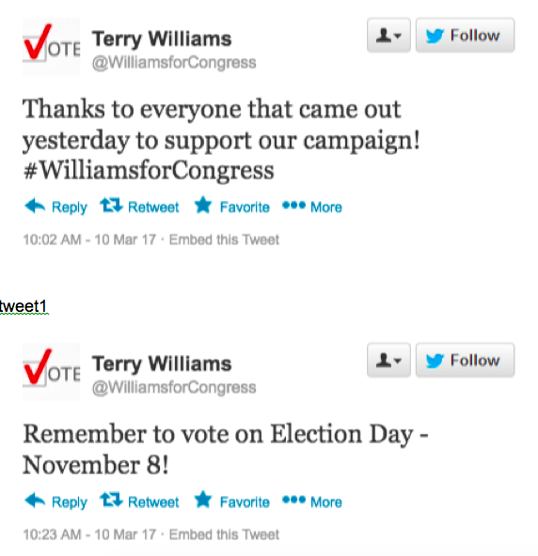
Figure 1. Introductory (Non-Controversial) Candidate Tweets

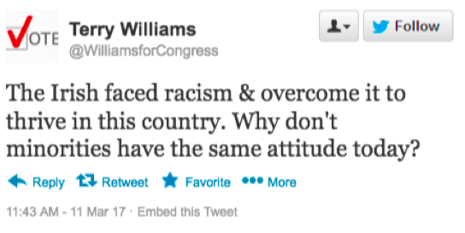
Figure 2. Controversial Candidate Tweet

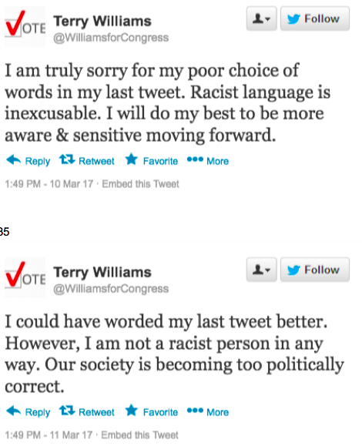

Figure 3. Experimental Treatment: Apology or PC Frame

