Jacob Marx
Haq
Twitter and the 2016 Presidential Election
Abstract:
With the rise of Donald Trump and his eventually successful campaign for President, it has become clear that conventional campaign methods will never be viewed the same. Trump used Twitter often and in ways that drove the coverage of his campaign in the mainstream media. Much of the communications side of his campaign came from his direct use of Twitter rather than having it run by his professional campaign staff. It was assumed that his erratic use of Twitter would be a liability, however, he was unexpectedly successful. Trump used Twitter to reach his supporters, gain news coverage, and build an unorthodox political persona. I first examine the evolution of the role of social media in presidential campaigns by focusing on Twitter in politics between the 2012 and the 2016 Presidential Elections. Social media’s full impact was felt in the 2016 election, and Twitter plays an active role in campaign communication. The 140 character limit allowed Trump to take complicated issues and make successful slogans out of them. Through examination of his tweets, their reach with both his supporters and critics, Google trends the week of the tweet, and the reaction in the media, I hope to better understand how this occurred and whether or not this is a tactic that will continue to be used by political candidates. I hypothesize that, although unorthodox, Trump’s tweets had a greater reach due to the attention they received in the media, his supporters, and his opponents.

Introduction:
As the 2016 Presidential Election has drawn to a close, it has become clear that one of the major “innovations” and changes in this past election has been how Twitter was used during the 2016 Presidential Campaign. Rather than just being used to disseminate general information from the candidates as was the norm during the 2012 Campaign, it was used as an attack tool by both the campaign and supporters, a way to spread false information, and a way to rally supporters. However, the past election cycle has given an opportunity to study between a campaign running a traditional social media presence (Democrat Hillary Clinton) against a candidate who ran an unorthodox campaign where almost anything went (Republican Donald Trump).
In this research project, I will examine the evolution of the uses of social media in the past three Presidential Campaign in order to have a better understanding of how social media has shaped the manner in which the candidates attempt to control the message, bypassing ‘traditional’ print and electronic media and communicate directly with voters. By examining the reach of tweets for the 2016 Presidential Campaign, the responses within the media, and of the general public, a better understanding of how campaigns have evolved over the past three presidential elections can be understood. Another important aspect of this research project is to give a clearer insight into the 2016 presidential campaign. Political Scientists will be examining the impact of Donald Trump’s tweets on political messaging and governing for a long time. My paper is a modest attempt at analyzing the innovative manner in which Donald Trump used Twitter to communicate with the American people during his campaign.
Traditional Campaigns
It is clear that Donald Trump ran an untraditional campaign. In order to appreciate how different his style of campaigning was, we need to look at the acceptable norms of campaigning. In his memoir Believer: My Forty Years in Politics, David Axelrod provides insight into how campaigns have been run over the past four decades. Axelrod gives insight into the communications side of both successful and unsuccessful campaigns, with two of the highlights being the election of President Barack Obama in 2008 and 2012. Through stories from his past campaigns, Axelrod highlights the need for working with the media (something that Trump has struggled with), setting up strong ground game operations (as highlighted by Obamas 2008 campaign), and the need for control within the campaign. By using this, traditional campaign methods such as television advertisements and print are highlighted while also giving input on the early use of social media on campaigns. The Message: The Reselling of President Barack Obama by Richard Wolffe argues that the skills that the Obama team had for technologically is grossly exaggerated from the 2008 campaign. “One of the myths of 2008 was the technological prowess of the Obama team. There was little doubt that Chicago was far better organized and technologically advanced than the McCain team. But that wasn’t saying much. The experience of 2008 was not especially helpful in crafting the strategy in 2012.” The passage continues to highlight the growth in social media over those three years between the first and second campaigns. By examining the traditional campaign tactics through Axelrod and Wolffes books, a better understanding can be built in order to prepare to examine the evolution of social media in the past three campaign cycles.
Social Media Campaign Basics
One of the key questions is how has the rise of social media changed the manner in which politicians communicate with voters? In Socially Elected by Craig Agranoff and Herbert Tabin, the writers argue that, compared to other social media, Twitter is used as a megaphone due to its reach and the capability to directly contact the receiver. In comparison, Facebook has much less of a reach due to the statuses only reaching those who follow and share the campaign. According to Socially Elected, “Streams of tweets ring around the world with increasing intensity. Since the end of 2010, there are now more than 100 million Twitter users.” It should be noted that the number has now grown to 317 million as of the third quarter of 2016. The book advises to “use Twitter to find real-time information on what people are thinking about issues relevant to your campaign,” “use Twitter to communicate with your social network and fire them up,” and “use Twitter creatively to show off your political prowess and become a hero to your constituents.” The Trump Campaign was very successful in the “use of Twitter creatively to show off your political prowess and become a hero to your constituents,” especially considering how creative Trump has been with the truth on his Twitter account. This is applicable to the project due to the information that is given in the Twitter chapter of Socially Elected can present a conventional, orthodox approach to using Twitter in a race. Finally on this front, the book The Victory Lab by Sasha Issenberg gives insight into analytics that can be used to receive a better understanding of what kinds of communication methods work best and how voter targeting can be perfected in order to have a better response from the viewers and recipients. For example, campaigns can use data such as magazine subscriptions and demographics in order to figure out who to target through direct mail and emails. However, Twitter does not require this sort analyzation due to the fact that it can reach anyone who is on the site or even those who are not because of the media attention that it receives.
Messaging in the Contemporary Age
With the rise of social media in the mid-2000s, campaigns began to expand their communications department into the new generation while still keeping focus on the traditional communication methods. An important aspect to examine in this project is the rate of success for tradition methods such as the use of television advertisements. In Effects of Political Advertising in the 2008 Presidential Campaign, the authors Lynda Lee Kaid, Juliana Fernandes, and David Painter examined the effects of video advertisements from the McCain and Obama campaigns on young citizens. In order to study the effectiveness of the advertisements, they surveyed 1,165 young citizens (defined as college students) at nineteen locations (universities that were members of the UVote2008 Research Consortium comprising of schools such as Iowa State, Georgetown, Akron, Texas A&M, and Virginia Tech) in order to gain a reading on whether political advertisements changed the cynicism that is widespread towards political candidates in college age Americans. The study found that there was not a significant change in the cynicism of the respondents before and after the viewings. Another portion of the study was to see how much of an advertisement that the respondents remembered and what issues mattered most to them. The test found that the students learned much more about the issues from the Obama advertisements than they did from the McCain advertisements. In comparison, social media posts are much more adapt at reaching the students. Staying “On Message”: Consistency in Content of Presidential Primary Campaign Messages across Media by Benoit, Glantz, Phillips, Rill, Davis, Henson, and Sudbrock focuses on how often candidates in the 2008 primary campaign stayed with the “conventional wisdom that candidates should stay on message.” In order to examine this, the researchers investigated the announcement speeches, TV spots, debates, candidate webpages, Facebook pages, and radio spots of nine Democratic and twelve Republican candidates in order to see how consistent they were during the campaign. In the past, the focus of campaigns has been “keep it simple, stupid” and “repetition, repetition, repetition.” The article found that candidates during the 2008 primary season more often than not strayed from their original message with significant variations of the original plan. They also found that even when debates are not put into play, the message still varies from moment to moment. In general, television advertisements and radio spots were the most consistent but that can easily be conveyed is in a controlled environment rather than at a debate or rally. This information can be used to examine how often the candidates using Twitter stayed on the standard message of their campaign while in the social media world.
The Rise of Social and Digital Media in Campaigns
After examining how the traditional communication methods used during the 2008 campaign have been examined, it is important to move onto the digital and web department of the 2008 Presidential Campaigns. One of the important dynamics of the evolution and growth of social media is the effects that it will have on the parties that use it. Digital Media, Power, and Democracy in Parties and Election Campaigns: Party Decline or Party Renewal by Chadwick and Stromer-Galley dives into whether the hierarchal nature of political parties are going away due to the involvement of digital media. The article highlights that digital media gives more of a party-as-movement feeling rather than following orders from others up the chain of command. This article shows that social media has given rise to candidates and groups that do not have the full support of the party that they are in front of, such as Bernie Sanders, Donald Trump, and the Tea Party uprising in 2011. Originating in 2015, the Trump and Sanders campaign both relied early on with Facebook for organizing events and getting information out, even when they were not popular candidates with the party itself. The research from Galey and Chadwick provide an important framework to understand the success of the unorthodox way that Trumps campaign has operated during this election and beyond. Trump has had a contentious relationship with the Republican Party, which led to the need for Twitter to get his message out since the party fought against him.
The article Deux Ex Machina: Candidate Web Presence and the Presidential Nomination Process by Christenson, Smidt, and Panagopoulos focus on websites in order to show how grass roots movements/candidates to creep into the scene through the use of digital internet media. They point out that, although the campaigns of Ron Paul and Howard Dean did not win their parties primaries, it is useful to examine them because the internet launched relatively unknown candidates into prominence within the campaign. A more recent example is how the Bernie Sanders campaigned used Twitter and Facebook during the Democratic primary. By using social media, more people were able to be reached when the media was not focused on the campaign. The study opens up the questions of what extent a candidate’s online presences has with their campaign performance and does the internet make a difference by helping candidates gain greater funding and political support. This study took 12 of the leading candidates during the 2008 campaign and examined the correlation between their web presence/media presence and their average poll standing. The results demonstrated that a strong web presence does benefit candidates in the long run, which is useful to use while examining the reach of Twitter by the candidates during the campaign. Another important takeaway from this article is: “The internet provides a cheap and almost immediate way for candidates to contact pre-existing supporters and motivated new supporters to find a candidate and give funds in response to a victory. Thus, we should expect the internet to be especially useful to candidates following primary victories,” meaning that a strong media presence alongside victories in the primary lead to more donations in the form of money. Finally, Social Media and Political Campaigns by Kristian Nicole Smith out of the University of Tennessee is a good tool for understanding the total use of social media during the 2008 Presidential Campaign by the Obama team. In her paper, Smith asks how social media has been utilized in prior political campaigns (mainly 2008 Presidential Campaign), did social media affect the outcome of the 2008 Presidential Race, and a few other questions that are very useful for this project. The article highlights some of the issues that surround the use of social media during campaigns, such as the danger of having a candidate personally controlling their own social media page. Previously, using messages (Tweets or Facebook statuses) that were untested could be detrimental for the candidate in which it could be used against them. “In under 140 characters, a campaign can be mortally wounded.” However, it should be important to note that this was not such the case in this election with Trump and his use of Twitter. Another area that is highlighted is the future use of social media in political campaigns. According to Smith, major changes will occur between 2008 and 2012, with “nanotargeting” becoming more important on Twitter. Considering the past few years, she was very correct in her predictions. According to Smith and her research, Obama’s campaign was a major factor in his victory due to the skill that his digital media team had over McCains digital media team. She concludes the article by stating the importance of social media will continue to grow over the next few campaigns.
During the 2012 Presidential Election, the importance of media and social media continued to grow with campaigns investing more into those programs. An article written by 2012 Obama campaign alum Domonique James titled How Social Media is Changing Political Campaigns highlights that campaigns at both the business and campaign level are investing more into digital advertising, with a growth of 13.5 percent in 2015. However, social media allows voters to engage at a deeper level with a campaign through allowing them to interact through the posts and tweets. According to her breakdown, 60% of American adults use social networking sites like Facebook or Twitter, with 38% having “liked” material relating to political or social issues that others have posted. This demonstrates that there was a growth in political engagement with the average user of social media.
Twitter Use during the 2012 Election
As campaign communication continued to involve and the 2012 Presidential Campaign occurred, social media grew into a strong tool for the campaigns. Daniel Kreiss, analyzes the use of Twitter in the Obama and Romney campaigns through the use of interviews with staffers from the two campaigns. In this article, staffers from both campaigns discussed how they used the platform to influence the stories that journalist’s report on and planned strategic communications surrounding political events such as debates. The staffers shared the importance of ensuring that the social media campaigns were well organized, with everyone involved understanding what needed to be done and when it needed to be done. They also discussed how campaigns should script social media (example: preparing Tweets and statuses in advance of debates about topics that are likely to be discussed) in order to disseminate information and influence the press in a way that will benefit the campaign. Kreiss found that campaigns can be successful by using “performative power,” which means “influence over other actors’ definitions and their consequent actions through well-timed, resonant, and rhetorically effective communicative action and interaction. In their research, Conway, Kenski, and Wang recorded the data between February 1st and May 2nd, 2012, the article demonstrated that during the 2012 primaries candidates had many differing profiles on Twitter and the candidates who tweeted the most did not receive the nomination. For example, Roember and Gingrich led by over 6,000 tweets by May 2nd, while Romney had less than 1,000 tweets by May 2nd. During the Republican primary, daily tweets by candidates remained about the same from beginning to end as well. In order to fully analyze the 2012 Presidential Election in the depth of social media, you must examine how events were framed and how the public perceived it. In Grosheks and Al-Rawi’s research article Public Sentiment and Critical Framing in Social Media Content during the 2012 U.S. Presidential Campaign, the authors examined the public sentiment in order to gain insight into the main topics and themes that were popular during the 2012 Election. By using mining software, the researchers were able to examine over 1.42 million social media posts on Facebook and Twitter. It was demonstrated that neither of the two candidates campaigns attacked the other candidate in an “overly critical manner,” however it is interesting to note that Obama was the top buzzword for both the Obama Facebook page and Romney Facebook page. However, it needs to be noted that the samples seemed to be much more similar to mainstream news rather than used as an attack weapon against the opponent. Finally, another article that examines portions of the effects of campaign communications during the 2012 election is Internet Political Ads in 2012: Can Humor Mitigate Unintended Effects of Negative Campaigning by Jody Baumgartner. By working with focus groups who rated the videos from both the Obama and Romney campaigns after watching them and giving their general feedback, it became apparent that ads targeting Romney from the Obama team had a negative effect on Romney, while attacks from the Romney camp on Obama generally backfired and caused a negative view of Romney instead of its intended target.
When Campaign Twitter goes bad
Finally, it is important to examine the use by the supporters of the candidates. This past election cycle, supporters of candidates such as Donald Trump have been rallied by the tweets of their candidates into doing dangerous and harmful things. For example, an article from The Washington Post titled “This is what happens when Donald Trump attacks a private citizen on Twitter” by Jenna Johnson highlights an attack on a then 18 year old college student, Lauren Batchelder, who asked Trump whether he supported women’s rights and the right to choose . The Trump campaign found out that she had volunteered a year before on the Jeb Bush campaign and Trump tweeted that she was a plant by the Bush campaign in order to embarrass Trump (ignoring the fact that Bush is pro-life). Batchelder began to receive death and rape threats through the mail, email, phone calls, and other methods from angry Trump supporters.
While doing this project, I am fortunate that the 2016 election is currently occurring so that I am able to gather information as it comes across the wire. By using prior research done by others on the 2012 campaign and doing my own research on the 2016 campaign, I have the ability to compare and contrast the two races while also examining different variables that have changed between the two elections. An example that is certain is rhetoric used by the candidates on Twitter has changed greatly due to the phenomenon that is Donald Trump tweets. Rather than run everything through his campaign through consultants and staffers, Trump has continued to use his own Twitter account that he created in March of 2009. This has given a much more “mud-slinging” campaign on Twitter rather than the scripted and tested Tweets that were sent out during the 2012 election. By cataloging the tweets from both the candidate’s personal accounts as well as the campaign, it will give a much broader view of how things have changed in the past four years.
One of the major issues that I came across from using the previous work is that the social media tactics used during the 2016 Presidential Campaign was completely unorthodox and unexpected. Even more unexpected was the victory of Donald Trump while having such a loose cannon Twitter account. Most of the articles that I have examined advised that the best option for campaigns to be heavily scripted for their Facebook statuses and Twitter tweets in order to prevent backlash from the public and potentially harm their campaign.
With the victory of Trump, it has become apparent that this seemingly unspoken rule does not apply anymore. During the 2016 Presidential Election, you had one campaign where everything was planned out, prepared, and tested before being released going against a candidate who would Tweet randomly, attack people unaffiliated with the campaign, and spread information that was incorrect/false. With common sense, a major backlash should have occurred with the second candidate and they should have lost support, but surprisingly enough they continued on and remained successful. Dubrofsky argues in Authentic Trump: Yearning for Civility that Trumps background as a reality show celebrity allowed him to avoid the ethical dilemmas that generally surround candidates who are running for office. Dubrofsky writes that “The reality TV genre is seen as trashy, featuring people without class in behavior and often in social and financial status.” This means that Trump was expected to be less respectful than the other candidates due to his background in reality TV. Another aspect to consider is that the 140 characters allowed on Twitter give the candidate (Trump) the ability to send out a complicated issue simplified almost to a fault. Dodo brings forth in My Theory on the Trump’s Phenomenon. Why Donald Trump? Why Now? that Trump was successful due to issues weighing heavily on many Americans minds such as free trade, the fear of globalization, immigration, and terrorism. Although normally difficult subjects to broach, Twitter allowed Trump the ability to reach his supporters in a much more simplified answer than the normal wonkish discussion.
For this project, I hypothesize that, although Twitter was important during the 2012 presidential election, it has grown in importance with both political campaigns and others due to its ease of access, attention gaining results, and free service. Another evolution that has occurred through Twitter during the 2016 campaign is that it gave Donald Trump the ability to build his identity and brand among his supporters. The catchphrase of this election was “Make America Great Again,” which was emphasized through Twitter due to Trumps constant use of the phrase. In a normal situation, campaigns and candidates must be careful in order to ensure that they do not create collateral damage to their brand, especially when information is so readily available on the internet for the opposition to use to turn the Tweet against said candidate. For example, Republican nominee Donald Trump has gotten in trouble in the past for retweeting pictures from known white supremacists and Neo-Nazis with Twitter handles like “@WhitegenocideTM.” Another incident that occurred was when the Trump campaign tweeted a meme attacking Hillary Clinton that used the Star of David while claiming that Clinton was corrupt. Although these incidents did not hurt the seemingly bulletproof Donald Trump at the time, retweeting people with questionable backgrounds and using seemingly covert anti-Semitism can easily damage a different campaign. It is important to note however that these did not harm Trump on Election Day, however it should be noted that future campaigns may not be as lucky and seemingly bulletproof as Trump was. I hypothesize that voters who supported Trump ignored the questionable tweets due to his populist message and power within the nation. Another aspect that has changed is that Twitter grants anonymity that can be used by people to attack others without facing repercussions, whether their targets are politicians, journalists, or supporters of opponents. Although it occurred in the 2012 campaign, it has become much more prevalent during the 2016 campaign cycle due to instances of “Bernie Bros” and the “Alt-Right movement” attacking opponents. For example, Trump supporters would launch verbal attacks on journalists and activists who did not speak fondly regarding their candidate, as did some in the Bernie Sanders camp.
Research
Tweet #1: October 17th, 2016
In reaction to the sexual assault allegations that plagued Trump in October, he tweeted “Can’t believe these totally phoney (sic) stories, 100% made up by women (many already proven false) and pushed big time by press, have impact!” at 0815 CST on October 17th, 2016. As of January 28th, 2017, the tweet was retweeted 10,037 times and had 28,662 likes. The reactions on his Tweet had some supporting him, such as Deborah Richard, who tweeted on October 19th, 2016 “@realDonaldTrump please don’t fall into that trap about talking about it just focus on your amazing plans for our country,” and Kelly on October 18th who tweeted “@realDonaldTrump just say don’t remember them, but if it did happen I am so sorry. You’ll get a lot more votes.” On the other side opposing his tweet had people such as Vincent Harris on October 18th, who tweeted out “@realDonaldTrump Still waiting on that mountain of evidence proving evidence. Not the appropriate time yet, I assume?” and Christina Pelland on October 18th who stated “@realDonaldTrump what did your mom do that you are so threatened by women?” In the media, the tweet did not pick up very much attention due to the fact that the main story was of the allegations against Trump rather than the tweet itself. In comparison with other tweets in the same time range, such as one accusing Vice President Joe Biden of molesting women (11,042 retweets and 18,678 likes), this tweet in question had a lower reach than others. During the week of October 16-22, 2016, the search term “Trump” popularity rating on Google Trends was falling from the previous high of 26% popularity rating, sitting at 19%. Trump would continue to fall to a low of 20% popularity out of 100 until the week of the election. However, it should be noted that Trump was still 14% higher than Clinton the week of the 16-22, with her sitting at 13%. In a matchup between the two candidate search terms, “Donald Trump” still led “Hillary Clinton” 16% to 10%. The peak popularity for the search term “Trump Rape” hit 100% popularity the week of November 6-10, but quickly fell to 17% by the next week. The week of the Tweet in question, the search popularity for the term was at 72%. The search term for “Trump Tweet” was at 12% for that week.
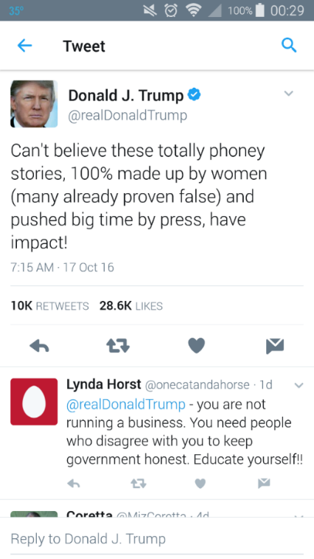
Tweet in Question
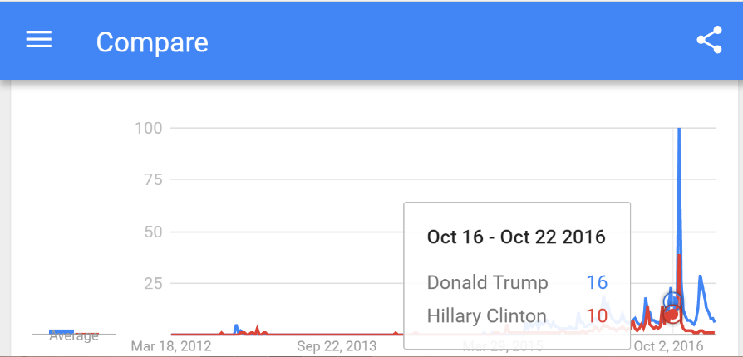
Examination between the search terms “Donald Trump” and “Hillary Clinton” for Oct.16-22 2016.
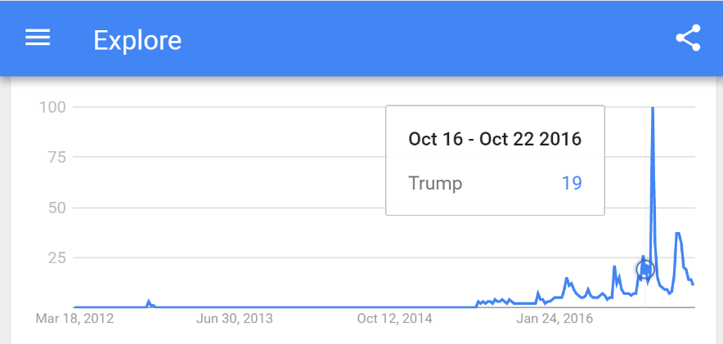
Google Trends for the week of Oct. 16-22 2016 for the search term “Trump”
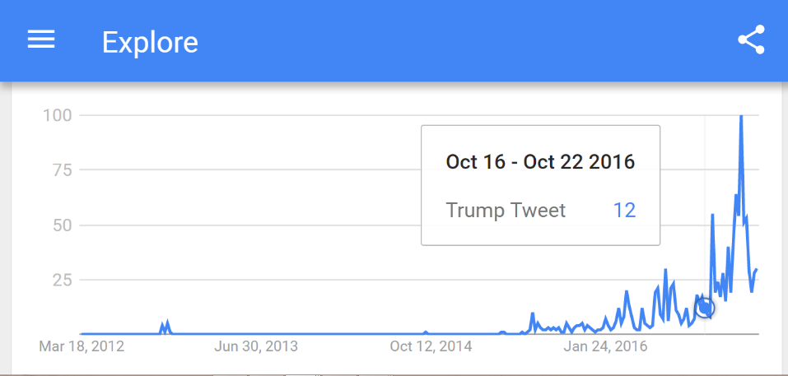
Google Trends for search term “Trump Tweet” Oct 16-22 2016

Tweet #2: September 30th, 2016
In a series of three tweets that occurred from 0414 to 0430 CST on September 30th, 2016, Trump proceeded to attack 1996 Miss Universe winner Alicia Machado for speaking in favor of Hillary Clinton. In the series of tweets, Trump attacked Clinton and Machado by claiming that Machado is a con and has a criminal history while claiming that the use of Machado by the Clinton campaign as an example of “BAD JUDGEMENT.” He then claimed that Machado received assistance from Clinton in becoming a U.S. citizen for the debate while also encouraging his Twitter followers to view the sex tape that Machado was in. The final tweet (mentioning the sex tape and citizenship) received the most attention from the public. The 0430 Tweet received 17,819 retweets, 35,458 likes, and over 18,000 responses. The responses ranged from supporters such as Virginia Coverdale (@gotapoint) saying “That is total bull shit. Another Clinton operative already debunked. Now speaking of rape that Bill Clinton..” On the opposite side, a liberal Twitter called “West Wing Reports” (@WestWingReport) responded with “@realDonaldTrump Being politically incorrect is great – until someone speaks that way to you. Then you whine that “it’s not nice.” Grow up.” The tweets proceeded to receive wall to wall coverage from both the internet, press, and television media. This movement by the media gave Trump free attention and allowed him to bolster attention to his campaign. In the week of September 25th through October 1st 2016, the search term “Trump” stood at 15% in comparison to the previous weeks 7%. In a matchup between the search terms “Donald Trump” and “Hillary Clinton,” “Donald Trump” still led 13% to 11%. “Trump Tweet” hit 18% popularity from the previous weeks 9% popularity. During the campaign period, the search term “Trump Tweet” hit 72% (the all-time high during the campaign) on November 6th through the 12th, the week of the election.
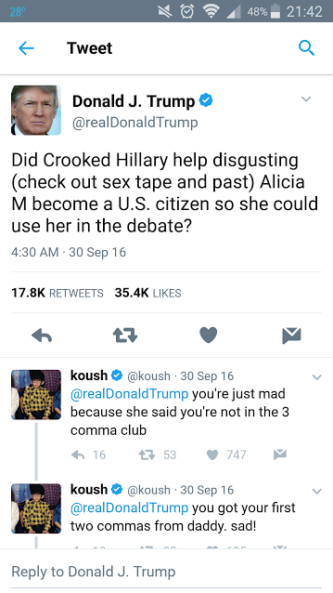
Tweet in question
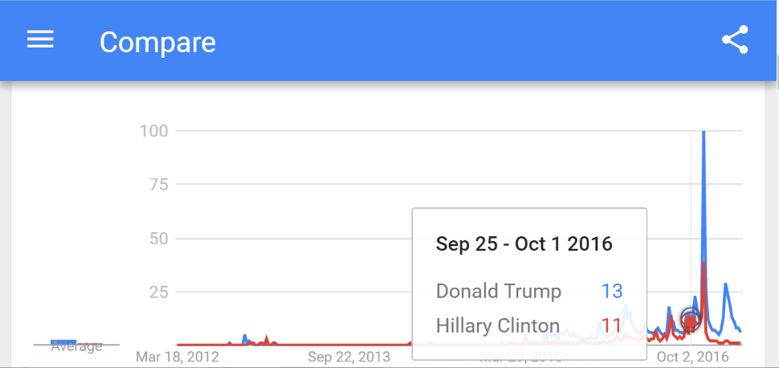
Comparison between search terms “Donald Trump” and “Hillary Clinton” from Sep. 25-Oct 1 2016
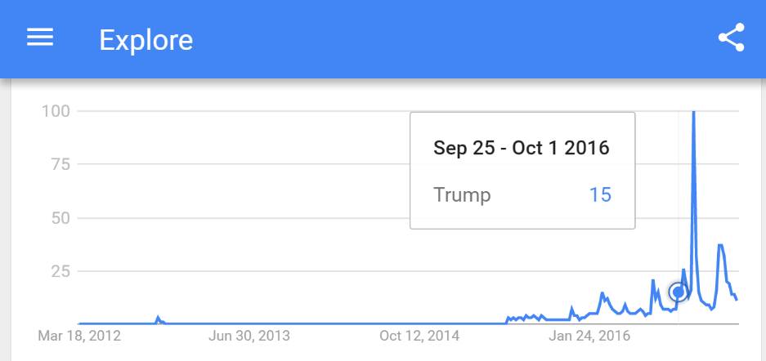
Google Trend for the search “Trump” from Sep. 25-Oct. 1 2016
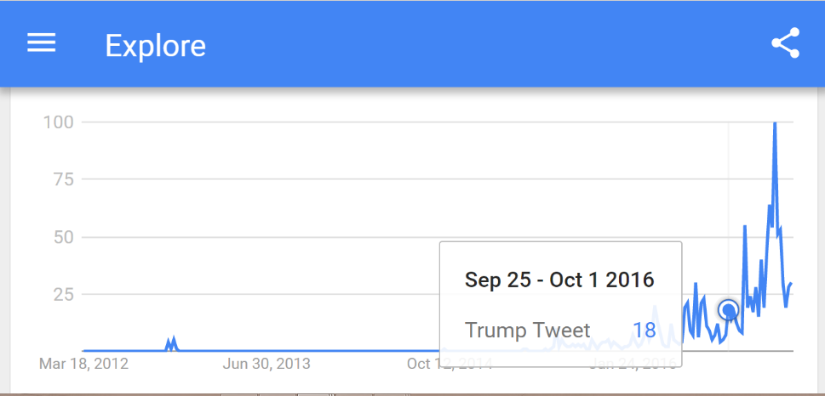
Google Trend data for search term “Trump Tweet” Sep. 25-Oct. 1 2016

Tweet #3: May 5th, 2016
Occurring well before Trump officially became the nominee for the Republican Party, one of his most memorable tweets occurred on May 5th, 2016 at 1457 CST. In celebration of the Mexican holiday Cinco De Mayo, Trump posted a picture of him posing with a taco bowl with the caption “Happy #CincoDeMayo! The best taco bowls are made in Trump Tower Grill. I love Hispanics!” The post immediately received attention from the media due to how some viewed the post as culturally insensitive and cultural appropriation. According to The Hill, then campaign manager Paul Manafort attempted to prevent the tweet from being sent out, reportedly arguing that it was unnecessarily offensive and condescending. Trump responded with “The people who we offended were people we wanted to offend.” Trump also stated on the show “Fox and Friends” in regards to the Tweet that “People loved it, and you know what, I’m going to do great with Hispanics.” The tweet received a total of 84,879 retweets and 119,474 likes. However, many of the responses were hostile in regards to the tweet. Jordan Uhl responded with “honestly, at this point, I’m fully expecting him to tweet a picture of him eating KFC for Black History Month” and Danny Woodburn tweeting “what an idiot. You think promoting trump tower tacos is going the win the “#Hispanics” vote?” However, his supporters responded well on the page, with a page called “Immigrants4Trump” posting three times on the Tweet with the same video of people of Hispanic descent speaking in favor and support of Trump. Kenny Wallace also responded with “I do not think I’ve ever seen anything retweeted or favorited 87,000 times @realDonaldTrump THATS BIG!” However, it should be noted that the top tweet for 2016 from Trump occurred on June 9th, 2016 when he responded to Clinton tweeting “Delete your account” with “How long did it take your staff of 823 people to think that up-and where are your 33,000 emails that you deleted.” The tweet received 164,960 retweets and 292,821 likes. Although the tweet received heavy coverage on twitter and in the media, search term “Donald Trump” was only at 10% google search trend percentage the week of May 1st-7th, up from 7% the previous week. The search term “Trump” was at 9% from the previous weeks 6%. However, the search term “Hillary Clinton” was at 4% that week. The search term “Trump tweet” was at 12% google trend, up from the previous weeks 2%.
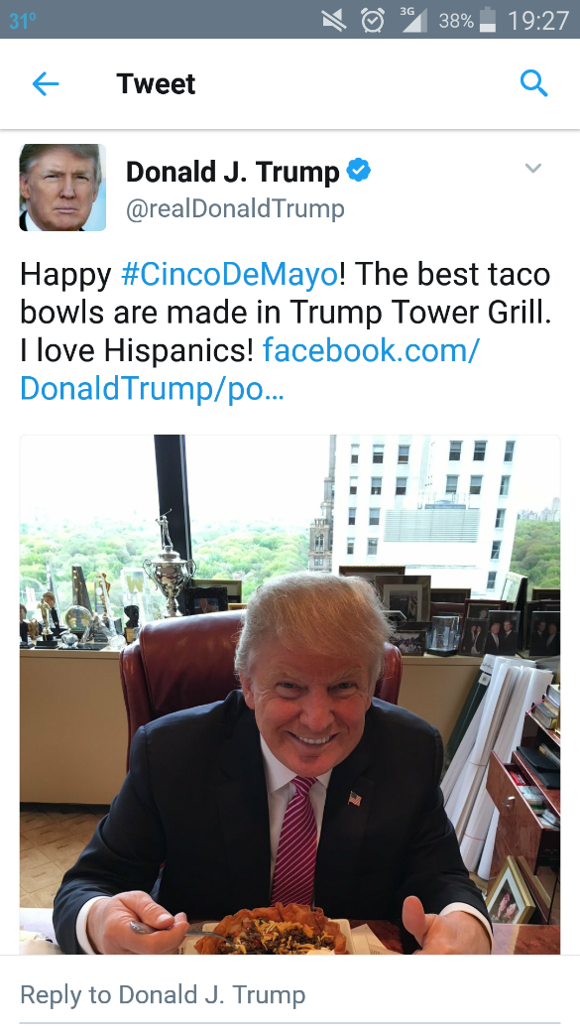
Tweet in question
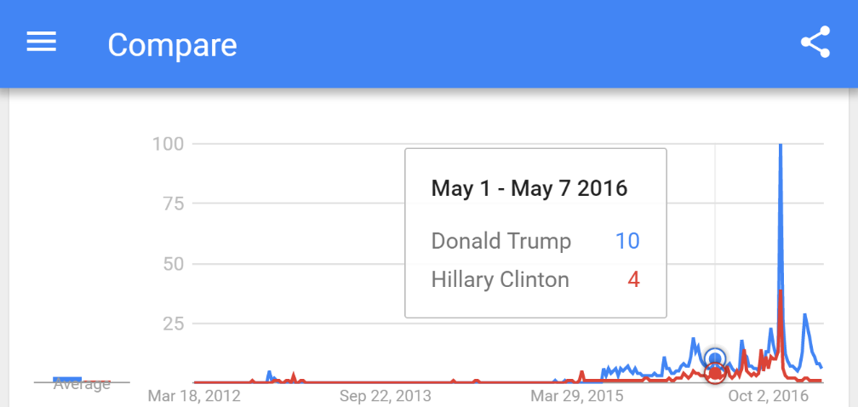
Comparison between the search terms “Hillary Clinton” and “Donald Trump” for week of May 1-7 2016.
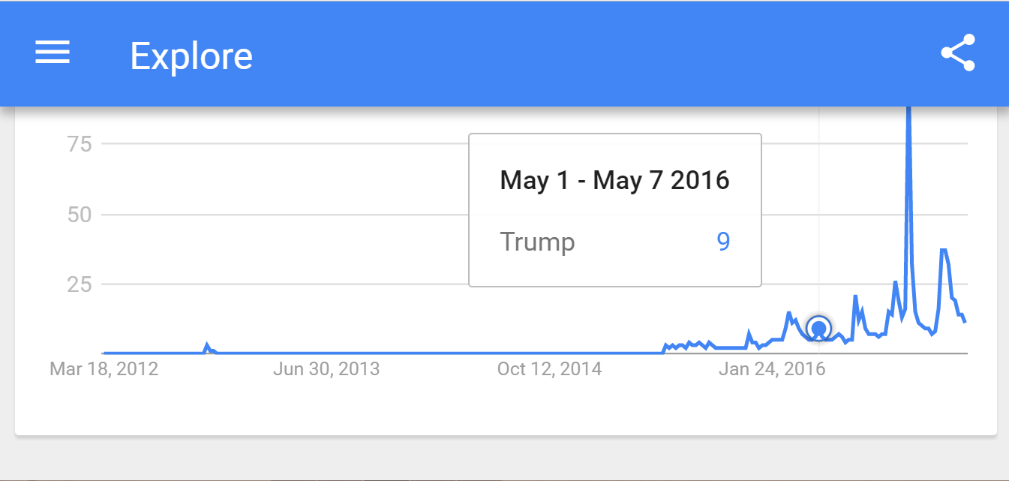
Data from the search term “Trump” for May 1-7 2016
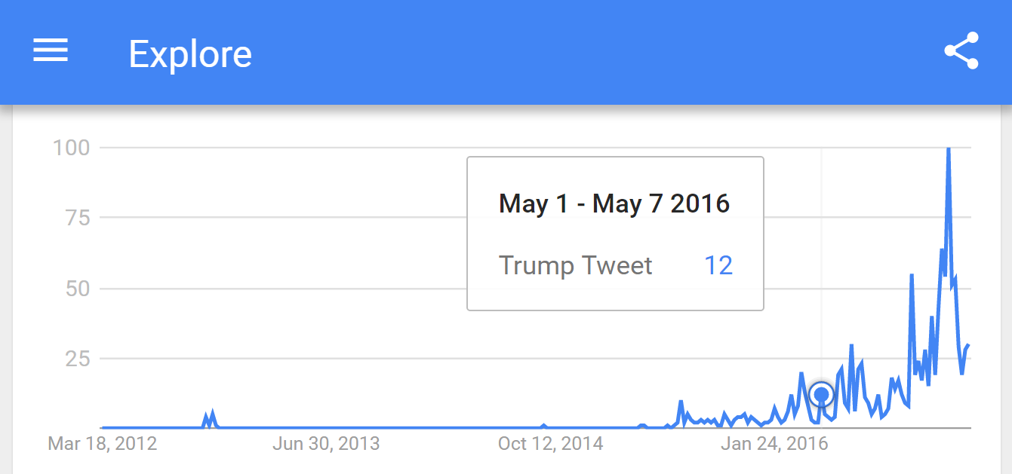
Google Trend Data from the search term “Trump Tweet” May 1-7 2016
Discussion: As it became clear that Trump would win on election night, the realm of campaign social media was changed for the foreseeable future. While the Clinton campaign seemed to have taken a traditional approach towards campaign social media, Trump had a much more loose style. During a single day, he could tweet up to ten times without control compared to Clintons which were a mix of being run by herself and campaign staffers. Throughout all of the weeks that had tweets that were examined, Trump continually led Clinton in Google trend search patterns.
The question that this elections opens is whether all publicity should be considered good publicity. Considering the controversy that surrounded such Trump tweets as the taco bowl on May 5th, 2016 and the attack on Alicia Machado on September 30th, 2016, it seems that the old saying holds true considering Trump received greater attention in both the media, on Google Trends, and on Twitter during these periods. This further grew his campaigns communications reach, even if it was for negative reasons. At least for the 2016 campaign, all publicity was good publicity, no matter how controversial.
Outside of the media attention and search terms, an undeniably important part of Trumps social media campaign came from his supporters. Whether it was retweeting his posts, commenting on them, or using them to gain power, the supporters were an instrumental part of his success. According to a New York Times article from October 5th, 2015 by Michael Barbaro titled “Pity, Mean and Powerful: How Donald Trump Mastered Twitter for 2016,” Trumps supporters have become his response team. Barbaro states that “On Twitter, Mr. Trump has assembled an online SWAT team of devoted (some say rabid) supporters who spring into action with stunning speed. In a pattern that has played out over and over, he makes a provocative remark, like one about Mrs. Fiorina’s face - “Would anybody vote for that?” – and hundreds of thousands of strangers defend him, spread his message and engage in emotional debates with his critics, all the while ensuring he remains the subject of a constant conversation.” The theme of all press is good press continues to ring true through his supporters. Even though others may find what he tweets to be reprehensible, his supporters remained true throughout the campaign and continued to defend him in retweets and comments. His supporters were also used as a weapon against his opponents, as noted when his supporters attacked Lauren Batchelder with death and rape threats after the No Labels Convention in October of 2015. Another instance occurred after Newsweek reporter Kurt Eichenwald wrote a story regarding how Trumps conflicts of interest could undermine national security. In response, Trump supporters targeted Eichenwald (who suffers from epilepsy) with an epileptogenic (something that triggers seizures) video sent to his account. According to an article in Newsweek from Eichenwald titled “How Donald Trump Supporters Attack Journalists,” he says in regards to a tweet he was tagged in, “I was carrying my iPad, looking at the still image on the video and, without thinking, touched the PLAY button. The video was some sort of strobe light, with flashing circles and images of Pepe flying toward the screen. It’s what’s called epileptogenic – something that triggers seizures. Fortunately, since I was standing, I simply dropped my iPad to the ground the second I realized what Mike had done. It landed face down on the bathroom floor. The deplorables are real. The deplorables are dangerous.” Alongside the attempted attacks on his health, Trump supporters also released information regarding Eichenwalds children, including where they attended school. The reckless and dangerous acts committed by Trump supporters in protection of their candidate is an entirely new phenomenon that has been created through the anonymity that Twitter can grant. Previously, someone would not yell out “MAYBE A FEW JOURNALISTS DO NEED TO BE WHACKED, MAYBE THEN THEYD STOP BEING BIASED HACKS. KILL EM ALL STARTING W/KATY TUR” in public. This was a tweet highlighted in Eichenwalds article that was posted in response to a story that NBC reporter Katy Tur reported on. Twitter now allows someone to post something such as though without fear of judgement from those around them or fear of repercussions.
Conclusion:
Through the research that I have completed in regards to the reach of Donald Trump’s twitter in the media, Twitter, and Google Trends, it is clear that my hypothesis that Trumps irregular tactics for Twitter was instrumental in his successful run for the President of the United States was correct. During the week of each tweet I examined, the search term “Donald Trump” received an uptick from the previous week’s trends, pointing towards the tweet or tweets having an impact on the reach of Trump over Google. However, it is important to note that this may just be a phenomenon and may not work for other candidates in the future. Through the research that I have done, I hope that a better understanding in regards to how Trump successfully used Twitter during the 2016 Presidential Election can be gained. In order to have a clear understanding of whether this was an outlier or a new, reliable tactic, the 2018 elections as well as the 2020 Presidential Election must be watched closely in order to see if other candidates use the same tactics that Donald Trump did during his campaign.

Bibliography
Conway, Bethany, Kate Kenski, and Di Wang. "Twitter Use by Presidential Primary Candidates during the 2012 Campaign." American Behavioral Scientist 57.11 (2013): 1596-610. Sage. Nov. 2013. Web. 20 Oct. 2016.
Kreiss, Daniel. "Seizing the Moment: The Presidential Campaigns' Use of Twitter during the 2012 Electoral Cycle." New Media & Society 18 (2016): 1473-490. Sage. Web. 12 Oct. 2016.
Agranoff, Craig, and Herbert Tabin. Socially Elected: How to Win Elections Using Social Media. USA: Pendant, 2011. Print.
Axelrod, David. Believer: My Forty Years in Politics. New York: Penguin, 2015. Print.
Baumgartner, J. C. "Internet Political Ads in 2012: Can Humor Mitigate Unintended Effects of Negative Campaigning?" Social Science Computer Review 31.5 (2013): 601-13. Web.
Chadwick, A., and J. Stromer-Galley. "Digital Media, Power, and Democracy in Parties and Election Campaigns: Party Decline or Party Renewal?" The International Journal of Press/Politics 21.3 (2016): 283-93. Web.
Christenson, D. P., C. D. Smidt, and C. Panagopoulos. "Deus Ex Machina: Candidate Web Presence and the Presidential Nomination Campaign." Political Research Quarterly 67.1 (2013): 108-22. Web.
Conway, B. A., K. Kenski, and D. Wang. "Twitter Use by Presidential Primary Candidates During the 2012 Campaign." American Behavioral Scientist 57.11 (2013): 1596-610. Web.
Groshek, J., and A. Al-Rawi. "Public Sentiment and Critical Framing in Social Media Content During the 2012 U.S. Presidential Campaign." Social Science Computer Review 31.5 (2013): 563-76. Web.
James, Domonique. "How Social Media Is Changing Political Campaigns | GRI." Global Risk Insights. N.p., 10 Mar. 2016. Web. 12 Dec. 2016.
Kaid, L. Lee, J. Fernandes, and D. Painter. "Effects of Political Advertising in the 2008 Presidential Campaign." American Behavioral Scientist 55.4 (2011): 437-56. Web.
Payne, J. G. "Massaging the Message in the 2012 Presidential Campaign." American Behavioral Scientist 57.12 (2013): 1647-649. Web.
Smith, Kristian N. "Social Media and Political Campaigns." Tennesse Research and Creative Exchange (2011): n. pag. Print.
Wolffe, Richard. The Message: The Reselling of President Obama. New York: Twelve, 2013. Print.
Issenberg, Sasha. The Victory Lab: The Secret Science of Winning Campaigns. New York: Crown, 2012. Print.
Neidig, Harper. "Manafort Tried to Prevent Trump's Taco Bowl Tweet." The Hill. N.p., 17 Aug. 2016. Web. 09 Mar. 2017.
Barbaro, Michael. "How Donald Trump Uses Twitter (Hint: Impulsively)." The New York Times. The New York Times, 05 Oct. 2015. Web. 09 Mar. 2017.
Barbaro, Michael. "Pithy, Mean and Powerful: How Donald Trump Mastered Twitter for 2016." The New York Times. The New York Times, 05 Oct. 2015. Web. 09 Mar. 2017.
Eichenwald, Kurt. "How Donald Trump Supporters Attack Journalists." Newsweek. N.p., 21 Oct. 2016. Web. 09 Mar. 2017.
Nelson, Libby. "Donald Trump Has Weaponized Twitter - with Dangerous Consequences." Vox. Vox, 10 Dec. 2016. Web. 09 Mar. 2017.
Dodo, Mahamat K. "My Theory on the Trump's Phenomenon. Why Donald Trump? And Why Now?" Journal of Alternative Perspectives in the Social Sciences 611th ser. 7.4,593 (2016): 593-611. Web. 19 Mar. 2017.
Dubrofsky, R. E. "Authentic Trump: Yearning for Civility." Television & New Media (2016): n. pag. Web. 19 Mar. 2017.

