Myles Nelson
Southern Illinois University- Edwardsville
Undergraduate
mynelso@siue.edu

A Comparison of President Donald Trump’s Administration Policy to Previous Republican Presidents

Abstract:
After Donald Trump’s successful presidential run in 2016, the attention started to shift away from campaign rhetoric and more towards policy. Being a complete political and military outsider, there were serious questions regarding administration policy and particularly the role of the national government and presidential power. It was uncertain whether President Trump would share the conservative beliefs of Republicans who have previously held the office of president. In order to determine the policies of President Trump and to see how similar or different he is compared to past Republican presidents, I collected the executive orders, presidential signing statements, and statements of administration policy for President Trump as well as Presidents George W. Bush, George H.W. Bush, and Ronald Reagan in their first year of office. After the necessary data was collected, a Word Cloud was created for each president for the three separate document types to find the most frequently used words. After examining the most frequently used words of each administration, the number of times each major word appeared and the significance of each word was recorded and a comparison was performed on each of the four presidents being looked at. Through analyzing the most common words used by each president across these documents, I will better understand the similarities and differences between Donald Trump and his predecessors as well as the common beliefs expressed in each administration’s policies. I hypothesize that even though President Trump is a political outsider, he will share similar principles of past Republican presidents on the role of the national government, presidential power, and administration policy.
Intro:
A major message on the campaign trail from then candidate Donald Trump was the need to send an outsider to Washington in order to save America. Donald Trump promised the American people that a change was coming and the rhetoric of previous presidents would turn into action and policy under his administration. Voters took to the polls and expressed their agreement with Donald Trump on the need for an outsider and on November 8, 2016, the establishment candidate was out and a complete outsider is in. While this surprised many, the shock soon turned into question. Americans did not know what policy to expect from a complete outsider. The 2016 election raised many questions, but also gave an opportunity to find answers and study the administration and policy of an outsider President.
This research paper will examine the administration policy regarding the roles of government and presidential power of President Donald Trump and compare them to the past three non-outsider Republican Presidents: George W. Bush, George H.W. Bush, and Ronald Reagan. By analyzing executive orders, signing statements and statements of administration policy from each President’s first year in office, there will be a better understanding of each president’s administration and a comparison will be possible. Through this comparison, I will be able to make sense of an outsiders’ policy and determine whether or not President Trump shares the same beliefs as previous Republican presidents.

Literature Review:
In order to better understand the importance of executive orders, signing statements, and statements of administration policy, there were several pieces of literature that I reviewed. The first article dealt with executive orders.
In order to determine the how and why Presidents use executive orders, I looked at Kenneth R. Mayer’s Executive Orders and Presidential Power. Mayer concludes that legal structure is disregarded as an approach to determining how and why presidents use executive orders. “Although studies that adopt the legal perspective make important contributions to our understanding the American politics, they do not answer most of the questions that entice researchers to study the presidency.” (Edwards and Wayne, 1994) Executive orders are not discussed about in terms of legality as much as they are discussed about in terms of a president’s agenda and his ability to pass his agenda through Congress. While an organizational approach is useful in determining what the president’s belief is as far as the role of the executive branch and issuing executive orders, Mayer focuses, or at least includes supporting evidence, on a political approach to executive orders. Mayer also proves through case studies and quantitative research that “Democratic presidents will issue more executive orders than Republican presidents.” (Mayer, 1999) This is due to the expansive government ideology the left embraces compared to the limited government ideals of the right.
As far as signing statements and statements of administration policy go, I looked at Laurie Rice’s Statements of Power: Presidential Use of Statements of Administration Policy and Signing Statements in the Legislative Process. Rice describes signing statements and statements of administration policy (SAP) as taking multiple forms. “Some provide glowing endorsements of the legislation under consideration—just like the rhetorical signing statements described by Kelley (2003)—some promise a veto, while others outline a series of objections that the president wants addressed before the bill is presented to him. These objections may or may not be accompanied by a threat of a veto.” (Rice, 2010) Signing statements and SAP’s allow the President to not only express his opinions on legislation, but it also allows him to send a message of approval or disapproval to Congress. Rice particularly focused on the importance of signing statements and how powerful they can be. “The signing statement may often represent a more powerful weapon than the veto. When the president uses one of these statements to make a constitutional pronouncement to disregard provisions, he leaves Congress struggling to respond. Any laws restricting signing statements could, after all, be met with a signing statement, rather than a veto.” (Rice, 2010) Not only do we get an idea of policy from these statements, but we also see the ability for a President to execute power that almost goes unchecked by Congress.

Hypothesis:
Through a comparison of administration policy by analyzing the executive orders, statements of administration policy, and signing statements from each President’s first year, President Trump will share previous beliefs of past Republican presidents regarding the role of the national government and presidential power. This is due to the fact that Republicans want a smaller United States government, for it to run in the most efficient manner possible and cut spending which would save taxpayers money, and since Donald Trump is a businessman he understands the importance of efficiency and cutting cost.

Methodology:
The first step in this research was to collect executive orders, signing statements, and statements of administration policy from the first year of Presidents Donald Trump, George W. Bush, George H.W. Bush, and Ronald Reagan. After these three documents were collected, a Word Cloud was made to help identify commonly used words from each document. Once the Word Clouds were reviewed, I picked ten words that I thought were necessary in analyzing the beliefs on the role of the national government and president power. I went back through each document and found how many time each word was used by each president and created a spreadsheet. Then, I found that the most used words across the board for each president were the words state and federal. After I determined that the words state and federal appeared so frequently in each of the President’s documents, I went back to the three documents and analyzed the usage and context of each word in each separate document for each President. It was through this process that I found the role of the national government that each President had and then I made the comparison between the presidents to see whether Donald Trump shared the same beliefs as his GOP predecessors.
For each President’s belief on executive power, I counted the number of executive orders from the first year in office and recorded them in a chart. I first had to determine how each of the Republican President’s number of executive orders being studied compared with their Democrat predecessor. Every President besides George H.W. Bush has a Democrat predecessor, so this comparison was made to determine whether Kenneth R. Mayer’s theory that Democrat presidents will have more executive orders than Republican presidents holds true with these Republican Presidents. Then, I did a comparison just between the Republican Presidents to see if anyone had a significantly higher number of executive orders or if they remained consistent in both regards to one another and their predecessors.

Data:
Figure 1: Word Cloud for President Ronald Reagan’s Executive Orders from 1981
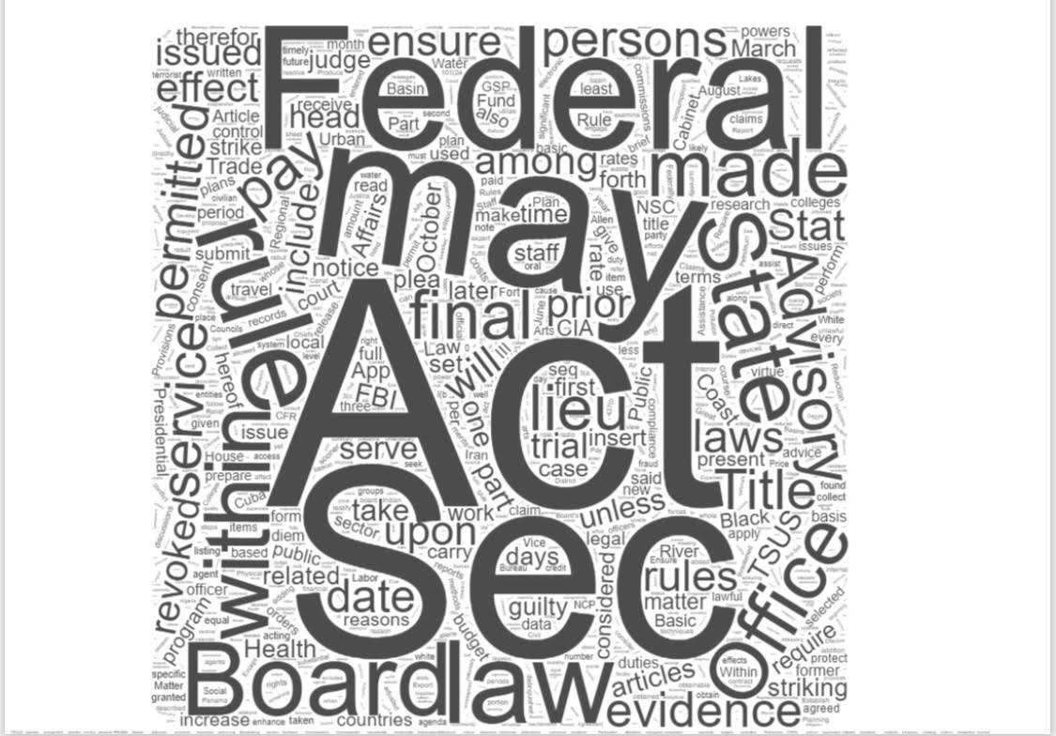

Figure 2: Word Cloud for President Ronald Reagan’s Signing Statements from 1981
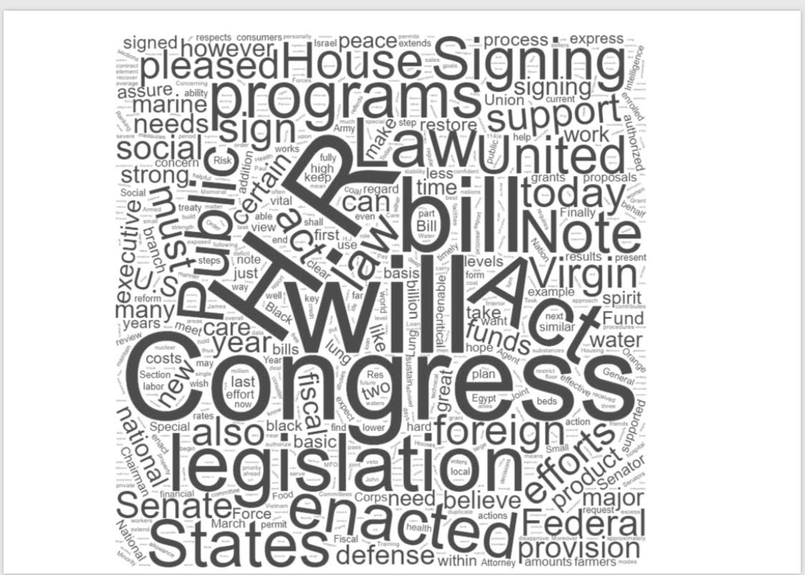

(Statement of Administration Policy for President Reagan in 1981 is nonexistent)

Figure 3: Word Cloud for President George H. W. Bush's Executive Orders from 1989
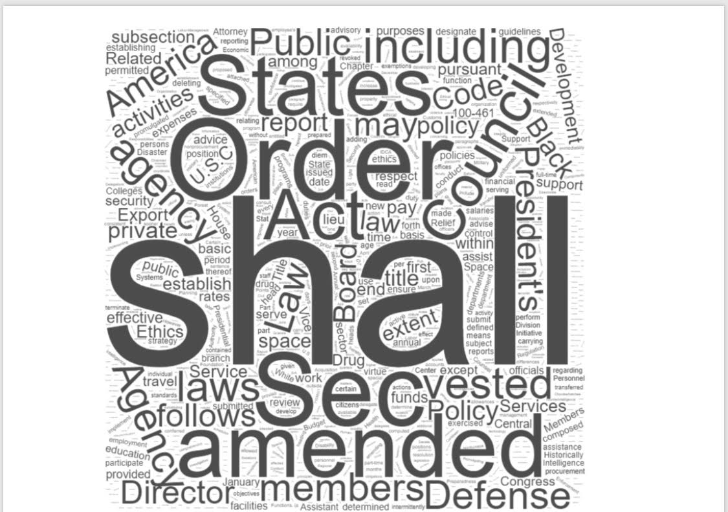

Figure 4: Word Cloud for President George H. W. Bush's Signing Statements from 1989
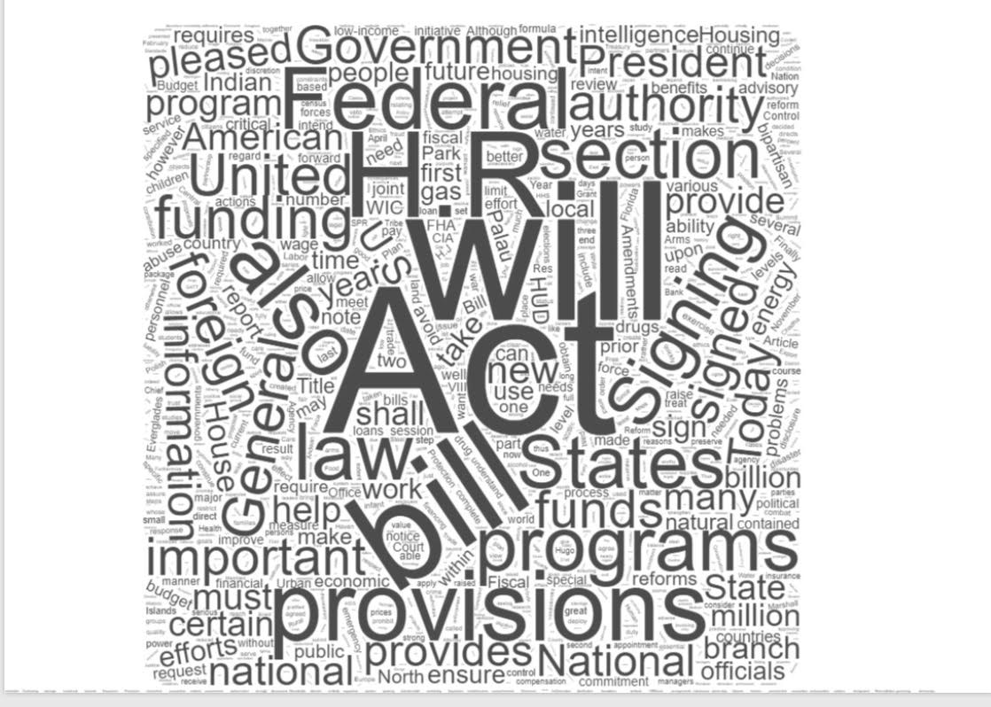

Figure 5: Word Cloud for President George H. W. Bush's Statements of Administration Policy from 1989
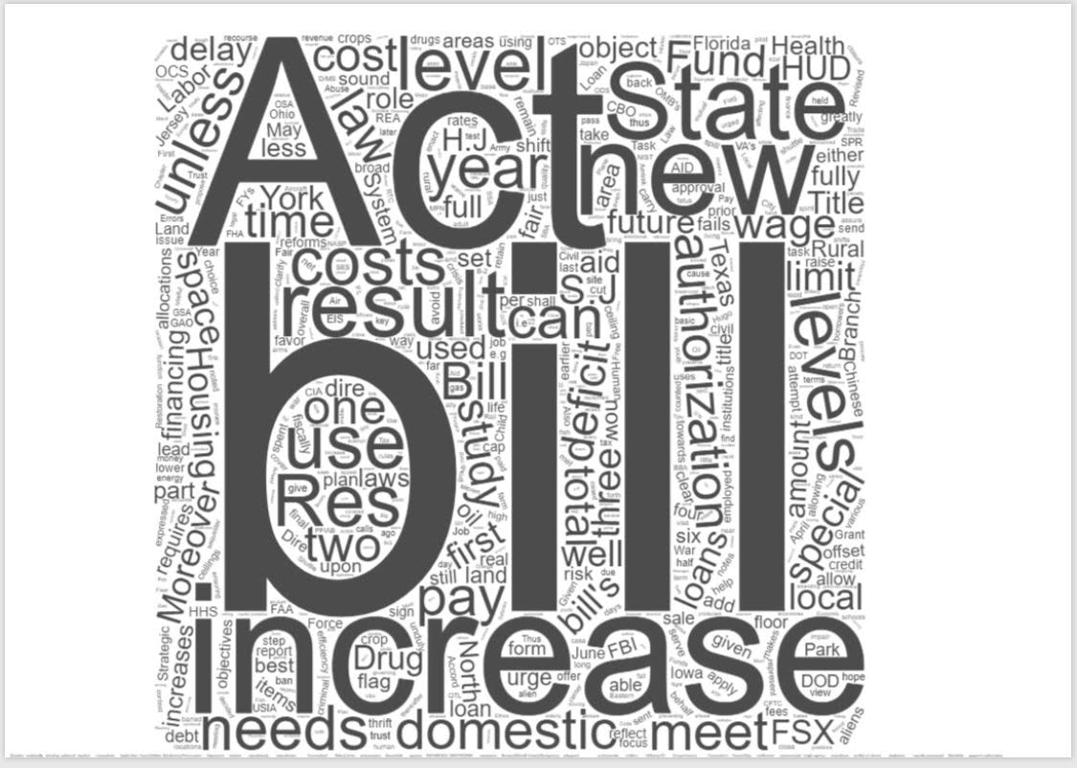

Figure 6: Word Cloud for President George W. Bush's Executive Orders from 2001
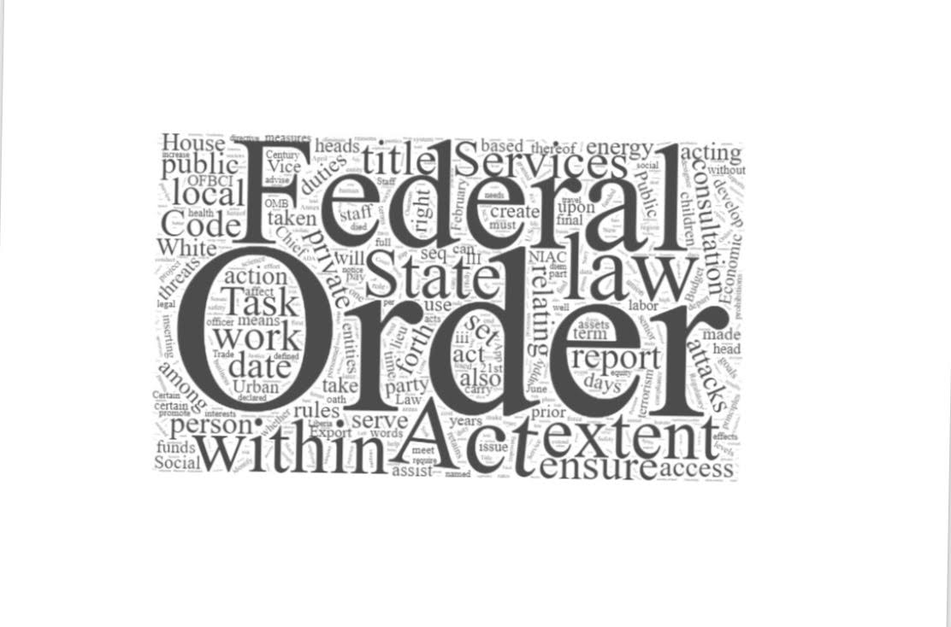

Figure 7: Word Cloud for President George W. Bush's Signing Statements from 2001
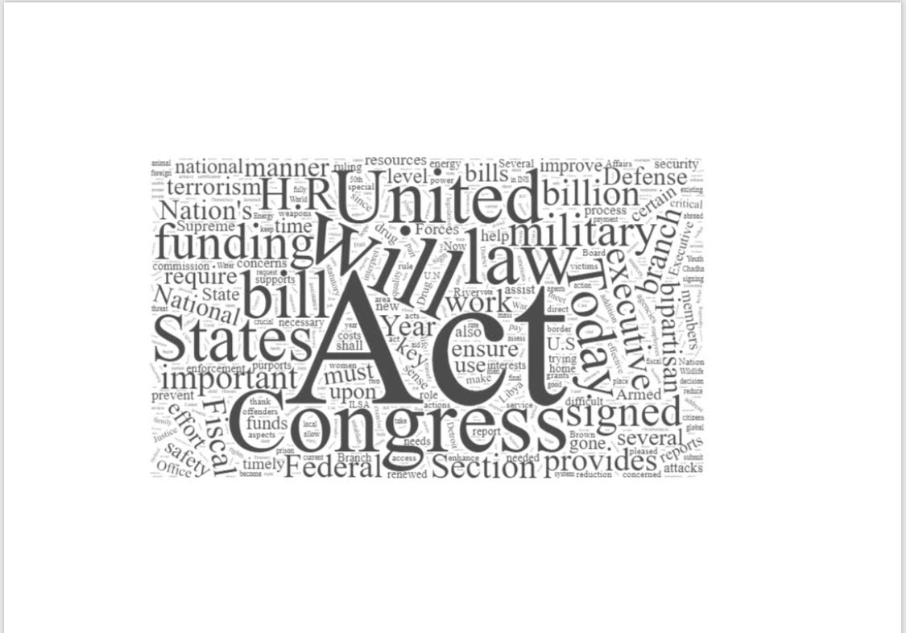

Figure 8: Word Cloud for President George W. Bush's Statements of Administration Policy from 2001
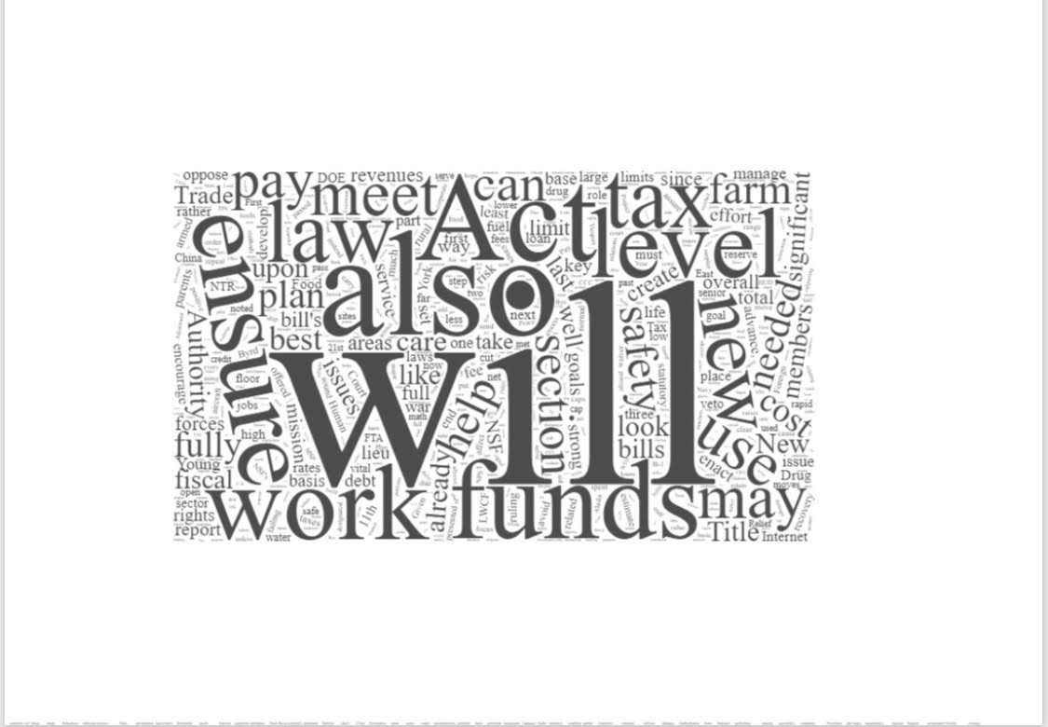

Figure 9: Word Cloud for President Donald Trump's Executive Orders from 2017
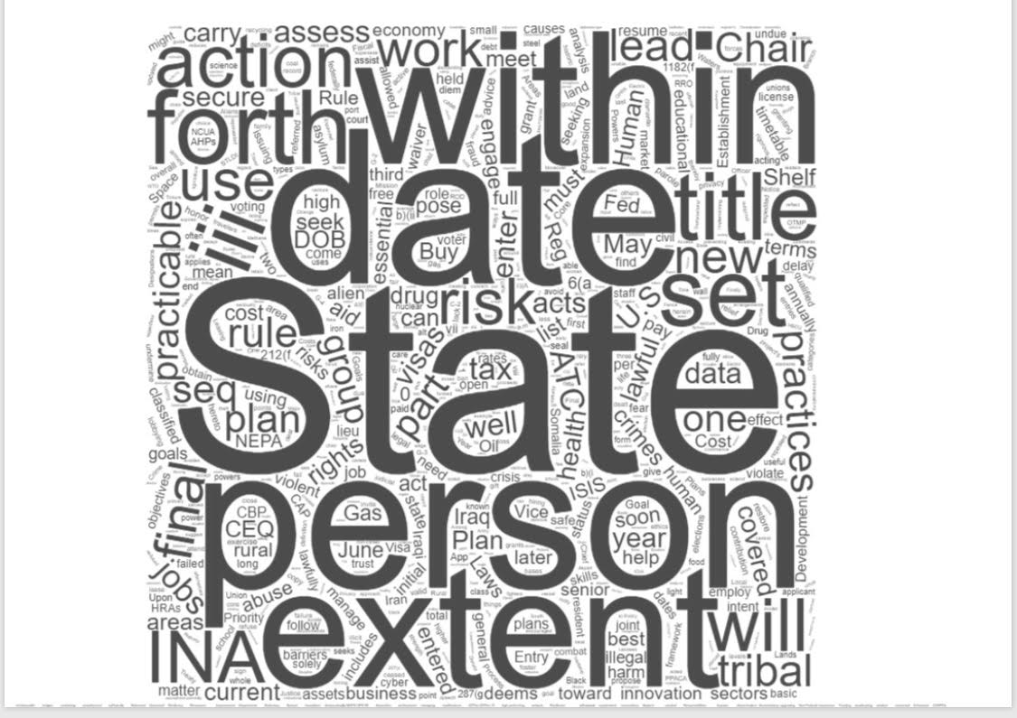

Figure 10: Word Cloud for President Donald Trump's Signing Statements from 2017
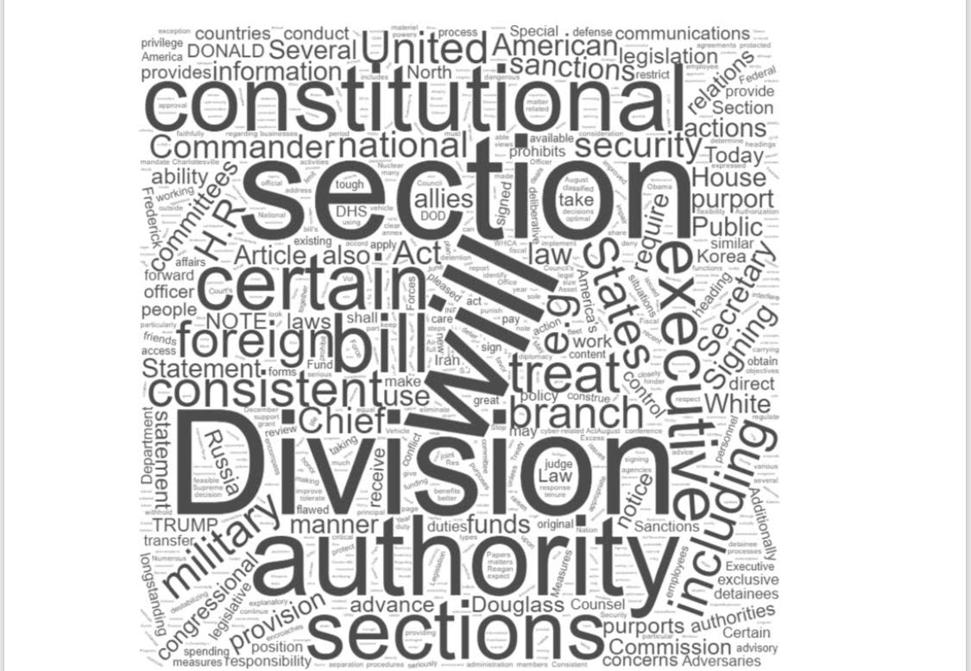

Figure 11: Word Cloud for President Donald Trump's Statements of Administration Policy from 2017

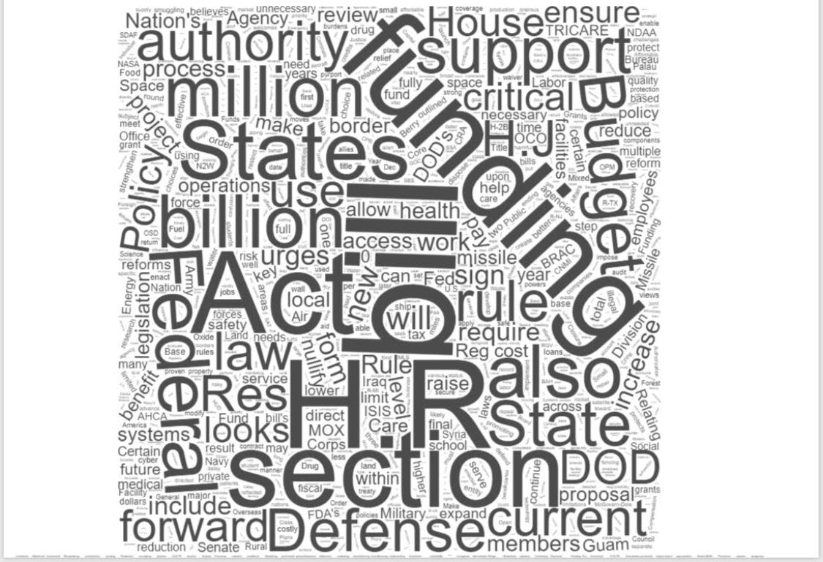

Table 1: Spreadsheet of the Frequency of the 10 Most Used Words in Regards to Administration Policy and Presidential Power

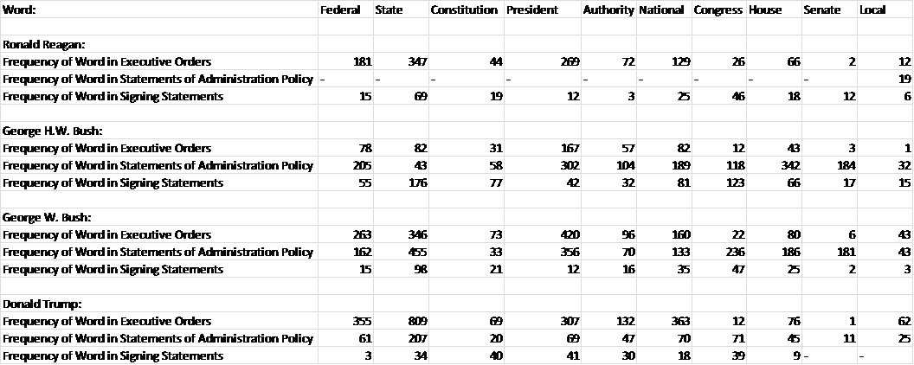

Table 2: Chart of Number of Executive Orders Each President had in their First Year
President | Number of Executive Orders in First Year
Jimmy Carter (D) | 66
Ronald Reagan (R) | 50
George H.W. Bush (R) | 31
Bill Clinton (D) | 57
George W. Bush (R) | 54
Barack Obama (D) | 39
Donald Trump (R) | 55

Discussion:
A Word Cloud was made for each type of document for President’s Reagan, H.W. Bush, W. Bush, and Trump. Figures 1- 11 show each of the most frequently words. I found that words such as congress, president, state and federal were common across each president. I then picked out 10 frequently used words that I thought was important in determining a President’s belief on the role of the federal government and presidential power. The most frequently used words out of the set of ten, and the most important in determining each President's beliefs are the words state and federal. Table 1 shows that in every case except one, every Republican President being studied used the word state in their documents more than the word federal. There was only one document where the word federal was used more than the word state, and that was the statements of administration policy of President George H. W. Bush. While the frequency of the word state over federal helps support my hypothesis on the Republican ideology of a smaller federal government since more focus is on the states, I still needed further proof of this, and more importantly to ensure that Donald Trump shares this common belief. After looking at the frequency of the words state and federal, I went through each document and analyzed the context and specific usage of the word federal for each president.
After reviewing President Regan’s usage and context of the word federal, I found that he favored a smaller government and focused on cutting and shrinking the federal government. For example, in Executive Order 12298 -Lake Tahoe Region, Reagan proclaims that “in order to eliminate unnecessary and duplicative Federal interference in the responsibilities of the Tahoe Regional Planning Agency (see Public Law 96-551 of December 19, 1980), it is hereby ordered that the Tahoe Federal Coordinating Council is terminated and Executive Order No. 12247 of October 15, 1980, is revoked.” (Reagan, 1981) This is a clear example of President Reagan’s belief that the federal government should not be bigger than it has to, and that it should run effectively. We also see this mentality of smaller government in Executive Order Executive Order 12308—Presidential Task Force on the Arts and Humanities. When President Reagan creates a task force, he makes sure that it stays as small as possible. “There is hereby established the Presidential Task Force on the Arts and Humanities. The Task Force shall be composed of no more than 36 members appointed by the President. No more than one member shall be a full-time Federal officer or employee. The remaining members shall not represent Executive agencies.” (Reagan,1981) The final example of President Regan deals with a specific role of the federal government that he believes is necessary. In Executive Order 12332—Establishment of the National Productivity Advisory Committee, he states that “the Committee shall advise the President and the Secretary of the Treasury through the Cabinet Council on Economic Affairs on the Federal Government's role in achieving higher levels of national productivity and economic growth.” (Reagan, 1981) This ideology of productivity and national growth goes hand in hand with efficiency and saving taxpayers money. The more productive a government is, the more efficient it is. The more economic growth a government produces, the more people there are working and getting money in their pocket. This is a classic example of the Republican approach towards the federal government.
President George H.W. Bush had a slightly different attitude towards the federal government. President Bush focused on the integrity of the federal government and wanted the American people to trust it, but not depend on it. There were many commissions created and laws passed during his tenure that promoted ethics in the federal government. In Executive Order 12668—President's Commission on Federal Ethics Law Reform, President Bush states that he established the President's Commission on Federal Ethics Law Reform. “The Commission shall be composed of not more than eight members appointed by the President. These members shall be distinguished individuals with broad experience in ethics and public service.” (H.W. Bush, 1989) Not only does he focus on ethics in government, he also limits how many people are on the committee to ensure that it is not bigger than it needs to be. In Executive Order 12674- Principles of Ethical Conduct for Government Officers and Employees, he strives to “ensure that every citizen can have complete confidence in the integrity of the Federal Government, each Federal employee shall respect and adhere to the fundamental principles of ethical service…” (H.W. Bush, 1989) He wants the people to trust the government, but not depend on it. We see an example of this in Statement of Administration Policy: H.R. 2042 - Studying the Use of Actual Crop Yields in Price Support Programs when he states that “one of the successes of the Food Security Act of 1985 has been to encourage producers to turn toward the marketplace rather than the Federal government.” (H.W. Bush, 1989) President Bush clearly doesn’t want any dependency on the government whether it be producers or consumers. The final example of President Bush’s policy deals with cutting spending and waste. The Statement of Administration Policy: H.J. Res. 165 - Disapproving the Recommendations of the Commission on Base Realignment and Closure details his effort of efficiency. The “national defense will be improved and costs reduced through a more efficient military base structure. Moreover, unneeded federal land will be restored and out to productive private or public use.” (H.W. Bush, 1989) This is a very similar approach that President Reagan had, and aligns with the Republican approach on the federal government.
President George W. Bush’s approach deals with improving the federal government, but also implementing state programs more with help from the federal government. In Executive Order 13217—Community-Based Alternatives for Individuals With Disabilities, President Bush proclaims that the federal government “must assist States and localities to implement swiftly the Olmstead decision, so as to help ensure that all Americans have the opportunity to live close to their families and friends, to live more independently, to engage in productive employment, and to participate in community life… These agencies should also ensure that existing Federal resources are used in the most effective manner to support the goals of the ADA.” (W. Bush, 2001) Not only does he want the States to be more involved; he also ensures that the federal government helps them in the most efficient way possible. President Bush also wants to cut the federal government and end many burdens that it creates. In the Statement of Administration Policy: H.R. 327 - Small Business Paperwork Relief Act, he declares that “the Administration will work with Congress to ensure that the bill's provisions will, in practice, succeed in advancing the bill's fundamental goal of reducing the paperwork burden that Federal agencies impose on small businesses.” (W. Bush, 2001) President Bush shares the same beliefs that his Republican predecessors have: cutting the federal government and making it as effective as possible. The last example of President Bush’s policy deals once again with effectiveness in the federal government. In the Statement of Administration Policy: H.R. 2590 - Treasury, Postal Service, and General Government Appropriations Bill, FY 2002, he states that this “initiative would play an important role in fulfilling the President's commitment to a Federal Government that is more efficient, productive, and responsive to its citizens.” (W. Bush, 2001)We see the same belief of Republican Presidents here as we did with Presidents Reagan and H.W. Bush.
President Donald Trump shares the same ideology of cutting government spending and efficiency as his Republican predecessors. He also focuses on the protecting the American people, which goes hand in hand with efficiency and ensuring that the federal government is doing its job. In Executive Order 13766—Expediting Environmental Reviews and Approvals for High-Priority Infrastructure Projects, he says that “infrastructure investment strengthens our economic platform, makes America more competitive, creates millions of jobs, increases wages for American workers, and reduces the costs of goods and services for American families and consumers. Too often, infrastructure projects in the United States have been routinely and excessively delayed by agency processes and procedures. These delays have increased project costs and blocked the American people from the full benefits of increased infrastructure investments, which are important to allowing Americans to compete and win on the world economic stage. Federal infrastructure decisions should be accomplished with maximum efficiency and effectiveness, while also respecting property rights and protecting public safety and the environment.” (Trump, 2017) He preaches saving taxpayers money and says this can be done if the federal government did its job properly. If a government is efficient, it would get things like infrastructure projects finished sooner, cutting costs across the board. In Executive Order 13774—Preventing Violence Against Federal, State, Tribal, and Local Law Enforcement Officers, we see the same urge to improve the government that we saw with President George W. Bush. President Trump wants to “enforce all Federal laws in order to enhance the protection and safety of Federal, State, tribal, and local law enforcement officers, and thereby all Americans.” (Trump, 2017) He again focuses on protecting the American people while striving to better the federal government in the process. The final example of his policy deals with cutting the power of the federal government and returning it to the States. In Executive Order 13791—Enforcing Statutory Prohibitions on Federal Control of Education , he explains that he issued this “in order to restore the proper division of power under the Constitution between the Federal Government and the States and to further the goals of, and to ensure strict compliance with, statutes that prohibit Federal interference with State and local control over education.” (Trump, 2017) This is arguably the best example of the role of the federal government in President Trump’s eyes. By returning power back to the States, you are not only shrinking the federal government, you are also cutting spending in the process by ending any previous involvement. This is textbook Republican ideology and something that we see from Presidents Reagan, H.W. Bush, and W. Bush.
The final portion of my research deals with presidential power. In order to analyze each President’s opinion on presidential power, I looked at the number of executive orders from the first year in office in comparison to each Republican president and their predecessor. It has already been established that Democrat Presidents issue more executive orders than Republicans, so I first looked at the comparison between Republicans and Democrats. Table 2 shows that every Republican President has a lower amount than their Democrat predecessor besides President Trump. President Trump had 16 more executive orders in his first year than President Obama. Not only did President Trump issue more executive orders than his Democrat predecessor, he also issued more executive orders in his first year than any of the Republican Presidents being studied. President Trump issued 5 more orders than President Reagan, 24 more orders than President H.W. Bush, and 1 more order than President W. Bush. So, as far as the executive order test on presidential power, it appears that President Trump holds a more favorable view of presidential power than his Republican predecessors.

Conclusion:
In this research paper I analyzed the executive orders, signing statements, and statements of administration policy from the first year office of Presidents Ronald Reagan, George H.W. Bush, George W. Bush, and Donald Trump. This was done to determine administration policy of President Trump and his role of the federal government and to compare his beliefs to previous Republican Presidents. I collected each document for each President and then created a Word cloud for each to help determine the most used words. After I found the most used words I quickly realized that the words federal and state appeared most frequently. Then, I went back through each document to determine the context in which those two words were used. It was through this process that I found the administration policy and how each President viewed the role of the federal government. Each of the Republican Presidents studied, including President Trump, shared the same ideology. President Reagan focused on cutting and shrinking the federal government, President H.W. Bush focused on the ethics of the federal government while ensuring the there was no waste within, President W. Bush aimed to improve the federal government making it more effective, and President Trump focused on cutting spending within the federal government while focusing on the efficiency of it. They all shared the beliefs of their party’s platform: a smaller and more effective federal government.
The final portion of this paper focused on presidential power. Using Kenneth R. Mayer's theory that Democrat Presidents issue more executive orders than Republican Presidents was tested first. Every Republican President studied besides President Trump issued fewer executive orders than their Democrat predecessors. Also, President Trump issued more executive orders than Presidents Reagan, H.W. Bush, and W. Bush. It can be concluded that President Trump favors presidential power more his past three Republican predecessors.
In conclusion, President Trump is both similar and different from his previous Republican predecessors. His ideology aligns with that of the Republican Party and Presidents Reagan, H.W. Bush, and W. Bush. All of which favor a smaller and more efficient federal government. He is different in his favorability of presidential power. He issued more executive orders in his first year in office than his Republican predecessors and President Obama. This difference regarding presidential power requires further research. A more precise method of research should be performed including analyzing which party controlled Congress and the popularity of each President at the time. With that research, there would be a better understanding of President Trump and presidential power.

References
Mayer, Kenneth R. “Executive Orders and Presidential Power.” The Journal of Politics, vol. 61, no. 2, 1999, pp. 445–466. JSTOR, JSTOR, www.jstor.org/stable/2647511National Archives and Records Administration, National Archives and Records Administration, georgewbush-whitehouse.archives.gov/.
Rice, Laurie L. “Statements of Power: Presidential Use of Statements of Administration Policy and Signing Statements in the Legislative Process.” Presidential Studies Quarterly, vol. 40, no. 4, May 2010, pp. 686–707., doi:10.1111/j.1741-5705.2010.03806.x.
Woolley, John and Gerhard Peters, The American Presidency Project [online]. Executive Order 12298 -Lake Tahoe Region. Santa Barbara,CA: University of California [hosted], Gerhard Peters [database]. http://www.presidency.ucsb.edu.
Woolley, John and Gerhard Peters, The American Presidency Project [online]. Executive Order Executive Order 12308—Presidential Task Force on the Arts and Humanities. Santa Barbara,CA: University of California [hosted], Gerhard Peters [database]. http://www.presidency.ucsb.edu.

Woolley, John and Gerhard Peters, The American Presidency Project [online]. Executive Order 12332—Establishment of the National Productivity Advisory Committee Santa. Barbara,CA: University of California [hosted], Gerhard Peters [database]. http://www.presidency.ucsb.edu.

Woolley, John and Gerhard Peters, The American Presidency Project [online]. Executive Order 12668—President's Commission on Federal Ethics Law Reform .Santa Barbara,CA: University of California [hosted], Gerhard Peters [database]. http://www.presidency.ucsb.edu.

Woolley, John and Gerhard Peters, The American Presidency Project [online]. Executive Order 12674- Principles of Ethical Conduct for Government Officers and Employees. Santa Barbara,CA: University of California [hosted], Gerhard Peters [database]. http://www.presidency.ucsb.edu.

Woolley, John and Gerhard Peters, The American Presidency Project [online]. Statement of Administration Policy: H.R. 2042 - Studying the Use of Actual Crop Yields in Price Support Programs. Santa Barbara,CA: University of California [hosted], Gerhard Peters [database]. http://www.presidency.ucsb.edu.

Woolley, John and Gerhard Peters, The American Presidency Project [online]. Statement of Administration Policy: H.J. Res. 165 - Disapproving the Recommendations of the Commission on Base Realignment and Closure. Santa Barbara,CA: University of California [hosted], Gerhard Peters [database]. http://www.presidency.ucsb.edu.

Woolley, John and Gerhard Peters, The American Presidency Project [online]. Executive Order 13217—Community-Based Alternatives for Individuals With Disabilities. Santa Barbara,CA: University of California [hosted], Gerhard Peters [database]. http://www.presidency.ucsb.edu.

Woolley, John and Gerhard Peters, The American Presidency Project [online]. Statement of Administration Policy: H.R. 327 - Small Business Paperwork Relief Act. Santa Barbara,CA: University of California [hosted], Gerhard Peters [database]. http://www.presidency.ucsb.edu.

Woolley, John and Gerhard Peters, The American Presidency Project [online]. Statement of Administration Policy: H.R. 2590 - Treasury, Postal Service, and General Government Appropriations Bill, FY 2002. Santa Barbara,CA: University of California [hosted], Gerhard Peters [database]. http://www.presidency.ucsb.edu.

Woolley, John and Gerhard Peters, The American Presidency Project [online]. Executive Order 13766—Expediting Environmental Reviews and Approvals for High-Priority Infrastructure Projects. Santa Barbara,CA: University of California [hosted], Gerhard Peters [database]. http://www.presidency.ucsb.edu.

Woolley, John and Gerhard Peters, The American Presidency Project [online]. Executive Order 13791—Enforcing Statutory Prohibitions on Federal Control of Education. Santa Barbara,CA: University of California [hosted], Gerhard Peters [database]. http://www.presidency.ucsb.edu.
Woolley, John and Gerhard Peters, The American Presidency Project [online]. Executive Order 13774—Preventing Violence Against Federal, State, Tribal, and Local Law Enforcement Officers. Santa Barbara,CA: University of California [hosted], Gerhard Peters [database]. http://www.presidency.ucsb.edu.

Data Sources
All executive orders, signing statements, and statements of administration policy come from:
Woolley, John and Gerhard Peters, The American Presidency Project [online]. Santa Barbara,CA: University of California [hosted], Gerhard Peters [database]. http://www.presidency.ucsb.edu.

