**The Sins of Our Fathers**

**By: Emily Frazer**

**Senior Seminar**

By the end of the Second World War the Germans had not only lost the war they had also lost a sense of who they were as a people. As the extent of the Nazi crimes against humanity was uncovered the German national identity became highly stigmatized. It seemed that after the war, no one quite knew what it meant to be a German citizen and even if they did they were ashamed to call themselves one. Now, almost 60 years after the mass genocide of the Jewish people Germany is in the middle of creating a new positive identity out of the ashes of their Nazi past. Germans are now expressing pride in their country and pride in their workmanship. The support that the German people have shown for European unity, as well as, the international community as a whole is evidence that Germany is a different state than it was previously. This research project will look at the effect stigmatization has had on the German national identity. Firstly, we will look at the break in the Germanys and analyze the stigma for both East and West Germany. We will then analyze the subtle changes that occurred in the stigmatization of the united Germany. The economic success and political asylum policy of West Germany and of the unified Germany will be followed by the dissection of Germany’s national pride. By understanding these facets of the German life since 1945 we will come to a better supposition of the impact that stigmatization has had and continues to have on German national identity.

**Stigmatizing Nations: A Stigma Recognition and Stigma Rejection**

In order to understand the shift in German national identity we must first look at what the effect is on the nation being stigmatized. A stigma, according to Rebecca Adler-Nissen are lessons that we impose on others in order to teach them what the norms are in a society and also act as a deterrent to particular behaviors. This drive to impose stigmas comes from our desire to hold some sort of order. Placing stigmas can sometimes render the offender to a status of less than human (Alder-Nissen, 2-8). Like individuals, nations can be stigmatized by international community. Alder-Nissen argues that there are three types of stigma management. They are: stigma recognition, stigma rejection, and counter—stigmatization. For our purposes we will only focus on the first two types as they are the only ones that apply directly got Germany (a counter-stigmatization example would be Cuba’s response to the US trade embargo as a result of finding Soviet Union missiles being set up on Cuban soil. The Cubans embraced the stigma and actually embarrassed the US with its continued survival and trade with other countries) (Alder-Nissen). We will discuss the other two ways to manage stigma in the next section. Below is a chart of Adler-Nissen’s that provides the differences between these three concepts:

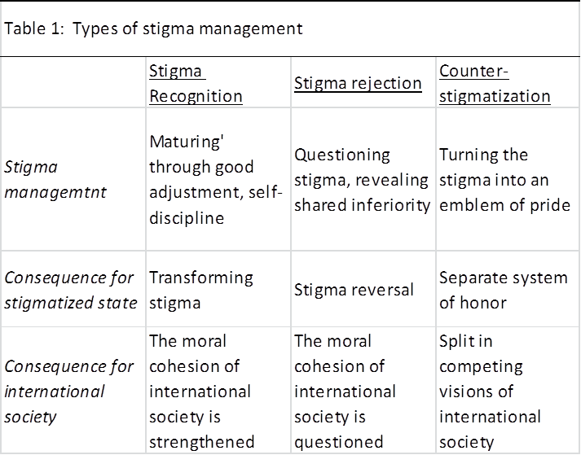

**The Separation of** G**ermany and the Emergence of Two Separate Stigmas**

The emergence of a divided Germany after the Second World War further complicated German national identity. The two countries split and both gained a new identity. Germany is located in the heart of Europe and provided a strong foothold for The Soviet Union’s plans to spread communism. The Western Allied Powers feared this and therefore, developed a strong desire to have a controlling interest in Germany as well (Erler, 387). So with the Soviet Union controlling East Germany and the western powers controlling Western Germany and neither one of them planning of releasing their hold any time soon, Germany had to settle into the role of having a split personality. Also, since “states that are weak in terms of resources or conflict-ridden [much like Germany was after WWII] may have few choices when it comes to coping with stigma. ‘Under-developed countries or countries recovering from atrocities or civil war…see the adoption of international norms as a requirement for their economic recovery program’” (Alder-Nissen, 14). This explains why East and West Germany became two very different sorts of countries. After all they were only modeling themselves after the powers that were controlling them (Erler, 380). This “case of divided Germany allows a direct comparison of territorial strategies in national identity construction between a centralized totalitarian and a federal democratic state and between and ethic and a civic identity” (Herb, 141). If one puts all of this information together (the location of Germany, the controlling powers involved, the fact that they were devastated by war, and the blame they inherited from Hitler) we are able to see how these separate Germanys became so polarized

*West Germany*

West Germany accepted the stigma placed upon them internalized the shame that went along with it. Because of this acceptance of the stigma and the pressure from their controlling powers they became the model cosmopolitan state. Stephen Welch and Ruth Wittlinger comment on how committed Germany was to being seen as a country that works well with others as well as non-threatening in the following statement:

“It showed a reluctance to articulate its national interest openly. It embraced Europeanism both as a cosmopolitan target of identification and also in part as a set of devices that locked in West Germany’s progress beyond the national paradigm. Its general approach to foreign policy was characterized by a renunciation of power politics as well as a style that showed modesty, moderation, and self-limitation. It was deeply committed to rights and values, as expressed (in universal language) in the basic law. It showed a commitment to multilateralism and a keenness to pool sovereignty in supranational structures” (45).

Welch and Wittlinger articulate perfectly the way in which West Germany conducted itself in all decisions in foreign policy. For a specific example we can look at Germanys asylum policy post WWII. Their policy was one of the most liberal in Europe and it is clear that the significance of this loose policy if because of their “historical baggage” (Schuster, 119).

To sum up, by accepting the stigma that was placed upon them by the international society, West Germany changed their national identity from a private, fiercely prideful country to that of a global, ashamed one.

*East Germany*

Unlike West Germany, East Germany rejected the stigma that was placed upon them because they felt that they were not at fault for Hitler’s rise to power. They refused the stigma that was placed upon them or outright ignored it. “They lived under a regime that explicitly claimed to represent a qualitative break with not only the Nazi era but with the German past in general” (Hancock, 67). Under Soviet Union control, East Germany would become a communist, poor, and very isolated country. In fact, Easterners were so poor that before the Berlin Wall was built in 1961, they would sneak across the border and take long stretches of low paying jobs in West Germany in order to supplement their income (i.e. ration cards). They would then make the dangerous trek back across the border to their homes in order to claim ration cards, given out monthly, for their families. This created resentment from the west who thought of the easterners as job stealing vagrants (Sheffer, 328-330). Even now, former “East Germans increasingly feel more like German citizens, albeit like ‘second class’ Germans…” (Hancok, 60). This built up resentment between the two states only served to separate them more firmly.

**Reunification**

With the fall of the Berlin wall in 1989 a reunified Germany sprung from the ashes. That is not to say it was easy. The built up resentment between these two countries did not suddenly dissipate. In fact, West Germany felt resentful that they would have to foot the bill for a poor and unorganized East Germany and East German’s were none too happy about having to ask their snobbish neighbors for help either (Mushaben, 79). However the fall of the Berlin Wall was a step toward the actual reunification of the German people. These formally two states took different routes when it came to stigma management. West Germany dug in and accepted their whole past while East Germany seemed to create a new one with The Soviet Union. However, when East and West were made one again they followed the, formally exclusive, West German model of doing things. This meant that the citizens of the former East Germany were forced to accept the stigma of World War II instead of ignoring it. This created some differences in the way that Germans connected with their, now reunited, country. For example, in Hilary Burbank’s study entitled *German National Identity: Patriotism and Pride across Germany*, she discovered that statistically, former East Germans displayed more pride in their country than did West Germans, but East Germans felt more shame about their pasts than former West Germans. What these findings show are the dissonances between the formally East and West Germans, but these dissonances make sense within the context of the German past. Since the former East Germany rejected the stigma of WWII they created a new identity for themselves that lasted from 1949 to 1989. During that time they were proud to be an East German and they had no reason not to be, but when they rejoined West Germany they realized what it meant to accept the stigma, but they had grown up in a proud environment so their spirits were dampened, but not as much as the West Germans. Since West Germany recognized the stigma and became a part of the global community they were used to being stripped of their pride and so they would of course feel less pride then East Germans, but the same does not apply to feeling ashamed. West Germans had time to cope and come to terms with their past and so they are less ashamed of it. East Germans, on the other hand, had distanced themselves from the Nazi past, but they were the poor cousins of the West Germans and they felt inadequate next to them. That is where this increased shame comes from.

*Reunification Stigma*

Former East and West Germany were not the only ones to harbor resentment for a unified Germany. Many believe that a unified Germany meant a strong Germany and that a strong Germany meant a dangerous Germany. These people believed that if Germany ever came into power again that it would be a terrible thing. Sander Gilman wrote about these fears in his article aptly named *German Reunification ad the Jews.* He expressed this trepidation by quoting Eli Wiesel, a survivor of the Holocaust:

“What next? Will this unexpected turn of events lead to a reunification of Germany? Will a united, powerful new Germany break away from the conquest-thirsty demons that dominated the old Germany? I cannot hide the fact that the Jew in me is troubled, even worried. Whenever Germany was too powerful, it fell prey to perilous temptations of ultranationalism” (qtd. in Gilman, 173-174).

None can question the validity of his argument and none could question his fears, especially right after the unification, but now they seem a little extreme. The fact that Germany is now a major player in the global community, an economic powerhouse in Europe as well as the world, and is generous in both their foreign and domestic policies is more than enough proof that the “perilous temptations” of the past have stayed in the past. Germans have been dealing with this past for over 60 years and they have taken many precautions to make sure that something like Hitler’s takeover would ever happen in their country again. For example, in the 1950’s West Germany’s plan of denazification and in 1960’s and the trial of Auschwitz perpetrators stand as explicit evidence that Germany has taken many steps to atone and rectify their past (Hancock, 67).

**The Shift**

I have seen Germany reclaim its economic prosperity and its pride in my lifetime. While it is has not fully recovered its national pride, it has excelled past its previous economic success. We can see the shift to a new German national identity now. We can see it in the prosperity of the German people, the move toward more moderate political policies, and the national pride shown at sporting events and by the satisfaction that Germans have in their governmental structure. For instance, attitudes towards Germany’s Basic Law are more than adequate when trying to judge support and satisfaction in Germany’s political structure (Hancock, 64). Below is a chart that shows us that the younger the person asked the question “has the basic law proven itself?” the higher the approval rate. This illustrates that now, and in the future, German’s pride in country will continue on the positive trend.



*Hancock, 64

*The Shift in the German Economy*

Contemporary Germany is an economic powerhouse in the European Union as well as the world. Michael Schuman and Claudia Himmelreich comment on how Germany, while saving small business and securing jobs, is also stabilizing the world economy in their article *How Germany became the China of Europe.* Schuman and Himmelreich show that Germany’s exports have grown 22% from 2000-2009 (9). This is incredible coming from a country that was split apart until 1989. In fact, currently “German is one of the richest countries in the world with a fifteenth place in the 2008 World Bank per capita GDP list ($44,471)…” (Langenbacher, 193). Also, Germany’s support of the European Union is what keeping the Euro alive (Langenbacher, 196).

*The Shift in Political Policies*

As another result of Germany redefining their national identity they have begun to move away from the liberal policies that they had in place as a result of a type of penance the German people were paying for the atrocities committed by their ancestors (Schuster, 120). Their political asylum laws were so liberal that they allowed anyone to enter the county and work if they claim to be politically persecuted (Fijalkowski, 852). Such liberal laws actually made it easy for those who were not persecuted for their religious or political beliefs to claim shelter from Germany by simply lying. This became a problem because the people who were lying in order to get into Germany were making it difficult for people who were actually seeking political asylum (Talbot, 834). In 1996 Germany reformed their immigration laws and the asylum policy was changed as a result of the sharp spike in asylum seekers after the reunification. The amended policy denied access to those trying to gain asylum from any EU country deemed “safe” by the German government (Hancock, 22).

This tightening up of the political asylum laws are Germany’s way of trying to separate themselves from the stigma attached to them after World War II. They are trying to create a more positive national identity by attempting to put space between themselves and the Holocaust. That is not to say that they would forget about what happened; they never could, but they do not want to dwell on that one aspect of German history and forget about everything else. Petra Kuppinger, a professor of Anthropology at Monmouth College[1], commented on this idea. She believed that if people boil down the entire history of Germany into one instance that would be extremely depressing because there is so much more to Germany than that.

*The Shift in German Mindset*

Time has passed and with it healing. Not that long ago there were many people so ashamed of their country’s past that they decided to renounce their own identity by joining the traditions of the ones that their ancestors had persecuted (like becoming a Rabbi or moving to Jerusalem or possibly evening changing their name so that they have no association with their past at all). These people see “the problem of stigma and the psychological dissonance it causes for Germans who feel they cannot relinquish their German identity is solved by inventing a new German identity” (Stigma, 154-155). Now, however, we are seeing more and more people remembering their past while not dwelling on it. For instance no good can come from constantly reminding the German people about the atrocities that their parents or grandparents committed (Moses, 45-47). Most believe now that the memory of the Holocaust should not be held over the heads of all Germans like a “moral cudgel” used to bully Germans into submission (Moses, 48). Some believe that people cannot only be classified as victims or as perpetrators, that life is way more complicated than that. She also thinks that it is past time for Germans to put the Holocaust in the same category as “the extermination of the Indians, the slave trade, serfdom, the gulag, colonization, the persecution of the Christians, the Inquisition, the Crusades…so that everyone can learn from them (Stigma, 143-144). There is tons of evidence that suggests that it is important to always remember the German past, not because one is responsible for the events that happened before one’s birth, but because the German people carry a certain responsibility to handle the situation with care when it arises and to understand that it is a part of the German past.

*The Shift in German Pride*

In 2006, the World Cup was hosted by Germany and it was a momentous occasion, not because Germany was a contender in this internationally watched match, but because of the thousands of German flags that were being waved by the spectators. This was the first mass display of national pride that the Germans seen probably in their lifetimes. While it is still considered bad manners to hang a German flag in one’s window every day, we were able to see that shift toward national pride in the German people (Kuppinger). We are able to see, through examples like this, that Germany has not only accepted the stigma placed upon them, but they have actually internalized it. They have forgone their national pride in order to do a penance for the sins that their fathers committed. It is not a surprise that the German people have a limited showing of outward pride for their nation. This persistence of the stigma has forced them into it. German opinion polls actually place Germany as one of the least “patriotic nations on earth, having internalized the postwar critique of nationalism and seemingly embracing Habermasian notions of postnationality, constitutional patriotism, or European identity” (Langenbacher, 189). But while we see this lack of pride in polls and studies time after time, we also see things like the 2006 World Cup that show that Germany is not letting go of their pride in nation completely.

**Conclusion**

Even with all of the advances that that Germany has made there are still pictures like this:

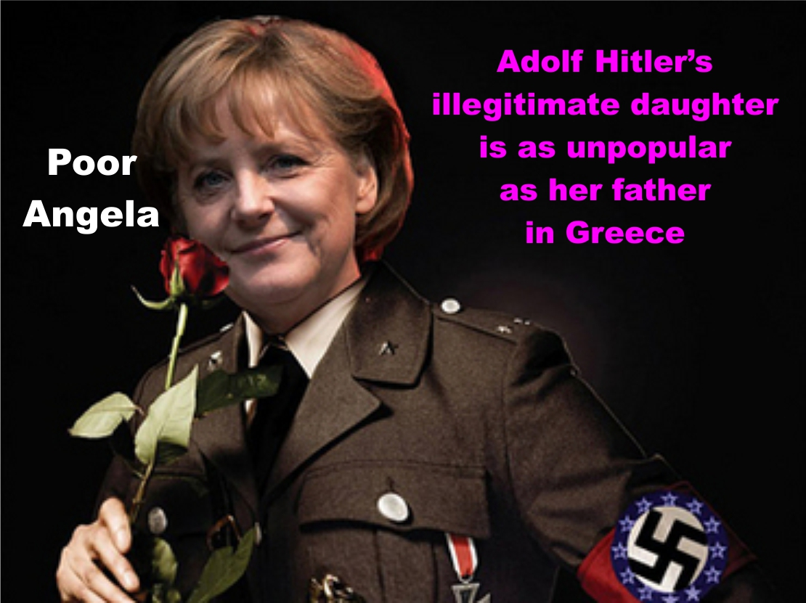

That is Angela Merkel dressed up as Hitler. Even though her policies in no way mirror those of that tyrant she is portrayed as him regardless. Kuppinger believes that these “types of comments (and displays) shuts down the conversation.” When asked if she was frustrated by these antics she responded by saying that they were more than frustrating because instead of talking about the real issues at hand he conversation is stopped because one cannot argue with someone who is ignorant. She maintains that anyone who would confuse the politics of a modern day Germany with those of Hitler’s is living in ignorance. Kuppinger did not vote for Merkel, but she asserts that she is a democratically elected leader and is obeying the laws and policies the German government has in place. To even be afraid that contemporary Germany is going to start another Holocaust is the most absurd thing that I have ever heard. Not only is Germany a part of a global society, is balancing their budget and coming out ahead, but it is promoting and supporting the idea of a European community and that right there concrete proof that the Germany now is nothing like the Germany of World War II.

In my lifetime I have been present for the fall of the Berlin Wall and the growth of a new and improved Germany that has become an economic powerhouse. I saw in amazement as the flags flew for Germany at the 2006 World Cup. I have seen Germany come into its own so I guess my question is why would we want to tear it down? Why would we be so blinded by the past that we try to hold back a country that has brought prosperity to the entire world? Germany has fallen, but it has also risen from the ashes of its failure and come back changed and better for the experience. It is now friends instead of enemies, hope instead of desolation, and the strength in character instead of the weakness of fear to support it.

**Bibliography**

Adler-Nissen, Rebecca. "Stigma Management in International Relations: Transgressive Identities, Norms, and Order in International Society." *International Organization*, 2014: 1-35.

Ahmed, Abu Nasar Saied. "From Division to Reunification." *Economic and Political Weekly*, 1990: 2242-2244.

Bubank, Hilary. "German Ntionl Identity: Patriotism and Stigma." n.d.

Erler, Fritz. "The Struggle for German Reunification." *Foreign Affairs*, 1956: 380-393.

Fijalkowski, Jurgen. "Aggressive Nationalism, Immmigration Pressure, and Asylum Policy Disputed in Contemporary Germany." *International Migration Review*, 1993: 850-869.

Gilman, Sander L. "German Reunification and the Jews." *New German Critique* , 1991: 173-191.

Gokturk, Deniz, David Gramling, and Anton Kaes. *Germany in Transit: Nation and Migration 1955-2005.* Los Angeles: University of California Press, 2007.

Hancock, M. Donald and Henry Krisch, POLITICS IN GERMANY, Washington D.C.: CQ Press, 2009.

Herb, Guntram H. "Double Vision: Territorial Strategies in the Construction of National Identities in Germany." *Annals of the Association of American Geographers*, 2004: 140-164.

Himmelreich, Michael Schuman and Claudia. "How Germany became the China of Europe." *Time*, 2011: 52-55.

Hiscocks, Richard. *The Adenauer Era.* Philadelphia/New York: Random House, 1966.

Jarausch, Konrad H. *After Hitler: Recivilizing Germans, 1945-1995.* New York: Oxford University Press, 2006.

Kuppinger, Petra, interview by Emily Frazer. (February 12, 2013).

Langenbacher, Eric. "Conclusion: The Germans Must Have Done Something Right." *German Politics and Society*, 2010: 185-202.

McCauley, Martin. *The German Democratic Republic Since 1945.* New York: St. Martin's Press, 1983.

Moses, A. Dirk. "Stigma and Sacrifice in the Federal Republic of Germany." n.d.: 139-180.

Moses, A. Dirk. "The Non-German German and the German German: Dilemmas of Identity After the Holocaust." n.d.: 45-94.

Mushaben, Joyce Marie. "Rethinking Citizenship and Identity: 'What it Means to be German' since the Fall of the Wall." *German Politics*, 2010: 72-88.

Schuster, Liza. "A Comparatie Analysis of the Asylum Poliy of Seven European Governments." *Journal of Refugee Studies*, 2000: 118-132.

Sheffer, Edith. "On Edge: Building the Border in East and West Germany." *Central European History*, 2007: 307-339.

Talbot, Margaret. "Germany Bars the Door." *Nation*, 1994: 832-834.

Welfens, P.J.J. "German unification and Systemic Transition: Towards A new German Economic Miracle?" *Acta Oeconomica*, 1992: 115-140.

Wittlinger, Stephen Welch and Ruth. "The Reslience of the Nation State: Cosmopolitanism, Holocaust Memory and German Identity." *German Politics and Society*, 2011: 38-53.

1. Petra Kuppinger. February 12, 2013