James Stratton

Obama Online

The Nation’s First Internet President

When President-elect Obama stepped on the stage at Grant Park in Chicago after winning the 2008 election the United States had been officially introduced to, not only its 44th president, but also its first Internet president. Throughout President Obama’s 2008 campaign he used the Internet, particularly social media to mobilize individuals to get to campaign stops, to push his policy, and to build a grassroots movement behind him. Social media was important to Barack Obama because he hired Chris Hughes, a founder of the social networking site Facebook, to create his webpage (Solop 37). However, now President Obama uses social media to push his policies and seem like a “friend” to the American public through things like Facebook, Twitter, and YouTube.

President Obama is not the first President to have a new media at his disposal and use it to his advantage. Presidents before him have done the same. Franklin Delano Roosevelt successfully used radio and “Fireside Chats” to push his policies in the 1930’s and Dwight Eisenhower used television in the 1950’s and early 60’s. Therefore this paper poses this question: How do presidents use new media of their time to their advantage to push policy, and build their image with the American people? I will analyze President Obama and his use of social media (Facebook, Twitter, and YouTube) and then compare it to how President’s Franklin Delano Roosevelt and Dwight D. Eisenhower used their new medias. I will start out with a definition of social media, discuss what scholars are saying about those three presidents and their media, explain the importance of social media to President Obama, describe and analyze his Facebook, Twitter, and YouTube usage, then draw conclusions and comparisons of him to FDR and Eisenhower.

Before this paper delves into presidential use of social media, it is important to understand what “social media” actually is. “Social Media is a group of Internet-based applications that build on the ideological and technological foundations of Web 2.0, and that allow the creation and exchange of User Generated Content,” (Kaplan & Haenlein 61). That definition has many terms in it, the first—web 2.0. Web 2.0 is basically a platform where content and applications are continuously modified by users and not just created once by a publisher. The second term that needs explanation is “user generated content” which is just like it sounds, content created by users of the networking site (Kaplan & Haenlein 60-61). An example of social media is Facebook. Instead of a person just creating a website and publishing it, users on Facebook continuously upload their own content and interact with each other. This paper will particularly look at President Barack Obama’s Facebook page, Twitter Page, and YouTube Channel.

So what?
President Obama’s use of social media was attributed to him winning the popular vote among young people. Without social media, one may argue that President Obama would still be Senator Obama.

Social media is something that 1/7th of the world’s population uses, over a billion people. It is rapidly becoming a source where people get everything from local, national, and international news, to getting news from their friends as well. If people are gathering their news from social media and their friends news as well, a public figure can easily spread news about his/herself over social media to people that follow them.

The specific numbers of how many people use Facebook in particular are extremely widespread. The Pew Internet Research Center has a great chart on the nation’s Facebook users.

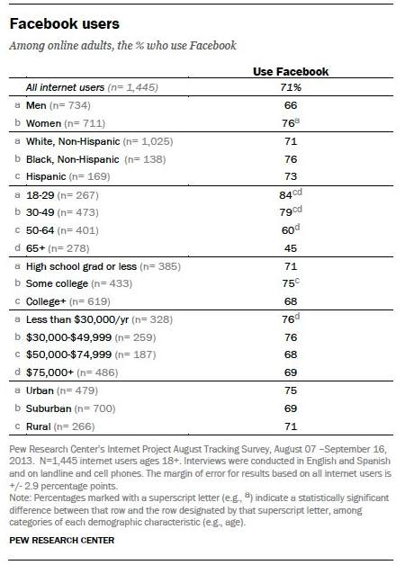

According to the Pew Internet Research Center in the United States, 71% of all Internet users use Facebook and 18% use Twitter. 76% of female Internet users have a Facebook account and 66% of male Internet users. 84% of 18-29 year olds, 69% of 20-49 year olds, 60% of 50-64 year olds and 45% of people age 65+, as for education levels, 71% of high school diploma or less, 75% some college education and 68% of college and higher education. Lower the income levels, the more likely people have a Facebook account. 76% of Internet users that make less than $30,000 have an account, 76% of users who make $30,000-$49,000. 68% of users who make $50,000-$79,499 and 69% of Internet users who make $75,000+ have an account. 75% of urban dwellers, 69% of suburban Internet users have an account and 71% of rural Internet users. By looking at these numbers we cannot only say that the majority of people across the board use Facebook, but there are some comparisons that can be drawn. For example, generally poorer Internet users have a Facebook account, more black Internet users over white and Hispanic have an account and people who haven’t completed college are more likely to have an account.

It is important to study this topic for a number of reasons, the first being the fact that President Obama’s social media use has not been studied, but candidate Obama’s use has. It is also important because the President is using this new form of media, and using it effectively. He has over ten thousand tweets, forty million followers on Twitter as well as thirty eight million followers on Facebook. The numbers alone prove the country is watching.

The country has always been watching, ever since the introduction to radio, the presidency has become public, the stage was originally set by Woodrow Wilson’s train excursion and FDR’s cousin Theodore Roosevelt. TR was the first president to coin the term “bully pulpit” which according to Merriam-Webster’s dictionary it is defined as “an important public position that allows a person to express beliefs and opinions to many people,” (Merriam-Webster). TR was the first president to use the Presidency to express his opinions to the public, the public then can pressure its congressmen to vote a certain way. This has become extremely important and a lot easier with the creation of radio, in which Presidents like FDR, Woodrow Wilson, and others have utilized, Then the creation of television in which Presidents such as Truman, Eisenhower and JFK all took advantage of. We now see, thanks to the creation of the Internet, the first Internet president—Barack Obama.

It is also important to note that President Obama was not the first President to use the Internet, even though he is considered the first “Internet president.” This is similar to FDR not being the first president on the radio and Eisenhower not being the first on TV. However, these three presidents were chosen because they were the first ones to fully grasp the new technology, take it under their wing, and use it to help themselves.

Literature Review
I defined President Obama’s social media as his YouTube channel, Twitter, and Facebook pages. A lot of scholars have researched Candidate Obama and what he did online in 2008 and 2012 to win the White House (Powell, Mackay, Harfoush); some also took that a step further and discussed how he built his own brand because of social media (Harfoush). Others discuss previous presidencies and how those presidents used media of their time to push their policies (Yu, Delli Carpini, Allen).

During Barack Obama’s 2008 campaign Obama had around two million Facebook fans while John McCain had roughly 600 thousand (Mackay 26-27). This shows that Barack Obama was not the only candidate using social media. However, he was the one who was getting the most attention. Barack Obama also made social media important in his 2012 campaign. In 2012 Barack Obama spent ten times the digital spending budget that Mitt Romney had. Obama spent $47 million while Romney spent a mere $4.7 million. In 2008 Obama still spent more on digital media than any other candidate, he spent $16 million (PBS).

Also, in 2008 Obama used Twitter to do a variety of things. During his campaign he tweeted 207 times about location information, 166 of his tweets were referencing his campaign website, and 101 of his tweets were notice of a live streaming event (Solop 42). These were the top three things the Obama campaign tweeted about and show Obama using social media to tell people what to do, basically. While he only tweeted 25 times about policy, he needed to get into office first and foremost, that is why he tweeted the most about rallying people to get to his campaign stops and get campaign info or watch live streaming speeches online. These live streaming speeches were posted on his YouTube channel. Obama and other candidates used YouTube as an inexpensive way to post campaign videos (Powell 86-87).

In all of these online categories, Candidate Obama was the frontrunner. He spent the most money; he had the most likes, the most engagement, the most YouTube views and subscribers. Because of this, once candidate Obama turned into President Obama he was expected to use this new media effectively in his presidency.

As soon as President Obama was elected his new media team created a few different websites. The first was Change.gov. Change.gov allowed users to submit their suggestions about issues to the Presidency. Organizing for America was created from MyBarackObama.com, which was his candidate web page. Obama created a grassroots campaign and hoped to change that group of people into a base to push his policy agenda. Whitehouse.gov was also revamped and President Obama became the first president to have a YouTube Channel and a blog (Harfoush).

Unfortunately, there has not been a lot of research done on the topic of President Obama’s use of social media. It seems to just be a conclusion in most books and articles. Therefore, this paper will look at as much as possible on what scholars are saying about President Obama on social media. However, most of the work will be rolling the sleeves up and delving right into his social media pages.

Going Public: Present and Past Presidencies
President Obama now has a large following on social media, 40 million Twitter followers and 38 million Facebook fans. This large audience allows him to reach the public through social media at any given moment. This is called “going public” and is a termed coined by Samuel Kernell. Kernell defines going public as “a strategy whereby a president promotes himself and his policies in Washington by appealing to the American public for support,” (Kernell 2). President Obama uses social media for just that, lately, from October- December 2013, Obama has been pushing the Affordable Care act on Twitter and on Facebook. His tweets talk about “getting covered” by the ACA. This is because the ACA website has been up and running lately, despite some glitches when the site first started. ACA, or Obamacare, has been the President’s top priority lately and has been one of his top priorities since he took office. On another issue, immigration, Obama posts a photo of congressmen who Facebook users should get ahold of to let them know about immigration control. The photo has their picture, what state their from, and then the a link is posted on how to get ahold of them. That is the biggest way President Obama goes public on Facebook. He makes it incredibly easy for users to contact their congressman and therefore puts pressure on them.

President Obama has the ability to reach people at their personal computers, cell phones, or tablets through social media. This taps into the homes and the personal lives of US citizens. The first type of media to do this was the radio and President Franklin Delano Roosevelt was the first to successfully use it. Now, FDR was not the first President to use radio, President Coolidge and President Hoover both used radio to broadcast speeches. FDR became the most famous through his fireside chats, in which he gave thirty of between 1933 and 1944. FDR pushed his war policies through radio as well as trying to boost morale and address domestic issues (Delli Carpini 30-32). FDR also pushed his “New Deal” over the radio and even had the new cabinet secretaries speak on the radio to the public (Yu 93). His most famous radio speech is most likely his “Day of Infamy” speech where he united the nation and rallied the US behind him in support of the war (Yu 89).

FDR was successful in his radio use because “this was the first time citizens felt as if they knew their President as a friend” (Yu 89). These addresses were not only directed at people, but the vehicle (the radio) was the centerpiece of their home. So, it felt as if the President was sitting right next to the family as he spoke to them in a personal way.

After radio, came television and television has “dominated politics since the 1950’s” (Delli Carpini 33). While President Truman gave the first ever television broadcast and Kennedy is considered the first “television president,” President Eisenhower was the first president to truly explore the realm of TV. That is why, in this paper I will use Eisenhower as precedent, rather than Kennedy or Truman.

Eisenhower brought his own fireside chats to television, set up the first news conference, conducted the first televisual cabinet meetings, and created the first White House TV studio (Allen 8). He held the first press conference in London in July 1942. His first policy ever announced on television was to speed up censorship screenings to make US and British reporters on equal ground. Eisenhower discussed the war on television similar to what FDR did on the radio.

Through television Eisenhower coined a couple of different terms, the first was “Modern Republicanism” which basically was an attempt to jumpstart a bored Republican party. It was a short, catchy term that was easily picked up by the media. Eisenhower, like Obama, used his new media of the time a lot more and a lot more effectively. Eisenhower’s 1956 campaign was almost all on television and contained great moving pictures with little to no words. While his opponent, Adlai Stevenson could not keep up (Allen 95). However, voting research showed that his televisual campaign made little to no difference (Allen 127).

The biggest breakthrough for Eisenhower was that now, for the first time, the American public could see and hear what a President was saying at any time (Allen 203). What Dwight Eisenhower did on television would set standards for Presidents in the years after and today.

The use of social media today is extremely widespread. Independent technology research company, Forrester Research found that in 2008, the year of Obama’s first campaign and election, “75% of Internet surfers used ‘social media,’ (Kaplan & Haenlein 59). Worldwide, there are 1.15 Billion people on Facebook, and 500 million Twitter users (Social Media Today). This is why social media is important to elected officials and why the Obama Presidency, can and does, use it to push President Obama’s Policy. “While new media has enormous power to help a candidate get elected, it also wields influence as a tool for operating a more efficient and transparent government—and advancing a political agenda” (Greengard 16). Social media is new media for President Obama, and similar to President’s before him, he has used this new media to his advantage.

Purpose of social media and how it is used
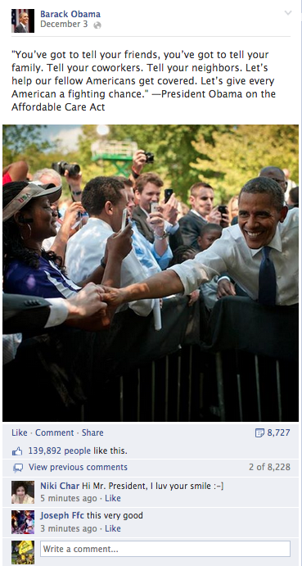
Social media builds brand awareness; in particular for elected officials it builds images of the person, instead of a brand. It also allows elected officials to push their policy into people’s social media feeds. It also allows other people to share what the President is sharing. For example, on December 3, President Obama posted a Facebook status and photo (previous page) that said, “’You’ve got to tell your friends, you’ve got to tell your family. Tell your coworkers. Tell your neighbors. Lets help our fellow Americans get covered. Let’s give every American a fighting chance.’—President Obama on the Affordable Care Act.” This was a quote directly from President Obama at a speech. His social media team was able to take that quote of President Obama and post it on Facebook with a photo and it receives almost 140 thousand likes, eight thousand comments and eight thousand shares. All of this engagement is what the social media team wants. The engagement allows it to pop up on people’s feeds who do not “like” the president on Facebook simply because their friends shared it, commented on it, or liked it. This is the second sphere that social media teams like to get their content to. The first sphere would be just be people who “like” Obama, however the second sphere are the friends of the people who “like” him. Once this info pops up on their feeds they are more likely to see it and/or engage with the post or “like” the President’s page. Thus, when President Obama has 36 million Facebook fans, he reaches a lot more than 36 million people when he posts something.

Social media is used by the President to push policy, but it is also used to show personal matters as well. This is an example of President Obama building his “friend” image. It is similar to what user’s regular friends would post. For example, on November 20 the Presidents social team posted a photo and status of President Obama and Joe Biden high fiving with a caption that read “Happy birthday, Mr. Vice President.” The comments on the posts were mainly other people wishing VP Biden a happy birthday. President Obama also follows social media trends. He posts a “Throwback Thursday” photo and status on Thursdays on Facebook. Throwback Thursday is where social media users post an old photo of themselves and usually add the hashtag #TBT. On Thanksgiving, President Obama posted an old photo of him and his family and labeled it “Thankful #TBT.” All of these posts reach the president’s Facebook and Twitter fans, but they also reach that second sphere as previously mentioned. The second sphere is key for the president to get his policies and images into the reach of people who do not necessarily believe what he believes and do not follow him on social media.

Analysis

Obama on Facebook
I chose to start analyzing Barack Obama’s Facebook page starting with November 4, 2008. This post is his election night speech in Grant Park in Chicago, Illinois. I chose this date instead of when he first started campaigning because this paper looks to analyze how presidencies use new media and not how candidates use it. My analysis ended on December 31st, 2013.
I then placed every post into categories, they are:
- Campaign statement
- Campaign inside look/behind the scenes
- Anti Mitt Romney statement
- Policy statement
- General inside look/behind the scenes
- Social media tradition (on Facebook users post things like “Throwback Thursday” and post an old photo of themselves, this is that category)
- Notice/reference to other media (SOTU address, other speeches, YouTube videos etc.)
- Recognition of other current events (9/11, holidays, etc.).
I broke the policy statement section down a little further into what the policies were such as:
- Iraq War
- War in Afghanistan
- Aiding other countries
- Healthcare
- Immigration
- Gun control
- Minimum wage/equal gender pay
- Fiscal/economic policy
- LGBT equality
- Education
- Energy/climate change
- Government shutdown
- Other

A Facebook post can fit into more than one category, for example: The post below from December 12 is a healthcare policy statement and a reference to
another media, a link to get covered, therefore it would fit in both categories. 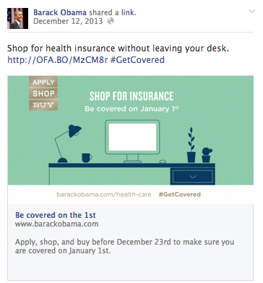

Looking at Table 1, you can see President Obama often encouraged users to watch another video or go to a different website. His top policies discussed on Facebook were healthcare, immigration, and gun control. However, gun control was not mentioned on his Facebook page until after the Sandy Hook Elementary shooting in Newtown Connecticut.

Table 1

Campaign Statement | 84
Campaign Behind the Scenes Look | 56
Anti Mitt Romney | 11
Iraq War PS* | 6
Afghanistan PS | 1
Aiding Other Countries PS | 4
Healthcare PS | 83
Immigration PS | 51
Gun Control PS | 72
Minimum wage/equal gender pay PS | 8
Fiscal/economic PS | 93
LGBT Equality PS | 27
Education PS | 19
Energy/Climate Change PS | 30
Government Shutdown PS | 19
Other PS | 33
General Behind The Scenes | 282
Social Media Tradition | 5
Reference to other media | 240
Recognition of current events | 89

*Policy Statement

Two of the more popular policies President Obama pushes are healthcare reform and gun control reform. To describe healthcare reform he gives images and stories from people who are being positively affected by healthcare. For example, on December 8, 2013 he talks about a boy named Isaac who was dropped from his old health insurance, but now because of Obamacare, that cannot happen. He makes the viewer of the post feel sympathetic for the kid named Isaac because he is facing all of these health issues and now is completely covered by Obamacare. Isaac is seen with a shirt that reads “HEALTH REFORM IS STILL A BFD” (BFD meaning “Big Freakin’ Deal). He looks happy and is in some sort of hospital room seated in a beanbag chair. He’s a cute kid and as a viewer my eyes are drawn to his happy facia
expression. A link is also attached to the post that allows the viewer to click and read “Isaac’s Story.” President Obama pushes his health reform policy to the Facebook user through the story of Isaac.

He also has posts like the one from October 26,2013 that adds a link to his YouTube page where he has one of his weekly addresses that is about Obamacare. He talks about how having Obamacare allows Americans to feel economically secure. This is more of a “going public” post than the post about Isaac. The post about Isaac shows the good that Obamacare is doing while the YouTube post is posting more of a direct push on congress and President Obama is seen giving a speech (which is normally how “going public” works in Kernell’s eyes).
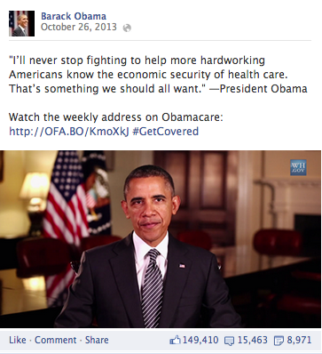
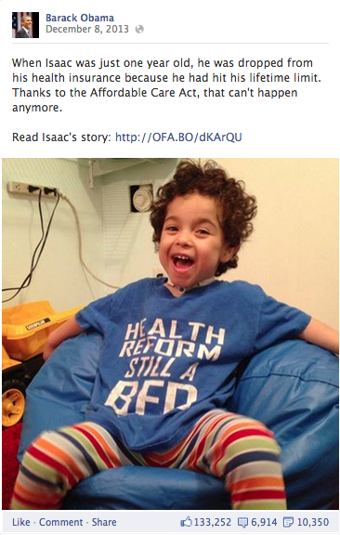

In general, the posts that President Obama has about Healthcare are tweaked to the situation. In December 2013 he was pushing for people to “get covered,” as his Facebook page stated, by January 1st 2014. Then, during the holidays he posted photos of families sitting down at dinner and discussing healthcare. During Halloween he posted a status about how healthcare shouldn’t scare you. There was even a post about Hanukkah where he posted a photo that said “There are 8 chances to talk about health insurance during Hanukkah” (Barack Obama Facebook). There were also a lot of posts similar to the post about Isaac in which families or people who benefit from Obamacare are shown and their stories are told.

Another large policy President Obama attempted to promote via Facebook was gun control. These gun control posts did not show up until after the Sandy Hook Elementary shooting on December 14, 2012. However, after Sandy Hook gun control was mentioned 72 times on Facebook by President Obama, the post that sticks out the most in which he is pushing gun control reform is a post from May 2, 2013. He has a petition link posted with a photo and a status that discusses more than 600,000 Americans signed a petition demanding action of Congress to act on “common-sense gun violence prevention” (Barack Obama Facebook). He even provides his own definition of Kernell’s going public in his photo. It says, “When the American people speak loudly enough, lo and behold, congress listens,” (Barack Obama Facebook). He is blatantly stating what he is trying to do. The more people that sign the petition, the more likely Congress will listen, and eventually act, on “Common-sense gun violence prevention.”

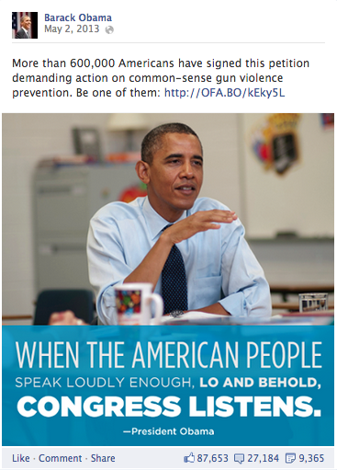
There are also multiple posts where President Obama posts something sympathetic to the families who lost children in the Sandy Hook shooting including one that had a link to his speech online that he gave immediately following the tragic shooting.

Overall, he pushes a lot of different policies on Facebook and he posts on Facebook extremely often. For example in December 2013 he posted 48 times comparatively he only posted four times in his first month in office, January 2009. He also uses Facebook to push his image. He builds a family man image by posting many pictures of him and his wife, kids and even dog, like in this post below from March 15, 2009.
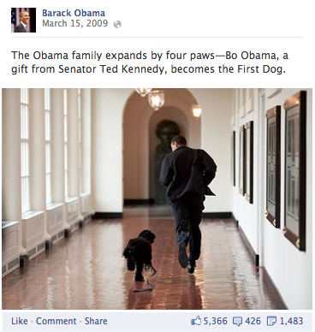

He has posted many photos of him and his family or him and his dog, Bo, similar to above. The family man image is easily built up. Facebook users are used to seeing their other Facebook friends posting photos of their families and President Obama does the same. He feels like a friend already because he is popping up on the newsfeed of a Facebook user, and then he adds regular Joe photos of himself like this one with his dog.
He also builds the Presidential image by posting things like this photo below from September 2009. 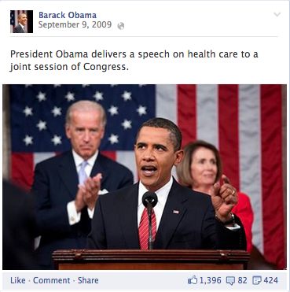
He is seen delivering a speech on health care (one of his main policy pushes on social media and in his presidency). This is something that an average American citizen wouldn’t regularly see unless they are watching CSPAN. By posting photos like this one President Obama builds his man in charge, or presidential image. This is him basically saying, “I’m the guy in charge and I will lead you where we need to go.”

The third and final main image President Obama pushes through Facebook and has throughout his campaign is the “cool guy” image. The cool guy image basically shows the President as just another man on the street or just another cool guy. By creating this image it shows that the President is just a normal person, even though he is the leader of the free world. My favorite photo in analyzing his entire Facebook page has to be the one below. It is President Obama fist bumping a regular guy and the caption reads “bump.” This photo once again builds the friend image as earlier mentioned as well as a cool guy image.

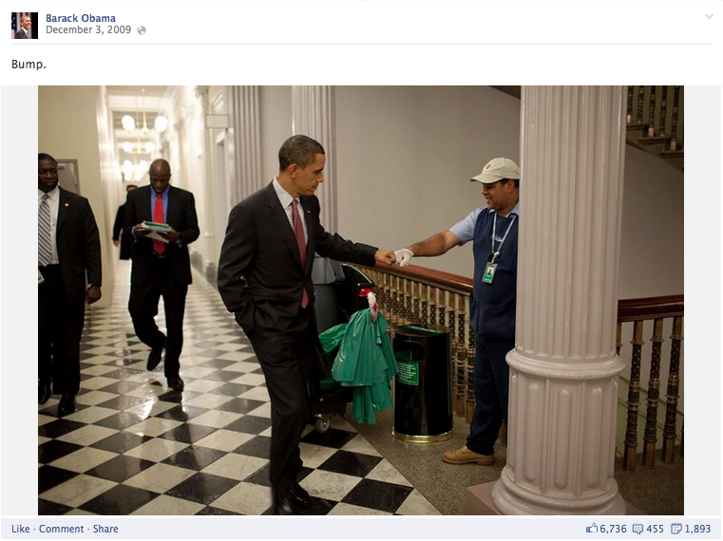
Iran PS | 1
Afghanistan PS | 1
Aiding Other Countries PS | 1
Gun Control PS | 1
Fiscal/economic PS | 1
LGBT Equality PS | 1
Education PS | 1
Official Speeches | 5
General Behind The Scenes | 13
Comedy | 6
Recognition of current events | 3

Obama on YouTube
President Obama technically has two YouTube pages. The first being “Barackobama.com” and the second being “The White House” YouTube Page, the BarackObama.com page is for campaigning and the White House is for Presidential business. The White House page features videos not just from the President. However, President Obama does do a weekly address on that YouTube Channel. I chose to only look at The White House YouTube page because that is what the Obama Presidency uses, rather than candidate Obama.

The thirty most popular YouTube videos, judged by number of views, were chosen and put into the same chart as the Facebook analysis, tweaked just a little. The categories are the same except comedy was added along with official speeches (SOTU, Inaugural address etc.) and Iran Policy Statement instead of Iraq. Table 2 shows the results.

Table 2
*Policy Statement

Similar to how Facebook was organized, YouTube videos can fit into more than one category. That is why the thirty top videos were analyzed and there are more than thirty numbers in the table.

Similar to Facebook, YouTube was used a lot for general behind the scenes look into how the White House operates. This also shows that users want to see behind the scenes action in the White House since thirteen of the thirty most popular videos were behind the scenes

Obama on Twitter
President Obama has almost 11,000 tweets and posts on Twitter a lot more than he does on Facebook, however due to the nature of Twitter that is perfectly okay and is in line with standards of other users of Twitter. In December 2013 he tweeted 191 times. Some of his tweets line up with his Facebook posts but are tweaked ever so slightly to fit into the 140 character limit of Twitter.

Healthcare PS | 105
Immigration PS | 9
Minimum wage/equal gender pay PS | 7
Fiscal/economic PS | 16
LGBT Equality PS | 2
Energy/Climate Change PS | 3
Other PS | 28
General Behind The Scenes | 5
Social Media Tradition | 1
Reference to other media | 118
Recognition of current events | 22
Retweets | 2
Also due to the nature of Twitter I can only see tweets dating back to August of 2013. Therefore, I analyzed the entire month of December 2013. I analyzed the tweets the same as I previously analyzed the President’s Facebook content. However, since I looked at only one month I had more of a narrow view. President Obama tweeted 118 times about healthcare and referenced other media 118 times as well. The results are shown in table 3.

Table 3

The nature of the tweets differs from the nature of the President’s Facebook content. He rarely uses Twitter for a behind the scenes look, but rather uses it more to push policy than to build images. As you can see below, a main use of Twitter for the president is to tweet quotes of what he says during speeches. This allows twitter users who are not watching the speech to still get parts of the speech.
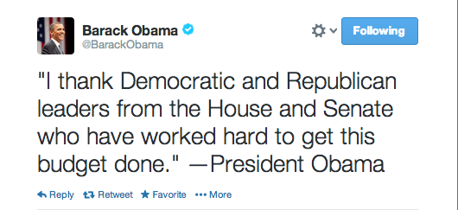
Also, similar to Facebook, the President uses narrative and actually posted Isaac’s story to Twitter. He uses narrative, like Isaac’s, to push his Obamacare policy agenda and also posts videos from his YouTube page about Obamacare. On the next page a photo of the President’s tweet about Isaac’s story. It is somewhat tweaked from the Facebook post.
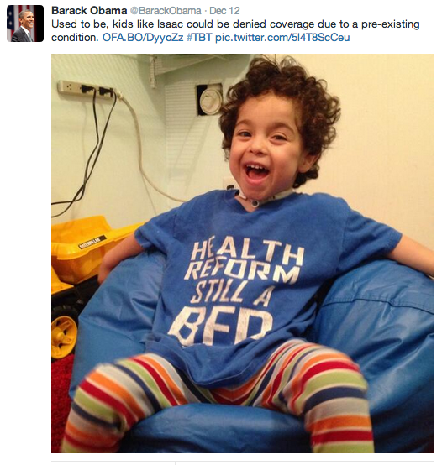
All in all, President Obama tweets a lot, but that is the nature of Twitter. He stays relevant through tweeting and is able to push policy, but he does not push his image as much as he did using Facebook. He also posts a lot less photos on Twitter than he does on Facebook.

Discussion

Social Programs
Franklin Delano Roosevelt discussed his New Deal policies through radio, even putting the new department secretaries on the radio as well. In his fireside chats, FDR would frequently discuss his New Deal policies, he had to rally a nation behind something they had never seen their government do before. He used stories to make the New Deal seem familiar and unthreatening to the American public. He told Americans that the government was partnering with private businesses, rather than taking control of them. FDR faced opposition that called the new deal socialist or communist. He responded with an analogy about the White House in chat number six. The White House was receiving some upgrades and FDR said, “the simplicity and the strength of the structure remain in the face of every modern test,’” (Ryfe 95). He compared the White House upgrades to how the New Deal was upgrading the government. The social programs were helping the government, similar to White House construction, but the US was still a democracy, similar to the White House was still the same structure. FDR pushed a large social program, the New Deal, through the radio airwaves and President Obama is currently doing the same thing through social media, no pun intended.

FDR also used intimate language in his fireside chats, especially when talking about the New Deal. He used intimate gestures like “you and I know,” and “my friends” paired with him talking about topics that were difficult to understand in his New Deal policy (Loviglio 9). He also used the analogy of “the average citizen” when discussing the success of the New Deal.”

President Obama’s big social program is the Affordable Care Act, otherwise dubbed “Obamacare.” The Obama Presidency even took to social media to embrace the name “Obamacare” A tweet from December 4, 2013 reads “’I know people call this law Obamacare, and that’s okay—because I do care.’ –President Obama” (@BarackObama). Like FDR, President Obama uses stories to help push his social policy across as well. His tweet from December 9, 2013 reads “Ray was paying $800/month in premiums and co-payments—now he’s covered thanks to Medicaid expansion in his state” (@BarackObama). Along with that tweet, he also posted a story about “Ray” from the New York Times. Also, on December 8, 2013 he posted a status with a picture of a kid named “Isaac” who was dropped from his health insurance because he went past his lifetime limit (previously shown in the analysis). Now, thanks to Obamacare Isaac can keep his coverage along with a link to “Isaac’s story” (Barack Obama Facebook). These stories are not only narratives, which are critical in Presidential language and used in FDR’s Fireside Chats, but they are narratives of “the average citizen” which is what FDR also used in his Fireside Chats that President Obama uses as well.

Similar to FDR’s new deal, the Affordable Care Act is a social program that is unprecedented in American history. It is something where the public sector is interfering into private business, similar to the New Deal. Therefore, though it is unclear if President Obama using social media to push Obamacare used the precedents of FDR using radio to push the New Deal. It is apparent that Obama and FDR have some communication similarities.

In contrast, FDR did address people’s needs with the implementation of the new deal. However, once WWII begun, he started to use the bully pulpit to guide them in the direction that he wanted and where he thought the country should go. This can somewhat be seen in President Obama’s use of Facebook. When the people need it, he addresses their needs. He believes the people need healthcare and he is addressing those needs. However, once it comes to concepts that he based his candidacy on, like immigration reform, he is starting to guide the people in the direction he wants and feels that the country should do.

Discussion Continued
President Obama has officially set the stage for candidates and Presidents to use social media to their advantage. He uses it in a way that the citizens of the US use it. In a weird way, this is unlike any other form of media that Presidents have used before. For example, a random person in the 1960s could not just make a TV show and go on TV whenever they wanted, neither could someone on the radio in the 30’s. Now, anyone can make a Facebook account and many people had an account before President Obama. While previous presidents have had to follow the rules of network anchors and radio broadcasters, President Obama had to follow the rules of the people who used social media. He encompasses the niches of social media as well by posting things such as “throwback Thursday” photos.

Also, President Obama’s social media team can quickly change subjects from day to day, where as on other medias, a President can only appear so often or else he runs the threat of losing legitimacy. For example, President Obama had four Facebook posts on December 31, 2013 about donating and becoming a member of his organization Organizing for Action and in last week or so of December he posted frequently about OFA. On December 18, 2013 he posted about enrolling in Obamacare and the previous day before that he posted about immigration reform. If FDR came on the radio or Eisenhower on TV three different times in a span of two weeks they wouldn’t be talking about three different topics. They would have to build up to one specific topic and then nail it home, and it is very rare that you see a President on TV or the radio that frequently.

However, social media gives Barack Obama the capability to change subjects quickly and push different policies frequently. Think of social media as President Obama driving a sports car. He can swerve it around corners at eighty miles an hour with no issue whatsoever. President Eisenhower and FDR using their new medias do not have the sports car capabilities. They must slow down and take those corners extremely slow compared to the social media sports car.

A lot of different positions are held on the White house Staff that deal with the Internet and “new media” as the White House puts it. To name a few, R. David Edelman is the Senior Advisor for Internet, Innovation, and Privacy, Leigh Heyman is the Director of New Media Technologies, Jesse Lee is the director of Progressive Media and Online Response and there are a handful of other positions as well. These are positions that are devoted strictly to this new media and giving President Obama what he needs online. These expanded positions are of course being funded by taxpayer dollars.

All of these people in the Presidency working on President Obama’s social media are, in my opinion, doing it effectively. The President Obama page stays relevant throughout the three social media platforms I researched. Also, even before I started researching this paper I had already liked him on Facebook and followed him on Twitter. He popped up in my news feeds regularly. He posted frequently enough on Facebook that it did not seem to be too much in my opinion. He also posted frequently enough on Twitter to stay relevant. Personally I don’t think there is a point of posting too much on Twitter.

I think he is effective overall, but individually his policy and image push that I did research were effective as well. The use of narrative in speeches has been seen since Presidents started giving speeches, it is given that people like to hear real life examples and they connect with them easier. So, President Obama is doing just that with stories about Obamacare through people like Isaac as mentioned earlier in this paper. It’s effective, the smiling little kid catches your eye and reading his story tugs on your emotions, before social media that was spoken by the President at speeches and events. Now, the country sees it on his social media page. We are already used to seeing other narratives on our feeds that one narrative from the President does not seem out of place. He seems like just another social media user.

The use of social media builds our own personal images. So, it is only natural that President Obama builds his own on social media pages. In my opinion, the photos of President Obama with his family effectively builds the family man image. On television we usually do not see President Obama with his family other than sitting next to them at an event or hugging them on stage like he did in Grant Park after winning in 2008. However, seeing him sitting down in the White House watching TV with his daughters lets us see him in a way we usually wouldn’t through other media. Also, Facebook especially gives us a great behind the scenes look at what the President is doing and we see things that we usually couldn’t through other media. The photo of him and a janitor fist bumping builds the “cool guy” image. He also builds on the presidential image by posting photos of him in the Oval Office. He posted one right after he got sworn in. This shows his audience that he’s the man in charge now. It shows thanks for voting for him but it also shows that he is now “the guy.”

Posting photos to build image is what we do as a population on social media without even realizing it. If someone gets a new job, they usually post a photo at their new desk. If someone wins a sports trophy, a photo likely goes up on their social media page. My newsfeeds are full of people’s children, once again building the same family man (or woman) image that President Obama has with photos of him and his children.
Essentially, the President is just trying to be like social media users while secretly advertising himself to the people that like and follow him on social media. He follows the unwritten guidelines of social media to seem like a just another person on a timeline. Social media users set the stage for Barack Obama on social media. However, he has definitely set the stage for Presidencies beyond him.

Limitations
Even thought I absolutely loved researching and writing this paper, it does have some limitations. Facebook was the first social media platform I analyzed and after analyzing and coding over 400 posts I realized that Facebook seemed to be the most important to me and I leaned heavily on it. If I were able to do this again I would love to research YouTube and Twitter a little more and maybe watch YouTube videos and code and analyze those more in depth as well. However, due to time and a full course load on top of this paper I was unable to do that. It would also be interesting to see the demographic of people that like President Obama on Facebook or follow him on Twitter or YouTube. Another thirty-page paper could be written on that and the comments on his Facebook page and tweet responses.

References
@BarackObama. (n.d.). Barack Obama twitter page. Retrieved from
https://twitter.com/BarackObama

Allen, Craig. Eisenhower and the Mass Media: Peace, Prosperity, & Prime-time TV.
Chapel Hill: University of North Carolina, 1993. Print.

Delli Carpini, Michael X. Radio's Political Past. N.p.: University of Pennsylvania, 1993.
Print.

Duggan, Maeve, and Aaron Smith. "Social Media Update 2013." Pew Internet Research
Center (2013): n. pag. Web.

Greengard, Samuel. "The First Internet President." Communications of the ACM 52.2
(2009): 16-18. Print.

Harfoush, Rahaf. Yes We Did: An inside Look at How Social Media Built the Obama
Brand. Berkeley, CA: New Riders, 2009. Print.

Kaplan, Andreas M., and Michael Haenlein. "Users of the World, Unite! The Challenges
and Opportunities of Social Media." Business Horizons 53 (2010): 59-68. Print.

Kernell, Samuel. Going Public: New Strategies of Presidential Leadership. 3rd ed.
Washington D.C.: Congressional Quarterly, 1997. Print.

Loviglio, Jason. Radio's Intimate Public: Network Broadcasting and Mass-Mediated
Democracy. Minneapolis, MN: University of Minnesota, 2005. Print.

Lumeng, Yu (Jenny). "The Great Communicator: How FDR's Radio Speeches Shaped
American History." History Teacher 39.1 (2005): 89-106. Print.

Mackay, Jenn Burleson. “Gadgets, Gismos, and the Web 2.0 Election” Communicator-
in-chief: How Barack Obama Used New Media Technology to Win the White
House. Ed. John Allen. Hendricks and Robert E. Denton. Lanham: Lexington, 2010. 19-35. Print

Merriam-Webster. "Bully Pulpit." Merriam-Webster Dictionary. N.d. Print.

PBS. "Daily Download: Obama Spent 10 Times as Much on Social Media as
Romney."PBS News Hour. PBS, 16 Nov. 2012. Web. 10 Dec. 2013.

Powell, Larry. “Obama and Obama Girl: YouTube, Viral Videos, and the 2008
Presidential Campaign.” Communicator-in-chief: How Barack Obama Used New
Media Technology to Win the White House. Ed. John Allen. Hendricks and Robert E. Denton. Lanham: Lexington, 2010. 83-104. Print

President Obama. "President Obama Facebook Page." Facebook. Facebook, n.d. Web. 4
Jan. 2014.

Ryfe, Dm. "Franklin Roosevelt and the Fireside Chats." Journal of Communication 49.4
(1999): 80-103. Print.

Social Media Today. "Social Media in 2013: By the Numbers." Social Media Stats and
Facts. Social Media Today, 6 Nov. 2013. Web. 15 Nov. 2013.

Solop, Frederic I. ""RT @BarackObama We Just Made History": Twitter and the 2008
Presidential Election." Communicator-in-chief: How Barack Obama Used New Media Technology to Win the White House. Ed. John Allen. Hendricks and Robert E. Denton. Lanham: Lexington, 2010. 37-49. Print.

