Mike Vanovermeir
Politics and Media
Spring 2011
Professor Day
Negative Campaigning: Is it really effective?
Political campaigns have changed significantly from those 60 years ago. The days of listening to the radio for information are gone and television and the internet have taken over. What used to be a behind the curtain operation is now public affair and what is seen on camera is a political actor. Over the years, the tactics these actors use in their political campaigns have shifted from supplying information about policies to supplying information about the opponent’s affair they had back in college. Mudslinging has been around since the first political campaigns, but it hasn’t been as widespread or as influential as it has the past 20 years or so. This research paper will look to address this change in political tactics, but more specifically the effectiveness of the negative campaigning. It will also address why politicians use this technique and what they believe it does. Following this, the paper will reflect upon how negative ads have changed over the last 60 years and the content they discuss. The remaining portion of this paper will discuss some of the most popular negative ads and the reasons for why these ads became so popular. In that, it means to answer the question of whether these became popular because the public liked them or they cause widespread commotion.
Despite the fact that a lot of renowned political scientists have claimed that negative ads don’t work, they are still used during political campaigns; now more than ever. For example, Washington reporters wrote about the issue, stating that, “it seems so far, that negative campaigning just doesn't work” (www.mcclatchydc.com). In fact, in the last presidential election, Hillary Clinton tried using several political attack ads on her rival, to which “the audience booed, critics winced and once again the New York senator's attempt to demonize her rival fell flat” (www.mcclatchydc.com). Furthering the idea that negative ads don’t work is Peter Schramm, the executive director of the Ashbrook Center for Public Affairs in Ohio, who stated that “people are just burned out on that stuff” (www.mcclatchydc.com). Similar information, regarding the ineffectiveness of attack ads, was discovered in a new research study conducted by Kevin Arceneaux of Temple University and David W. Nickerson at the University of Notre Dame. Their study indicated the overall effectiveness of personally delivered-negative ads. “In two very large field experiments conducted during the 2004 election, with a combined 69,000 participants contacted, the researchers found that a negative tone in the message had very little, if any, discernable effects on voter turnout and participation” (www.miller-mccune.com). Their study goes on to explain that:
“there’s strong evidence suggesting that “going negative” in the mass media can be devastatingly successful, but — as this new research illustrates — directly contacting voters with unsavory information can yield mixed results. Unlike being bombarded by negative advertising while passively watching TV, likely voters who are approached on the street or called by phone have to digest and instantly respond to a campaign volunteer who delivers the dour message. Instead of absorbing the information through repetition (like they would with a TV commercial) they have to immediately assess this data and come to a conclusion quickly” (www.miller-mccune.com).

Regardless of the countless situations in which this has happened, political candidates continue to spend tens of millions of dollars on these ads, but how much exactly? “Of total expenditure over all races, Democrats were slightly less negative than Republicans. Democrats were about 55 percent negative while Republicans were about 57 percent negative. In all Republicans spent over 11million dollars on advertising; but, they were out spent by the Democrats. Democrats spent over 15 million dollars on advertising. Of total advertising, 55.8 percent was negative” (More News Coverage). In fact, Table 1 shows the exact percentage of negative ads used during a specific election. In several states, the numbers were almost 50%.
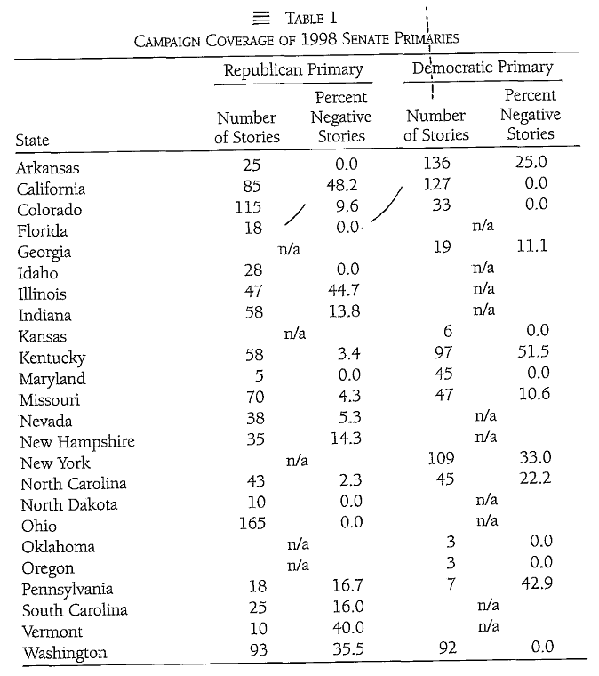
(Impact of Negative Campaigning)
Spending this kind of money indicates that politicians truly believe that negative ads stand to work in their favor; but is this really the case?
“Negative political advertising may achieve its intended effects, but it may also produce boomerang effects. A strong attack on a candidate, if perceived by the audience as untruthful, undocumented, or in any way unjustified, may create more negative feelings toward the sponsor, rather than the target” (Mediating influence on gender). This boomerang effect, which happens more frequently than is populalry believed, is often overlooked in several instances such as family and character accusations. Many candidates exaggerate an opponent’s situation with their family or a situation the opponent faced in the past. Regarding situations like this, a participant survey published by thisnation.com “indicated the following kinds of information should be considered out of bounds: lack of military service, past personal financial problems, actions of a candidate's family members, and past drug or alcohol abuse” (www.thisnation.com). The rebound effect is a danger to all who use negative ads, but it’s still done because they get through to certain audiences.
Manipulation is what allows negative campaigning to work within the various elections. For example:
“seeing a negative advertisement, the audience retains impressions about a certain party or candidate that will affect the way they vote. For instance, in the presidential campaign of 2004, Democrat John Kerry used television ads to imply that Social Security would be endangered if his opponent were elected. These kinds of ads increase people’s consciousness of the vulnerability of their Social Security, and generate a negative feeling toward the person that the ad claims threatened it” (Why Negative Political).
General concensus on the issue amongst experts is that, while American citizens have grown tired of negative political ads, many still become influenced by what they heard. These same groups of people that become influenced by the negative ads are often the people that enjoy the negativity itself. But what about the negativity is it that these audience members look forward to? Because it provides them with the information they were seeking. “Negative ads help inform an uninformed and indifferent public” (Why Negative Political).
What is it about negative campaigning that makes it so attractive for politicians to use? According to various experts, “political campaigns use negative political ads because they are influential, effective, and informative. Influential negative advertisements stay in the minds of voters and either consciously or subconsciously molds the decisions that they make” (Why Negative Political). Other reasons exist as well for why politicians choose to go negative during their campaigns. For example, many political actors feel that negative advertising will get their message more air time than a positive policy message. According to a study by two professors from Denison University and Texas A&M University, “because of media values, campaign strategies, and the quality of candidates in the campaign, negative campaigns receive more coverage. Neither the candidates nor the press are entirely to blame since they feed off one another to create an environment conducive to negative campaigning” (Impact of negative).
According to the Bush Administration, the media focuses too much on conflict. Since negative campaigning invariably causes conflict between two candidates, it’s viable to believe that media sources would cover them more in order to receive more viewers. Backing up this claim is information from a study of news coverage and negative campaigning:
“It appears that negative campaigning is responsible for most of the correlation between news coverage and advertising expenditure. Media are attracted to conflict because conflict represents the point of disagreement in a debate or political campaign. Conflict also directs us to problems in the world that need to be resolved” (More News Coverage).
The information from that study suggests that conflict pushes us towards problems in the world that need to be fixed. If this were the case, the conflict caused by negative campaigning would in fact point out some problems that need to be addressed, making them an effective tool for political campaigns. With this in mind, it becomes completely believable that politicians do in fact use negative advertising to increase their media coverage, which, in turn, gives more information to the people and shines new light on previously unaddressed topics.
The plots shown on the graph on the next page indicate a strong spike in negative advertisement spending and time being broadcasted just before the elections in California in 2000. These plots show a slight increase in negative ad broadcasting from September to October and another small increase throughout the entire month of October. In November, the amount of negative ad expenditures more than quadrupled from the month of September.
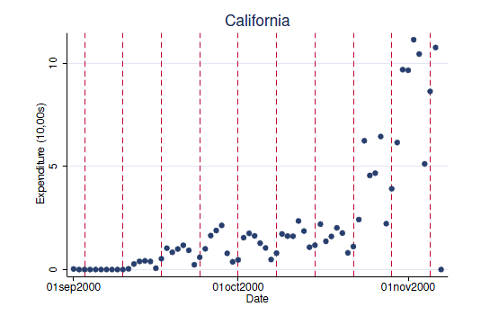
(More News Coverage)
Attack ads have become so personal over the past 60 years. Even though the ads might not come out and explicitly say something, the audience can gather what message the advertisement is trying to convey. “Some negative ads imply opinions or impressions about the opponent, others will simply label the opponent with what they want their audience to believe about them” (Why Negative Political). This is done in such subtle ways that many people believe it is intended to be understood subconsciously. Though it sounds absurd, it wouldn’t be the first time that government workers tried to use subliminal messages.
Today’s ads are far away from the negative ads of the 1950’s, in which one featured a cartoon of a two-headed GOP member, implying that GOP members are two faced and will say one thing but mean another. In the Johnson/Goldwater election, one of the most famous political attack ads that was aired only once is The “Daisy Girl” ad, which showed a little girl pulling apart a flower’s petals, and it ended with a nuclear countdown and an explosion after the girl plucked the last petal. Following this ad was a vote for Johnson tagline with the slogan, “The stakes are too high for you to stay home.” Even though the ad never mentioned Goldwater’s name, it was perceived as negative because of statements that Goldwater had said in the past concerning nuclear war. In 1988, the George Bush campaign captivated audiences with the ad that portrayed Michael Dukakis as a supporter of weekend passes for prisoners. In this commercial, a prisoner named Willie Horton, who is serving a life sentence, received multiple weekend passes, and during one, he raped a woman and killed her husband. This ad was used to show that Bush wouldn’t allow for weekend passes, but Dukakis is soft on crime. Jumping forward now to the George W. Bush/John Kerry election in which the Bush Administration used video footage of John Kerry windsurfing. This ad, which cited numerous accounts of Kerry voting in seemingly opposite directions, portrayed him as only going whichever way the wind blew. The last example occurred during the Obama/Clinton run for the Democratic nomination. In the ad, which is a spoof off of an old Apple Computers commercial, portrays Clinton on a huge television monitor speaking to mindless people when a runner heaves a sledge hammer through the screen, freeing the people from her control. Through all of the years of negative campaigning, there is a clear distinction that can be seen from the 1950’s to the 2008 election (www.press.uchicago.edu). Ads have gotten much harsher, in that, they attack the opponent’s personal faults and often shy away from larger scale problems. Regardless of this, it still remains and will continue to remain one of the most widely used techniques in all of political campaigning.
The timeless political ads mentioned earlier are popular for a reason, but did they gain popularity because people were drawn to them? Or was it because the public was disturbed by them? Understanding why certain ads gained popularity is important to understanding why or why they weren’t effective in the sponsor’s favor. It’s important to break these ads down and evaluate what elements gave them their popularity.
Certain harmless ads, much like those featured in the 1950’s gained popularity mainly because they were catchy, often accompanied by music tunes that the audience could connect with. Simply put, people were drawn to those ads because of the level of innocence they maintained. During the 1960’s with the scare of nuclear war, Johnson’s ad was aimed at the people’s fear in the war and it gained popularity not because people were drawn to it, but because the potential truthfulness of the ad frightened them. The Bush Sr. campaign commercial became popular because it played off of people’s fears as well, just about crime instead of imminent nuclear war. The Bush Jr. campaign commercial in which John Kerry was windsurfing was aimed to be a personal attack against Kerry’s actions as a representative. It gained popularity because it was humorous, made valid points, and exposed some little known facts about Kerry’s past. This was another example of an ad that somewhat connects with its audience like ads from the 1950’s; it appealed to the audience’s humor rather than their fears. The Obama viral ad that was mocked up from an old Apple Computers commercial attempted to appeal to older voters by forcing the recall of the origin of the video. It also played off the fears that electing Clinton would promote further brainwashing of Americans. The strongest message that commercial communicated was that change from the norm was possible. This message appealed to the frustrations that many Americans had with American Politics. Examining how these negative campaign ads rose to popularity brings up the interesting point that most of them are playing off of one fear or another, and were developed to cause a stir with the public. This point goes back to the accusation from George Bush, in which he said the media focuses too much on conflict. Maybe that’s the case. Perhaps that’s why there’s a pattern with negative ads and the general fear of the American society.
“The underlying research question is simple: Do negative advertisements lead voters to like or dislike one candidate more than the other? The answer however has not been so easy to ascertain. Or perhaps the question is not as simple as it appears” (Mediating influence on gender). According to much of the literature discussed in this paper concerning negative ads, while going negative is a risky business for any political campaign, it has still proven to be a moderately effective strategy. The results of negative ads may not always be the ones the sponsor was looking for, but the question to be answered in this paper was whether or not negative campaigns are in fact effective; not necessarily in favor of the sponsor, but overall. Given the fact that these political ads are able to influence the decisions of millions of voters, and the research consensus is inconclusive but leans toward negative ads being effective, it is possible to conclude for the purposes of this paper that negative campaigning is, in fact, effective in swaying voting decisions.

Works Cited
Armstrong, Dan. "Negative Campaign Ads, Do They Work?" Connectmidmichigan. Web. 20 Mar. 2011. <http://www.connectmidmichigan.com/news/story.aspx?id=533383>.

Asay, Garrett. "Does negative campaigning necessarily lead to more news coverage?" Paper presented at the annual meeting of the The Midwest Political Science Association, Palmer House Hilton, Chicago, Illinois, Apr 20, 2006 <Not Available>. 2009-05-25 http://www.allacademic.com/meta/p137060_index.html

Chang, Won Ho, Jae-Jin Park, and Sung Wook Shim. "Effectiveness of Negative Political Advertising." E.W. Scripps School of Journalism. Dec. 1998. Web. 18 Feb. 2011. <http://www.scripps.ohiou.edu/wjmcr/vol02/2-1a-B.htm>.

DJUPE, PAUL A., and DAVID PETERSON. "The Impact of Negative = Campaigning: Evidence from - the 1998 Senatorial Primaries." People.tamu.edu. 3 Nov. 2001. Web. <http://people.tamu.edu/~daveamp/neg1.pdf>.

Geer, John. "Attack Ad Hall of Fame." Www.press.uchicago.edu. 2008. Web. <http://www.press.uchicago.edu/Misc/Chicago/284996.html>.

Hayden, Erik. "Study: Personally Delivered Negative Messages Don't Work." Smart Journalism. Real Solutions. Miller-McCune. Web. 20 Mar. 2011. <http://www.miller-mccune.com/politics/how-negative-campaigning-can-fall-flat-7667/>.

King, J. D. and McConnell, J. B. (2003), The Effect of Negative Campaign Advertising on Vote Choice: The Mediating Influence of Gender. Social Science Quarterly, 84: 843–857. doi: 10.1046/j.0038-4941.2003.08404012.x

Lightman, David. "Why Doesn't Negative Campaigning Work like It Used To? | McClatchy." McClatchy | Homepage. Web. 20 Mar. 2011. <http://www.mcclatchydc.com/2008/02/22/28455/why-doesnt-negative-campaigning.html>.

"Negative Political Advertising Is Necessary." Advertising. Ed. Laura K. Egendorf. San
Diego: Greenhaven Press, 2010. Opposing Viewpoints. Gale Opposing Viewpoints In
Context. Web. 18 Feb. 2011.
"Negative Political Advertising Is Necessary." Advertising. Ed. Laura K. Egendorf. San
Diego: Greenhaven Press, 2006. Opposing Viewpoints. Gale Opposing Viewpoints In
Context. Web. 18 Feb. 2011.
"ThisNation.com--Do Negative Campaign Ads Work?" ThisNation.com-American Government & Politics Online. Web. 18 Feb. 2011.<http://www.thisnation.com/question/031.html>.

"WHY NEGATIVE POLITICAL ADVERTISING WORKS." Www.tyllabradley.com. Web. <http://www.tyllabradley.com/Why%20Negative%20Political%20Advertising%20Works.pdf

