Leah Middagh
Conference Paper
20 April 2018

Introduction
Throughout the 2016 presidential campaign, people were surprised when Donald Trump had decided to seriously make a name for himself in the political world. A reality star and business entrepreneur, Trump became a household name by creating a reputation for being ruthless and money-hungry. He created a legacy name for his family, and was not opposed to creating scandal in his personal life. But still, he succeeded in the primary election and then took the electoral college in November of 2016 to make him the most recent president of our country. All the while, some media held a bias against Trump and definitely let it be known. So with a reputation in dire need of a PR fix and the media as his enemy, it is really a question of how Trump won the entire election.
Donald Trump’s entry in the 2016 presidential election is the latest example of celebrity politics. Other celebrity-turned-politicians include Arnold Schwarzenegger, Fred Gandy, Jesse Ventura, Sonny Bono, Al Franken, and Ronald Reagan. Studies have shown that in the lastest elections, traditional party loyalty has been dying and that the use of celebrities in politics has risen. Usually, people tend to use party as the foremost cue in the voting booth. However, party membership and party loyalty is extremely unstable; people change which party they support even during one election campaign. Party membership tends to be more stable among those who are highly sorted in that their party and ideological preference match: Democrats with a liberal ideology and Republicans with a conservative ideology. But overall, party affiliation has become less stable in recent elections, setting a trend for the future (Allsop & Weisberg, 2015).
However, people also use name recognition and attractiveness of a candidate to help them at the voting booth. Increased familiarity and attractiveness translates to a perceived increase in the candidate’s knowledge, ability, and credibility to the voters. Celebrities are well-known and attractive individuals, so the halo effect states that people would vote for celebrities over politicians on account of likeability, familiarity, and perceived knowledge and ability from their attractiveness.
Because there are so many celebrities now getting involved in politics themselves, the research question of this paper is to determine whether voters use a celebrity candidate as a voting cue. Celebrities encapsulate several minor voting cues (familiarity, likeability, and attractiveness), and so the purpose is to see if all of these voting cues combined have a stronger effect on people’s vote choice when manifested in the celebrity candidate. It is hypothesized that those with extreme partisan and ideological preference will use party to determine their vote choice and will choose political candidates over celebrity ones. However, people who do not belong to a party or do not have extreme ideological preference will vote for the celebrity candidate over a political candidate because the celebrity embodies three voting cues (familiarity, likeability, and attractiveness) while the political candidate only embodies two (perceived party's and the individual candidate’s ability based on past experience in office).

Literature Review
Weng’s (2015) study tested a series of vote models to determine what voting cues individuals use at the voting booth. Many theories have been created to explain voting behavior, but party preference still remains one predictor based on the valence model, along with leader images and partisanship. These three components are what make up the valence politics model, and so, “this model outperformed all other model competitors and provided the best explanation for vote choice not only in mature democracies, but also in Taiwan’s presidential elections,” (as cited in Weng, 2015). The valence model is a model of voting beavior that states people determine their vote by the three components mentioned above. Evaluations of leaders provide voters with information on a specific party’s readiness to take over governing and deliver desirable party outcomes. A second factor that is related to the first is voters’ perceptions on which issues are the most important in an electoral district, and so, which party is best able to handle them based on past performance. The third factor, party identification of voters, plays some sort of role in predicting vote choice, but it is not as strong as a predictor as the other two components. Especially in recent elections and among the younger demographic, party affiliation has become increasingly weak. Therefore because not as many people are loyal to just one party, using party preference as a voting predictor could be extremely unstable.
Jon A. Krosnick (n.d.) proposes a theory of lifelong partisan identity that the valence model does not support. Based on surveys, he argues that the most powerful predictor of a person’s vote choice is his or her political party identification. This identity is stable: a person identifies with a certain party because the party shares his or her preferences on a number of policy issues that the person cares the most about. However, voters’ perceptions of candidates’ personalities provide a second predictor on voting behavior. Candidate personalities, such as their intelligence, knowledge, trustworthiness, and ability to be strong leaders affect people’s assessments of the health of the country, and therefore, how they should vote.
However, Dee Allsop and Herbert F. Weisberg (1998) supported the theory that individual party identification is volatile, even throughout one election campaign. While partisanship was originally viewed as being a long-term factor as Krosnick (n.d.) suggested, research in Europe has led to partisanship as being seen as less long term. In the 1984 presidential election alone, the general results of this study showed that there were more people who favored the Democratic candidate, and therefore supported the Democratic party early on, while there was a shift for the Republican candidate and party in the second half of the campaign. However, more specifically the results show that party identification of voters shifted back and forth between Democrat and Republican throughout the entire election campaign. The researchers believe the cause of the party identification shifts is because of the bandwagon effect, in which people follow what party their peers are members of regardless of their own opinions or beliefs.
Gabor Toka (1998) explains voter loyalty as voters’ willingness to stay with party preferences over time as a function of their value voting, or ideology. Voters are more likely to stick with parties that agree with them on major issues. The effect of values on voter loyalty is independent of status or demographics of voters. Looking at countries with new democracies, Poland, the Czech Republic, Hungary, and Slovakia, it was found that pure structural voting, on the basis of social class, religion, or place of residence, rarely makes a contribution to the stabilization of critical partisan alignments. Except in Poland, there was no direct effect of structural voting on the stability of a party. There are several explanations as to why. Firstly, the European countries studied have fractionalized party systems, in so that many different demographics are members of the same party. Therefore, sizeable groups are not homogenous enough in their party preferences to allow for structural voting. Second, some argue that identity among groups of individuals is weak after decades of communism. Value preferences provide a solid foundation for explaining partisan attachments. Therefore, those with a strong ideology preference that have strong beliefs on certain issues will stay more attached to a party, and therefore, will be more likely to vote for a politician with the same party.
Nicholas Davis and Lilliana Mason’s (2016) thesis furthers Toka’s research on ideology affecting partisan loyalty: if an individual’s partisan and ideological identities match (Republican and conservative or Democratic and liberal), a person is highly sorted and is less likely to cross party-lines when voting. While partisan strength remains a strong predictor of casting a split-ticket vote, sorting gives a more complete picture of how a person’s partisan and ideological identities work together to affect electoral decision-making. Based on the 1972-2012 national elections, the researchers found that split-ticket voting decreases as individuals transition from independent identifiers to strong partisans. This pattern persists across values of sorting: 35% of those with cross-cutting partisan and ideologies cast a split-ticket vote, while only 5% of individuals with the most sorted political identities do so. However, it was found that fully sorted people (extreme ideologies and strong partisans) split their ticket 50% less than those who only identity as strong partisans. The more congruence there is between a person’s partisan and ideological identity, the less likely he or she is to cast a split-ticket vote because of a psychological orientation that prevents association with an out-group. Further, because of this out-group phenomenon, highly-sorted voters will be less likely to vote for celebrities because they are not part of the usual “in-group” seen in politics.
Allsop and Weisberg (1998) attribute the causes of the volatile nature of people’s partisan identities to bandwagon effect and Toka (1998) attributes it to the organizational styles of parties, the level of party fragmentation, and the stability of electoral institutions. Davis and Mason (2016) attempt to answer the question of voter loyalty by attributing it to how well a party’s identity aligns with an individual’s ideological identity.
But because party preference can be unstable, citizens rely on other factors besides party identification to make their voting decision, like name recognition, according to several studies by Cindy D. Kam and Elizabeth J. Zechmeister (2011). In the first experiment, increased presentations of a candidate’s name had significant effects on vote choice and inferred viability. The results show that mere exposure to a candidate induces liking and that subjects make viability inferences based on their familiarity with the candidate, which leads to greater support for the candidate. Therefore, a causal link exists: increased name recognition is proportional to increased vote choice for that candidate. This defines Robert Zajonc’s concept of the mere exposure effect, which is the tendency for people to feel more positive about stimuli to which they have been more exposed (as cited in Kam & Zechmeister, 2011). Diarmiud B. Verrier (2012) demonstrated the mere exposure effect outside the laboratory by studying the Eurovision Song Contest. Acts that viewers had previously seen received more positive feedback than acts that were not previously seen. While there are limitations to this study regarding lack of control variables, a viewing audience of 600 million means the points are based on a very large number of people. No laboratory experiment’s sample size can match the size of the data in Verrier’s study.
Another factor that subliminally affects vote choice is the attractiveness of a candidate. Carl Palmer’s and Rolfe Peterson’s (2016) study using the American National Election Study survey data showed that more attractive individuals are viewed as more knowledgeable, more persuasive, and more likely to be sought out by others for political information. Also, more attractive individuals are more likely to persuade others even if they are relatively uninformed. These findings have implications on how voters view political experts and candidates, because citizens will be more likely to vote for the attractive candidate.
Brad Verhulst, Milton Lodge, and Howard Lavine (2010) directly studied these implications by conducting an experiment that placed a pair of photos of hypothetical Congressional candidates together for subjects to chose which one they would vote for. The results showed that immediate perceptions of attractiveness led to implicit judgements of increased competence. People tend to ascribe a broad range of positive traits to people that they find physically attractive. These automatic judgements are implicit, but powerful: based on the long standing finding that people implicitly believe what is beautiful is good, these judgements create a halo around attractive political candidates that make voters perceive them as more competent.
So people using familiarity and attractiveness as voting cues sets the stage for celebrities to enter the political arena and be considered viable candidates based on perceptions around them. Because of this, the influence of celebrities in the 21st century has extended far beyond the entertainment sector. The industry is going under “mission creep,” to expand the enterprise’s goals (Chong & Berger, 2009). The celebrity industry has expanded to product endorsements and sitting on UN committees to name a few. With the rise of global internet, and the chance more people will see celebrities and become familiar with them, there will be an increasing connection between Hollywood and politics in the USA.
The line dividing Hollywood and Washington has practically disappeared, according to Jennifer Brubaker (2011). Hollywood and politics require similar skills: an ability to communicate with large groups of people, capability to perform, and a knack for navigating fame and power. Ronald Reagan successfully made the switch from actor to President of the United States. Often, it is the actor’s familiarity, developed through the media, that provides the publicity needed to develop and succeed in full-fledged political careers. Darrell West explains the disappearing line between Hollywood and Washington as a result of the post-World War II period’s emergence of television. Before 1960, most people obtained their public affairs information from newspapers and believed print sources to be the most reliable source of information. But ten years later, people turned to television as the most reliable news source. This is advantageous to celebrities because they know how to get around the medium by being photogenic and know how to attract media coverage. Because of the glorification of celebrities, they make great copy in media once they enter the political arena, only further increasing their familiarity with voters.
As society increasingly gratifies celebrities, Feldmann (1999) has suggested that society’s alliances to political parties are decreasing at the same time. Potential candidates no longer have to serve lower offices before running for positions like governors or president. This is a result of citizen cynicism about conventional politicians and the corrupt stereotype that politicians have. Candidates that are famous, able to fundraise or have the wealth for campaigns, able to attract the media, and do not have a corrupt stereotype can enter politics, which uncoincidentally are all the characteristics of celebrities. So not only are do the voting cues of familiarity and attractiveness help celebrities when running for office, but the weakening of traditional parties allows celebrities to garner votes from previously loyal partisan voters.

Methodology
In order to investigate the research question of whether voters use celebrity as a voting cue instead of partisan preference, students at St. Bonaventure University were surveyed. The instrument used included survey items about demographics, ideological preference, party membership, and the amount of news a student consumes. Respondents were then asked to rank their top three candidates from a list of 16. Two different versions of the survey was produced. One survey had the parties of each candidate listed next to their names, while one survey did not, creating two treatment groups for this experiment. An equal number of each survey was given-- the survey with party cues was given to every other subject. The two survey results will then be compared to each other to provide a control. The survey is included in the appendix.
A survey is appropriate for this study because it directly compares the votes of highly-sorted and party loyal individuals versus low-sorted and non-member voters to see which voting cue each group used more.
The research question being addressed is if citizens use celebrity candidates as a voting cue. One hypothesis based on the literature review is that highly-sorted individuals with high party loyalty and ideological preference would use the party of a candidate as a stronger voting cue than non highly-sorted individuals. Furthermore, strong liberals and strong conservatives, compared to moderate and weak liberals and conservatives, should choose their given party’s politician more often than the given party’s celebrity because they are more sorted. Because of the halo effect, if non-sorted individuals rely more on name recognition and attractiveness and use it as a measure of perceptions of viability, reliability, and intelligence, then they should chose the celebrity candidate more than those who are highly-sorted.
185 students were surveyed on the campus during the week of October 23-27, 2017. Surveys were given to the classes of the professors that the researcher had as professors in the Fall 2017 semester, and as well to the classes of the capstone advisor. Surveys were voluntary and were kept anonymous by giving each survey an individual number after collecting from each class.
Each survey asked the subject for their: age; gender; if someone was registered to vote; if they were a registered member of a party; how much news a person consumes per week; what their main source of news was; where they fall on a given ideological spectrum.
These variables are the independent variables. The variables are broken into different categories and coded, which can be found in the Appendix.
Each survey had a list of hypothetical 2020 presidential candidates. Each subject chose their top three candidates. The list of candidates had 4 Democratic politicians, 4 Republican politicians, 4 Democratic celebrities, and 4 Republican celebrities. Celebrities were defined as people who have a common household name and are well known in the modern decade. These included actors, singers, bloggers, athletes, and businessmen. Candidate gender, race, and age was controlled for by selecting the same number of male and female candidates of all races and ages. Each name was selected because each person had mentioned or hinted at running for the 2020 presidential election. The three candidates that subjects chose are the dependent variables and were coded, which is found in the Appendix.
The results of the two versions will be kept separate and used in different cross tabulations that will compare strength of ideology with the subject’s vote choice.
Cross- tabulations comparing ideology, party, gender, vote registration, news consumption, and whether they obtain news from social media to the subject’s first-choice candidate are to be made in order to test these hypotheses:
H1: In a comparison of individuals, those who are more highly sorted are more likely to favor political candidates than will those who are not highly sorted.
H2: In a comparison of individuals, those who have a stronger ideology preference will be more likely to vote for a political candidate than will those who do not have strong ideological preference.
H3: In a comparison of individuals, those who are liberal will be more likely to favor political candidates than will those who are conservative.
H4: In a comparison of individuals, those who are a member of a party will be more likely to vote for a political candidate than those who are not registered to vote.
H5: In a comparison of individuals, those who are registered to vote will be more likely to vote for a political candidate than those who are not registered to vote.
H6: In a comparison of individuals, those who are female will be more likely to vote for a political candidate than will those who are male.
H7: In a comparison of individuals, those who consume the news 5 times or more a week will be more likely to vote for a political candidate than those who do not consume the news more than 5 times a week.
H8: In a comparison of individuals, those who consume their news from social media will be less likely to vote for a political candidate than those who do not consume their news from social media.

Results
Hypothesis 1 Supported When Cues Not Given: Sorted
When given party cues, respondents who were sorted chose politicians 74.3% of the time and celebrities 25.6% of the time. Respondents who were not sorted chose politicians 77.7% of the time and celebrities 22.2% of the time (Table 1). With a chi-square value of 6.12 and a p-value of 0.411, H1 has to be rejected that states that sorted individuals will choose politicians more than unsorted individuals. With a Cramer’s V value of 0.180, this further rejects the hypothesis.

Table 1: How Being Sorted Affects Vote Choice When Given Party Cue
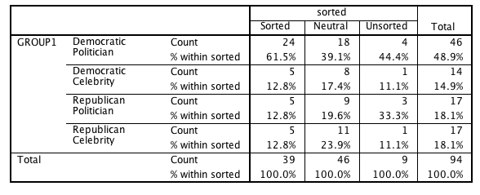
When no party cues were given, however, H1 can be supported. Sorted respondents chose politicians 86.1% of the time and celebrities 13.9% of the time. Unsorted respondents chose politicians 17.6% of the time and celebrities 82.4% of the time. With a chi-square value of 29.304 and a p-value of 0.000, H1 can be supported. There is a moderately strong relationship between the two variables as seen by a Cramer’s V value of 0.408.

Table 2: How Being Sorted Affects Vote Choice When Not Given A Party Cue
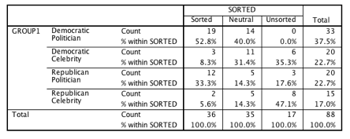

Hypothesis 2 Supported: Ideology Strength
When looking at respondents with high ideological preference, there is a common trend: these respondents will vote for political candidates more often than celebrities. When given a voting cue on their survey, strong and moderate liberals chose Democratic political candidates 84.8% of the time and only chose Democratic celebrities 12.1% of the time. Strong and moderate conservatives chose Republican political candidates 46.2% of the time, but chose Republican celebrities 53.8% of the time. Centers and weak liberals and conservatives voted for celebrities 40.4% of the time.

Table 3: How Ideology Strength Affects Vote Choice When Given Party Cue
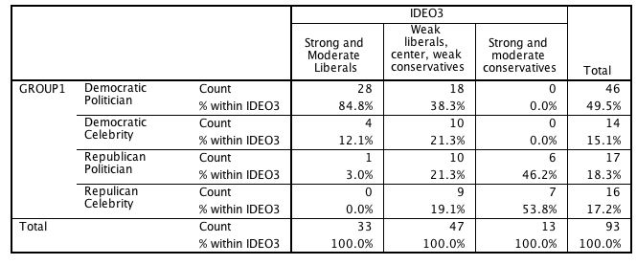

The chi-square value is 45.204 with a p-value of 0.000; the Cramer’s V is 0.493. Because the p-value is less than .05, the results are statistically significant and H2 can be supported: people with higher ideological preference will be more likely to vote for political candidates than celebrity candidates. The relationship between ideological preference and choosing a political candidate is moderately strong.
Just as when there was party cues, people with high ideology preference chose political candidates more than celebrity candidates when there were no party cues. Strong and moderate liberals chose political candidates 60.0% of the time and celebrities 40.0% of the time. Strong and moderate conservatives chose political candidates 68.4% of the time and celebrities 31.6% of the time (Table 4). With a chi-square value of 21.834 and a p-value of 0.001, H2 can be supported. The relationship between ideological strength and whether a person will vote for a political candidate is moderately strong, with a Cramer’s V value of 0.354.

Table 4: How Ideology Strength Affects Vote Choice When Not Given Party Cue
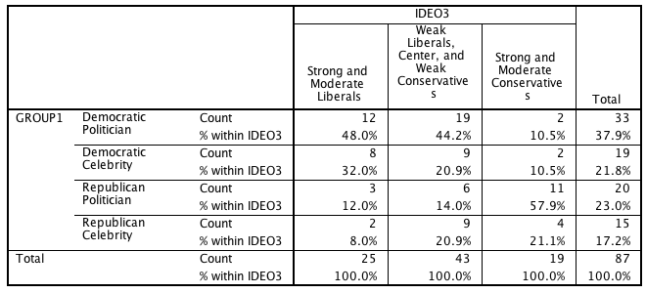

However, the Cramer’s V value when party cues are given is 0.493, and when cues are not given, Cramer’s V is 0.354. Therefore, the correlation is stronger for the group that was given party cues.

Hypothesis 3 Supported: Liberal or Conservative Ideology
Furthermore, people who identify with a liberal ideology chose political candidates more often than people who align with conservative ideology. When given party cues, liberals chose a political candidate 86.1% of the time; conservatives chose political candidates 55% of the time (Table 5). The chi-square value is 55.869, with a p-value of 0.000, and a Cramer’s V value of 0.548, H3 is supported, which states that those with a liberal ideology will be more likely to favor political candidates than those with a conservative ideology.

Table 5: Effect of Liberal or Conservative Ideology on Vote Choice When Given Party Cues
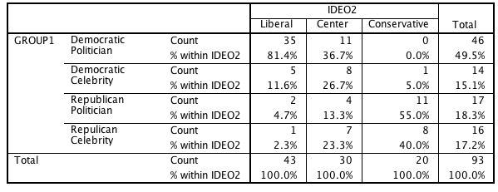

Also when given the survey without party cues, people with a liberal ideology tended to vote for political candidates more than people with a conservative ideology. Liberals chose political candidates 67.7% of the time and celebrities 32.3% of the time. Conservatives chose political candidates 60.8% of the time and celebrities 39.1% of the time (Table 6). With a chi-square value of 21.344 and a p-value of 0.002, H3 can be supported: liberals are more likely to vote for political candidates than conservatives. This relationship is moderately strong, as seen by the Cramer’s V value of 0.350.
The Cramer’s V value when party cues are given is 0.548, and when cues are not given, Cramer’s V is 0.350. Therefore, the correlation is stronger for the group that was given party cues.

Table 6: Effect of Liberal or Conservative Ideology on Vote Choice When Not Given Party Cues
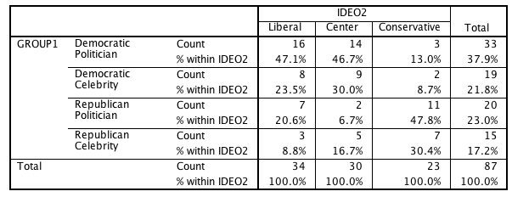

Hypothesis 4 Rejected: Party Membership

However, party membership does not determine whether people will vote for political candidates over celebrity candidates. When given the survey with party cues, people who are members of a party chose political candidates 73.5% of the time; they chose celebrity candidates 26.5% of the time. People who are not registered to a party chose political candidates 60.0% of the time; they chose celebrity candidates 40.0% of the time (Table 7). The pearson chi-square value is 2.099 with a p-value of 0.552. Cramer’s V has a value of 0.149. Because the p-value is more than 0.05, H4 cannot be supported, stating that those who are members of a party will favor political candidates more than those who are not members of a party. This rejection of the hypothesis is further supported by the Cramer’s V showing a weak relationship between the two variables.

Table 7: Effect of Party Membership on Vote Choice When Given Party Cues
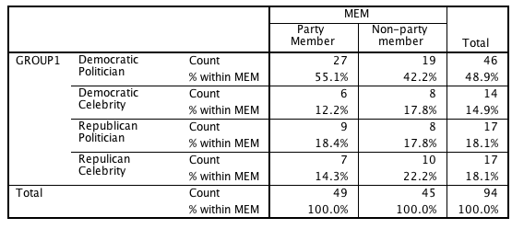

This was also true when respondents were not given party cues. People who are members of a party chose political candidates 60.0% of the time; they chose celebrity candidates 40.0% of the time. People who are not registered to a party chose political candidates 62.2% of the time; they chose celebrity candidates 37.8% of the time (Table 8). The pearson chi-square value is 4.716 with a p-value of 0.194. Cramer’s V has a value of 0.229. Because the p-value is more than 0.05, H4 cannot be supported. However, the Cramer’s V is showing a moderate relationship between the two variables.

Table 8: Effect of Party Membership on Vote Choice When Not Given Party Cues
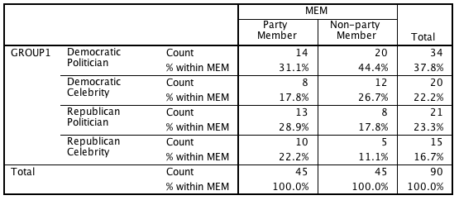

Hypothesis 5 Supported When Cues Not Given: Registered to Vote

When given party cues, registered voters as a whole barely chose political candidates more than non-registered voters. Registered voters chose political candidates 71.6% of the time and chose celebrity candidates 28.3% of the time. Non-registered voters chose political candidates 61.3% of the time and chose celebrities 38.7% of the time (Table 9). The chi-square value is 7.039, with a p-value of 0.071 and a Cramer’s V value of 0.278. H5 cannot be supported, which stated that those who are registered to vote will be more likely to chose political candidates than those who are not registered to vote.

Table 9: Effect of Being Registered to Vote on Vote Choice When Given Party Cues
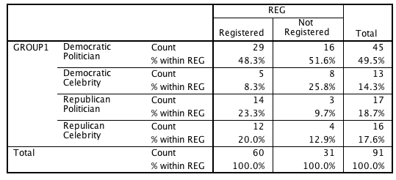

However, when not given party cues, registered voters chose political candidates more than non-registered voters. Registered voters chose political candidates 69.0% of the time and chose celebrity candidates 31.1% of the time. Non-registered voters chose political candidates 45.2% of the time and chose celebrities 54.8% of the time (Table 10). With a chi-square value of 11.063, a p-value of 0.05, and a Cramer’s V value of 0.353, H5 can be supported: registered voters are more likely to vote for political candidates than non-registered voters. This relationship is moderately strong.

Table 10: Effect of Being Registered to Vote on Vote Choice When Not Given Party Cues
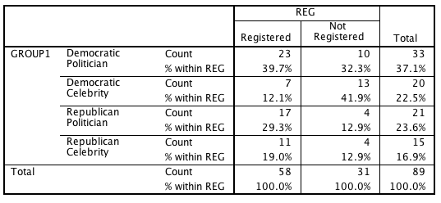
Hypothesis 6 Supported When Cues Not Given: Gender
Females did not vote for political candidates more than males when given party cues. Females chose political candidates 73.1% of the time and celebrities 26.9% of the time. Males chose political candidates 58.5% of the time and celebrities 41.4% (Table 11). The chi-square value is 3.779 and the p-value is 0.286. H6 has to be rejected that states that females will be more likely to choose a political candidate than those who are males. However, the Cramer’s V value is 0.202, suggesting a moderate relationship between gender and voting cues.

Table 11: Effect of Gender on Vote Choice When Given Party Cues
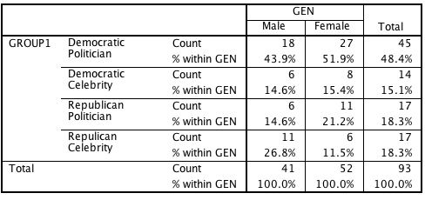

Gender did, however, significantly affect whether a person votes for a political or celebrity candidate when party cues were not given. Females chose political candidates 65.9% of the time and celebrities 34.0% of the time. Males chose political candidates and celebrities 55.8% of the time (Table 12). Because the chi-square value is 9.333, the p-value is 0.025, and the Cramer’s V is 0.322, H6 can be supported.

Table 12: Effect of Gender on Vote Choice When Party Cues Are Not Given
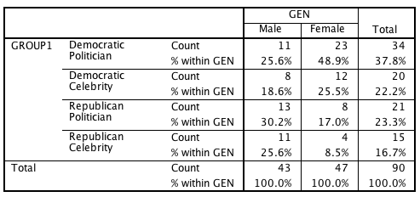

Hypothesis 7 Supported When Cues Not Given: News Consumption
From the surveys with party cues, the amount of news a person consumes did not have a statistically significant effect on whether they chose a political or celebrity candidate (Table 13). With a chi-square value of 12.570 and a p-value of 0.183, H7 cannot be supported which states that those who consume the news 5 times or more a week will be more likely to vote for a political candidate than those who do not consume the news more than 5 times a week. However, there is a moderate relationship between news consumption and voting cues with a Cramer’s V value of 0.213.

Table 13: The Effect of News Consumption on Vote Choice When Party Cues Are Given
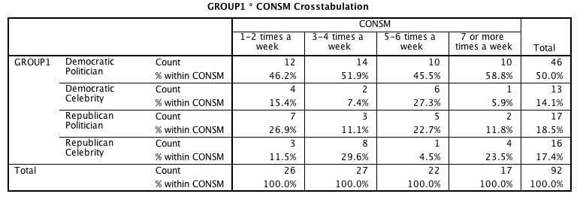

Howver, the amount of news a person consumed when party cues were not given produced a result that was statistically significant on whether respondents were more likely to vote for a political or celebrity candidate (Table 14). With a chi-square value of 17.096, a p-value of 0.047, and a Cramer’s V value of 0.252, H7 is supported that news consumption affects vote choice.

Table 14: The Effect of News Consumption on Vote Choice When Party Cues Are Not Given
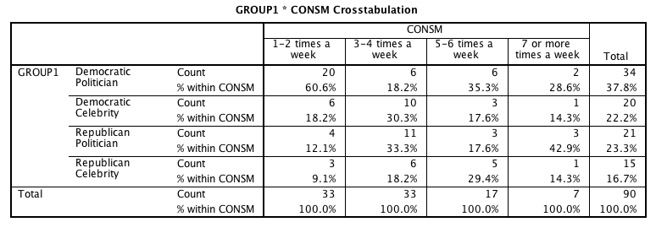
Hypothesis 8 Rejected: News Platform
When party cues were given, the news platform that people obtain their news from did not affect whether people vote for political or celebrity candidates. People who did not use social media as their news platform chose politicians more (77.8%) than those that used social media as their news (56.3%). With a chi-square value of 10.259 and a p-value of 0.330. Therefore, H8 cannot be supported, which states that those who consume their news from social media will be less likely to vote for a political candidate than those who do not consume their news from social media (Table 15).

Table 15: The Effect of News Source On Vote Choice When Party Cues Are Given
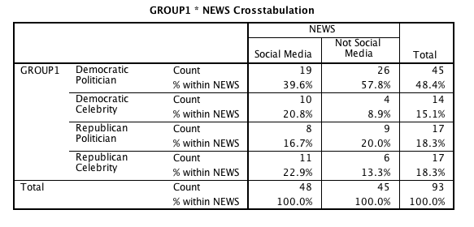
When not given party cues, people who obtained news from social media chose political candidates 52.3% of the time and celebrities 47.7% of the time. People who obtained news from television, the newspaper, or other sources that were not social media, chose political candidates 69.6% and celebrities 30.4% of the time (Table 16). Because the chi-square value is 4.712 and the p-value is 0.194, H8 cannot be supported: the platform of news where people obtained their information did not affect if people would vote for a political or celebrity candidate. This weak relationship was further supported by a low Cramer’s V value of 0.229.

Table 16: Effect of News Platform on Vote Choice When No Party Cues Are Given
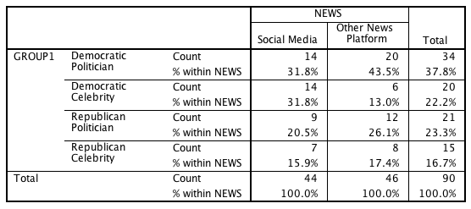

Discussion
The purpose of this study was to examine if voters use celebrity status as a voting cue. The study looked at different candidates of all backgrounds, including active political office-holders at all levels and parties and sport athletes, actors, and prominent businessman. All celebrities had a household name to ensure that they are in fact celebrities or of equal status. Respondents answered demographical questions and reported their top three vote choices of who they would vote for in a hypothetical election between the given 20 candidates. Statistical analysis was then done with several independent variables and how they affected the subject’s first vote choice.
H2 and H3 were supported both with party cues and without party cues. H4 and H8 were rejected with both versions of the survey.
H1, H5, H6, and H7 had statistically significant results when the survey did not have a party cue but not significant results when a cue was given. The reasoning behind this difference is complex, and claims offering insight into these complexities have not been established. One hypothesis is that sorted, registered voters and voters who consume more news could be more informed than unsorted, non-registered voters who only consume little news, and thus, the previous do not need the party cues as much. This result also be because of a small sampling size, with 90 surveys given with no cues and 95 surveys given with cues. There could have not been enough cases to accurately test the variable, and so these results had occurred because of chance and sampling error.

Ideology Strength and Sorted Voters
The ideology strength variable was supported by the research in so that those with a stronger ideological preference chose a traditional politician over a celebrity candidate. Therefore, those with little or no ideological preference will choose a celerity over a politician. Highly-sorted people will be more likely to stay loyal to a party that supports their ideological values. But people without preference on different issues leave their vote open. In turn, they are not as active in politics and getting to know different candidates and their stance on issues. Because they do not vote on the issues, people with a weaker ideology preference vote with their heart, rather than their mind. When unsorted respondents see a name of a candidate that they are especially familiar with, they are immediately drawn in, as defined by the halo effect.

Registered Voters
When people go to the ballot box, most people vote along party lines rather than for a specific candidate. Most individual candidates are not known by name, which helps to explain the voting differences between surveys with party cues and surveys without voting cues. Joshua Tucker states that people default to party lines when voting because they usually have not heard of the individual candidates (as cited in Zarelli, 2016). This supports the results from the surveys with no party cues that when respondents are registered to vote, they voted for politicians more than celebrities. It can be assumed that these respondents are more educated than those who are not registered, and so, they could identify politicians within their own party and defaulted to party lines when choosing their top candidate, as suggested by the valence model in the literature review.

News Consumption
Celebrities are not that far out of political realm as it seems. Many politicians often have celebrity endorsements for their campaigns. Politicians know that they are not a common household name but celebrities are. Voters will believe they know what a certain celebrity stands for because he or she is familiar with and in favor of that celebrity. Thus, if a familiar celebrity is supporting a specific politician, voters believe the politician’s values must be similar to the celebrity’s if that celebrity is endorsing them. Celebrities become trusted guides to individuals when deciding on what politician to vote for. Viewing a politician through mediums like entertainers and celebrities changes voters’ perceptions of politicians and lessens their corrupt stereotype. It can be argued respondents who consume less news were not familiar with the politicians’ names and therefore chose celebrity candidates, unlike the respondents who consume more news and did not use the celebrity choices as their guide because they recognized the politicians.
The campaign process takes a different route for celebrities than it does for politicians. Candidates usually make their political involvement be known in campaigns to establish credence and credibility. But in the case of Trump, his lack of political involvement and his outsider status was an advantage for him. Increasingly, more Americans are seeing politicians as corrupt individuals who are not running the country correctly. In 2015, 75% of Americans perceived widespread corruption in the American government. This increasing trend has been stable since 2010 (“75% in US”). Celebrities are viewed much less negatively than politicians are, which can help explain why so many citizens are drawn into outsiders in a campaign race.
Those who are less informed about the different campaigns rely on the negative political stereotypes as a shortcut on how they should cast their vote- they will chose celebrities with a supposed better reputation than politician, explaining why those who are not registered to vote will chose celebrity candidates over politicians. But those who are registered to vote have to be interested in politics to some extent and will actively seek out information about politicians instead of relying on stereotypes. They become more educated about individual politicians and feel more connected as they dispel stereotypes, leading them to choose politicians over celebrities.

Overall
There are benefits of being a celebrity of going into politics, but that does not always guarantee a success. As the surveys have shown, people with a strong ideological preference remain loyal to candidates they know will have the same stance on important issues they share. Celebrities are much less predictable, which is not a marketable quality to registered party members or people with strong ideologies. Also eventually, politicians will become more center in their platform once campaign races are between parties, rather than during primaries when the races are between contenders of the same party, to garner a broader number voters who are not as loyal to parties or do not have a strong stance on issues. Celebrities cannot do this because then they lose the eccentric qualities that make them a celebrity in the first place. Most people know a celebrity’s stance pretty well, and if celebrities moderated their ideas, most would see this as going back on word to collect more votes.

Conclusion
Therefore, being a traditional politician or celebrity has advantages and disadvantages that lead to certain voters supporting different kinds of candidates. Because voters with strong ideologies and party members have strict values, they will vote for candidates that share these values as well. Whether they know certain candidates with the same stances or default to party lines, either cue will lead to voting for a candidate who will support these values. Because people with weak or moderate ideologies and those who are not members of a party do not have strict values, they will not necessarily default to voting party lines at an election, like most researchers suggest. It does not make sense that a person with no membership to a party would default back on party lines; the surveys have supported previous literature that the importance of party membership is decreasing, as most respondents were not members of a party. As the halo effect suggested, these respondents defaulted their choice on familiarity and likeability. Therefore, these voters will vote for celebrities because of their unusually positive stereotype despite scandals and political inexperience because they do not have the party voting cue to fall back on. However, solidify the results of this experiment, futher research with a bigger sample size is needed on the variables that were significant with one version of the survey and not the other.

Appendix
Instrument
1. Age: _____
2. Gender: _____
3. Are you registered to vote? Y or N
4. Please circle where you fall on this ideological spectrum.
Strong Liberal
Moderate Liberal
Weak Liberal
Center
Weak Conservative
Moderate Conservative
Strong Conservative

5. Do you identify with a particular political party? Y or N

6. If you do identify with a party, what party do you identify yourself with? ­­­________________

7. On the average week, how much news do you consume?
1-2 times per week 3-4 times 5-6 times 7 or more times

8. What is your main outlet you obtain your news from? ­­­____________
Here is a list of people who mentioned they might run in the 2020 presidential election:
Gavin Newsom (D): He is the current lieutenant governor of California.
Mark Cuban (R): The billionaire businessman is a star on Shark Tank and is the owner of the NBA Dallas Mavericks.
Kamala Harris (D): The former California attorney general has now been a U.S. Senator for four months.
Ann Coulter (R): Sometimes referred to as an “internet queen,” she is a political and social commentator, writer, and lawyer.
Sherrod Brown (D): He is a U.S. Senator from Ohio, and was previously a member of the Ohio House of Representatives.
Kanye West (D): Rapper, record producer, and fashion designer who was one of the first people to declare his potential candidacy in 2015.
Dwayne Johnson (R): The wrestler and star of the “Fast and the Furious” film franchise has flirted with running for office.
Kristen Gillibrand (D): She is a U.S. Senator from New York and served for two years in the U.S. House of
Representatives.
Katy Perry (D): Singer and songwriter who made strong political endorsements in 2016.
Nikki Hailey (R): Current U.S. Ambassador to the United Nations. From 2011 to 2017, she was the governor of South Carolina.
Tulsi Gabbard (D): Serving as a U.S. Representative for Hawaii since 2013, she is the first Hindu member of Congress.
Jeff Flake (R): The Arizona senator wrote a book criticizing the chaos created by Trump and scolded his own party for going along with it.
Oprah Winfrey (D): She is a talk show host of her own show and a philanthropist.
Sheryl Sandberg (R): Facebook COO who drew praise for her book “Lean In,” which discusses women in the workforce.
Scott Walker (R): Current governor of Wisconsin.
Hilary Duff (R): Actress and singer best known for her role on Disney Channel’s Lizzie McGuire.
Out of these potential “candidates,” please choose the top 3 you would vote for – in order of preference, with (1) being the most preferred.

Code Book

- Case Number (CASE)
- Cue (CUE)
  - 1. No cue
  - 2. Cue
- Age: nominal (AGE)
- Gender (GEN)
  - 1: Male
  - 2: Female
  - 3: Other/ TBD
- Registered (REG)
  - 1. Yes
  - 2. No
- Ideological Spectrum (IDEO)
  - 1. Strong Liberal
  - 2. Moderate Liberal
  - 3. Weak Liberal
  - 4. Center
  - 5. Weak Conservative
  - 6. Moderate Conservative
  - 7. Strong Conservative
- (IDEO2)
  - 1. Liberal
  - 2. Center
  - 3. Conservative
- (IDEO3)
  - 1. Strong and moderate liberals
  - 2. Weak liberals, center, weak conservatives
  - 3. Strong and moderate conservatives
- Identify with Party (MEM)
  - 1. Yes
  - 2. No
- Parties (PART)
  - 1. Democrat
  - 2. Republican
  - 3. Other
- News Consumption (CONSM)
  - 1. 1-2 times per week
  - 2. 3-4 times per week
  - 3. 5-6 times per week
  - 4. 7 or more times
- Main News Outlet (NEWS)
  - 1. Social Media
  - 2. Other
- SORTED
  - 1. Sorted
  - 2. Neutral
  - 3. Unsorted
- Candidates (CAND1, CAND2, CAND3)
  - 1. Gavin Newsom
  - 2. Mark Cuban
  - 3. Kamala Harris
  - 4. Ann Coulter
  - 5. Sherrod Brown
  - 6. Kanye West
  - 7. Dwayne Johnson
  - 8. Kristen Gillibrand
  - 9. Katy Perry
  - 10. Nikki Hailey
  - 11. Tulsi Gabbard
  - 12. Jeff Flake
  - 13. Oprah Winfrey
  - 14. Sheryl Sandberg
  - 15. Scott Walker
  - 16. Hilary Duff
- Groups (GROUP1, GROUP2, GROUP3)
  - 1. Democratic Politician
  - 2. Democratic Celebrity
  - 3. Republican Politician
  - 4. Republican Celebrity

Bibliography
Allsop, Dee, and Herbert F. Weisberg. "Measuring Change in Party Identification in an Election Campaign." American Journal of Political Science 32, no. 4 (November 1998): 996-1017. http://www.jstor.org/stable/2111198.

Brubaker, Jennifer. "It doesn’t affect my vote: Third-person effects of Celebrity Endorsements on College Voters in the 2004 and 2008 Presidential Elections." American Communication Journal 13, no. 2 (Summer 2011): 4-22. Accessed September 6, 2017. http://ac-journal.org/journal/pubs/2011/summer/brubaker_Proof.pdf.

Choi, Chong, and Ron Berger. "Ethics of Celebrities and Their Increasing Influence in 21st Century Society." Journal of Business Ethics, 2009, 313-18. http://www.jstor.org/stable/27749800?Search=yes&resultItemClick=true&&searchUri=%2Faction%2FdoBasicSearch%3Fswp%3Don%26amp%3Bso%3Drel%26amp%3Bfc%3Doff%26amp%3Bprq%3DEthics%2Bof%2BCelebrities%2Band%2BTheir%2BIncreasing%2BInfluence%2Bin%2B21st%2BCentury%2BSociety%26amp%3Bwc%3Don%26amp%3Bhp%3D25%26amp%3BQuery%3D%26amp%3Bacc%3Don&refreqid=search%3Af42d4689dcbd3f96b9ad054431759b66&seq=1#page_scan_tab_contents.

Davis, Nicholas, and Lilliana Mason. "Sorting and the Split-Ticket: Evidence from Presidential and Subpresidential Elections." Political Behavior 38, no. 1 (June 2016): 337-54. http://eds.a.ebscohost.com/ehost/detail/detail?vid=14&sid=cd589e3e-6ed7-4dd4-ac05-8fc19d005b8b%40sessionmgr4007&bdata=JnNpdGU9ZWhvc3QtbGl2ZQ%3d%3d#AN=114816327&db=a9h.

Hagen, Lisa. "The 43 people who might run against Trump in 2020." TheHill, May 8, 2017. Accessed September 21, 2017. http://thehill.com/homenews/campaign/332156-the-43-people-who-might-run-against-trump-in-2020.

Kam, Cindy, and Elizabeth J. Zechmeister. "Name Recognition and Candidate Support." Paper presented at Princeton University, April 28, 2011.

Krosnick, Jon A. "The Psychology of Voting." Stanford. Accessed September 6, 2017. https://pprg.stanford.edu/wp-content/uploads/10-The-psychology-of-voting.pdf.

Palmer, Carl L., and Rolfe D. Peterson. "Halo Effects and the Attractiveness Premium in Perceptions of Political Expertise." American Politics Research 44, no. 2 (March 2016): 353-82. http://eds.b.ebscohost.com/ehost/detail/detail?vid=5&sid=f61ec050-e4a8-4b09-a359-03dce1b33635%40sessionmgr104&bdata=JnNpdGU9ZWhvc3QtbGl2ZQ%3d%3d#AN=112916362&db=a9h.

"75% in U.S. See Widespread Government Corruption." Gallup. Last modified September 19, 2015. Accessed November 8, 2017. http://news.gallup.com/poll/185759/widespread-government-corruption.aspx.

Toka, Gabor. "Party appeals and voter loyalty in new democracies." Political Studies 46, no. 3 (September 1998). http://Party appeals and voter loyalty in new democracies.

Um, Nam-Hyun. "Effectiveness of Celebrity Endorsement of a Political Candidate Among Young Voters." Social Behavior & Personality 45, no. 9 (2017). http://search.ebscohost.com/login.aspx?direct=true&db=a9h&AN=125672403&site=ehost-live.

Verhulst, Brad, Milton Lodge, and Howard Lavine. "The Attractiveness Halo: Why Some Candidates are Perceived More Favorably than Others." Journal of Nonverbal Behavior 34, no. 2 (June 2010): 111-17. http://eds.b.ebscohost.com/ehost/detail/detail?vid=7&sid=f61ec050-e4a8-4b09-a359-03dce1b33635%40sessionmgr104&bdata=JnNpdGU9ZWhvc3QtbGl2ZQ%3d%3d#AN=50329162&db=a9h.

Verrier, Diarmiud B. "Evidence for the Influence of the Mere-Exposure Effect on Voting in the Eurovision Song Contest." Judgment and Decision Making 7, no. 5 (September 2012): 639-43. Accessed September 5, 2017. http://journal.sjdm.org/12/12327a/jdm12327a.pdf.

Weng, Lu-Chung. "Contextual Effects on Individual Voting Behavior: The Case of Taiwan." Asian Journal of Political Science 23, no. 3 (December 1, 2015): 321-45. http://eds.a.ebscohost.com/ehost/detail/detail?vid=4&sid=27dd4291-368d-459a-be91-e665ff09d09b%40sessionmgr4010&bdata=JnNpdGU9ZWhvc3QtbGl2ZQ%3d%3d#AN=111555342&db=a9h.

West, Darrell M., and John M. Orman. Celebrity Politics. N.p.: Prentice Hall, 2003.

Zarrelli, Natalie. "Why Americans Consider Celebrities for Political Office." Atlas. Last modified November 10, 2016. Accessed November 6, 2017. https://www.atlasobscura.com/articles/trumps-celebrity-past-may-have-been-his-biggest-political-advantage.

