Suffolk University
Government Department

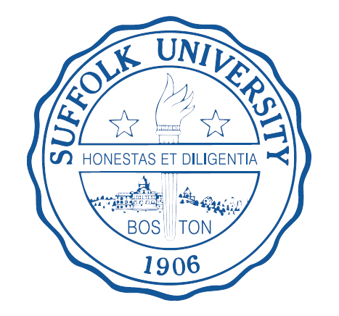
DEMOCRATIC VARIATION IN AFRICA: THE ROLE OF MODERNIZATION AND EMANCIPATIVE VALUES

Mark Bradshaw
Jessica Shirazi
Theory and Practice of International Relations
Professor Dominguez

ABSTRACT
This study explains the variety of political regimes throughout Africa since the collapse of the Colonial system and the subsequent emergence of newly independent states. Specifically, it seeks to explain the conditions under which democratic practices are impeded by highlighting the variance in regime types in the Africa by applying the corollary of the mass mobilizing tendency model to the cases of Nigeria, South Africa, and Sierra Leone during the third wave of democracy in the 1990s. While past literature on the erosion of democracy in post-colonial states has placed blame upon external sources, such as the economic and cultural impact of colonialism (i.e. underdevelopment and indirect administrative rule, or the resource curse in attempting to ascertain the troubled path of democracy—these accounts do not explain the emergence of a spectrum of democratic regimes throughout Africa. Instead, this study will attempt to illustrate the importance of internal actors in the course of political change in African states, and will attempt to account for the variation in qualities of democracy by measuring the level of Capability and Will (modernization and emancipative values, respectively) in the cases of Nigeria, South Africa, and Sierra Leone. By analyzing the effects of capability and will of the masses, a mass mobilization tendency model can illustrate a successful path to democracy. Also, by using three former British colonies as case studies, this study will examine the relationship between British colonial rule, and the indicating trends produced by the three case studies in their paths to democracy. The paper then attempts to illustrate the slight, but measurable proportional relationship between the independent and dependent variables indicating that capacity and emancipative beliefs are necessary for successful alteration of the domestic balance of power, and thus the establishment of a legitimate and sustainable democratic regime.
INTRODUCTION
To date, the third wave of democratization, as termed by Samuel P. Huntington in his seminal book The Third Wave, has brought more than 60 countries around the world from authoritarian rule toward some kind of democratic regime (Schleder, 91). The standards of the Polity IV Index indicate a jump from 44 to 93 democracies from 1985 to 2005, halving the number of authoritarian regimes (Haerpfer et al., 1). While in 1900, not a single country was democratic by today’s standards; a hundred years later, 119 states met the minimalist requirements of democratic practice (Zakaria, 13).
Autocracies
The spread of democracy as an institution has consolidate the boundaries of politics, economics, and social life. In any debate today about democratization, we must be clear about concept of democracy. Zakaria also conveys the critical distinction between political democracy and liberal democracy in his introductory chapter (2005, 13-27). According to Zakaria, political democracy simply means “rule of the people”. Its only requirement is to have open and fair elections to elect government officials and leaders- nothing more. Political democracy, therefore, does not imply benign or fair governance. It does not ensure the protection of individual liberties, and can in fact lead to the elections of “racists, fascists, [and] separatists,” (Zakaria 17-19). “After all” he notes, “Hitler became chancellor of Germany via free elections.”
Democracies
It is the goal of this paper to illustrate theory that is able to account for the variety of democracies across the globe. It must account for the conditions of democratic transition and how they affect prospects for democratic consolidation. Christian Welzel, Professor of Political Science at Jacobs University in Bremen, Germany, admits that although the emergence, deepening, and survival of democracy are distinct aspect of democratization, they tend to merge with regard to sustainable democratization- it is then important to “theorize about how different factors interplay in the making of democracy,” (Welzel, 75). Only by understanding the way in which certain structural conditions have limited the options and decision of leadership during critical junctures during the democratic transition can one truly grasp the reason for failure or success of the sustainment of that democracy. By examining three case studies, all of which are former British colonies, this study will illustrate theory that is able to account for the variety of democracies across the globe, examine their individual paths to democracy, while at the same time examining the relationship between British Colonial Rule and the tendencies that have arisen during democratic consolidation of the three cases provided.
LITERATURE REVIEW
While some scholars argue that the theoretical insights derived from one area of the globe can and should be applied to the study of democracies in another; other academics insist that a genuine understanding of how and why democracies have been established, and their potential trajectories, must be based on a deep understanding of the culture and history of the particular geographical area in question. For example, are the theoretical insights of Guillermo A O’Donnell- and his study of democratic transition and consolidation in Latin America- applicable or, better yet, useful to understand the relative failures of democratic consolidation in some African States?
Since the 1986 work Transitions from Authoritarian Rule, by Guillermo O’Donnell, researchers have proposed a number of causal factors to explain the origin and sustainability of democracies since 1974. They include the impact of class actors, the role of the military, external intervention, economic development, demographics, political culture, education, inequality, the role of institutions, Islam’s incompatibility with democracy, and international systemic pressures. While some of these theories claim to be universal in scope, others claim to be case specific.
COLONIAL LEGACY
The colonial era may have been relatively short, but it had a gigantic impact on politics throughout the world. Colonial rule left the African continent with quite a terrible inheritance. Some key elements to colonial inheritance are: the incorporation of Africa into the international modern state structure, the imposition of arbitrary boundaries, weak link between state and civil society, and the promotion of an African elite.
Much scholarly work has been done on the affects of colonialism on the African continent. These works include Alex Thomson and his basic textbook entitled An Introduction to African Politics. His work provides a basic understanding of colonial rule and the affects that came with it.
The more prominent work on the subject can be pointed to Walter Rodney and his booked entitled How Europe Underdeveloped Africa. This book became a mainstay in political thought and has influenced many in the study of democratization in Africa. Economic underdevelopment, the dangers of indirect rule and the creation of non-hegemonic states are the three main independent variables that must be looked at when considering the affect of colonial legacy on African democratization.
EXTERNAL DEMOCRATIZATION:
Perhaps the most convincing argument explaining the inadequacy of democracy in Africa is the power approach, which is able to link transition to consolidation. According to Welzel, the successful transition to democracy occurs when power is in the hands of the people. “Quite logically then, the conditions under which democracy becomes likely must somehow affect the power balance between elites and the masses, placing control over resources of power in the hands of the people” (Welzel, 75). Only when this power is distributed widely into public hands, ordinary people become capable of coordinating actions through social movements with newfound political and social power.
Arguably the best explanation for both the emergence and sustainability of democracy involves the successful combination of both capability and will, both essential aspects for internally driven democratization. If it is possible to analyze cause studies from the continent of Africa to show that an external event triggered the outset of ‘electoral’ democracy without the capabilities and will of the masses to alter the domestic status quo (balance of power), then the external inefficiency model will work. These notions (capability and will) are best explained by the emergence (or lack thereof) of modernization its relationship to emancipative beliefs in the masses.
METHODOOLY, RESEARCH QUESTION
What accounts for the variation in the quality of democratic regimes in Africa? What are the indicating trends in the former British colonies by the paths taken in their attempts at democratic consolidation?
HYPOTHESIS:
A directly proportional relationship between independent variables x and y, and the dependent variable, z. As the capacity (represented by level of modernization) and emancipative beliefs lessen, so too will the quality of democratic consolidation. Overarching tendencies can be seen in the path to democracy taken by the three case studies, all of which are former British colonies.
Dependent variable: Quality/ type of regime:
The quality of democracy, and therefore the success of consolidation, will be measured on the Polity conceptual scheme, used by the Polity IV Project. This measuring stick “examines concomitant qualities of democratic and autocratic authority.” The Polity “score” places these regimes on a 21-point scale, where -10 is a hereditary monarchy, and 10 is consolidated democracy. “This perspective envisions a spectrum of governing authority that spans from fully institutionalized autocracies through mixed, or incoherent, authority regimes (termed "anocracies") to fully institutionalized democracies.”
Independent Variables: Capability and Values
CAPABILITY- Modernization and Human Development
To measure the level of capability of the public mounting successful pressure against the elite to alter the balance of political power, we use level of modernization. According to Christian Welzel, modernization can be indicated by the presence (emergence or growth) of productivity growth, urbanization, occupational specialization, social diversification, rising levels of income and prosperity, rising literacy rates and levels of education, more widely accessible information, more intellectually demanding professions, technological advancement in people’s equipment and available infrastructure, communication, transportation (Welzel, 81).
Due to the lack of a comprehensive and workable modernization scale, this study instead uses the Human Development Index as a proxy for modernization. Indeed, many of the elements are the same, and HDI accounts for both material and societal concepts such as education, environmental practices, level of health, GDP, GNI, level of violence, social media, technology, life expectancy, labor rates, poverty, etc. (“Defining and Measuring Human Development”).
VALUES- Emancipative beliefs
Emancipative values can be defined as beliefs that emphasis the power, freedom, agency, quality and trustworthiness of ordinary people” (Welzel 2009, 85) They can be operationalized by measuring five mass-level attitudes, which include an emphasis on human freedom reflected on liberty aspirations, an affinity to civic action, tolerance of nonconformity reflected in an acceptance of homosexuality, a basic sense of being at peace with oneself reflected in life satisfaction, and an esteem of people in general reflected in generalized interpersonal trust (Welzel and Inglehart 2006, 80). These values are measured in the World Values Survey according to these standards.
In our cases, it is hypothesized that a higher degree of capability (level of modernization) and a higher diffusion of emancipative values during the “third wave” of democratization in Sub-Saharan Africa resulted in the emergence of a slightly more successful institutionalization of those values in a form of democratic government. In contrast, it is hypothesized that an inadequate amount of either capability (level of modernization) or emancipative values, or both resulted in the preservation of the domestic balance of power in the the elite that blocked the institutionalization of people power and even resulted in the emergence of a consolidated authoritarian regime in some cases.
These case studies will seek to both utilize expert analyses in the region by examining scholarly published work, from field reports, newspaper and journal articles, and from regional area study books. We also hope to supplement this comparative study with the work of Christian W. Haerpfer, John Markoff, and Christian Welzel (2009) in their analysis of emancipative belief theory. Polity IV index will be used to rate the resulting democratic consolidation during our time period. A more thorough investigation will require an analysis of primary sources, opinion polls, and regional reports such as the Human Development Index, and the World Values Survey. These sources will be used to determine the level and presence of independent variables. Definitions, concepts, indicators, and measurements of the dependent variable are readily available in the Polity IV index.
CASE STUDIES
NIGERIA
MODERNIZATION
Nigeria is Africa’s most populous country and the 8th most populous country in the world. With an estimated population of 150 million, one in every five Africans is a Nigerian. According to UNICEF, the country has been undergoing explosive population growth and has one of the highest growth and fertility rates in the world. By UN estimates, Nigeria will be one of the countries responsible for most of the world’s total population increase by 2050. According to the CIA’s country profile of Nigeria, the country has an urban percentage rate of about 50 percent, leaving it right in the middle, with the world urban rate also being about 50 percent.
While the population increases, so too does the counties economy. Nigeria has one of the fastest growing economies in the world. Petroleum and oil resources play a large role in the Nigerian economy. It is the 6th largest producer of petroleum in the world; it is the 8th largest exporter and has the 10th largest proven reserves. (CIA) While the revenues made from oil provide the largest source of income for Nigeria, the country has become overly dependent on its oil sector. This gigantic reliance on the countries oil profits, has lead to huge income disparity, large levels of poverty and corruption, and even violent conflict in the Niger Delta region.
Nigeria possesses a stark dichotomy of wealth and poverty. In spite of the country’s vast oil wealth, the majority of Nigerians are poor. 71 per cent of the population is living on less than one dollar a day and 92 per cent on less than two dollars a day. (UNICEF) Although the country is rich in natural resources, its economy cannot yet meet the basic needs of the people. Such disparity between the growth of the GDP and the increasing poverty is indicative of a skewed distribution of Nigeria’s wealth.
The 2007 United Nations Human Development Index ranks Nigeria 158 out of 177 countries; this is a significant decrease in its human development rank of 151 in 2004. About 64 per cent of households in Nigeria consider themselves to be poor while 32 per cent of households say their economic situation had worsened over a period of one year. Although National statistics report that the trend in poverty is on the decline, it is painstakingly sluggish and progress towards meeting the Millennium Development Goal of eradicating extreme poverty and hunger is slow. Poverty still remains one of the most critical challenges facing the country and population growth rates have meant a steady increase in the number of poor. Life expectancy remains low and is estimated to have decreased from 47 years in 1990 to 44 years in 2005.
Education is a necessity in order for a truly democratic society to thrive. After much research, scholars seem to be split on the state of Nigerian education. According to the United Nations development program, Nigeria ranks 139th out 178 countries in terms of literacy rate, at 72 percent. UNICEF follows this negative view of Nigerian education citing that the state of the countries education system is, “in a state of neglect largely due to decaying institutional infrastructure.” This idea of neglect can further be advocated by the Nigerian government spending 0.9 percent of its GDP on education. That ranks 183rd, out of 186 countries, according to the CIA. The United Nations Human Development Index also reports that the mean years of schooling throughout the country is only 5 years.
Access to information and technological advance is a cornerstone of modernization and democracy movements. Nigeria ranks 66th in the world in main line telephone use, and 16th in mobile telephone use. The CIA’s world factbook’s general assessment of telephone use is that, “further expansion and modernization of the fixed-line telephone network is needed; network quality remains a problem.”
Broadcast media remains a gigantic part of Nigerian society. Nigeria has nearly 70 federal-government-controlled national and regional TV stations; all 36 states operate TV stations; several private TV stations are operational; cable and satellite TV subscription services are available; a network of federal-government-controlled national, regional, and state radio stations; roughly 40 state-government-owned radio stations typically carry their own programs except for news broadcasts; and about 20 private radio stations also operate. Internet access is widely available throughout the country, with over 43 million users, Nigeria ranks 9 in the world amount Internet users. (CIA).
EMANCIPATIVE VALUES
Simply increasing the capability of the masses says nothing about why and when democratic consolidation will exist. “It is only when people come to find appeal in the freedoms that define democracy that they begin to consider dictatorial powers as illegitimate, and when this happens, the tools of modernization-increased communication, availability of information, etc- are used to mount an attack on the elite to secure their democratic freedoms. (Welzel, 83). The emancipative values, or, the democratic will of the citizenry, it an absolutely must for a successful democratic consolidation.
Nigeria’s Third Republic was not technically started by a large mass mobilization. In an excerpt from Liberal Democracy and its Critics in Africa, Tukumbi Lumumba-Kasango cites that there is a general scholarly consensus that the 1999 transition, produced by transactions between the rump of the political class and the jaded military elite, was a shallow one, resulting in what some have characterized as transition without change "The authoritarian regime from which this country has just transited was not just a merely military-backed one, but specifically military in character, long entrenched in government and with a surfeit of corrupt interests hanging on to power, The continuing visibility of retired generals with financial muscle in the polity as well as an authoritarian hangover resulting from the long years of military kleptocracy represents one dimension of this problem.” (Kasango, 154). This long and painful history of military influence is just one issue when it comes to the topic of the 1999 transition to democracy and government that followed it.
Corruption has deep roots in Nigerian politics. Years of British Colonial rule left many Nigerians to become involved in the colonial government as a way to better their situation financially. When independence came in 1960, these methods were not relinquished; in fact, they were passed down to the Nigerians who were to run the newly independent country. Offices of the state are not sought after for moral reasons, but as a way to achieve more power, and to exploit the countries resources. Richard Joseph, a political scientist from Oxford University, has termed this behavior, “prebendal politics.” He is quoted in Liberal Democracy and its Critics in Africa. “People fight for possession of such offices with the aim of procuring direct material benefits for oneself or ones acknowledged communal or other social group.” (Kasango, 155). This competition for power is so political parties can exploit the resources of the country; this resource power struggle is what makes up electoral competition in Nigeria. The effect this large-scale corruption has in democracy is enormous. Elected officials become unaccountable due to the fact that the electorate never elected them democratically.
Nigeria also has problems when it comes to ethnic and regionally based power politics. British colonial powers practically created large ethnic groups by creating large regions throughout the country. This allowed for easier governance and easier exploitation. The three major ethnic groups, the Hausa-Fulani, Yoruba, and Ibo, were modern creations, with no real embedded history in the country. What this did come independence, and what it still does today, is cause regionally based, ethnic power politics. Regional and ethnic interests become more important to citizens then the country at large. This battle for power between the regions has lead to violence, civil war, vote rigging, nepotism, corruption, etc.
Religion has also played a large part in de-unifying the country. Alex Thomson writes in An Introduction to African Politics, “It is religion that has caused the most conflict in the Third Republic. Since 1999, violence has accompanied the decision of 12 northern states in the federation to enforce full shari’a law. Each instance of a judge passing an unmitigated sentence for a had crime precipitated riots, collectively costing hundreds of lives.” (79).
SIERRA LEONE
MODERNIZATION
Democracy is slowly coming to Sierra Leone after a brutal civil war that lasted just over a decade. Thousands of people lost their lives, and over a third of the population, roughly 2 million people were displaced. The military has taken over security within the country following the departure of UN peacekeepers in 2005, providing stability to a country that desperately needs it. The armed forces remained on the sideline during the 2007 presidential election, but still look to the UN Integrated Office in Sierra Leone (UNIOSIL), a civilian UN mission, to support efforts to consolidate peace. “The new government's priorities include furthering development, creating jobs, and stamping out endemic corruption.” (CIA)
Sierra Leone remains an extremely poor nation. 70 percent of the country remains below the poverty line. Inequality, in terms of income distribution, gini index, Sierra Leone ranks 134th out of 140 countries with available data. Its GDP ranks 163rd out of 220 countries at 4.72 billion. While it possesses substantial mineral, agricultural, and fishery resources, including its well-known diamond resources, they have lead to the existence of corruption, civil war, a concentration of wealth into the hands of the ruling elite, and the exploitation of the majority of the countries citizens. Leading many to believe in the existence of a resource curse within the country.
Manufacturing consists mainly of the processing of raw materials and of light manufacturing for the domestic market. Alluvial diamond mining remains the major source of hard currency earnings, accounting for nearly half of Sierra Leone's exports, but as previously mentioned, this had lead to a great deal of conflict. The fate of the economy depends upon the maintenance of domestic peace and the continued receipt of substantial aid from abroad.
The United Nations Human Development Index ranks Sierra Leone 180th out of 187. Ranking them in the “low human development” category. In positive news, this represents an increase in their human development since 1980, gradually increasing their stats, although still remaining at the bottom of the pack. Poverty still cripples the country, and leaves its citizens with an unhealthy living environment. Sierra Leone spends 1.4 percent of its GDP on health and public services, its under-five mortality rate, per 1,000 lives, is 192, and even more disturbing, life expectancy sits at 48 years.
Education is the cornerstone to a successful, flourishing, democracy. In percentage of its GDP, Sierra Leone spends 4.3 percent. An increase from 3.1 percent in the previous year, upgrading the country, in terms of education expenditures, from low human development, to medium human development. It’s literacy rate sits at a very low 40 percent. (CIA) Education, however, is one of the government’s highest priorities. The Education and Youth Development program seeks to contribute to an increase in primary school enrolment and reducing the gender gap. UNICEF reports “Enrolment levels are increasing year but the gender gap is still widening, indicating that efforts are still needed in this regard. The rehabilitation of schools is also a key priority. About 50 per cent of the primary schools are now functioning, although often in very inadequate conditions”
Technology and the countries communications sectors are holding Sierra Leone in the past. Ranking 199th out of 230 countries with 14,000 main line telephones in use, 137th in cell phone use, and again 199th in internet users, Sierra Leone lacks the modern communication capacities that so many other states have. In terms of media, 1 government owned TV station exists; one private station, and about two dozen privately owned radio stations can be heard in cities’ throughout the country.
EMANCIPATIVE VALUES
In 1991, the country descended into one of Africa’s most terrible civil wars. It lasted a decade or so, killed tens of thousands of people and spawned a new set of words and images that shocked the world: “blood diamonds”, drugged-up child soldiers, warlords and militiamen amputating the hands of their victims for doing nothing worse than voting. At the end of it all, a Truth and Reconciliation Commission appointed by the government decided that one of the war’s main causes had been the rampant corruption that had infested every level of government in the preceding decades. If Sierra Leone was to avoid a repeat of the 1990s, corruption was the biggest vice to be eradicated.
Even after the commission published its reports in 2004, Sierra Leone post-conflict governments struggled to eradicate the problem. Bribery and fraud continue to haunt the country, investors became increasingly worried of misuse of foreign aid, specifically Britain. The former colonial power of the Sierra Leone, and its biggest donor, refused to give money to the Anti-Corruption Commission (ACC). Sierra Leone’s budget from the ACC is a tiny $500m a year, but its leaders still enjoy rich pickings. A recent WikiLeaks cable suggested that senior military men had squandered an aid grant worth $1.9m from Britain on plasma-screen televisions and hunting rifles. “If you have been here for some time, you will know that anybody and everybody is stealing everything,” claims Desmond Luke, an Oxford-educated former chief justice of Sierra Leone.
Sierra Leone is a constitutional republic with a directly elected president and a unicameral legislature. The current system of government in Sierra Leone, established under the 1991 Constitution, is modeled on the following structure of government: the Legislature, the Executive and the Judiciary. Elections for government positions have remained widely participated in. According to the International Institute for Democracy and Electoral Assistance, parliamentary elections in 2007 received a 76 percent turnout rate. In comparison, the 2010 turnout rate for congressional seats in the United States was 42 percent.
Since Independence in 1961 to present, Sierra Leone's politics have been dominated by two major political parties: the Sierra Leone People's Party (SLPP) and the All People's Congress (APC). Other political parties have also existed throughout but with no significant supports. Civil rights and religious freedoms are respected, being named by the US Department of State as one of the most religiously tolerant countries in the world. Marriage between different ethnic groups and different religious sects remains prevalent, and religious violence is considered not a problem. (US)A critical press continues to operate, although journalists and editors are occasionally arrested for publishing articles the government considers inflammatory.
SOUTH AFRICA CASE STUDY
MODERNIZATION
South Africa is the 4th most populous country within Africa and the 25th most populous country in the world. Unlike that of Nigeria, the population growth, birth rate and the death rate of South Africa are increasingly dismal. At negative .38 percent, South Africa has one of the world’s worst population growth rates. According to CIA statistics, the death rate stands at 17.09 deaths per 1000 people, the 3rd highest death rate in the entire world. Additionally, the life expectancy at birth stands at 49.33 years. Due to several socio-economic factors, namely minimal healthcare expenditures (45th in the world) and low physician density, South Africa has the world’s highest rate of death from and people living with, HIV/AIDS.
Given South Africa’s negative overall health statistics, it’s somewhat surprising that they possess the largest economy in Africa. With roughly 50 percent of the population below the poverty line and 25 percent unemployment, the country is still recovering from the economic scars of the Apartheid era. Mining is still a huge factor in the economy, with lucrative and vast mining operations going back to the late 1800’s. While South Africa’s mining sector has peaked, it is still the 2nd largest producer of gold (CIA) and the world largest producer of electronic-depended metals such as chrome, manganese, platinum, vanadium and vermiculite.
However, even with the country’s extremely lucrative mining sector, vast inequality is an omnipresent fact throughout the country. As of 2010, 29.80 percent of blacks were still unemployed, compared to 5 percent of whites, a solid indicator that Apartheid era policies, while outlawed, still have a large effect on the South African economy. The Gini Coefficient is measured from 0 (true equality) to 1 (absolute inequality) and South Africa’s rating stood at .70 in 2009, a four-percentage point rise from 1993. The 2011 United Nations Human Development Index ranked South Africa 123 out of 187 countries examined.
The long-term and high unemployment factor is a direct corollary of the countries other socio-economic woes, specifically the extremely poor education and health system. Naturally, what follows the above-mentioned symptoms is systemic crime and South Africa has one of the world’s worst crime problems.
The United Nations Office on Drugs and Crime compiled a survey between 1998 and 2000, ranking South Africa second for assault and murder out of the 60 countries examined. Additionally, total crime per capita was 10th worldwide. The same UN survey also examined sexual violence and South Africa ranked first for rapes per capita, a statistic that has led to the nickname “rape capital of the world”. Compared to that of other industrialized nations, South Africa also has a major problem with carjacking’s, another consequence of systemic unemployment.
Being a vessel to a fully democratic society, education is imperative in the overall calculus. South Africa’s shoddy education system only compounds the countries socio-economic problems. With only 5.4 percent of GDP spent on education-45th worldwide-school life expectancy stands at 13 years. The United Nations Education Index, based on the mean years of schooling for adults and the expected years of schooling for children, reports that South Africa is ranked 123 out of 187 countries examined, a further indication of the South Africa educational problems.
Modern infrastructure remains well developed throughout urban areas, and communication, internet use, and transportation remain high in comparison to its sub-Saharan counterparts. The CIA states that South Africa’s telephone system, “is the best developed and most modern in Africa.” The country has over 3 million internet hosts, ranking 24th in the world, and has 578 airports, ranking eleventh in the world. (CIA).
EMANCIPATIVE VALUES
As has been seen in the previous two case studies, corruption has plagued democratic consolidation. South Africa is no different. Even in post-apartheid South Africa, white South Africans, a significant minority within the country, still control the countries major resources and economic functions. This continues to hinder the majority of black South Africans political and economic freedoms and values.
South Africa’s demographics are roughly the opposite of America’s, 77 percent of the population is black and 11 percent is white. If apartheid era policies are over with in the country, why are whites still currently overwhelmingly market-dominant? Amy Chua answers this question. “It is because they have a gargantuan economic head start. They have this head start because generations ago, their forebears turned the black majority around them into a mass pool of uneducated, disenfranchised, dehumanized labor held in check by a police state.” (Chua 99). As of August 2000, blacks controlled only 1.7 percent of the Johannesburg Stock Exchange’s total capitalization. According to a report released by South Africa’s Black Economic Empowerment Commission, almost all of South Africa’s mines, banks, and major corporations remain in white hands. (Chua 100). This economic dominance makes it increasingly difficult for full democratic consolidation to exist, and greatly diminishes the political capability of the masses to change the status quo.
Between 2006 and 2009, current president Jacob Zuma was three times charged with corruption and cleared of those charges on procedural grounds. In several instances, the tender process for contracts associated with the 2010 World Cup were alleged to be corrupt and nontransparent; in a few cases, journalists and local activists reported tender-related violence. South Africa was ranked 54 out of 178 countries surveyed in Transparency International’s 2010 Corruption Perceptions Index. (Freedom House).
South Africa has one of the world’s most liberal legal environments for homosexuals. The 2006 Civil Unions Act legalized same-sex marriage, and a 2002 Constitutional Court ruling held that homosexual couples should be allowed to adopt. Nevertheless, homosexuals are subject to physical attacks. The government also protects freedom of religion and academic freedom, and South Africans are allowed to join independent trade unions.
Nigerian Case Summary
Nigerian Modernization, or Human Development, as expressed through the Human Development Index. 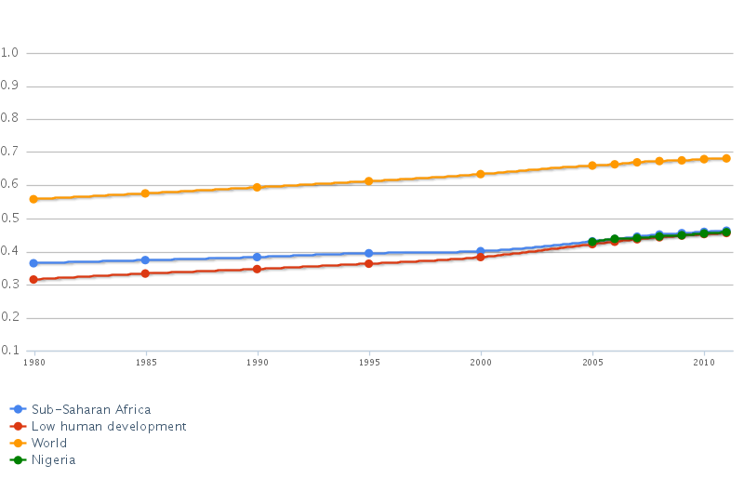
As the graph illustrates, Nigerian modernization remains consistent with that of its sub-Saharan counterparts, but is stuck in the low human development category and trajectory. The case study provided supports this claim.
Nigerian Emancipative Values, as expressed through the World Values Survey’s scatter graph (simplified by this study to only include Nigeria’s score) Traditional values are represented on the y-axis, from -1 to -2. Secular-Rational values are represented on the y-axis from 0.5 to 2. Survival values are represented on the x-axis from -2 to 0. Self-expression values are represented on the x-axis from .5 to 2. Nigeria falls, on the y-axis, to traditional values. This has a large part due to the many ethnic groups that exist within the country, the large populations, and the role these groups play in shaping the countries values. On the x-axis, Nigeria falls into the middle ground, not quite full self-expression, and not quite full survival. As modernization increases, values shift from survival to self-expression on the x-axis. This phenomenon can be seen in todays advanced countries, as modernization has lead to great wealth, and in return, survival is taken for granted. Thus, Nigeria, with low human development and modernization, has not quite reached the self-expression values that have come to dominate successful democracies.

Sierra Leone Case Study Summary
Modernization as expressed through the Human Development Index
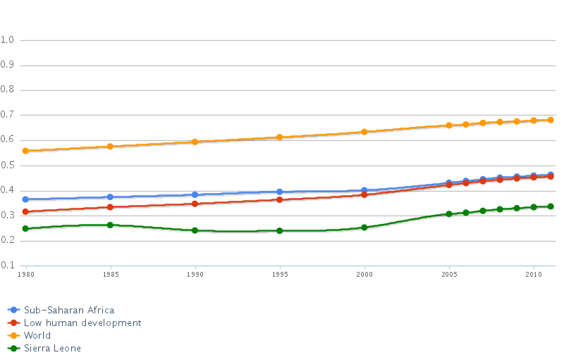
Sierra Leone’s modernization, or human development, sits even lower than that of its sub-Saharan counterparts, and lower than that of Nigeria. As represented in the case study, Sierra Leone exhibits low human development, or low modernization, and its position on this graph supports this claim.
Sierra Leone’s Emancipative Values, as expressed through the World Values Survey scatter graph (simplified by this study to only include Sierra Leones Score) Placed very similarly to Nigeria, Sierra Leone sits in the tradition values on the y-axis, and in the middle on the x-axis. While its modernization is lower than that of Nigeria’s, Sierra Leones government is making larger strides to combat its government corruption and consolidate its democracy. Ethnic and religious tolerance is also much higher in Sierra Leone.

South Africa Case Study Summary
Modernization as expressed through The Human Development Index
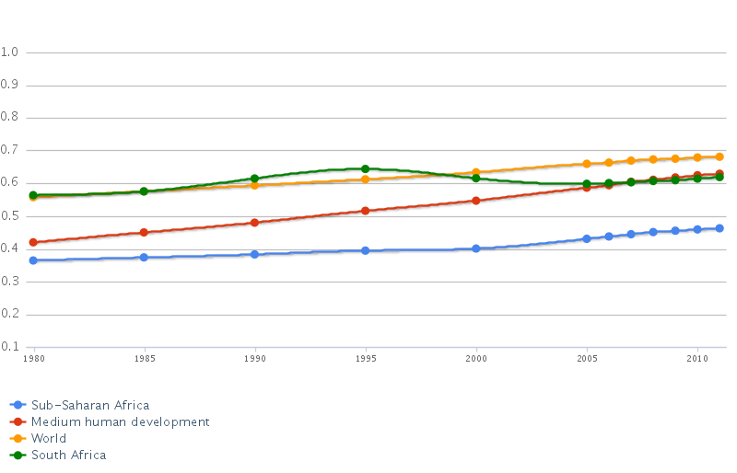
South Africa’s Modernization, or human development, sits well above its sub-Saharan counterparts, and above the two other case studies presented, Nigeria and Sierra Leone. It is categorized as medium human development, and the findings presented in the case study support this claim. With solid infrastructure and communication technologies, modernization can improve the lives of many of the countries citizens.
South Africa’s Emancipative Values, as expressed by the World Values Survey. South Africa falls on the traditional values on the y-axis, and right in the middle again on the x-axis. With high levels of modernization, emancipative values remain pretty average. This is due to the fact that the majority of South Africans do not have a significant stake in the countries resources, wealth, and political process.

Quality/Type of Regime, as expressed through the Polity IV Index
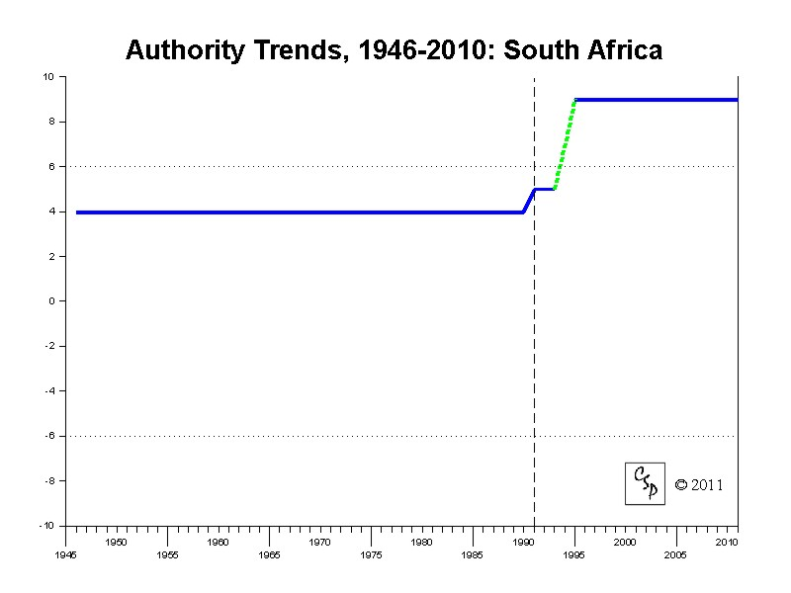
South Africa ranks highest out of the three case studies provided, with a Polity Score of 9, putting it in the category of “democracy.” A score of 10 represents a consolidated democracy, putting South Africa closest to achieving such a title. This is no surprise, as South Africa has the highest levels of modernization, while its emancipative values remain consistent with Nigeria and Sierra Leone.
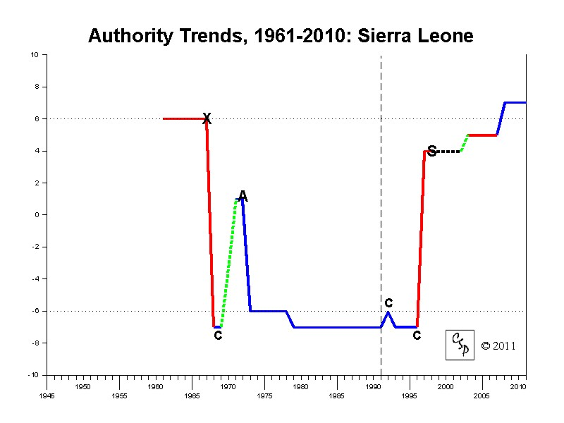(Polity IV)
Sierra Leone’s Polity Score is a 7, putting it also in the category of “democracy.” While modernization in the country was the lowest of the three case studies, Sierra Leone makes up for this in their recent improvements in battling government corruption, and the high levels of voter turnout that have come to be seen in successful democracies. If modernization can improve, democracy will become even more consolidated in Sierra Leone, matching the government’s recent improvement in their emancipative values.
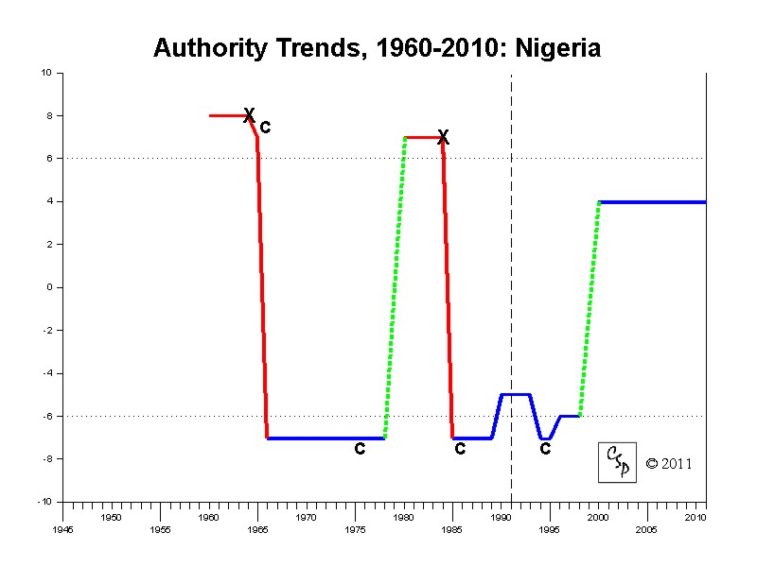(Polity IV)
Nigeria comes in last with a Polity Score of 4, putting it in the category of “anocracy,” or a society in which central authority tends to be weak. Modernization remains consistent with that of its sub-Saharan counterparts, but government instability and corruption, military influence in government, religious and ethnic tensions, and conflicts in Niger Delta region have lead to a decrease in the consolidation of its democracy. Resources lay in the hands of the ruling elite, and the emancipative vales of its citizens are being crushed by “prebendal politics.”
Trends
Being three former colonies of the British Empire, this study will attempt to summarize some overarching trends that have come about in the paths to democracy taken by Nigeria, Sierra Leone, and South Africa. In all three cases, British Colonialism left these countries, during the times of their independence, with a hand picked ruling elite. This phenomenon has both hindered democracy and lead to uprisings that have enabled countries to establish a better-consolidated democracy.
In the case of Nigeria, ethnic groups that the British deemed superior, or, individuals who used colonial rule as a means to better their own financial and social situations, were left to govern the country post-independence in the 1960’s. These methods were not relinquished when it came time for Nigerians to govern themselves. Offices of the state were not sought after for moral reasons, but as a way to achieve more power, and to exploit the countries resources. “Prebendal Politics,” as it is referred to by Richard Joseph, has taken over the Nigerian government. The vast wealth that has come from the countries oil exports are not being filtered down to the masses, leaving concentration of wealth and power into the hands of the ruling elite. Democratic consolidation, therefore, is by no means a main concern for the Nigerian government.
For Sierra Leone, the Lebanese minority had already controlled most of the country’s modern commerce at the time of its independence. This, was of course a by-product of British colonial powers setting up economic and social conditions that favored it’s own country. Power was passed down into the hands of a ruling elite, who used this power to their advantage. Amy Chua describes this in her book, World on Fire, she writes, "By the early 1980’s the influence wielded by the Lebanese was so great that they were referred to as Sierra Leone’s “invisible government.” (Chua 149). While the ruling elite became rich, of the countries resources, mainly diamonds, the majority of citizens lived in poverty. A bloody civil war followed with the rise of the RUF. By establishing a ruling elite, British colonial powers cooked up a natives vs. foreigners civil war that continues to rock the countries democratic foundations. It was only until recently that Sierra Leone began to take strides in combatting government corruption. Democratic consolidation is on the rise as the past is slowly made into a rallying cry for a better future.
In South Africa, years of British Colonial rule have lead to a ruling white minority, while the majority of its black population suffers through extreme poverty. White’s throughout South Africa control the major economic functions of the country, including resources, corporations, and the stock exchange. Years of apartheid era policies have left the black population in a steep uphill battle to claim the democracy and country they thought they had taken back with Nelson Mandela’s election. Democratic consolidation is higher than that of Nigeria and Sierra Leone, but to ever achieve a full-consolidated democracy, the majority of South Africans must have their share of their country.
CONCLUSION
Arguably the best explanation for both the emergence and sustainability of democracy involves the successful combination of both capability and will, or modernization and emancipative values. This study presented a variety of democratic consolidation throughout the continent of Africa by examining three former British colonies, Nigeria, Sierra Leone, and South Africa. By analyzing each countries modernization and emancipative values, a level of democratic consolidation can be seen. Varying degrees of modernization and emancipative values lead to a varying degrees of democratic consolidation. Modernization provides the capabilities and resources needed to express a citizenries emancipative values. Increases in both of the independent variables, lead to a better quality dependent variable. The relationship between the two can be seen in the case studies provided, and by the graphs and charts that measure these independent and dependent variables, which were provided by the Polity IV Index, the Human Development Index, and the World Values Survey. Being three former British colonies, a trend can be seen in their paths to democracy. This trend is the formation of ruling elites that have either hindered democratic consolidation, or lead to a mobilization of the masses that created a better quality regime. Further study and research is needed for complete overarching trends to be seen, calculated and measured.
This study was not without its difficulties. The overall scope of the paper and the topic in general provided a big challenge, and demanded a lengthier study than assigned. Also, research regarding Sierra Leones emancipative values remains hard to find. Further studies focusing on the historical rooting’s of democracy in Africa could further enhance the readers understanding of the topic.
REFERENCES

Thomson, Alex. 2010. “An Introduction to African Politics.” London. Routledge Taylor & Francis Group.

Lumumba-Kasango, Tukumbi. 2005. “Liberal Democracy and its Critics in Africa.” New York. Zed Books.

"CIA - The World Factbook." Welcome to the CIA Web Site — Central Intelligence Agency. Web. 02 Apr. 2011. <https://www.cia.gov/library/publications/the-world-factbook/geos/ni.html>.

“UNICEF-Nigeria”. The Nigerian Situation- UNICEF. Web. 02. Apr. 2011. http://www.unicef.org/nigeria/1971_2199.html

Bernhagen, Patrick. 2009. “Measruing Democracy and Democratization.” In Democratization, ed. Christian W. Haerpfer, Patrick Bernhagen, Ronald F. Inglehart, and Christian Welzel. Oxford: Oxford University Press.

Zakaria, Fareed. The Future of Freedom: Illiberal Democracy at Home and Abroad. New York: W.W. Norton &, 2003. Print.

Huntington, Samuel P. 1991. The Third Wave: Democratization in the Late Twentieth Century. USA: University of Oklahoma Press.

Inoguchi, Takashi, Edward Newman, and John Keane. 1998. “Introduction: The Changing Nature of Democracy.” In The Changing Nature of Democracy, ed. Takashi Inoguchi, Edward Newman, and John Keane. Tokyo: United University Press.

King, Charles. 2000. “Post-Postcommunism: Transition, Comparison, and the End of ‘Eastern Europe’.” World Politcs, Vol. 53, No. 1 (October) pp. 143-172.

Linz, Juan J. and Alfred Stephan. 1998. “Toward Consolidated Democracies.” In The Changing Nature of Democracy, ed. Takashi Inoguchi, Edward Newman, and John Keane. Tokyo: United University Press.

Haerpfer, Christian, Patrick Bernhagen, Roldand F. Inglehart, and Christian Welzel. 2009. “Introduction.” In Democratization, ed. Christian W. Haerpfer, Patrick Bernhagen, Ronald F. Inglehart, and Christian Welzel. Oxford: Oxford University Press.

Markoff, John. 2009. “The Global Wave of Democratization.” In Democratization, ed. Christian W. Haerpfer, Patrick Bernhagen, Ronald F. Inglehart, and Christian Welzel. Oxford: Oxford University Press.

Munck, Gerardo L. 2001. “The Regime Question Theory Building in Democracy Studies.” World Politics, Vol. 54, No. 1 (October) pp. 119-144.

O’Donnell, Guillermo A. 1996. “Illusions About Consolidation.” Journal of Democracy 7.2 pp. 34-51.

Chua, Amy. World on Fire: How Exporting Free Market Democracy Breeds Ethnic Hatred and Global Instability. New York: Doubleday, 2003. Print

Welzel, Inglehart. "World Values Survey." World Values Survey. World Values Survey. Web. 17 Dec. 2011. <http://www.worldvaluessurvey.org/>.

"Polity IV Project: Home Page." Center for Systemic Peace: Home Page. Web. 17 Dec. 2011. <http://www.systemicpeace.org/polity/polity4.htm>

"Indices & Data | Human Development Reports (HDR) | United Nations Development Programme (UNDP)." Human Development Reports (HDR) - United Nations Development Programme (UNDP). Web. 17 Dec. 2011. <http://hdr.undp.org/en/statistics/>.

