Diversion Program vs. Mandated Treatment
I collected data from 128 domestic violence (DV) misdemeanor cases filed in 2006. For this study, a DV case is defined as a misdemeanor file that includes a charge of either domestic battery (DB), a violation of order of protection (VOP) charge, or both. We used both Kankakee and McLean County so as to test the effectiveness of Kankakee County’s Diversion program and see if the effectiveness is related to the factors used to screen applicants for the program or to the dismissal of the DV charge.
I gathered information regarding offenses charged and court activity from the Electronic Justice System (EJS). EJS is an integrated justice information system with software that permits data to be shared among McLean County’s various divisions of the justice system.
Throughout the semester, I built off of the original data sheet created by the evidence collection team. I was under the supervision of Circuit Judge Charles Reynard and Professor Tom McClure. I recorded the information on an Excel spreadsheet. A graduate assistant of Prof. McClure transferred the data to an SPSS spreadsheet and I ran the statistical calculations.
I compared the data that I completed for McLean County to the data that Prof. McClure gathered for Kankakee County. This report will present the following: (1) An explanation of the Diversion program; (2) Demographic characteristics of 2006 DV defendants; (3) recidivism rates of various classifications of DV defendants; (4) an analysis of whether the Diversion Program helps curb recidivism.
The summaries and analysis presented in this report are based on all 268 cases examined. Some defendants were charged in two or more DV cases in 2006. We opted not to exclude any case from consideration. Although we acknowledge that this might skew the data, we were unable to devise an objective non-arbitrary way to determine which cases should remain and which cases should be eliminated from our reviews.
DIVERSION PROGRAM
Kankakee and McLean County both have treatment programs for DV offenders. Kankakee County has a Diversion program that was created by Judge John F. Michela, Judge Clark E. Erickson, the Kankakee County State’s Attorney’s office, Harbor House, and the Duane Dean Prevention and Treatment Center, in an effort to control, if not end, the problem of domestic violence in Kankakee County. In the Diversion Program, the defendant agrees to plead guilty to the pending charges and undergo a drug and alcohol evaluation and treatment, as well as a 26-week Abuser Counseling Program in exchange for a dismissal or reduction of charges. The case is not actually dismissed until all of the requirements have been successfully completed. Anyone who is charged with a qualifying Class A misdemeanor, either Domestic Battery and/or Unlawful Violation of an Order of Protection, is eligible to participate in the program, providing that they do not have an extensive criminal record. The Court does not charge a fee for the program but the defendant is require to pay for the initial drug and alcohol assessment and the Inward Bound classes. The fee ranges from $5-$35 depending on the defendant’s income. If a defendant chooses to participate in the program they must sign a plea agreement. When the defendant’s case comes up for review, the Judge will be notified of their progress in the program. If the defendant is complying with the program, the case will be continued for another review, and eventually, upon successful completion, for gradation. If the defendant fails to comply with the plea agreement, the Judge has the option of revoking the plea agreement and entering a conviction for the offense(s) charges. Because the defendant has stipulated to the facts, they will not be entitled to a trial, a conviction will be entered and the defendant will be sentenced. The judge may also order the defendant to undergo the Abuser Counseling Program and drug and/or alcohol treatment as part of sentencing.
DEMOGRAPHICS
Out of 128 defendants, the average age in McLean County at the time of the case filing was 32, and the median was 29. The youngest offender was 17 and the oldest was 65. The most common age of the offenders was 29, 8 members of this age group faced DV charges. Chart 1 displays the frequency of ages.
Chart 1: Defendant’s age-McLean County 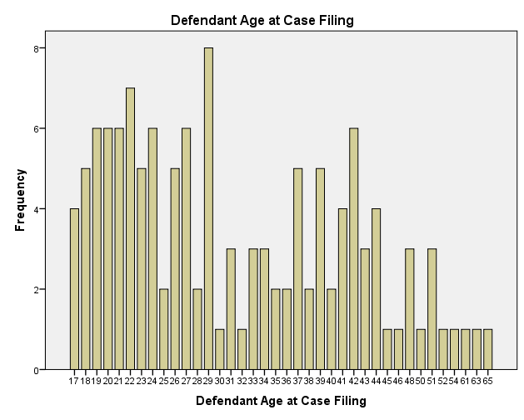

Out of 140 defendants, the average age in Kankakee County at the time of filing was 33 and the median was 30.5. The youngest offender was 17 and the oldest was 66. The most common age of the offenders was 22, 9 offenders from this age group were charged with Domestic violence. Chart 2 shows the age frequencies in Kankakee County.
Chart 2: Defendant’s age-Kankakee County
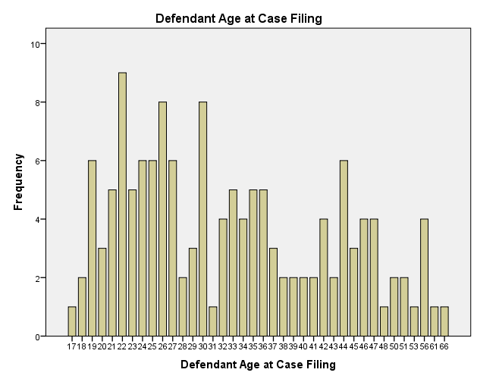
About 80% of the defendants are male in McLean County and about 82.1% are male in Kankakee County.

Almost 72% were indigent in McLean County, as evidence by the court’s appointment of a public defender. (See Table 1) Only 46% were indigent in Kankakee County, as also seen by the court’s appointment of a public defender. (See Table 2)
Table 1: Defendant’s legal representation-McLean County
 |  | Frequency | Percent | Valid Percent | Cumulative Percent
Valid | No PD Appointed | 36 | 28.1 | 28.1 | 28.1
 | PD Appointed | 92 | 71.9 | 71.9 | 100.0
 | Total | 128 | 100.0 | 100.0

Table 2 : Defendant’s legal representation-Kankakee County
 |  | Frequency | Percent | Valid Percent | Cumulative Percent
Valid | No PD Appointed | 76 | 54.3 | 54.3 | 54.3
 | PD Appointed | 64 | 45.7 | 45.7 | 100.0
 | Total | 140 | 100.0 | 100.0

In McLean County, 92.2% of defendants had no prior DV charge and 94.3% had no prior DV charge in Kankakee County. 75% had no prior non-DV misdemeanor charge in McLean County and 84.3% had no prior non-DV misdemeanor charge in Kankakee County. 97.7% had no prior non-DV felony charge in McLean County and 97.9% had no prior non-DV felony charge in Kankakee County. (See tables 6-12).
Table 6 : Prior DV Charge-McLean County
 |  | Frequency | Percent | Valid Percent | Cumulative Percent
Valid | No | 118 | 92.2 | 92.2 | 92.2
 | Yes | 10 | 7.8 | 7.8 | 100.0
 | Total | 128 | 100.0 | 100.0

Table 7 : Prior non-DV Misdemeanor Charge-McLean County
 |  | Frequency | Percent | Valid Percent | Cumulative Percent
Valid | No | 96 | 75.0 | 75.0 | 75.0
 | Yes | 32 | 25.0 | 25.0 | 100.0
 | Total | 128 | 100.0 | 100.0

Table 8: Prior non-DV Felony Charge-McLean County
 |  | Frequency | Percent | Valid Percent | Cumulative Percent
Valid | No | 125 | 97.7 | 97.7 | 97.7
 | Yes | 3 | 2.3 | 2.3 | 100.0
 | Total | 128 | 100.0 | 100.0

Table 10 : Prior DV Charge-Kankakee County
 |  | Frequency | Percent | Valid Percent | Cumulative Percent
Valid | No | 132 | 94.3 | 94.3 | 94.3
 | Yes | 8 | 5.7 | 5.7 | 100.0
 | Total | 140 | 100.0 | 100.0

Table 11 : Prior non-DV Misdemeanor Charge-Kankakee County
 |  | Frequency | Percent | Valid Percent | Cumulative Percent
Valid | No | 118 | 84.3 | 84.3 | 84.3
 | Yes | 22 | 15.7 | 15.7 | 100.0
 | Total | 140 | 100.0 | 100.0

Table 12: Prior non-DV Felony Charge-Kankakee County
 |  | Frequency | Percent | Valid Percent | Cumulative Percent
Valid | No | 137 | 97.9 | 97.9 | 97.9
 | Yes | 3 | 2.1 | 2.1 | 100.0
 | Total | 140 | 100.0 | 100.0

RECIDIVISM RATES
Court-ordered DV treatment is imposed to rehabilitate. Recidivism rates are a traditional method of examining the effectiveness of treatment, diversion or just regular treatment. At the time of my data collection, 5.7% of defendants in McLean County were charged with a subsequent DV charge while 3.9% in Kankakee were charged with a subsequent DV charge. 7.7% of females and 2.9% of males were charged with a subsequent DV charge in McLean County and 0% of females and 7% of males were charged with a subsequent DV charge in Kankakee County. 16 defendants in McLean County had a prior alcohol charge but none had a subsequent DV charge. 8 defendants in Kankakee County had a prior alcohol charge and 1 had a subsequent DV charge. 0% were charged with a prior DV charge in both McLean and Kankakee County. Out of 32 defendants in McLean County with a prior non-DV misdemeanor charge, only 1 had a subsequent DV charge. Out of 22 defendants in Kankakee County with a prior non-DV misdemeanor charge, only 3 were charged with a subsequent DV charge. Out of 96 in McLean County with no prior non-DV misdemeanor, only 4 had a subsequent DV charge. Out of 118 with no prior non-DV misdemeanor in Kankakee County, only 5 had a subsequent DV charge. 3 defendants in McLean County had prior non-DV felony and only 1 with a subsequent DV charge. 3 defendants in Kankakee County had a prior non-DV felony and 0 had a subsequent DV charge. Out of 125 with no prior non-DV felony in McLean, only 4 had a subsequent DV charge. Out of 137 in Kankakee County with no prior non-DV felony, only 8 had a subsequent DV charge.

From the close relationship between the Kankakee County data to the McLean County data, we can conclude that the effectiveness of the Diversion program is related to the factors used to screen the applicants for diversion, and not the dismissal of the DV charge. Those convicted in Kankakee County have virtually the same recidivism rates as those convicted in McLean County.

