Latino’s Influence on American Political Campaigns
Marcia Ortiz, Monmouth College
Abstract:
The tremendous growth of the Latino Population has led to a bigger impact of Latinos during presidential elections and more action from candidates to attract the Latino vote. Latinos have long influenced politics in the United States; however, 2012 is the year that the presence of Latinos in this country may determine the outcome of the Presidential election. Today, it is essential that any candidate running for the presidency has the support of the biggest minority in the U.S., Latinos. The Hispanic community is currently divided on who to support, the GOP’s hostility towards immigrants is alienating Latinos but President Obama’s broken promise to reform immigration has made Latinos dubious about supporting him. In this research project I examine the wooing of the Latino Vote by President George Bush in 2004 and President Obama in 2008. I then examine Republican presidential primary campaign and the challenges Republican Party faces in attracting the Latino vote. President Obama and the nominated GOP candidate will need to work in different ways in order to get the Latino vote.

POPULATION
Often called the “sleeping giant,” Latino’s influence on American politics has been increasing throughout the years as a result of its growing population. For instance, data shows that in 1970, the number of foreign-born Latinos in the United States was 1.8 million and in the year 2006 it has increased to 17.7 million, an increase of 883% (Andrade 62). Furthermore, a more recent analysis by Pew Hispanic Center data, “Mapping the Hispanic Electorate”, shows the foreign-born population in the U.S. in the year 2010 was 21.1 million. Most importantly, the number of foreign-born Latinos is projected to continue to grow; however, it is important to note that not all Latinos share an interest on American Politics and not all are eligible to vote and participate in politics. Nonetheless, due to its high population and steady growth, Latinos are still considered a “sleeping giant”; as a result, Latinos are one of the biggest targets during national electoral campaigns in the United States, with its importance greatly increasing year by year.
In 2006 the Latino population was growing a rate of 4,000 per day and 1,400,000 per year and eighty percent of its population was concentrated in 10 states. There are several states where the Latino population has had an increase of over 100%; those states are California, Texas, Florida, New York, Illinois, Arizona, New Jersey, New Mexico, Georgia, Nevada, North Carolina, and Washington. Even though Latinos reside in all 50 states, today 15 states have a Latino population higher than 500,000. In 2004 there were only 10 states where the Latino population exceeded 500,000 comparing to 15 in 2007 (Andrade 62). According to the U.S. Census Bureau in 2010, the number of Hispanics in our nation increased by 15.2 million in only 10 years between the year 2000 and 2010. This growth of 43 percent is four times the nation's 9.7 percent growth rate.
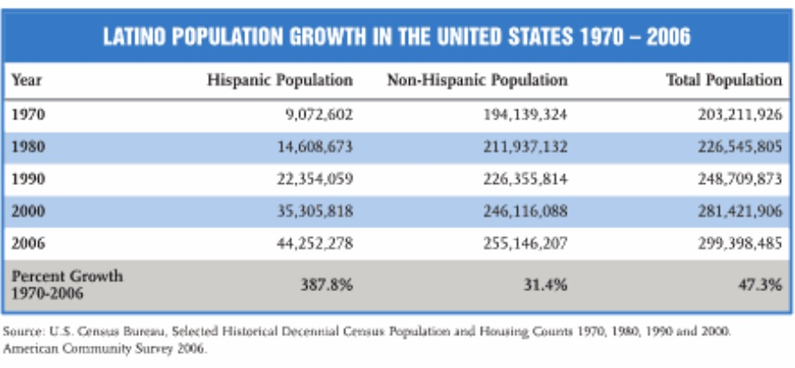
(Andrade, 6)

VOTING
According to data gathered by The Pew Latino Center, by 2008 there were 19,346,000 million Latinos eligible to vote in the nation. By the 2012 electoral election, Latinos will account for more than 10% of the adult population eligible to vote in 11 states. In the rest of states, Latinos account for 5-10% of potential voters. In total, Latinos can influence the electoral outcomes in 24 states. The four states where Latino influence is the highest are New Mexico, Florida, Nevada, and Colorado. The number of Latinos in these states continues to grow day by day. Likewise, in states like Connecticut, Georgia, Pennsylvania, Wisconsin and Massachusetts, Latinos account for over 5% of potential voters, and each state is anticipated to have a competitive Presidential contest in 2012. For instance, in Georgia, the Latino population has grown by 96% since 2000 while the White population grew by 6%; a state McCain won by just 5% in 2008. In Wisconsin Latinos grew by 74% compared to 1% growth for Whites, and could be one of the most fiercely contested states in 2012 (Mapping the Latino Electorate).
Besides these 10 states, other states where Latinos will be influential are Virginia, Indiana, Missouri and Ohio. The Latino population in these states is smaller, but the numbers continue to grow. In Missouri the Latino population grew by 79%, which is 20 times faster than the White population that grew by 4%. However, the growth of Latino population is indeed important, but another key element is getting all these potentially voters to register and actually vote. National wide, it is estimated that 21.5 million Latino citizen adults will be eligible to vote in November 2012, comparing to 19.5 million in 2008. If registration rates continue constant, there will still be 8 million Latino people eligible to vote but who did not register to vote. For instance, while Latinos are growing in influence in Arizona, there are over 400,000 Latinos eligible to vote but are not yet registered. In Florida, over 600,000 Latinos who are potential voters have not been registered. There is about half-million of new potential voters each year of Latinos turning 18 or new naturalized citizens that could be registered (Mapping the Hispanic Electorate). 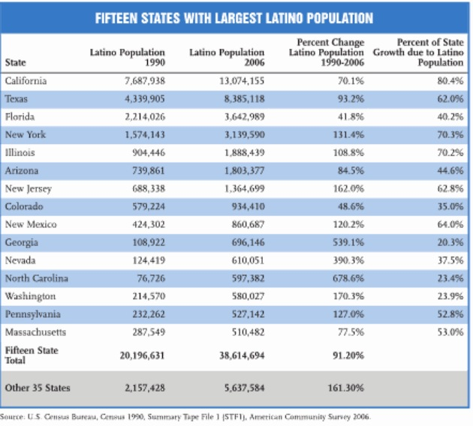
(Andrade, 14)
Currently, Hispanic News reports that there are different groups that have started working on registering Latinos to vote. Groups like Mi Familia Vota, Democracia USA, The Hispanic Institute, and Voto Latino and many other groups that run mainly on donations and extensive volunteering. This investment of Latino voter registration could make the Hispanic population even more influential in the 2012 campaign. In Texas, there is a projected 2.1 million Latino eligible voters but they are not yet registered. This could be very important to either party in order to win and hold office in Texas in the future. Also, in California there are another 2 million eligible Latinos that could be registered. In our state, Illinois there are 300,000 unregistered Latinos who could be voters. In an U.S. Senate election in 2010, the election was by less than 60,000 votes. Latino voters are placed to have an important position in many states (Barreto, Where Latino Votes Will Matter).
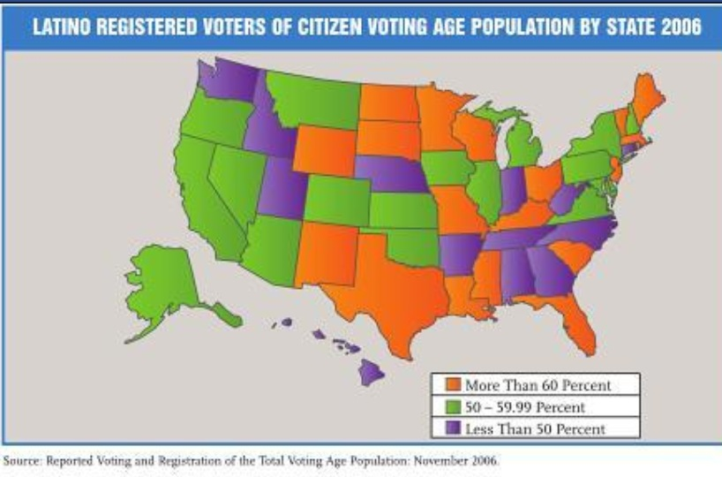
(Andrade, 16)
Getting Latinos to participate in American politics is more complicated that it seems. Registering Latinos to vote does help and increase Latino participation, but there are very strong forces that are stopping many Latinos from fully participating in American politics. For example, Latinos come from different countries in Latin America that are ruled by different political systems like democracies, autocracies, military, single-party rule and others. A new immigrant to the United States will most likely be unfamiliar with the American two-party system and the differences between these two parties. This unfamiliarity with the political system adds to the challenge that candidates take when trying to gain Latino’s support. When creating different types of advertisements candidates need to know what information should be provided and highlighted in order to attract Latinos to their party. Furthermore, 70 percent of foreign-born Latinos arrive in the United States as adults, and therefore do not experience any civic learning provided by high schools or colleges. The rest of the foreign-born population are underage Latinos that are very likely to be dropped out of high school, and therefore do not count with proper education either (Abrajano, 23).
Elections 2004
As previously discussed, the growth in Latino population cannot go unnoticed. As explained in the article, Hispanics and the 2004 Election; Population, Electorate and Voters, Latinos made up for half of the population growth in between the elections of 2000 and 2004; however, they only accounted for only one-tenth of the increase in the total votes in 2004. The authors explain that there are two reasons that differentiate Latinos from other voters during elections: a large amount of Hispanics is too young to vote or others are not eligible citizens. Between the two elections of 2004 and 2008, there was an increase in Latino population of 5.7 million, eligible to vote; however, the increase of Latino voters was only of 1.4 million. In the year 2004, Hispanics made up 6 percent of all the votes, a .5 increase from 5.5 percent four years earlier. Also, the Latino share of the population increased from 12.8 percent in 2000 to 14.3 percent in 2004 (Fry, Passel, and Suro). Latinos receive much attention in the early stages of a political campaign, due to their growing numbers, and analysts wonder when will be the year the “sleeping giant” will actually awake.
In the campaign of 2004, a national exit poll showed that President George W. Bush had taken 44 percent of the Hispanic vote, a 10-percentage point increase over his share in the year 2000. Over the past two decades, there has been substantial variation on which party the Hispanic population really supports. President George W. Bush made an evident effort to reach to the Latino community and gain their support. The use of religion in the 2004 election was what probably inclined the Hispanic community to vote republican. According to Adam Segal, director of the Hispanic Voter Project at Johns Hopkins University, “The Bush campaign used moral values, and especially the national discussion over gay marriage and abortion rights, as wedge issues within the Hispanic community to try to break off a conservative religious segment” (Johnson, Hispanic Voters Declared Their Independence).
Besides religion, Bush's guest-worker suggestion helped his goal of reaching Latinos, as also did the great number of advertisements in Spanish. The exit polls showed Bush was making gains among Latinos in California as well, to about 34 percent, up about five percentage points compared with 2000. Bush appears to have picked up Latino support since the year 2000; a likely reason might be because 2004 Democratic presidential candidate John Kerry made fewer efforts to reach this community. The campaign focused on Latino outreach by revolving around opposition to abortion rights and gay marriage. The group aired Spanish-language advertisements on 200 radio stations nationwide and sent information to about 13,000 churches (Puzzanghera, Latino Support Helped Bush Sway Election). For example, Johnson states the views of Mr. Dorrance, "I voted for Bush based on his moral stance, Bush is pro-life, I'm pro-life. He believes marriage should be between a man and a woman, and so do I."
Cisneros, President and Chief Executive of American City Vista, a San Antonio company that builds urban housing, said,” the outreach at churches, particularly among Latino Catholics, appeared to help Bush, who enjoyed strong support from Latinos when he was governor of Texas”. Certainly, the 2004 election shows a “religion gap” in the electorate. According to the exit poll, George W. Bush did well mainly among Protestants, born-again Christians and the more religiously inclined. For instance, “Bush beat Kerry by 19% (59 vs. 40) among Protestants, by 57% (78 vs. 21) among born-again Christians, and by 22% (61 vs. 39) among weekly church-goers”. On the other hand, Cuban Americans have known for traditionally voting for the Republicans. In a poll done by the October Washington Post/Univision/TRPI poll shows that “80% of Cuban-American voters, who made up about 6% of the Latino electorate, indicated they support Bush in the presidential election. Twenty-four percent of Hispanic voters in the same poll said they leaned toward the Republican Party, and 86% of Republican identifiers and leaners reported their support for Bush (Puzzanghera, Latino Support Helped Bush Sway Election).
The television advertisements in Spanish by Bush, negatively attacked John Kerry's voting record and his stance on abortion. While Mr. Kerry's Spanish television advertisements were more positive and rarely even mentioned Bush’s name. "The bottom line to me is that with this result, it's no longer sensible to think of Hispanic voters on a national basis as a core constituency of the Democratic Party," said Roberto Suro, the Director of the Pew Hispanic Center, a nonpartisan research organization based in Washington. George W. Bush was already strong among Hispanic voters in Texas, who are mainly Mexican-Americans; however, Cuban-Americans already have given the Republican Party their support among Hispanic voters (Johnson).
Elections 2008
The several efforts that George W. Bush made to attract Latino support proved to be essential in his 2004 political campaign and success. The Republican Party has experienced a growth in Latino support over the years as a great number of Latinos went Republican in the 2004 election; however, this changed in 2008. A very important year for Republicans, Democrats and Latinos was 2006 when Latino support shifted towards the Democratic Party. Although it is believed that immigration is one of the top issues that concern Latinos in the year 2006, Congress passed legislation to build a fence along the Mexican-American border and Senators McCain, Clinton and Obama all voted in favor of it (Lopez, How Hispanics Voted in the 2008 Election).
Obama’s approval of the 2006 legislation to build a fence did not affect his political campaign as much. Although immigration is a very important issue to Latinos, there are a wide variety of opinions among Latinos regarding what the right immigration policy should be. As a result, it was not of much interest of either candidate to bring the issue up needlessly. Karen Smith reports in the article, Courting the Latino Vote, that according to surveys, immigration was not on the top three issues that Latinos were concerned about in 2008. Latinos named the same top three issues as have general voters, those issues were the economy, the war in Iraq and health care (Lopez).
In the 2008 election, Latinos voted for Democrats Barack Obama and Joe Biden over Republicans John McCain and Sarah Palin by a margin of 67% versus 31%, according to an analysis by the Pew Hispanic Center of exit polls. According to the national exit poll, “64% of Hispanic males and 68% of Hispanic females supported Obama.” Young Latinos also supported Obama by a margin of 76% and McCain with 19%. Obama got much higher support from Latinos in all states with large Hispanic populations. Florida was one of his greatest success states where he won 57% of the Latino vote; even though Florida is a state where Latinos have traditionally supported the Republican Party. In 2004 President Bush won 56% of the Latino vote in Florida. Other states with big Hispanic populations where he was very successful were 78% in New Jersey, 76% in Nevada, and 74% in California.
However, even though McCain's Latino support was much lower than the support Bush received, it was still higher than the 21% share of the Hispanic vote that Sen. Robert Dole received as the GOP presidential nominee in 1996. John McCain made great efforts to gain the support of Latino voters; he seemed to understand the importance of the Latino population. McCain tried to appeal to Latinos by showing concern on the immigration issue. In the year 2007, him and Senator Edward Kennedy, co-sponsored an immigration reform bill that would have given illegal immigrants a “pathway toward citizenship.” McCain spoke very sympathetically about the difficulty that undocumented immigrants deal with day to day. Karen Smith also explains that McCain reminded people “Just as with other waves of immigrants, Hispanics have ‘enriched our culture and our nation.’” (Lopez, How Hispanics Voted in the 2008 Election)
Furthermore, McCain, as well as George W. Bush supported traditional religious and family values, a tactic that could have attracted the Latinos who voted for President Bush. McCain has a good trajectory record with Latinos, in his 2004 Senate re-election he did particularly well in his home state Arizona where he won 70 %of the Latino vote. Smith also explains that analysts have shown that, “In elections where there are both black and white candidates, Latinos tend to favor the white candidate. “ This was an advantage to McCain. These factors made it seem as if McCain had the better position; however, after the primaries President Obama effectively launched his campaign in order to attract Latino voters who supported of Hillary Clinton during the primaries (Lopez).
Jorge Ramos, an anchorman for Univision, said “No one can make it to the White House without Univision.” Univision is America’s most watch Spanish television network and serves as a medium for politicians to communicate with the Hispanic population in the United States. A candidate who made sure to take full advantage of this medium was the current President, Barack Obama. In total, during the 2008 campaign, both parties spent 38 million dollars together on advertising in Univision. However, out of the 38 million, Obama spent 20, which is twice the amount that Kerry and Bush spent in the campaigns of 2004 together. At the end, this proved to be a wise investment from President Obama since he made sure to get two-thirds of the Latino vote (Abrajano, 147).
Additionally, President Obama had the support of Governor Bill Richardson of New Mexico; he was the first Latino to run for president. Moreover he also had the support of Cesar Chavez’ granddaughter, the founder of the United Farm Workers union. By mid-2008, Senators Clinton and Obama had spent $4 million, the highest amount ever spent on Spanish-language advertising. In the primaries, Texas and Puerto Rico, Hillary Clinton won the Latino vote 2 to 1 over Obama. As she left the race, President Obama made sure to put Latinos at top of his priority list in order to get the support Hillary Clinton had from Latinos. With his extra effort of reaching the Latino community by investing in Spanish advertisings, attracting young and independent Latino voters, among other efforts, he become the 44th President of the United States with the help of Latino Voters (Abrajano 179).
Who are Latinos?
Getting the Latino vote is a very complex challenge because of the diversity in the views and culture of Latinos. The Latino population is a culturally and ethnically diverse group of people from different countries in Latin America. People of Latino heritage differ tremendously in their histories and background. While a lot of the southwest portion in the U.S. used to belong to Mexico, many people from the Caribbean, like Cubans have immigrated to Florida seeking asylum from Castros’ communism; Puerto Ricans are considered American citizens, they are in a different situation because they can come and leave as they wish. People of Latino descent can be 5th or 6th generation Americans, new immigrants, undocumented or seasonal workers or somewhere in the middle.
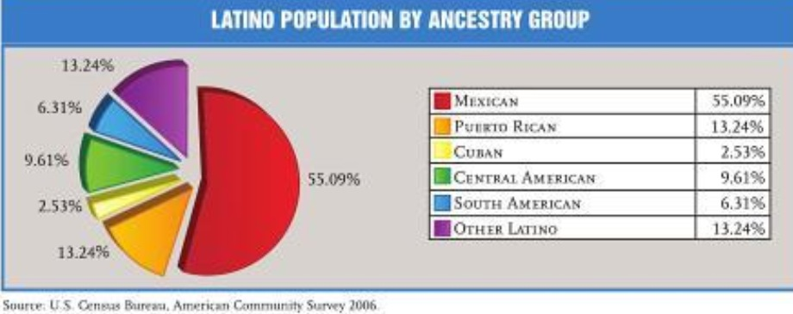
(Andrade. 25)
However, Latinos do distinguish with certain common characteristics from other ethnic groups. A very important fact that characterizes the Latino electorate is that it is “overwhelmingly young.” One third of Latino voters are between the ages 18 and 29 and this number is expected to rise in coming years. The young Latino population is different from the older Latinos in many aspects; for example, they are more likely to be born in the U.S. than older generations. Younger Latinos born in the U.S. become more incorporated into the United States political system and as a result; they tend to be less supportive of the Democratic Party” (Baik, Lavariega-Monforti, McGlynn, 2009). There are several other factors that make Latinos a very complex group; for instance, Latinos tend to be more conservative regarding social issues like same-sex marriage and abortion. Latinos also seem to be less politically active than non-Latino white and blacks. Moreover, Latinos have been hit harder by the recession with a median household net worth drop of 66% from 2005 to 2009 (Dias, Why Latino Voters Will Swing the 2012 Election).
Much of the Latino population is also geographically concentrated in the important swing states, making them an important constituency in presidential elections. In each of the five states of California, Texas, Florida, Illinois, and New York, Latinos constitute between 20 and 35 percent of the state populations. These states alone account for 168 total Electoral College votes, which is more than half of the votes needed in victory in a presidential election.
The GOP, Latino Support and Immigration
After George W. Bush’s successful effort to increase Latino’s support for a GOP presidential candidate during the 2004 presidential campaign, the GOP leadership understands the importance of the Latino vote and is currently attempting to gain Latino support in 2012. As previously mentioned, getting the Latino support is a very complex challenge because of the diversity in the views and culture of Latinos. In 2004, George W. Bush had the support from Latinos in the US; however, in 2008 even after John McCain’s evident efforts, the GOP did not count with Latino support. If anything, it seems like the Republican Party today has developed an ineffective position for attracting Latinos. The GOP candidates’ negative tone on immigration could continue to affect their political campaigns. The 2012 candidates are losing the support of the biggest minority in the United States.
Angela Maria Kelley, Vice President for Immigration Policy and Advocacy, and Philip E. Wolgin, Immigration Policy Analyst, at the Center for American Progress Action Fund explain that “Mitt Romney has taken an ever increasing hardline on immigration, telling audiences nationwide that he would veto the DREAM Act, and most recently calling Arizona’s anti-immigration law, S.B. 1070, a ‘model’ for the rest of the nation.” But, even though Romney has won the Republican primary in Arizona, his tough anti- immigration position may lead to him losing Arizona in the general election if he is the nominee for the Republican Party. A poll in late February showed that Mitt Romney had a 27 percent approval rating with Latinos, and a 66 percent disapproving rate. Countrywide, 74 percent of Latino voters are against the Arizona S.B. 1070 law and the proposed self-deportation offer that Romney strongly suggests as a policy. (Kelley et al, Why Romney’s Immigration Policies Will Take Him Nowhere)
Furthermore, the disapproval for Romney’s ideas go beyond Arizona, a recent poll of Latinos nationally, released on January 25, found that the majority of Latinos saw immigration reform and the DREAM Act as very important issue that need to be addressed urgently. Even more troubling from the GOP’s perspective, the poll found that if the election were held now, 67 percent of the Latino’s would support Barack Obama and 25 percent Mitt Romney. Similarly, regarding the government’s policy on undocumented immigrants, 71 percent agreed on an earned citizenship program, while only 11 percent believed on making all illegal immigrants criminals. Above all, the subject of immigration is profoundly personal to Latinos because of the close ties that the overwhelming majority of Latinos have with undocumented immigrants A great number of Latino voters know someone soon to be deported or has already been deported. The rest of non-Latino population has also reinforced a sensible attitude to immigration, with increased border security on the one side, and a path to legalization on the other, instead of making life more and more tough for illegal immigrants ((Kelley et al, Why Romney’s Immigration Policies Will Take Him Nowhere).
The DREAM Act was introduced by Senator Orin Hatch, and Senator Richard Durbin in 2011 and it would allow young undocumented students to be eligible for a 6 year long conditional pathway to citizenship that requires completion of a college degree or two years of military service. According to Professor Roberto Gonzalez of the University of Washington:
“The experiences of undocumented children belonging to the 1.5 generation represent dreams deferred. Many of them have been in this country almost their entire lives and attended most of their K-12 education here. They are honor roll students, athletes, class presidents, valedictorians, and aspiring teachers, engineers, and doctors. Yet, because of their immigration status, their day-to-day lives are severely restricted and their futures are uncertain. They cannot legally drive, vote, or work. Moreover, at any time, these young men and women can be, and sometimes are, deported to countries they barely know. They have high aspirations, yet live on the margins. What happens to them is a question fraught with political and economic significance” (The Dream Act).
The future of thousands of young and bright students depends on the DREAM Act, and this is the reason why Latinos support and want to see this come into reality; however, the GOP’s lack of support does not seem like a good option for Latinos.
One of the most important factors in alienating Latino’s voters from the GOP is the party’s support of draconian anti-immigration laws such as Arizona’s law S.B. 1070. Elizabeth Diaz reports that instead of trying to gain the Latino support, many Republicans concentrate on wooing the more anti-immigration wing of their party. Herman Cain, for example, excited the crowds by making jokes about electrifying a fence on the Mexican-American border and guarding it with alligators; Michelle Bachman signed a “double” fence” pledge. Moreover, Mitt Romney argued against in-state tuition breaks for undocumented students and encouraged “self-deportation” for the 11 million undocumented immigrants currently living in the United States. Moreover, none of the four GOP contenders has enunciated support for an amnesty that would give younger undocumented immigrants to a path to become permanent legal residents. Of the four republican candidates, only Newt Gingrich has the most cooperative policy toward illegal immigration, he calls for citizen review boards to allow long-term illegal residents to stay in the United States (Abrajano 204).
However, the GOP contenders are dubious to directly criticize the Arizona law since more than two-thirds of non-Latino Republican primary voters in Arizona said that they will most likely support the candidate that supports the SB1070 law. The GOP candidates opposition on immigration is popular with conservative primary voters, but this might have a high cost in November because it is very probable that Latinos will account for a larger share of the general electorate in important states like Colorado and Nevada than they did during the last presidential election. There is great pressure over immigration between candidates Gingrich and Romney. Gingrich stated that “someone who's been here 25 years, somebody who has been a good local citizen, may well belong to your church, has children and grandchildren in the United States,” and claimed that he doesn’t believe that Americans are going to call the police on those people in order to ship them out of the U.S. However, he also mentioned that most illegal workers in the United States “should go home immediately” and “we should make deportation dramatically easier.” Later, in an ad he called Romney the “the most anti-immigrant candidate” (Curry, Are Latino Voters A Missed 2012 Opportunity for Republicans?).
In addition, Rick Santorum also voted in opposition of the 2006 immigration reform bill that incorporated a form of the DREAM Act. He is in favor of legal immigration, in order to enhance population growth; however, he says that “people who have come to this country illegally have broken the law repeatedly” by working here and therefore have to be deported. Lastly, the GOP contender, Ron Paul, also voted against the Dream Act in 2010, and claimed that “We spend way too much time worrying about the border between Afghanistan and Pakistan. Use some of those resources on our own border.” Though, Ron Paul differentiates himself because he implied that illegal immigration could be more tolerable if we were living in a boom economy. He said, “The weaker the economy, the more resentment there is when illegals come in. “If you have a healthy, vibrant economy, it's not a problem; we're usually looking for workers,” he said. As already stated, none of the GOP candidates offers a solution that Latinos could agree on; therefore, this might cost them the Latino vote if they do not act quickly (Curry).
There are different approaches that the GOP could take in order to gain Latino’s support. But it is important to understand that Latinos may share a common ancestral language that unifies different nationalities and geographic allegiances but that is it. A recently naturalized Mexican is Los Angeles is more likely to vote Democratic than a fourth-generation immigrant in New Mexico, who is more likely to be liberal than a 65 year old Miami Cuban, whose 23 year-old daughter is more likely than her father to have voted for Obama in 2008, explains Elizabeth Diaz. (TIME) Cesar Martinez, President of MAS Consulting, advises the GOP candidates to take action now to get the Latino vote if they want the “nation’s driver’s seat.” Martinez says that Republicans need to apprehend that there is still a chance to win the Latino vote, but only if they act now, and they still have that chance because of President Obama’s inaction. The reason there is hope for republicans to get the Latino vote is because President Obama has failed his promises to Latinos and has fallen very short with the outcome of his presidential term. Martinez advises the Republican candidates not to steer too far to the right, going too far the direction of the Tea Party because it will make it hard to keep the wheel straight in a general election against Obama.
Martinez questioned Mitt Romney’s campaign as to why is former governor Pete Wilson leading his campaign in California? And why is one of the creators of the Arizona immigration law, Kris Kobach, serving as an adviser? He refers to both of them as “toxic” to Latino constituents. Martinez foresees Spanish-language ads Democrats will create attacking Romney for those relations. Also, Martinez encouraged Romney to talk more about the fact that his father was born in Mexico. On the other hand, the advice to Gingrich was to continue with his good Latino record and use it well. It is time “double down" as columnist Ruben Navarrete said. Go rápido to Arizona, California and Texas and say, "Mi casa también es su casa” (Martinez, Why the GOP Needs to Start Talking to Latinos)
When it comes to Rick Santorum, Martinez said he has a lot of work to do but there is hope for him because he is a family man and a person of faith and hard work—just like many Latinos in the U.S. If he actually looks for ways to connect with Latino voters, it will pay off. To Ron Paul, Martinez told he is the only candidate still in this race from Texas where Latinos account for 37 percent of the population. He has great support from young voters, so he could start talking to Latinos keeping in mind that 40,000 U.S. born Latino kids turn 18 every month (Martinez).
Generally, he gave advice to the GOP candidates in general. He stated that their champion is Ronald Reagan because he understood Latinos as the governor of California. Reagan told Lionel Sosa, his advisor during his reelection campaign in 1984, “Remind Latinos that they are Republicans, they just don’t know it yet.” Martinez says that, “Latinos are conservative, faithful, anti-big government, patriotic, and have strong family values.” Therefore, the republicans could get their support if they really work for it. “It’s time to lock down the Latino vote, because the GOP needs the support of the largest minority in the United States. Winning the White House is impossible without their vote,” Martinez wrote.
Democrats and the Latino Vote
Obama’s approval ratings among Hispanic voters have been pretty weak this year, but as the Republican primary campaign continues Obama does not show signs of concern in losing Latino support to his potential opponents, Benji Sarlin explained (Democrats Consolidating Hispanic Vote Early). President Obama has made efforts to court Latino voters, in 2011, Adrian Saenz was hired as his Latino vote coordinator and launched a new project as part of “Operation Vote.” Saenz was also in the 2008 presidential campaign and he ran his projects in states like Texas and New Mexico. More recently, President Obama has increased his efforts to connect with the Latino community; he has granted more interviews with Spanish television and answered Latino voters’ questions (Sarlin)
The Obama campaign is strongly aiming at repeating the solid Latino support of the 2008 election when 67% of Latinos voted for him. Obama aims to be able to win in states like Arizona, for the first time since Bill Clinton and states like Colorado, Indiana, Michigan, Nevada, New Mexico and North Carolina. However, he is aware of the continuous criticism among Hispanic leaders and activists for his failure to complete the immigration reform that he promised Latinos during his last campaign. Moreover, Obama has “focused on ratcheting up deportations and contributing to the drop of estimated undocumented immigrants in the U.S. from 12 million to less than 11 million,” Gabriel Lerner alleged. Furthermore, “The Obama Administration is accountable for the separation of thousands of families with children who are U.S. citizens,” wrote Univision news anchor Jorge Ramos in the latest issue of Time magazine. Ramos added, "Obama has deported more immigrants--over 1.2 million--than any other President in history" (Latino Vote 2012: President Obama Takes Steps to Increase Connection to Hispanic Voters).
President Obama was also interviewed by Eddie Sotelo, the very popular radio show host also known as "El Piolín.” Sotelo, asked President Obama, "Thousands of families were separated because of these deportations, leaving their children alone in this country... do you believe you still have the support of the Hispanic community?" Obama answered, “First of all, Piolin, my presidency is not over; I’ve got another five years and we'll get this done." Then, he moved on to an unrelated topic about his achievements which he stated benefit Latinos. "First of all fixing the economy...we made sure that unemployment insurance got extended... the housing settlement that we just passed... the work we've done on education… and more" (Lerner).
However, according to Lerner, the issue of immigration is not on the top three main concerns for Latinos. Jobs, the economy and education are the issues that Latinos care the most, Lerner wrote. Still, what makes the Hispanic community unique is that most Latinos have family members or close friends who either came illegally to the US or overstayed their visa. About six-in-ten Latinos, in a 2008 Pew Hispanic Center survey, said they are concerned they themselves or a family member, or a close friend could be deported. “The only way we are going to get this done fully is by getting Congress to do its job,” Obama told Piolin regarding immigration reform. Then, Obama explained that they have in fact done things in favor of immigrants, like making sure only criminals get deported and facilitating it for immigrants to apply for residency without having to leave the United States (Lerner).
In a different interview with Radio Bilingue during the first week of March 2012, news director Samuel Orozco questioned Obama about his deportation policy along with the DREAM. "What can be done with the alarming and increasing number of children whose parents were detained or deported by ICE, and who are now in foster care or adoption?" asked Orozco. "Our focus should be the criminals and predators of our communities, and this is where we have moved our efforts,” Obama responded. Obama's crew has faith in success on getting the Latino vote because "the choice will not be that difficult," when facing GOP candidates that have an anti-immigration position. He went on to comment on the promise he made in 2008 to Latinos on immigration, “I would have only broken my promise if I hadn’t tried. But ultimately, I’m one man. You know, we live in a democracy. We don’t live in a monarchy. I’m not the king" (Lerner).
Obama has several advantages over the GOP candidates. Republicans have made immigration one of the main issues in the presidential campaign. Romney has disagreed with the proposal of granting in-state tuition to illegal immigrants and Cain has seriously offended Latinos by jokingly proposing electrifying people crossing the Mexican-American border on an electric fence. It is widely known that he strongly opposes the DREAM Act. This bill has 84% of Latino voter support according to Univision. Irrespective of who wins the GOP nomination, the hostility of the GOP candidates towards immigration will follow the GOP into the presidential elections in November. Obama’s campaign is clearly benefitting from the GOP’s stance on immigration when it comes to getting the Latino vote. “We may just run clips of the Republican debates verbatim,” Obama said, “We won’t even comment on them, we’ll just run those in a loop on Univision and Telemundo, and people can make up their own minds,” Benjy Sarlin reported.
In conclusion, after taking a deeper look at the Latino population in the United States, it can be concluded that Latinos should not be classified in only one category. As previously discussed, Latinos differ significantly in culture and their views. While older generations tend to be more conservative and possibly favor the Republican Party, the newer generations are usually more liberal and tend to favor Democrats. Education also has a great impact on which party Latinos in the U.S. support. A great amount of the Latino youth do not finish high school and others immigrate to the U.S. and do not attend high school; therefore, they do not have access to basic education about the government and our political system. The amount of time Latinos have lived in this country also affects their political affiliation because Latinos come from different countries and they each have different political systems. The previously discussed factors affect Latino involvement or sometimes lack of involvement in politics in the United States.
Although it is important to note that Latinos do have some characteristics in common. There are two things that unite most Latinos, which are; a common language and the issue of immigration. First, most Latinos speak Spanish; however, it is important to clarify that many Latinos in younger generations do not speak Spanish. Secondly, as a result of the high growth of Latino population in the U.S., documented and undocumented, most Latinos, if not all have friends or family who are undocumented. Immigration becomes an important issue when we realize that our undocumented friend or family can just be deported any time.
As a result of the GOP current hostility against immigrants and Barack Obama’s broken promises regarding immigration reform; Latinos will not have an option for their ideal candidate because there is none. Without this important growing population, both parties will have a tough time winning elections in November. Only seven months away from the national elections and only time will tell the increasing influence Latinos have on American Politics.

Works Cited
Abrajano, Marisa A. Campaigning to the New American Electorate. Stanford, California: Standford University Press, 2010. Print.
Andrade, Juan. The Almanac of Latino Politics . N.p.: U S Hispanic Leadership Institute, 2008. Google Books Online . Web. 3 Mar. 2012.
Baik, Ellen R., Jessica Lavariega-Monforti, and Adam J McGlynn. "Latino Cabinet
Appointments and Young Latino Voters: A Preliminary look at GOP efforts to
attract Latino Voters." The Social Science Journal. ScienceDirect, Apr.
2009. Web. 10 Apr. 2012. <http://www.sciencedirect.com>.
Barreto, Matt. “Where Latino Votes Will Matter.” Hispanic CC. N.p., 1 Apr. 2011. Web. 4 Mar. 2012. <http://hispanic.cc/‌where_latino_votes_will_matter_in_2012.htm>.
Curry, Tom. “Are Latino Voters a Missed 2012 Opportunity for Republicans?” NBC Politics . N.p., 2012. Web. 17 Mar. 2012. <http://nbcpolitics.msnbc.msn.com/‌_news/‌2012/‌02/‌22/‌10477876-are-latino-voters-a-missed-2012-opportunity-for-republicans>.
Dias, Elizabeth. “Why Latino Voters Will Swing the 2012 Election.” TIME Feb. 2012: 17+. Print.
"The Dream Act." Immigration Policy Center. N.p., n.d. Web. 10 Apr. 2012.
<http://www.immigrationpolicy.org/just-facts/dream-act>.
Johnson, Kirk. “Hispanic Voters Declared their Independence .” The New York Times. N.p., 9 Nov. 2004. Web. 1 Mar. 2012. <http://www.nytimes.com/‌2004/‌11/‌09/‌politics/‌campaign/‌09hispanics.html>.
Kelley, Angela Maria, and Philip E Walgin. “Why Romney’s Immigration Policies WIll take him Nowhere .” Think Progress Justice . N.p., 3 Mar. 2012. Web. 4 Mar. 2012. <http://thinkprogress.org/‌justice/‌2012/‌03/‌03/‌436939/‌why-romneys-immigration-policies-will-take-him-nowhere-in-november/‌?mobile=nc>.
Lerner, Gabriel. “Latino Vote 2012 : President Obama Takes Steps to Increase Connection To Hispanics .” The Huffington Post. N.p., 28 Feb. 2012. Web. 5 Mar. 2012. <http://www.huffingtonpost.com/‌2012/‌02/‌28/‌obama-latino-voters-connection_n_1302539.html>.
Lopez, Mark Hugo. “How Hispanics Voted in the 2008 Election.” Pew Hispanic Center. N.p., 5 Nov. 2008. Web. 1 Mar. 2012. <http://pewresearch.org/‌pubs/‌1024/‌exit-poll-analysis-hispanics>.
“Mapping the Latino Electorate.” Pew Hispanic Center. N.p., n.d. Web. 3 Mar. 2012. <http://www.pewhispanic.org/‌2010/‌10/‌05/‌mapping-the-latino-electorate).>.
Paseel, Jeffrey, Richard Fry, and Roberto Suro. “Hispanics and the 2004 Election: Population, Electorate and Voters.” Pew Hispanic Center. N.p., 27 June 2005. Web. 5 Mar. 2012. <http://www.pewhispanic.org/‌2005/‌06/‌27/‌hispanics-and-the-2004-election/>.
Puzzanghera, Jim. “Latino Support Helped Bush Sway Election.” WCVI Institute . N.p., 4 Nov. 2004. Web. 3 Mar. 2012. <http://www.wcvi.org/‌press_room/‌press_clippings/‌2004/‌merc_news_110404.html>.
Sarlin, Benji. “Democrats Consolidating Hispanic Vote Early.” Talking Points Memo. N.p., 1 Nov. 2011. Web. 10 Mar. 2012. <http://2012.talkingpointsmemo.com/‌2011/‌11/‌democrats-consolidating-hispanic-vote-early.php>.
“2010 Census Shows Nation’s Hispanic Population Grew Four Times Faster Than Total U.S. Population.” US Census Bureau. N.p., n.d. Web. 3 Mar. 2012. <http://2010.census.gov/‌news/‌releases/‌operations/‌cb11-cn146.html>.

