Spain EEC and EMU Economic Integration 1985-2010
Paul Davies
Spain has had a turbulent history of conflict and an authoritarian regime under General Franco. As one of the newer democracy in Europe its integration first into the EEC and EMU have played a significant role in turning Spain into a consolidated democracy. Due to long authoritarian rule Spain’s economy had stagnated. In 1986 and in 1997 Spain had to go through economic reforms in order to meet expectations for integration first into European Union and then into European monetary union. The stabilization of Inflation, Bond interest prices amount of exports and imports, and lowering debt contribution to GDP, were the main goal for integrating economies. They also needed political requirements as well to be a full functioning member of the EMU. Many people speculate that Spain should be ejected from the EMU, because there was a slow rate of convergence seen by Spain in the European community. Their 20 billion Euro debt crisis happening even after they received a bailout the year before. Was Spain’s economy ready for a monetary union in 1999? In this research project I explore the four convergence criteria used for European Monetary Integration in order to and answer this question. I conclude that .
Introduction

General Franco’s long authoritarian rule left a bitter legacy in Spain. Once Franco was in power, he put in place The Law of Political Responsibilities in 1939 which gave such wide powers to his rule that in the first three months 250,000 people were arrested. Thousands died before firing squads, tortured and languished for years in prisons. These people were mostly those who had and did speak out against his government regime, anyone who seemed to disagree or endanger his rule. Most intellectuals and artists had to flee to other countries because of their beliefs and for their own career and intellectual paths. Its was the higher educated people that Franco’s regime feared, because they were the ones that could convince the masses to rise up against him.
In 1945 the newly formed United Nations (known previously as the League of Nations), formally voted against Spanish membership. They did not see their membership as being beneficial to the overall ideals of what the United Nation is/was, and also because of their neutrality during the war. This neutrality made them almost look as if they weren’t needed in the UN because they didn’t participate in the last world war, so they served no threat to the balance of power in Europe. The following year Franco closed Spanish borders to foreign powers and concentrated in the consolidation of his power within his own country. Not many people were allowed in or out of Spain, and also the trade almost stopped because of the tariffs and trade barriers put in place. With their closed borders, Spain had to look inwards for strength to persevere a status on par with those of the democratized countries in Europe that bordered them. From this new isolation tactic that Franco had put upon Spain, by the 1950’s inflation had skyrocketed and Spain’s GDP was 40% of the average of other European countries. The years from 1950-53 were rough on unemployment and inflation rates, but when Spain signed a treaty for financial aid from the US for their use of military bases in Spain during the cold war. This gave the economy the boost it needed for some growth, and also showed the government that they are in a very crucial strategic spot throughout all the major conflicts in the recent decade. It was called the Pact of Madrid, and it was 500 million dollars of funding. After two more years in 1955 Spain was accepted into the United Nations and as a result the door for tourism and other financial opportunities opened for Spain.
At the start of the 1960’s Spain’s economy was doing improving mostly because of greater relations with the outside world. Even though they were still under Franco’s rule, they experienced steady drops in inflation and a higher standard of living. Their ship building industry was ranked fifth in the world during the mid 1960’s People were starting to feel oppressed more than ever by Franco’s regime; they wanted to see the end of the regime. Franco had lined up his successor by the mid 1960’s and also had groups asking for more civil rights. After he had lined up his successor, people were afraid that this regime would continue on through his successor or successors. Angered student and skilled labor works asked for higher wages because of the influx of cash from the financial aid and tourism, and because they had seen very little of the profit put into infrastructure of their society. Becoming a part of the OECD (Organization for Economic Co-operation and Development) gave the citizens a comparative perspective on the freedoms their European counterparts had gained since the end of WWII. Democratization had shown the people of Spain that under something other than an authoritarian rule, the connection of state and government could exist without one completely overpowering the other.
From 1959 to 1974 the economic growth seen by tourism and a boom in manufacturing sectors along with a rise in the middle classes standard of living gave Spain the second fastest growth rate behind Japan. The emergence of more export trade in Spain sparked this boom, In 1965 though, Spain was denied entrance into the EEC because they were not seen as political and economically stable to be a member The EEC knew that not giving Spain membership could ultimately persuade the authoritarian government to change its policies..
The Death of General Franco in 1975 gave way to a new age of political unrest for the democracy coming to the people of Spain, with this and the oil shocks of the mid 1970’s marked the end of a long period of growth for Spain as well. Juan Carlos took the place of Franco and started the process of democratization, in 1977. Censorship had finally been removed from their news, political parties were allowed to exist and elections were held. The citizens of Spain were asked in 1978 if they approved of the new constitution set into place, and they got as high as an 89% approval rating. During the early 1980’s as democracy settled into place in the 13 new established states, and some new factors came into play that hadn’t before like a high crime rates in major cities. Policy issues were diverted from the economy, and to the strengthening of themselves as a nation, but with 80% of their energy being imported there were at a critical point in their nations history. They had just been denied entry into the EEC in 1965, lost a dictator in 1975, and had an economic boom up until they became a democracy in 1978. How should they combat the problem of importing 80% of all their energy during a time when oil shocks are happening, they managed to keep their economy as stable as possible while uplifting taxes on fuel and energy.
Much like North Korea, Spain under authoritarianism was heavily centralized even though they had outside influences they were still very dead set on keeping things the way they always were. Even during the boom from manufacturing and tourism, they still failed to become a fully open economy. A brief timeline of important events going up to 1987 correlate with the ups and downs in their economy (see attached timeline provided by BBC) and provide a better scope of all the social event that occurred during pre and post regime. Production was aimed almost exclusively at the domestic market (Spain and the E.E.C.). When economies are aimed too domestically, they lose out on their ability to use comparative advantage. Once their monetary policy shifted towards union regulations, they gained more trade openness, exports and imports boomed, and Foreign Direct Investment went up.
Getting into the EEC wasn’t an easy task for Spain their economic policies started to change directly after 1975-1986 in what some economist called their “transformation phase” and then moved into the “convergence phase” post 1986. The transformation phase refers to the phase where Spain was converging into an establish democracy. Even when a country first becomes a democracy, it faces some inner struggle from that of the old government that was in place. Spain’s convergence into a democracy happened in the middle of the oil crisis, but didn’t deter Spain citizens from finally traveling abroad once they became a democracy. Once Spain became a member of NATO, their military institutions became less threatening and also gave citizens more control. Economics changed once Spain became a democracy, its Government financing of pensions, unemployment benefits, health care, and education funding went up 40% as to GDP in 1975-1982 showing that the government normative was changing for the country as a whole. It rose another 58% of GDP between the years of 1982 to 1989 showing the shift in financial allocation of government spending for these years. The higher the spending on infrastructure, the more money a country needs to come up with so they can balance their economy. Spending on social industries was doubled from 1975 to 1980, because of these jumps in GDP it signaled the ending the era of militarized government dominance in Spain’s government and state. (Spain and the E.E,C, Nov, 1, 1965 p 130)

The convergence phase was a time where Spain focused on meeting the convergence criteria of the EEC by changing their overall monetary policies. They had to comply to all of the economics criteria and political criteria, which put them in the positive cash flow from where they were in 1975 but also in some political turmoil. Such a drastic change, made certain economic factors of Spain flourish in the short term but fail in the long term. For instance Spain experiences high inflation before they started their new monetary policy, but this was only prevalent for a short time. In reality Once Spain became a democracy, they were thrust into new government policy faster than other new consolidating democracies. Some theorist believe that the E.E.C presence not only escalated the effect of democracy in its members, but also may have pushed it too fast. For a new consolidate democracy to have so much policy influencing it, when it doesn’t even know the direction it wants to go to better its own citizens can be detrimental to the growth of a new country.
The long term consequences of their actions hasty entrance into this union have been apparent throughout the past couple of years. The four contributing economic factors are inflation, exports and imports, bond interest rates, and debts contribution towards GDP. All of these factors are intertwined because they all are relevant to the health of an economy. Most of these factors explained, will show that Spain never really lived up to the fiscal standard the EU expected from them.
Exports and Imports
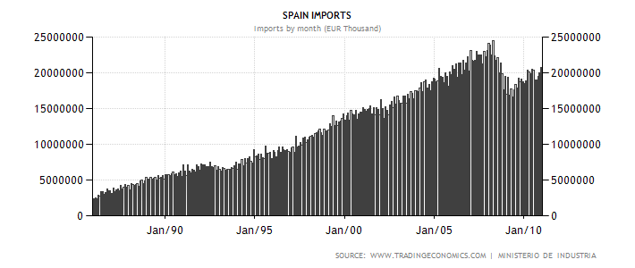
f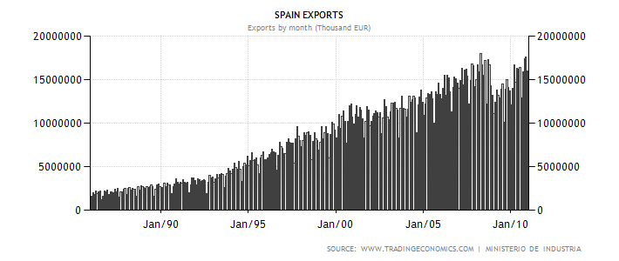
The first economic factor studied to see the health of the Spanish economy and integration is exports and imports from abroad compared to Euro zone Countries. Once an economy is brought into the EEC, they become a preferred trading partner. As a percent of GDP imports rose from 8% in 1980, to 15% in 1990, and then finally 32% in 2000.
Exports had a similar nature about them, starting at 11% in 1980, then to 16% in 1990, and finally 31% in 2000. Spain’s trade with the Euro zone countries represents around 60% of the total imports and exports.
Although the opening-up of the Spanish economy has been gradual, one of the key dates was undoubtedly Spain’s entry into the EEC because of its implications for the performance of the external sector. The large-scale tariff dismantling required by economic integration and the introduction of VAT (value added tax) as of 1986 clearly had an impact on the performance of Spain’s external trade, and, specifically, on exports and imports, the responses of which to the new situation differed markedly…. As a result, the degree of openness of the Spanish economy increased sharply, although entirely because of the expansion in imports. (Fifteen years may not be enough, nov, 26, 2003 p4)
Exports and imports rose sharply during this time period, The rapid increase in exports and imports was a result of a late integration of Spain into the world economy. For example During 1982-1986 these percentages of GDP in Germany only fluctuated 2% total, starting at 23% and 24% respectively, to a high in 1984 of 25% and 26.3%, then finally back down to its starting percentages in 1986. A steady rate of export and import growth shows that an economy has been immersed in the world market and progressing with the world market, but extreme growth can be detrimental. Your monetary policy and fiscal policy can be under adapted to compliment your extreme growth, for instance you can adapt policy to further your economic goals. This shock can cause high unemployment from shifts in the LM (labor market) from previously established industry workers migrating to the new and upcoming industries encouraged by changing monetary policy. The overarching theme of discussing exports and imports growth from the beginning of Spain’s EEC admittance shows just how much being a preferred trading member increased the countries profitability from the world market and specifically their EEC trading partners. Without being a member of the EEC, would Spain’s growth been as extreme as it was? In the article 15 years may not be enough, the articles stated

“European integration was, overall, quite beneficial for the Spanish economy. This is not to say, however, that it did not also induce some costs that will perpetuate. Europe is responsible for the not-so-efficient agricultural policy or fishing policy and has pervaded Spanish external relations, in particular with Latin America. Additionally, the rigidities in the EU in both the labor market and the product markets, and the inherent protectionism of the EU represent a dead weight for the perspectives of Spanish potential growth” (Spain and Portugal in the European Union: The First Fifteen Years, p163)

Once the EEC became the EMU (European Monetary Union) their currency went from the peseta to the Euro, bringing down the most significant trading barriers in the EEC by introducing a uniform currency. Now that the Euro Zone countries all had one currency after 1997, they didn’t have to convert whenever they traded amongst each other. This brought down the price of transaction cost, but also made each country focus on stabilizing the Euro’s currency exchange rates.
Contribution of Debt to GDP
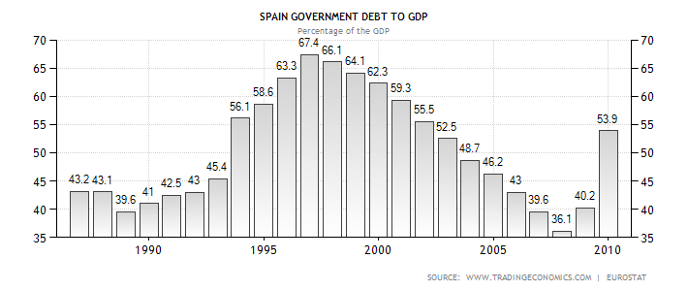
The next important step toward monetary stability is the rate of government debt to GDP, and controlling that specific factor as much as possible. One way that a country can lose their AAA status is to have an enormous amount of debt % of GDP
To understand how this treaty changed the overall meaning of European integration, the economic factors affected by the treaty need to be discovered. The Maastricht treaty put more regulations into place then that the treaty of Paris, because it had more restrictive requirements on economic factors. This was only because after the treaty of Paris, more requirements were needed for the entire community under the Euro. Provisions amending the Treaty Establishing the European Economic Community with a view to establishing the European community in 1992 set into motion the adoption of the Euro. These are the restrictions that were amended from the original sanction, but only highlight the effects to economic markets:
(a) the elimination, as between Member States of customs duties and quantitative restrictions on the import and export of goods, and of all other measures having equivalent effect; (b) a common commercial policy; (c) an internal market characterized by the abolition, as between Member States, of obstacles to the free movement of goods, persons, services and capital... (f) a common policy in the sphere of transport; (g) a system ensuring that competition in the internal market is not distorted. (j) the strengthening of economic and social cohesion (l) the strengthening of the competitiveness of Community industry; (n) encouragement for the establishment and development of trans-European networks;
This higher level of integration and interplay of standardization among the new EMU states seems much like the same regulations as the EEC, but they require and include different monetary policy and what contributions of GDP should be coming from. The constitution for the EMU continues to say…
“These activities shall include the irrevocable fixing of exchange rates leading to the introduction of a single currency…the primary objective of both of which shall be to maintain price stability and, without prejudice to this objective, to support the general economic policies in the Community, in accordance with the principle of an open market economy with free competition.”(Emu constitution 2/7/1992)
The treaty goes onto give all the economic factor regulations needed to become a member of the EMU, steady inflation rate, and a low percent of debt % of GDP. This portion Article 104c (referenced #2) gives the ramifications of sufficient public debt contributions to GDP. Spain was entering a phase where they needed to keep their % of Debt to GDP in check or there would be consequences with the council that presided over documenting these factors. This council limited budget deficits to 3 % of GDP and debt to be 60 % of GDP. In 1985, when Spain became an EEC member with a budget deficit of 6.4% of GDP and debt to GPD was 40.4%. In the next few years the budget deficit did go down 3% and debt 39.8% in 1988, but rose again in 1994 peaked at budget deficits of 6.7% and debt to GPD 47.6%. Spain’s % of debt to GDP was well under the benchmark set by the treaty after 1994, but their budget deficits ratio was far higher than the benchmark placed. It stayed consistently over 6% until 1995 when it dropped to 2.8% in 1997. By 2000 the budget deficits stay around 1%, but debt % of GDP continued to rise and by 2000 it was exceeding 60% at 60.6%. This was a signal to most economists at this time that Spain would have a hard time keeping economic factors consistent with the treaty bylaws, by the erratic behavior of just this economic factor. The debt contribution to GDP was still over the amount allowed, and Spain was still an economy that integrated the Euro. Budget deficits are not a great way of looking at long term economic health, but growth in overall debt contribution is alarming after seeing over a 6 year span rising 14%. Mentioned in Lessons from the Integration of Spain and Portugal to the EU, countries seemed to be able to manipulate economic factors so they could meet convergence criteria. This integration was misconstrued for long term instead of short term effects on this economy.
On January 1, 1999, Spain became founding member of the European Monetary Union (EMU), which as late as 1997 was considered an outside candidate for joining the euro zone, fulfilled the inflation, interest rates, debt, exchange rate, and public deficit requirements established by the Maastricht Treaty. (Lessons from the Integration of Spain and Portugal to the EU)
The criteria are still monitored by the EMU councils, but after their admittance their economic factors had to stabilize and stay constant. This large amount of extreme growth in, exports, imports, and amount of debt % of GDP shows the amount of benefits Spain’s economy has received. They were buying more, selling more, and allowed to borrow more for expansion; but such rapid growth came at a price.
Inflation
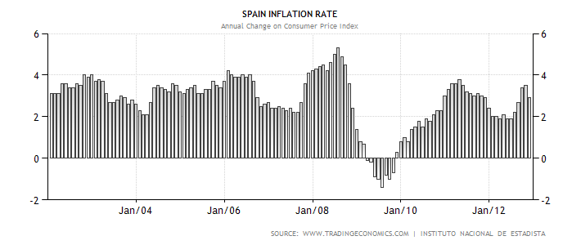
Every year since Spain has become a member it has exceeded the EU average for inflation. At the start of its membership in the EEC Spain was allowed the reduction of inflation expectations and the enhanced the credibility of fiscal policy, giving rise to a virtuous cycle that, at the end, made it possible for Spain to meet the criteria and become a founding member of the European Monetary Union. In 1996 Spain had a 8% overall chance to be a part of the EMU, and then 2 years later they had an 80% chance of getting into the EMU. Wage moderation and the granting of independence to the Bank of Spain (1994), brought the introduction of annual inflation targets, allowed expectations of inflation to diminish, and the prominence of Spain becoming a member of the EMU increased. In the 1970’s Spain’s inflation rate exceeded 20%, which could be attested to their dictatorship ruler. By 1987, their inflation rate was under control and was averaging at 5%, and in 1989 rose to 6.5%. Their inflation rate has exceeded the euro zone’s by an average of over 1 percentage each year and widen the gap to 1.5 in 2004. This economic factor is the most prevalent in any analysis of an economy, because it shows how much prices for goods and services are growing.. According to Lessons from Spain and Portugal integration on contributions towards economies.
During 1994-99, EU aid accounted for 1.5% of Spain's GDP and 3.3% of Portugal's. EU funding has allowed rates of public investment to remain relatively stable since the mid-1980s. The percentage of public investment financed by EU funds has been rising since 1985, reaching average values of 42% for Portugal and 15% for Spain. Moreover, the European Commission has estimated that the impact of EU structural funds on GDP growth and employment has been significant: in 1999, the contribution of these funds to GDP growth was 9.9% in Portugal and 3.1% in Spain in 1999. These funds amount to just over one-third of the EU budget. (Lessons from the Integration of Spain and Portugal to the EU Nov 9 2003 p 164)
For such small countries to receive one-third of the EU budget, was very beneficial to these countries but there is not guarantee of success. This money is seen as an investment into the less off countries, so they can eventually learn to stabilize their economic factors. If these economies take this money and invest it poorly, then they would be farther in the hole than if they had never received the funds in the first place. For Spain, papers by Andrés and Hernando (1996 and 1997) [8] and Andrés, Hernando, and Krüger (1996) conclude that inflation reduces real per capita income growth over an extended period of time, there being a permanent impact on the level but not on the growth rate. It’s also said that inflation influences unemployment, because the higher the inflation the less incentive there is to save money. In a world with high inflation, the prices are changing so quickly that people see an advantage of consuming more now and saving later. This wasn’t the case though, because it also effects employment, the cost of goods is rising faster than expected so the prices of raw material goes up resulting in less products made and less workers needed to make them. This could be a large factor in the amount of unemployment Spain currently has, because they have been over the inflation rate average of the EU for so long. Spain’s unemployment rate was near 30% before the integration into the EEC and EU, and dropped to 13.7% by 2000. Comparing the inflation rate to the unemployment rate, when the inflation rate was higher than other EU countries, Spain’s unemployment was higher as well.
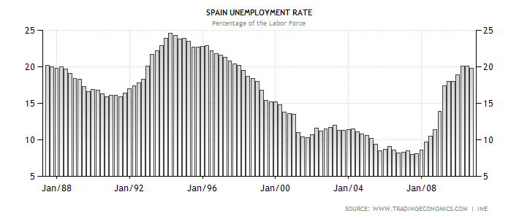
After Spain was pegged to the Euro, their economic status started to really impact the value of the currency. With all of the investment going into Spain from Euro funds and their contribution of debt and budget deficits to GDP, Spain found that they needed even more incentives for investment into their country.
They achieved this investment through different means, they sold government bonds but after they became a part of the EMU the investment meant something different than it did before. Now that Spain had the Euro, they were paying back government bonds with a currency that was linked to the rest of Europe. This created some strife, because if Spain was selling government bonds as the same rate that Germany was, they would be giving back the same type of currency but not having the same economic backing as Germany means that Spain pushed some of the weight on the rest of the Euro countries. According to EMU and European Stock Market Integration
Concerns about the ability of highly indebted governments to control budget deficit led to a substantial widening of long-term interest rate differentials among European countries.
These long term interest rate differing from each other became a large problem among the borrowers in the EU, specifically Spain and Greece. Interest rates for ten year bonds were at a 16% rate in 1985 for Spain, and they were at 10% for Germany. These bond levels were about to converge because of the connection of their currency in 1997, so how was Spain going to cut bond prices by one-third by the time the Euro was introduced? Speculation suggests that the growth that was experience from their integration in 1986 helped them bring down their bond yield price, but how will they keep their bond yield prices up once they need more investment than they receive. Under a uniform currency if one country is running a deficient, it brings down the value of the currency for all players that use that currency. Integration should have occurred only after countries had demonstrated their willingness to purse such stability oriented policies, but this was contradicted or skewed by the economic growth during the 90’s (Countries like Greece and Italy saw prosperous growth during the 90’s which might have been the only reason they meet the criteria possible to get into the European union in the first place).
Spain’s debt seems to keep getting deeper, and if they keep circulating bonds, they will keep circulating Euros bringing down the value of the currency. Their bond yield price is still above the average of EU countries but is low enough to not extremely bottleneck all Euro investment towards them.
Most critics of Spain’s integration into the EMU, say that the convergence Takes a longer time than was allowed for Spain. At the begging Spain was given economic regulations that were broader so they could meet convergence criteria, for instance EU funding and breaks on debt contribution ratios. The European union took a gamble at letting Spain into their economic community, but Spain has grown so much from it they have no reason to complain. Their jump from a dictatorship third world country, to one of a first world country in a matter of 25 years shows how much a small economy can gain from partners in a big economy.
Spain is not the only country in the EU that is struggling and trying to not ask for another bailout of their country. Portugal, Greece, and Italy all have had their economic troubles since their admittance into the EU. In 2010 Spain’s retirement age was changed from 65-67, and was said to be because the lifespan of citizens was getting so much longer that people were need in the job force longer to produce more for the nation. They also did this so they could have a more flexible labor market that could adapt better to changing export trends. On 3/272011 an article was written in The Guardian newspaper saying that we should not compare Spain to Portugal, because it’s not in a place where it could fall into a full debt crisis. An excerpt from the article states
More important, Spain has recently demonstrated a great deal of fiscal responsibility. From 2000 to 2008 it often ran budget surpluses. The moderate public debt went down from 66% to 47% of GDP in this period. Other countries that were also growing saw their debt increase during the same period, for instance the United States (54% to 71%) and the UK (from 45% to 57%), or they maintained debt at very high levels, as Greece did (from 115% to 105%).
Than in 2009 the contribution of debt to GDP for Spain, again skyrocketed from two factors. The first of these factors was 2009 was a post election year, which seems to disrupt the business cycle when there is any political uncertainty. The second was from the surge of the bailout epidemic in other European countries.

This statement may have held firm at the end of 2010, but by 2012 the percentage of debt to GDP rose even higher than ending in another potential bailout for Spain. These countries of Italy, Portugal, and Greece all had similar factors of how and why they got into the European Union. Greece’s debt contribution to GDP was over 90% in 2010 and has only gotten bigger since they have been bailed out twice by the EU. At what point though does a country go from a contributing society for the union, to a black swan detracting from the overall value of the Euro currency? Spain was never kicked out for having a gap in their convergence criteria, even after their back bailout and Greece even after their second bailout. At what point is it that enough is enough and they should have some type of punishment for not having sound fiscal policies.
Once a country in the EU has had an extremely high unemployment rate, inflation, and contributions of debt to GDP after a certain period of time and economic assistance their membership should be revoked. This is not saying that every country has to be as prosperous as the German and Netherland economy, but they shouldn’t be so far away that Germany becomes an outlier in economic comparisons. For the EU to work solidly, its criteria for membership should be regularly standardized and regulated by a centralized government. This would never fly in the EU because so many people in that region have been under a powerful empire before, and want no more overpowering Economic Union bodies residing over them or their fellow members. The big problem with kicking people out of the Euro is that both the Euro and the new establish currency of the nation value would plummet. Without the Bank bailout though Spain makes 250 billion Euro’s in exports, and with a devalued currency they could do quite well, is a quote from the opposition of what if Spain left the Euro. This would hold true if they exited the EU, but if they were denied admittance back in 1997 or to the EEC back in 1986 they would have never seen the growth or export partners that did show up because of the dismantled tariffs and preferred trading partner status they receive from these two unions.

Works Cited
- BBC News. "Spain - Timeline." BBC News. BBC, 30 Apr. 2012. Web. 08 Dec. 2012.
- Sevastian, Meguel. "Spain in the EU: Fifteen Years May Not Be Enough." Aei.pitt.edu. Universidad Complutense, 5 Jan. 2003. Web. 2 Nov. 2012
- United States Central Intelligence Agency. "Central Intelligence Agency." CIA. United States Central Intelligence Agency, 1 Oct. 2012. Web. 20 Sept. 2012. <https://www.cia.gov/library/publications/the-world-factbook/geos/sp.html>.
- E.E.C. "Treaty Establishing the European Community." - Part Five: TITLE I. E.E.C. Council, 25 Mar. 1957. Web. 25 Oct. 2012. <http://www.hri.org/docs/Rome57/Part5Title1.html>.
- Sanchez, Rafael Myro. "The Integration of Spain in the European Union: Main Industrial Effects." UCM.ES. University of Madrid, 9 Apr. 2001. Web. 10 Sept. 2012. <http://www.ucm.es/info/ecap2/myro_r/Spanish%20Integration%20(1).pdf>.
- Samuel Bentolila, Juan J. Dolado, Wolfgang Franz and Christopher Pissarides. "Labour Flexibility and Wages: Lessons from Spain." Jstor.com. Centre for Economic Policy Research, 18 Apr. 1994. Web. 26 Sept. 2012. <http://www.jstor.org/stable/1344458>.
- Laureano López Rodó. "Spain and the E.E.C." Foreign Affairs, Vol. 44, No. 1 (Oct., 1965), Pp. 127-133. Council on Foreign Relations, 2 Oct. 1965. Web. 14 Dec. 2012.
- Sebastián Royo. "Lessons from the Integration of Spain and Portugal to the the EU." Political Science and Politics, Vol. 40, No. 4 (Oct., 2007), Pp. 689-693. : American Political Science Association, 4 Nov. 2007. Web. 16 Nov. 2012.
- The Economist Online. "The Pain in Spain." The Economist. The Economist Newspaper, 24 July 2010. Web. 25 Oct. 2012. <http://www.economist.com/blogs/graphicdetail/2012/07/daily-chart-15>.
- Walsh, James I. "National Preferences and International Institutions: Evidence from European Monetary Integration." JStor. Wiley-Blackwell on Behalf of The International Studies Association, Mar. 2001. Web. 21 Sept. 2012. <http://www.jstor.org/stable/3096101>.
- Charles R. Bean. "Economic and Monetary Union in Europe." The Journal of Economic Perspectives, Vol. 6, No. 4 (Autumn, 1992), Pp. 31-52. American Economic Association, 22 Oct. 1992. Web. 1 Nov. 2012.
- Gikas A. Hardouvelis, Dimitrios Malliaropulos, Richard Priestley. "EMU and European Stock Market Integration." The Journal of Business, Vol. 79, No. 1 (January 2006), Pp. 365-392. The University of Chicago Press, 1 Jan. 2006. Web. 12 Oct. 2012.
- European Community. "THE MAASTRICHT TREATY PROVISIONS AMENDING THE TREATY ESTABLISHING THE EUROPEAN ECONOMIC COMMUNITY WITH A VIEW TO ESTABLISHING THE EUROPEAN COMMUNITY."Eurotreaties.com. European Economic Community, 1994. Web. 25 Nov. 2012.
- From the Print Edition | Leaders. "The Flight from Spain." The Economist. The Economist Newspaper, 28 July 2012. Web. 15 Sept. 2012. <http://www.economist.com/node/21559614>.
- "Spain Unemployment Rate." Spain Unemployment Rate. Cia World Fact Book, 1 Jan. 1987. Web. 14 Dec. 2012.
- "What If Spain and Greece Did Leave the Euro?" Yahoo! Finance UK. Yahoo Finance UK, 24 May 2012. Web. 26 Feb. 2013.
- Marcet, Albert. "Spain's Economy Isn't like Portugal's." The Guardian. Guardian News and Media, 27 Mar. 2011. Web. 26 Feb. 2013.
- Oliver Oy and Irene Chapple. "Spain: Perils of Being 'filthy Stinking Poor'" CNN.com. CNN Financial, 3 Oct. 2012. Web. 2 Feb. 2013. <http://edition.cnn.com/2012/10/02/business/spain-sovereign-bailout/index.html>.
- Oliver Joy. "Spain's next Threat: Losing 20% of Its Economy." CNN International. CNN Financial, 25 Nov. 2012. Web. 1 Jan. 2013. <http://edition.cnn.com/2012/10/12/business/catalonia-independence-spain>.
- Lisa Abend. "Spain’s Corruption Scandals: The Crisis of the Royal Family." Time World. Times Magazine, 23 Feb. 2013. Web. 25 Feb. 2013. <http://world.time.com/2013/02/25/spains-corruption-scandals-the-crisis-of-the-royal-family/>.

