An Oligarchic Democracy
Amjad Karkout
Monmouth College
Abstract
Scholars have identified different causal factors for the income inequalities in the U.S. Only recently scholars started to pay attention to the role of policy change as opposed to technical change or skill-biased markets. How did policy change through organized interests –political or economic– play role in more income inequalities in the U.S.? In this paper, I argue that organized interests played an important role in increasing inequalities through different political and economic actions, that can be divided into three categories: 1) Demobilizing the public – 2) Decreasing political and economic competition – and most important 3) Mobilizing political action for wealth defense and rent seeking behaviors. Process tracing is utilized to identify the ways that organized interests change policies, which widened the income gap. The U.S. is cited as the strongest economy in the world for decades. Yet, with this economic growth and increased wealth, the U.S. is also cited for its inequalities. To ask why there are inequalities in the richest country in the world is significant by nature. This paper contributes to the literature by outlining the implications of organized interests with the income inequalities.
Keywords: inequality, organized interests, institutions, political economy, U.S economy, policy change

An Oligarchic Democracy
“He who has the gold makes the rules” is what my supervisor commented when he knew I will be studying capitalism and politics, as I was working with him for Monmouth College Facilities Management during winter break 2016-2017. My supervisor, who was an electrician, told me that I should keep in my mind this Golden Rule, as he called it. I smiled at that moment for I was happy to know that maybe people realize that the U.S. is suffering from the influence of wealth on the directions and processes of policymaking. I was reassured it would be beneficial to keep that in mind by my instructor who taught me capitalism and politics, as I used this story in my first weekly reflection for that class. In this paper, I use the theoretical framework of inclusive/extractive institutions introduced by Acemoglu and Robinson (2012a) in their book Why Nations Fail to define a third set of institutions, which I call exclusive institutions. This set of institutions emerged from the organized political and economic interests, and in turn, fostered their growth and allowed their persistence in the American political and economic atmosphere. Then, I argue that organized political and economic interests in the U.S. solidified the rapid increase in income inequalities through the special membership they were offered by these exclusive institutions. These organized interests should be understood as actions that demobilized the public, reduced political and economic competition, and further, mobilized political action to wealth-defense and rent-seeking. Understanding political and economic interests in this manner provides us with better understanding to the role of policy change in the growing income inequalities.
Exclusive institutions and the organized interests
Acemoglu and Robinson (2012a) introduced two kinds of institutions on the economic and political levels; Inclusive political/economic institutions, and extractive political/economic institutions. Extractive economic institutions “are designed to extract incomes and wealth from one subset of society to benefit a different subset” (Acemoglu & Robinson, 2012a, p. 76). Inclusive economic institutions “are those that allow and encourage participation by the great mass of people in economic activities that make best use of their talents and skills and that enable individuals to make the choices they wish” (Acemoglu & Robinson, 2012a, p. 74). However, they made their position clear; by inclusive institutions they did not mean merely free market “Inclusive markets are not just free markets” (Acemoglu & Robinson, 2012a, p. 77). Extractive or inclusive economic institutions need the kind of political institutions that would allow them to survive. Hence, they defined inclusive and extractive political institutions “We will refer to political institutions that are sufficiently centralized and pluralistic as inclusive political institutions. When either of these conditions fails, we will refer to the institutions as extractive political institutions” (Acemoglu & Robinson, 2012a, p. 81).
The centralized but not pluralistic political institutions enable powerful authority to the leaders. Hence, they could construct the economic institutions the way they desire; this is what Acemoglu and Robinson called the absolutist power. In this case, those who have the power would make sure to maintain and increase their power. They would do so by establishing more extractive economic institutions that would allow them more benefits on the expanse of the society. At the same time, they would make sure these institutions would not allow other groups to gain power and wealth. On the other hand, if the political institutions are pluralistic but not centralized at all, they would be extractive too. That is because the different groups would be competing violently; this will lead to a failed state with a cycle of conflicts preventing the economic growth. Also, extractive economic institutions would provide wealth to their leaders, which would allow them to influence and affect the political life in a way that would lead to extractive political institutions. This feedback loop between extractive political and economic institutions explains how individuals can increase their power and wealth. The dangers of these institutions are many. As these institutions prevent political and economic participation, prevent the mobilization of the public, and maximize the political and economic mobilization of the elites, they prevent the collective action and economic growth that would lead the society to prosperity. The institutions in the U.S. are in between inclusive and extractive.
I define a new form of institutions –that exists at least in the U.S.– which I like to call exclusive institutions.
Exclusive institutions are the pluralistic and centralized institutions that allow the great mass of people to participate in political and economic lives under an ordinary membership but enable premium membership for selected subsets of society at the same time.
This form of institutions has been shaping the political and economic aspects of the U.S. since the 1970’s and found the way to success during the 1980’s; during Reagan’s presidency, the private sector was able to transform the inclusive institutions into exclusive ones, leading to less incentives and resources for the citizens to participate in economic and political life as well as increased incentives for large businesses to rent-seek and wealth-defend, leading to sustained growth in inequalities.
To think about it in a simple and fun way, consider how it is if we play some competitive video game in which I enjoy premium membership and you are merely an ordinary member. It is true that I pay more money than you to get all the nice and neat items, but remember, I would use these items to make you weaker, to reduce your chances in getting stronger, and to improve my status of power and wealth. At the end of the day, you either stagnated at your level or barely leveled up, while I leveled up 5 times or more. And at the end of the day, I brought back earnings 5 folds larger than what I paid, while you barely brought back something to build upon. Take this premium membership away from me and you might find that you play much better than me. But as long as premium memberships dealers are paid well by the premium buyers, and perhaps few are both dealers and buyers, it is unlikely you could take away the premium membership. This interconnectedness between dealers and buyers, politics and economy, while still allows you to participate, will ultimately favor its dominance. This is the organized political and economic interests.
Growing Inequalities in the U.S.
I am an American and live must be good!
One might question if income inequality in the U.S. is real. Indeed, many Americans do not have the knowledge on this topic. Norton and Ariely (2011) surveyed a diverse sample of U.S. citizens asking them for estimations of wealth distribution. They found that there was an underestimation of wealth distribution among respondents, the ideal distributions which respondents suggested had more equality than what they erroneously believed to be the wealth distribution, and that all demographics including Republicans and wealthy individuals preferred more equal distribution. At the same time, many Americans believe they have good chances to be rich one day (DiPrete, 2007). There are many misinformed Americans about the influences of economic policymaking on their lives (Bartels, 2008), yet, many tend to not favor policies that would reduce inequality (Benabou and Ok, 2001). Based on the findings that suggested misinformed public about political matters, political scientists are inclined to believe that a misinformed public would not get the Congress to seriously consider the issue (Carnes, 2016; Norton and Ariely, 2011).
Inequality, it is real…
To answer those who might question the severity of inequalities in wealth, it is best to include what scholars found concerning the topic. Bivens and Mishel (2015) tested the divergence between productivity and worker’s compensation. Their methodology in showing the gap of inequality explained that productivity is still increasing while the largest sector of the American workforces is suffering from wage stagnation. Graph 1 (borrowed from EPI) shows the gap between net productivity and median seasonally-adjusted hourly compensation. Instead of using gross productivity, which will even show bigger gap if it was used, they decided to use the net productivity (i.e., excluding all costs of production). Comparing net productivity to the seasonally-adjusted compensation, in both mean and median forms, shows the error in distributing the benefits of productivity growth; the huge difference between the mean and median shows that few people cultivate most of the productivity earnings shifting the average hourly compensation to higher levels. Therefore, the average is not an indicator of inequality, but the gap between productivity-and-the median compensation and the average-and-the median compensation are the indicators of the huge inequalities.
Bivens and Mishel’s (2015) findings go in line with what other scholars found in studying wealth inequality. By testing pre-tax income, Piketty, Saez, and Zucman (2016) suggested that economic growth at the bottom 50% of income distribution has been shut off since 1970, even though the U.S. economy is still witnessing growth. At the same time, the top 1% of the income distribution witnessed 205% increase in their income, and the top 0.001% of income distribution enjoyed 636% increase in their income. Hacker and Pierson (2010b) in their well-articulated paper about winner-takes-all system and inequality in the U.S. reported similar results in which they suggested three features of the growing inequalities; concentration of wealth at the very top, the gains were sustained and growing since 1980s, the gains slightly benefited who are not at the very top.
Figure 1:
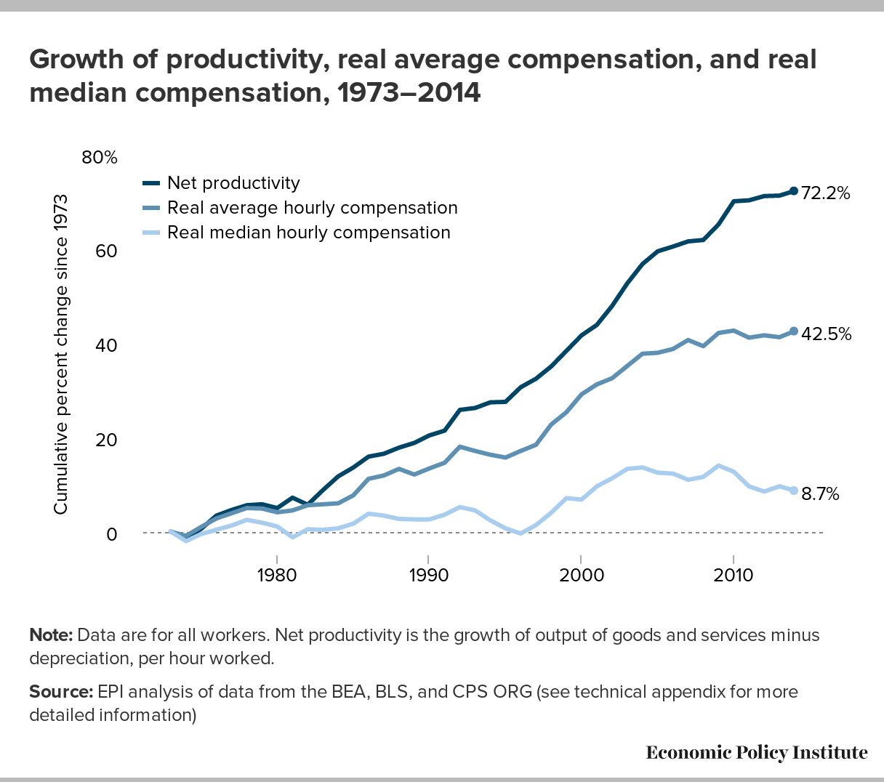

Categories of Action
This inequality is the product of competing American dreams of large businesses on the one side and the working class on the other. As Hacker and Pierson (2010a) like to call it, “The Politics of Organized Combat”, in which the winners were the organized and mobilized businesses. They explained how businesses started to unite and organize their interest to influence policies since the 1970’s. Vogel (2003) reported the history of U.S. businesses interactions with the American politics. According to him, businesses’ top executives started to mobilize their resources and efforts to produce more business-friendly policies, which he also explained how it started in the 1970’s as well. Vogel (2003) and Hacker and Pierson (2010a) provided examples of the massive increase in budgets, staffing, and meetings with political officials of these organizations just between 1970 and 1979. At the same time, they explained how the American businesses did not feel satisfied with President Carter, although they enjoyed several wins against the well-fare state policies and the worker-friendly policies. Not until President Reagan arrived to the White House the American Businesses enjoyed political power.
Carnes (2016) conducted several tests to measure who votes for inequalities in the U.S. Congress. Although limited to the 2011-2012 legislative season, his findings suggested that Republicans vote for policies that increase inequalities almost all the time, no matter who their constituents are. Also, among Democrats, those who receive more money from businesses, who raise more money overall, who ran business most of their careers, who worked in white-collar jobs are more likely to vote for policies that would increase inequalities. Alongside his analysis, Carnes (2016) combined previous literature on inequality to define six potential obstacles preventing the Congress from taking actions to reduce inequalities:
1. Many Americans don’t realize how unequal the United States is, or they don’t care.
2. The rich are more likely to participate in public affairs.
3. The rich are better able to advance their goals with organizations and lobbyists.
4. Lawmakers depend on wealthy campaign donors to finance their elections.
5. The parties are polarized, and Republicans oppose policies that would reduce inequality.
6. Most lawmakers are from the top economic strata themselves.
With all of that in mind, it is almost criminal to miss how the organized interests shaped the American institutions to be exclusive. Here, I explain the three categories of actions that are the outcome of the political and economic interests of the organized businesses to maximize their profit.
Demobilizing the public
The key feature of democratic systems is the ability of the mass public to participate in the political and civic lives. Although there is no agreement among political scientists on one definition for democracy, they agree on minimal political rights (i.e., free and fair elections, most individuals can run for office, regularly scheduled elections, and voters have multiple choices to vote for) and civil liberties (i.e., freedom of speech and expression, freedom of the press, freedom of assembly, freedom to join parties and interest groups, and freedom to access sources of information) as essential in defining democracy (see Dahl, 1971; Dickovick & Eastwood, 2016a; Schmitter & Karl, 1991 for democracy definitions). As such, the public in democratic countries utilizes civil liberties to organize and mobilize public support for a common cause. While the U.S. maintains these rights and liberties, it is important to note that they have been hijacked by organized interests favoring the few while the rest of the public became demobilized.
Decreasing political and economic competition
Another undesired outcome of such organized interests is the reduced political and economic competition. There is no disagreement among economists and political scientists that competition is the drive of a democratic capitalist society. Capitalism function as members of a given society are able to freely participate in the market. As they participate in the form of business they prefer, they become specialized, and the outcome is more produced and better enhanced goods. Capitalists are motivated by more earnings. Their incentive to earn more –as they compete with other businesses– is what leads to goods that are cheaper and better in quality. Specialization also allows new jobs as new businesses would emerge to supply the demand of a specific product. Hence, the supply and demand, the cycle of money in producing and consuming goods, and the productivity of the labors’ invisible hand in competitive, specialized, and free markets would stimulate the economic growth. In turn, this would increase the wealth of capitalist nations. From Adam Smith, to John Keynes, to Milton Friedman, to contemporary economists, this simplified explanation of how capitalism works is approved. Yet, the role of government in facilitating this process is what they disagree upon (see Kaletsky, 2010; Read & Friedman, 1958; Skidelsky, 1992; Smith, 1950 for detailed explanations of capitalism). Despite their disagreement, the take away from this is that competition drives productivity and is important to increase the wealth of the nations.
On the other hand, political competition is no less important than market competition. Political participation, as I explained in demobilizing the public section, is the key element in a democratic society. Whether participation was through political parties, interest groups, holding an office, voting, or any kind of political activism, it is what allow the collective action of a given society to produce the best possible outcome for the society’s members. As such, all sectors of the society should be able to express their interests and to influence policymaking processes in a way that does not allow the few to dictate the destiny of the larger population. However, politics and economics are nothing but best friends; we cannot approach or think of one of them without considering the other. The organized interests in the U.S. decreased political and economic competition through these exclusive institutions, which should be conceived as a serious threat to the American democracy and economic growth.
Mobilizing political action for wealth defense and rent seeking behaviors
The last and most important category of organized political and economic behaviors is the mobilization of the political action for wealth defense and rent seeking behaviors. It is no surprise that the U.S. is criticized for crony capitalism (The Economist, 2014) and for manipulating capitalism into corporatism (Ammous & Phelps, 2012). Dr. Jessica Vivian, a political economy professor at Monmouth College, shared with me that capitalism is driven by profits, and the genius of capitalism maintains that owners of capital will always find ways to reduce the cost of production, and this process influences the state to deliver what capitalism wants as well as influencing the social and political structure (J. Vivian, personal communication, February, 2017). Hence, American businesses found their way to accomplish that through rent seeking and wealth defense; in other words, by mobilizing political action to increase profits. Rent seeking is the economic behavior that influences political process to keep tax rates low while increasing profits at the expanse of the citizens, and it explains much of the inequalities in the U.S. (Thoma, 2014).
The Oligarchic Democracy; American Dream, No More
In this section, I provide explanations of how the organized interests injected the American democracy with exclusive institutions, transforming it to an oligarchic democracy. When I started my political science studies, I thought I was being smart to notice that there are some oligarchic tendencies in the American political system, and I thought I was creative to call this system an oligarchic democracy. It turns out that I am not on my own in this context. Winters and Page (2009) argued that oligarchy is not inconsistent with democracy and that oligarchs can influence political action without direct involvement in politics. They argued that the wealthiest Americans enjoy greater political power through lobbying, campaign finance, and shaping the public opinion. Let us explore some oligarchic practices that utilized the exclusive institutions they created to demobilize the public, reduce political and economic competition, and enhanced the mobilization of their political action to rent-seek and defend their wealth.
Hi, my name is ALEC, my best friends are Citizens Divided
Lobbying is an important feature of the democratic process in which the public might influence policymaking directly or indirectly. Direct lobbying is when lobbyist interact with legislatives directly to pass the legislations of interest. Indirect lobbying is when lobbyists mobilize public pressure to pass the legislations of interest (Holman, 2006; National Conference of State Legislatures, 2017; Roy, 2015). Lobbying is perhaps the strongest tool for influencing policymaking. A huge amount of money is spent on lobbying (see figure 2), which tells us how effective these people are. While lobbying spending has been increasing since the 1970’s, it stagnated and the number of registered lobbyists dropped since 2008. Is it because of better regulations imposed on their practices? Probably not, especially that our goal should not be to reduce or eliminate lobbying but to allow the mass public to participate in the policy making process. What explains the stagnation in lobbying spending and the drop in the number of lobbyists are the demobilized public, the reduced political and economic competition, and the mobilized efforts to rent-seek. Let us investigate the situation.
In 1993, President Clinton signed a tax reform to disallow deductions on lobbying practices (Holman, 2006; Legos & Jones, 1995). This reform harshly hurt the economy by denying the access of ordinary citizens to lobbying. Eliminating the deductions on lobbying expenses is an important reason of why there was an increase in the lobbyists pay; for their income is not allowed the deductions tax credits, their paycheck needs to make-up for this. As such, the only entities that would be able to pay for the lobbying costs are the well-off entities. This opened the door wide for monopolies on the federal and state levels since only the well-off can influence policymaking. Hence, there was decrease in economic competition since only they rich can effectively pay lobbyists, in turn, there was decrease in political competition.
Figure 2: lobbying spending and lobbyists number
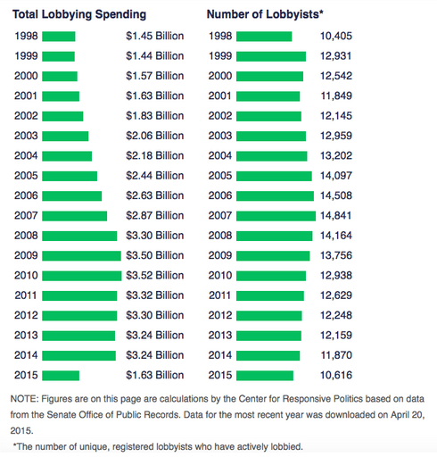
NOTE: the figure was borrowed from Roy (2015).

To make that worse on the local level as well, section 162 (e) within the Internal Revenue Service (IRS) tax code maintained that deductions for lobbying and local expenditures in the case of any legislation of any local counsel, including Indian tribal governments, are allowed. However, this law was in practice up until December of 2017 tax year. However, the recent tax reform in 2017 dictated a permanent change on this law. The reform will eliminate the deduction for local lobbying expenses for amounts paid or incurred after the date of enactment. With monopolies come too many other, undesired outcomes such as decline in small businesses and start-ups, weakened infrastructure and public goods, and decline in the supply-demand cycle (decline in local spending). But the story does not end here. Something called ALEC told us that there was further mobilization to influence policymaking through different means.
Hi, my name is ALEC, my best friends are Citizens Divided
ALEC. It stands for the American Legislative Exchange Council. But what is ALEC exactly? It is a corporation of conservative state legislators and private sector that is qualified by the IRS as a 501(c)(3) organization, which would make it a tax-exempt entity; it is considered as non-for-profit organization and its practices are not considered lobbying. How good are these people? Very good, and here is why. Publication 529 in the IRS Tax Code maintains:
You generally can't deduct amounts paid or incurred for lobbying expenses. These include expenses to:
- Influence legislation;
- Participate, or intervene, in any political campaign for, or against, any candidate for public office;
- Attempt to influence the general public, or segments of the public, about elections, legislative matters, or referendums; or
- Communicate directly with covered executive branch officials in any attempt to influence the official actions or positions of those officials.
Lobbying expenses also include any amounts paid or incurred for research, preparation, planning, or coordination of any of these activities.
At the same time, Jackman (2013) tested the likelihood of ALEC’s influence over policymaking on the state level. She found that proposed bills that would have relations to ALEC are more likely to pass. ALEC is designed to influence politics through all the points stated by the IRS as lobbying practices which should be taxed with deduction disallowance. Somehow, they managed to be tax-exempted! ALEC guys work on influencing legislations, they participate in political campaigns for and against candidates, they influence the general public about elections and legislations, they communicate directly with both legislative and executive branches, and they fund research, planning, preparations, and coordinating for these practices. We are not done with these exclusive institutions, yet. ALEC is not the only organization with this political power. Let us check one more similar organization.
Citizens United. It is another conservative nonprofit organization, qualified as 501(c)(1) organization, which is also tax-exempt. Citizens United succeeded in 2010 to change a major policy in campaign finance, reallowing easier ways for unlimited money spending on campaigns; through the famous Supreme Court Case Citizens United v. FEC. No wonder that registered lobbyists are dropping in number for such lobbying-like organizations are doing very well in changing laws while not considered as lobbyists. Since 2010, campaign spending did not increase or decrease, but the outside (not party) spending increased for federal elections to make up more than 20% of the total spending (see figure 3). At the same time, considering incumbency advantage (which I talk about in the following section), most of the legislatives at the federal and state levels are the same, hence, these organized interests needed only to pay little more on campaigns to keep their beloved incumbents in charge. Why would they spend more on lobbying while there are cheaper ways? Again, ALEC and Citizens United are not the only corporates in which businesses use to mobilize political action. Also, it not only conservatives who use such cheap politics, latterly “cheap politics”. Democrats also utilize such organizations (see Democratic Governors Association, American Federation of State, County, and Municipal Employees, and Service Employees International Union for examples). Now let us talk about incumbency advantage.
Figure 3: Percentage of outside spending in federal elections
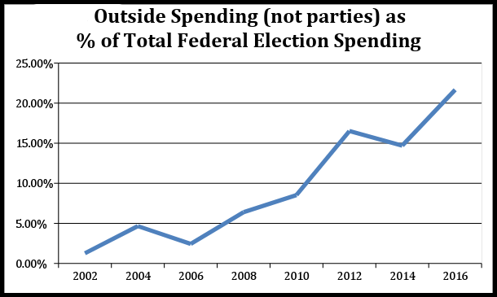Sources: Biersack, B. (2018). 8 years later: how citizens united changed campaign finance. Retrieved from https://www.opensecrets.org/news/2018/02/how-citizens-united-changed-campaign-finance/

Incumbency advantage
Incumbency advantage is a phenomenon in which office holders have better chances for reelection than their challengers. Research on incumbency advantage suggested many reasons why incumbents may have greater chances to win. Some scholars argue that incumbents win reelections because they have higher qualities than their challengers (Cox & Katz, 1996; Levitt, & Wolfram, 1997). Other scholars argue that a large part of the advantage is because of scare-off; that is, potential opponents do the math before they run against an incumbent (Jacobson, 2009; Sidman, 2008). Hall and Snyder (2015) suggested in their study that party incumbency plays a role in favoring the incumbent’s reelection and that scare-off phenomenon almost plays no role in U.S. elections.
Kondik and Skelley (2016) provided data on the reelection rates for the 2016 elections compared to post-WWII. As shown in figure 4, incumbents in the House had 93% total success rate, in the Senate had 80% total success rate, and governors had 73% total success rate before the 2016 elections. The 2016 elections even presented higher reelection rates, which suggest that incumbency advantage is not going away. Incumbency advantage represents the three categories of action for keeping almost the same people in charge allows mobilizing political action for rent-seeking, it reduces political competition and in turn economic competition since these are the same guys who vote against the rest of the Americans, and it keeps Americans demobilized since mobilizing efforts against incumbents is unlikely to help.
Figure 4: reelection rates:
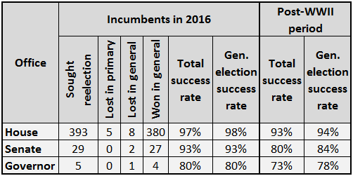
Sources: Crystal Ball research; Vital Statistics on Congress. In Kondik, K., & Skelley, G. (Eds.). Incumbent reelection rates higher than average in 2016. Rasmussen Reports, 15, 12.

De-unionization
Since the early 1970s, there has been a decline in unions membership in the U.S. (Farber & Krueger, 1992; Visser, 2006; Western & Rosenfeld, 2011). Unions foster equal wage distribution (Freeman & Medoff, 1984; Western & Rosenfeld, 2011), therefore, this decline was suggested to account for much of the increased income inequality (Card, 2001; Hacker & Pierson, 2010a; Hogler, Hunt, & Weiler, 2015; Western & Rosenfeld, 2011). With this decline in unions, a large slice of the public is undergoing a decline in its ability to mobilize support and influence policymaking.
The role of political and economic interests is central to the decline in unions. Hacker and Pierson (2010a) argued that corporates and firms at the top of economic distribution started to well organize and influence policies since the 1970s. These economic interests conflicted with the organized labor interests manifested in labor unions. In turn, political interests favored the growing influence of corporates and businesses, while opposing reforms and regulations that would strengthen labor unions. Cowie, J. (2010) argued that unions suffered from political defeats in the 1970s and the 1980s, in which employers gained power that allowed them to prevent organizing campaigns that would strengthen workers bargaining power.
At the same time, unions were not only watching and accepting their political defeats. Vogel (2003) explained how in 1978 unions mobilized their efforts and attempted to pass a major labor reform bill. The reform passed the House and gained majority in the Senate. However, employers mobilized their resources and targeted Republicans and Southern Democrats. Hence, a Senate filibuster was maintained regardless to the majority support. Farber and Western (2002) reported that unions held many strikes during the 1980s, which were out of desperation rather than the unions ability to mobilize collective action. Indeed, the labor demand for unions in the U.S. is unfulfilled, and this unfulfillment is the largest compared to labor demand for representation in other countries (Freeman, 2007). Finally, Hacker and Pierson (2010a) argued that the advanced industrial countries with stronger unions did not witness the top 1 percent economic shift. With all of this evidence, the political economy of the declining unions is nothing but the outcome of the organized political and economic interests. In demobilizing and weakening labor forces, employers were able to increase their profits since their workers were desperately unable to effectively bargain for better income or to influence policy change. Hence, this is one of the signs in which the 1970’s witnessed the emergence of the exclusive institutions that would widen the income gap between employers and workers.
Mediatization
From the 1980’s to the 2000’s, the number of corporations that owned most of the mass media dropped from fifty elites to five giants; Time Warner, Disney, Comcast, News Corp, and CBS (Campbell, Martin, & Fabos, 2012). This media consolidation has huge effects on democracy and mobilizing public actions, clearly, because the sources of information and communication are limited. According to Clarkson, Miller, and Cross (2010), corporate consolidation is the combination of two or more corporations to form one corporation as an entirely new entity. The newly formed corporation takes over the rights, powers, privileges, titles to any property, assets, debts, and obligations of the combined corporations, while the combined corporations no longer exist. Let us explore how organized media could influence public opinion and policymaking.
In political communication studies, mediatization is defined as the influences of mass media on shaping and framing politics, culture, education, religion, and the society (see Hepp, Hjarvard, & Lundby, 2015; Hjarvard, 2013; Lilleker, 2006; Mazzoleni & Schulz, 1999; Strömbäck, 2008 for a collection of mediatization definitions). Hepp, Hjarvard, and Lundby (2015) clarified that mediatization does not necessarily suggest a causal force in which media manipulate or dictate change, but it suggests interactions between media and sociocultural changes, in which media is not the only causal force of transformation in politics, economics, education, religion, etc. Hjarvard and Petersen (2013) suggested transformation in authority performance and reputation building and defense. They also suggested that developments in media technologies shape the affordability of media, thus, mediatization could be directed towards specific path. As such, many scholars suggested mediatization to be a challenge to democracy and economic integration (Landerer, 2013; Mazzoleni & Schulz, 1999; Strömbäck, 2008).
Campbell, Martin, and Fabos (2012) discussed how antitrust laws are limited. They explained that antitrust laws aimed to ensure multiple voices, however, since the 1980s, media companies were able to impose monopolistic existence through diversification, forming local monopolies, and merging with other big media companies. Diversification means that most media companies never dominate one particular media, instead, they operate through multiple media industries (see table 1 for more information). These firms, through diversification and the limits of the antitrust laws, were able to establish local monopolies. That means, they were granted monopoly status on the local community level in which they provide the only newspaper or tv channels to a community (Campbell, Martin, and Fabos, 2012).
It would be misleading to assure that these media firms conspire with policymakers and businesses against the general public. But at the same time, it would be misleading to disregard the danger of restraining media within few giant companies. By allowing local monopolies there are less voices which would reflect in our opinions and views as well, and this could lead us to think and act against our interests. Let us consider unions again and how their attempts to mobilize efforts and change policy were portrayed by these major media companies. Martin (2004) explained that labor was framed in over a ten-year period as to be hurting the American consumer economy. The pattern in which these media news and corporate news portrayed labor unions or any collective action is similar. They did not portray them as inherently bad thing, but the bias in sharing the stories as the strikes hurt the economy without explaining why the strikes are happening in the first place has a clear demobilizing effect on the public, and it has clear effects on our policymakers and their decisions.
Table 1: list of few media industries owned by the 5 media giants
CBS | News Corp | Disney | Comcast | Time Warner
CBS Radio | Twentieth Century Fox | Walt Disney Studios & Pixar | Universal Pictures | Warner Bros.
CBS News | Fox Searchlight | Buena Vista | USA Network | TBS
Showtime | Wall Street Journal | Nickelodeon | NBC | TNT
Simon & Schuster | New York Post | Lifetime Television | Xfinity | CNN
CBS Films | HarperCollins | ABC | NBC News | Time Warner Magazines
Last.FM. | Fox Broadcasting | Citadel Broadcasting Corp. | DreamWorks | HBO
CBS Sports | MyNetworkTV | ESPN | MSNBC | DC Comics
CW-TV | Fox News Radio | Marvel Entertainment | NBC Sports Group | Hulu
Source: Campbell, R., Martin, C. R., & Fabos, B. (2012). Media and culture: An introduction to mass communication. Boston, MA: Bedford/St. Martin’s.

Conclusion

Most of our policymakers has been the same people holding offices and directing our politics. At the same time, there has been huge efforts by businesses to organize their political and economic interest to further increase their profits. As such, they targeted the political and economic institutions to allow them exclusive memberships in which they could insure their success and increased earnings through demobilizing the public, reducing economic and political competition, and improve their mobilizing efforts to rent-seek and wealth-defend. To overcome this dangerous dominance of businesses over our politics, we need to establish a better policymaking process that would enable workers to represent their voices alongside owners. Hacker and Pierson (2016) explained that if we are to make American great again, we are supposed to allow the bigger size government that is able to intervene and correct the market failures (i.e., monopolies, externalities, and public goods).

Government intervention in the context of my paper should not be only focused on better monetary and fiscal policy, it also need to account for regulating business interventions in political and social institutions. Acemoglu and Robinson (2012b) explained why state capitalism could favor economic growth but at the same time is related to authoritarian regime where the political power is centralized. In their article, they did not consider the U.S. as to function as state capitalism, which makes sense if we are to compare it to China, for example. However, they clarified that state capitalism could lead to creative destruction because of the innovation and the economic growth it creates, which will lead to more inclusive institutions and therefore democracy. But also, it could lead to stagnation and economic breakdown if the shift from extractive political and economic institutions to inclusive ones was not completed.

At this point, I see the American challenge is to push towards the more inclusive institutions instead of allowing the exclusive institutions to evolve into extractive ones. Acemoglu, Robinson, Hacker, and Pierson emphasized the importance of the interventionist government in correcting the market failures rather than to support certain economic practices. The American challenge is to restore their government from these organized interests.

References
Acemoglu, D., & Robinson, J. A. (2012a). Why nations fail: The origins of power, prosperity, and poverty. New York, NY: Crown Business.
Acemoglu, D., & Robinson, J. A. (2012b). Is State Capitalism Winning?. Project Syndicate, 31. Retrieved from https://www.project-syndicate.org/commentary/why-china-s-growth-model-will-fail-by-daron-acemoglu-and-james-a--robinson?barrier=accessreg
Ammous, S., & Phelps, E. S. (2012). Blaming Capitalism for Corporatism. Project Syndicate. Retrieved from https://www.project-syndicate.org/commentary/blaming-capitalism-for-corporatism
Bartels, L. M. (2008), Unequal Democracy: The Political Economy of the New Gilded Age. New York, NY: Russell Sage Foundation and Princeton, NJ: Princeton University Press.
Benabou, R., & Ok, E. A. (2001). Social mobility and the demand for redistribution: the POUM hypothesis. The Quarterly Journal of Economics, 116(2), 447-487.
Biersack, B. (2018). 8 years later: how citizens united changed campaign finance. Retrieved from https://www.opensecrets.org/news/2018/02/how-citizens-united-changed-campaign-finance/
Bivens, J., & Mishel, L. (2015). Understanding the Historic Divergence between Productivity and a Typical Worker’s Pay: Why It Matters and Why It’s Real. Washington DC: Economic Policy Institute. Retrieved from http://www.epi.org/publication/understanding-the-historic-divergence-between-productivity-and-a-typical-workers-pay-why-it-matters-and-why-its-real/
Campbell, R., Martin, C. R., & Fabos, B. (2012). Media and culture: An introduction to mass communication. Boston, MA: Bedford/St. Martin’s.
Card, D. (2001). The effect of unions on wage inequality in the US labor market. ILR Review, 54(2), 296-315.
Carnes, N. (2016). Who Votes for Inequality?. In Congress and Policy Making in the 21st Century (106). Cambridge University Press.
Clarkson, K. W., Miller, R. L., & Cross, F. B. (2010). Business law: text and cases: legal, ethical, global, and corporate environment. Boston, MA: Cengage Learning.
Cowie, J. (2010). Stayin'alive: the 1970s and the last days of the working class. New York, NY: The New Press.
Cox, G. W., & Katz, J. N. (1996). Why did the incumbency advantage in US House elections grow?. American Journal of Political Science, 478-497.
Dahl, R. A. (1971). Polyarchy: Participation and opposition. New Haven, CT: Yale University Press.
Dickovick, J. T. & Eastwood, J. (2016a). Democracy and democratization. In Dickovick, J. T. & Eastwood, J. (Eds.), Comparative politics: Integrating theories, methods, and cases (2nd ed.) (pp. 119-144). New York, NY: Oxford University Press.
DiPrete, T. A. (2007). Is this a great country? Upward mobility and the chance for riches in contemporary America. Research in Social Stratification and Mobility, 25(1), 89-95.
Farber, H. S., & Krueger, A. B. (1992). Union membership in the United States: the decline continues (No. w4216). National Bureau of Economic Research.
Farber, H. S., & Western, B. (2002). Ronald Reagan and the politics of declining union organization. British Journal of Industrial Relations, 40(3), 385-401.
Freeman, R. B. (2007). America Works: Thoughts on an Exceptional US Labor Market. New York, NY: Russell Sage Foundation.
Freeman, R. B., & Medoff, J. L. (1984). What do unions do. Indus. & Lab. Rel. Rev., 38, 244.
Hacker, J. S., & Pierson, P. (2010a). Winner-take-all politics: How Washington made the rich richer--and turned its back on the middle class. New York, NY: Simon and Schuster.
Hacker, J. S., & Pierson, P. (2010b). Winner-take-all politics: Public policy, political organization, and the precipitous rise of top incomes in the United States. Politics & Society, 38(2), 152-204.
Hacker, J. S., & Pierson, P. (2016). Making America great again. Foreign Affairs. Retrieved from https://www.foreignaffairs.com/articles/united-states/2016-03-21/making-america-great-again
Hall, A. B., & Snyder, J. M. (2015). How Much of the Incumbency Advantage is Due to Scare-Off?. Political Science Research and Methods, 3(3), 493-514.
Hepp, A., Hjarvard, S., & Lundby, K. (2015). Mediatization: theorizing the interplay between media, culture and society. Media, Culture & Society, 37(2), 314-324.
Hjarvard, S., & Petersen, L. N. (2013). Mediatization and cultural change. MedieKultur: Journal of Media and Communication Research, 29(54), 7.
Hjarvard, S. P. (2013). The mediatization of culture and society. Routledge.
Hogler, R. L., Hunt, H. G., & Weiler, S. (2015). Killing unions with culture: institutions, inequality, and the effects of Labor’s decline in the United States. Employee Responsibilities and Rights Journal, 27(1), 63-79.
Holman, C. (2006). Origins, evolution and structure of the lobbying disclosure act. Public Citizen, 11.
Jackman, M. (2013). Alec’s influence over lawmaking in state legislatures. Brookings Institute Blog, December, 6.
Jacobson, G. C. (2009). The Politics of Congressional Elections. London, U.K.: Longman
Kaletsky, A. (2010). Capitalism 4.0: The birth of a new economy in the aftermath of crisis. Philadelphia, PA: PublicAffairs.
Kondik, K., & Skelley, G. (2016). Incumbent reelection rates higher than average in 2016. Rasmussen Reports, 15, 12.
Landerer, N. (2013). Rethinking the logics: A conceptual framework for the mediatization of politics. Communication Theory, 23(3), 239-258.
Legos, G., & Jones, D. (1995). B. disallowance of a deduction under IRC 162 for lobbying expenses. IRS. Retrieved from https://www.irs.gov/pub/irs-tege/eotopicb95.pdf
Levitt, S. D., & Wolfram, C. D. (1997). Decomposing the sources of incumbency advantage in the US House. Legislative Studies Quarterly, 45-60.
Lilleker, D. G. (2006). Key concepts in political communication. London: Sage.
Martin, C. R. (2004). Framed!: Labor and the corporate media. New York, NY: Cornell University Press.
Mazzoleni, G., & Schulz, W. (1999). " Mediatization" of politics: A challenge for democracy?. Political Communication, 16(3), 247-261.
Milanovic, B. (2011). The Haves and the Have-Nots: A brief and idiosyncratic history of global inequality. New York, NY: Basic Books. 193-197.
National Conference of State Legislatures. (2017). How states define lobbying and lobbyist. Retrieved from http://www.ncsl.org/research/ethics/50-state-chart-lobby-definitions.aspx
Norton, M. I., & Ariely, D. (2011). Building a better America—One wealth quintile at a time. Perspectives on Psychological Science, 6(1), 9-12.
Piketty, T., Saez, E., & Zucman, G. (2016). Economic growth in the United States: A tale of two countries. Washington Center for Equitable Growth. Retrieved from http://equitablegrowth.org/research-analysis/economic-growth-in-the-united-states-a-tale-of-two-countries/
Read, L. E., & Friedman, M. (1958). I, pencil: My family tree. Foundation for Economic Education.
Roy, T. (2015). From K street to wall street: Does lobbying equal profits? Dividend. Retrieved from http://www.dividend.com/how-to-invest/from-k-street-to-wall-street-does-lobbying-equal-profits/
Schmitter, P. C., & Karl, T. L. (1991). What democracy is... and is not. Journal of democracy, 2(3), 75-88.
Sidman, A. (2008). Challengers to incumbents. In K. F. Warren (Ed.), Encyclopedia of U.S. campaigns, elections, and electoral behavior (pp. 118-119). Thousand Oaks, CA: SAGE Publications Ltd. doi: 10.4135/9781412963886.n53
Skidelsky, R. (1992). John Maynard Keynes: the economist as saviour, 1920-1937 (Vol. 2). London: Macmillan.
Smith, A. (1950). An Inquiry into the Nature and Causes of the Wealth of Nations, (1776). London, U.K.: Methuen.
Solt, F. (2011). Diversionary nationalism: Economic inequality and the formation of national pride. The Journal of Politics, 73(3), 821-830.
Strömbäck, J. (2008). Four phases of mediatization: An analysis of the mediatization of politics. The International Journal of Press/Politics, 13(3), 228-246.
The Economist. (2014). The new age of crony capitalism. Retrieved from https://www.economist.com/news/leaders/21598996-political-connections-have-made-many-people-hugely-rich-recent-years-crony-capitalism-may
Thoma, M. (2014). Explainer: How economic “rents” affect inequality. Retrieved from https://www.cbsnews.com/news/explainer-how-economic-rents-affect-inequality/
U.S. Department of the Treasury. Internal Revenue Service. (2017). Publication 529: Miscellaneous Deductions. (Cat. No. 15056O). Retrieved from: https://www.irs.gov/pub/irs-pdf/p529.pdf
Visser, J. (2006). Union membership statistics in 24 countries. Monthly Lab. Rev., 129, 38.
Vogel, D. (2003). Fluctuating fortunes: The political power of business in America. Washington, DC: Beard Books.
Western, B., & Rosenfeld, J. (2011). Unions, norms, and the rise in US wage inequality. American Sociological Review, 76(4), 513-537.
Winters, J. A., & Page, B. I. (2009). Oligarchy in the United States?. Perspectives on Politics, 7(4), 731-751.

