Victoria Nemec
Professor Palmer
Topics in American Government
December 9, 2018
Support on abortion for minority women and white women
Support for abortion is very split: you’re either pro-life or pro-choice. I began thinking about how different groups in society are more likely to hold a strong opinion on abortion and it raised the question whether white women receive more support for having an abortion than minority women do. Finding out whether or not there is a bias towards women of color receiving an abortion over white woman is important because there isn’t a lot of prior research done on this issue. Even with very little research on the measurements of a bias towards women of color receiving an abortion, there is a lot of data and research to support that women of color have unequal access to reproductive health resources. In order to find out if my hypothesis was correct, I decided to conduct my own research experiment through Amazon Mechanical Turk instead of using pre-existing data to test this out.
In my research design, I decided that it was important to use a vignette experiment to test whether there was a bias towards woman of color. I do so using a narrative with names that have been more commonly associated with particular races/ethnicities. A vignette is a short illustration or story that gives a small narrative on the subject of the characters. I wanted to represent the Hispanic/Latino, Black and white community so I used Jasmine, Destiny and Lindsay to try to indicate the race of each woman as the different treatment conditions that will serve as independent variable. For my dependent variable, the vignette being used would insert the name and say, “is 22 and became pregnant on accident. She is not able to financially support the baby when it is born. She is planning on having an abortion since she can’t properly care for the baby. Do you support her decision on having an abortion?” For the vignette’s, no one got all of the same three vignettes because it would be hard to test if there was an actual bias or if people started answering the same for each closely identical question. For my controls, I used age, race/ethnicity, education, gender, partisanship, religion, if they know someone who had an abortion and if they believe that abortion is morally wrong or morally acceptable. These controls were selected carefully to understand who is participating in the research and to see if any of these controls would show a significant correlation between the biases. The controls are also a huge part of the research set-up because it is important to place each question strategically to make sure that a previous question didn’t influence the next question. For example, if I asked a participant to identify their religion (if any) before I asked if they believed if abortion was morally wrong or morally acceptable, it could possibly influence someone to say it is morally wrong if they identify as religious. Choosing each control and what order they are asked is very important to the research because it’s important to try to keep the possibility of an outside influence to a minimum.
Since there has been a lot of disparities between people of color and white people with access to resources, many women of color do not have an equal access to reproductive health care. According to the article, “Disparities in Abortion Rates: A Public Health Approach”, it addresses how disparities can really cause a disadvantage to women who are of color and experience a socioeconomic divide. “Three potential avenues for addressing disparities are consistent with this framework: prevention of unintended pregnancy, access to quality abortion care, and prenatal care and economic supports for women who continue their unintended pregnancies to term.” (Linton, 2017) After reading that there is some research supporting my hypothesis that women of color have a difficult time having access to help prevent and provide services to them, I wanted to include race as one of the controls to see if the participants’ race will affect the response on which woman, they support having an abortion. I expect to see a person of color would be more reactive to the vignette treatment that indicates a woman of color as opposed to someone who is white. Many women of color do not have an equal access to having an abortion because getting contraceptives, money disadvantage, and lack of health care coverage is all part of the socioeconomic divide they have had to endure.
There has been a bias towards women of color compared to white woman when it comes to reproductive health rights. In the article, “Fake Clinics—or Fake Feminism,” when women visited these clinics looking for help, the clinic uses that time to shame the women on their choice of having an abortion or taking the steps to get birth control. One of the main reasons why women are being shamed when they come to these clinics when seeking out help is that the clinics are pushing their religion (Christianity) onto the women in hoped of them not to go through with the abortion. These fake clinics are starting to appear more than actual clinics, “Currently in the United States, there are close to 4,000 pregnancy centers, compared to 780 abortion providers.” There are, in other words, thousands of privately-funded pregnancy centers offering free services, goods, and support to women and their families, compared to 780 abortion businesses worried about their bottom line” (Maffucci, 1). Because there has been a long-time conflict between abortion and religion, I felt that it was important to include religion as one of the controls in my experiment. Asking the volunteers which religion they identify with or if they identify as non-religious is important because this will influence how a participant answers the question. Before I ran my regression when I collected all of the data, I believed that a participant who identified strongly with any religion would be more against abortion (pro-life) and a non-religious participant would be more in support of a women regardless of race/ethnicity having an abortion.
When it comes to partisanship, it’s more common that people who identify within the Democratic party are more for pro-choice while the Republican party is more known for being pro-life and valuing traditionally and more conservative beliefs. Even though the outcome was kind of predictable, I still believed it was important to ask the participants their partisanship since it does play a big role in whether or not someone supports abortion. Republicans/conservative party identifiers in the past have taken steps to try and stop women from having the right to make decisions regarding their own bodies. According to the article, “Should Women Be Prosecuted for Abortion,” it addresses that many women fear that with the President Donald Trump in office, he is proposing a law to punish women for getting an abortion. Trump believes that a woman shouldn’t be able to receive an abortion after 20 weeks of being pregnant. If a woman were to seek out an abortion and succeed or perform a self-abortion, she would face the possibility of being prosecuted. He believes that Roe vs. Wade should be un-done and it would make it very difficult for women to have an abortion and take away rights to their own bodies. Since the republican party has been pro-life in the past and is still currently very pro-life, I never ran the regression on the results of partisanship affecting the responses since the findings would not have been significant.
There has been a significant gap when it comes to race/ethnicity and abortion. In the article, “Abortion’s Racial Gap”, it says that, “Women of color are more likely to have an abortion than white women. Abortion has been the lowest it has ever been in the United States since Roe vs. Wade.” (Dutton, 2014) Since women of color/minority women are more likely to have an abortion and also have the least access to abortions, I feel that it is important to see if women of color receive more of a bias when it comes to having an abortion. Many people are not in favor or in support of providing resources or creating an equally accessible opportunities for an abortion to women of color or minority women, it is clearly based on a bias. Even with abortion being at it’s lowest since Roe vs. Wade, we can see that it is still high for the black community. It’s surprising to hear that abortion has been low since the ruling of that case since you’d think more women would be having an abortion due to it being generally more accessible now. There is a socioeconomic divide between women of color and white women having accessible resources, “Women denied an abortion were more likely than were women who received an abortion to experience economic hardship and insecurity lasting years. Laws that restrict access to abortion may result in worsened economic outcomes for women” (Foster, 1). If the possibility of there being a law to undo Roe vs. Wade or to make it more difficult for women to get an abortion, it would affect minority women more due to it already being more difficult for them.
Having the control, education, was a decision made for being able to measure what kind of participants I would have. In the survey, I asked the participants to identify their level of education such as: no schooling completed, some High School/no diploma, High School graduate/diploma or equivalent (GED), some college credit/no degree, Trade/Technical/Vocational Training, Associate Degree, Bachelor’s Degree, Master’s Degree, Professional Degree and Doctorate Degree. When I was forming my hypothesis, I believed that with the participates with the higher level of education, they will be more in support of a both a white woman and a woman of color having an abortion. When I ran my regression, this was not the case and my assumption was incorrect. My outcome read with a P-value of 0.9812 and the Coefficient of -0.00198. Since my lower numbers were people with a lower education and ascended to 10 with Doctorate being the highest level, the more education someone has received, the more they were against a minority woman having an abortion. This outcome was very shocking to me since there has been a lot of research regarding education level and abortion, “A high level of education is associated with a liberal stance on the abortion issue – while such expressions of religion as frequent church attendance and affiliation with Catholic and conservative Protestant churches are associated with a conservative stance. Although some of education’s and religion’s influence may be mediated by other variables, both appear to be important antecedents of abortion attitudes” (Peterson, 1). People who have a higher level of education typically are better at critical thinking and more liberal since they have been trained in this area and are more educated on these subjects. This led me to believe that because people with a higher education level have these skills, they would support a minority woman receiving an abortion. Since my results have come out the exact opposite from what I expected, this has raised my interest in finding out more about this result and possibly lead to more research I could do.
I decided to conduct my research through Amazon Mechanical Turk which is resource that people can sign up through and take multiple surveys and make money doing. Even though the amount of money people can make through each survey is only a couple of cents, it provides a decent marketplace to conduct research. In order for my research set up to get approved to be put on Amazon Mechanical Turk I had to become certified and create a statement of informed consent for each participant to confirm in order to participate. Each of my participants had to be at least 18 years of age and agree to the terms. My research set-up had to be done very strategically because if not I could risk the option of having previous questions affect the participants’ answers for the next question. My questions and their order were: What is your age, what is your race or ethnicity, what is your highest level of education obtained, Do you believe that abortion is morally wrong or morally acceptable, what gender do you identify as, Do you know someone who had an abortion, what political party do you closely identify with, what religion do you most closely identify with and then I followed up the questions with the vignette (Jasmine, Destiny and Lindsay).
Most of the participants for my research were young and white. Out of 208 participants, 153 were white and 73 identify as non-religious. Because so many of the participants were white and young, it was hard to come to a conclusion if the data could be relevant based on who participated and it not being a diverse selection of participants. My results gave me surprising data and conclusions. Out of all of my controls, I only ran regression for gender, race/ethnicity, age, education, if they know someone how had an abortion and religion. The results for gender were a Coefficient of -0.39407 and a P-value of 0.19476. Gender did not have a great significance on the results. There a small effect on the findings because participants that identified as female were more in favor of a woman of color and a white woman having an abortion. This was something I expected because women are usually more in favor of abortion than women because they typically support women’s rights and fight for the control of their reproductive rights but I expected it to have more of an impact. Race and age were another control that had an effect on the results. Race had the Coefficient of 0.231686 and with a P-value of 0.503404, surprisingly most of the participants were more in favor of a minority woman having an abortion than white woman. This was surprising to me because I thought if anything, there would be an equal result for who people were more in favor of. Age gave me the results that I honestly expected with the Coefficient of 0.283182 and a P-value of 0.02315. The older the participants were, the more they were against abortion.
My last three controls that I ran a regression for were education, knowing someone who had an abortion and religion. The level of someone’s education was something that I knew I wanted to run a regression for because I believed before my experiment that someone with higher education would be more for abortion. My results had a Coefficient of -0.00198 and a P-value of -0.02358. The more education someone identified as having, the more they were against a minority woman receiving an abortion than a white woman. This was a very interesting result because typically people with a higher education are more seen as liberal and open to diversity. This result leads me to questioning my findings since it is hard to know if the participants answered honestly and if my data was skewed to a certain finding. My next control was asking if someone knew someone who had an abortion and its results were somewhat expected. It had a Coefficient of 0.992755 and a P-value of 0.001171. It reads that if someone answered that they knew someone who had an abortion, they were more in favor of abortion than that of someone who didn’t know anyone who did. My final regression that I ran was for religion and its Coefficient was -1.37175 and a P-value of 1.57E-05. The findings for this were both expected and surprising. It was expected because the participants that identified with a religion were not for abortion than those who do not identify with a religion. The surprising part of this data was how many people identified as non-religious. Out of 208 participants, 73 identified as non-religious. I think this can be due to the fact that it was dominated mostly by young participants than other participants and the younger generation is more known for not holding religion to the same value as older generations.
My findings for the independent and dependent did not support my hypothesis. Through using a vignette to test a bias for the Black and Hispanic/Latina community wasn’t successful. Destiny only had a Coefficient of -0.23855 and a P-value of 0.506615 making it somewhat able to read that there might be a bias but there is not hard evidence that based on the name, there wasn’t much of bias towards black women receiving an abortion. Jasmine only had a Coefficient of -0.4033 and a P-value of 0.249083. It had the same findings as Destiny, there wasn’t any strong data to show that there is a bias towards the Hispanic/Latina community.
Based on the research that I collected through my own social experiment, my hypothesis was completely wrong. From what I learned in class regarding political psychology is that there are many factors that will affect someone’s political beliefs and it is difficult to know for sure what it would exactly be. There are a lot more things to take into consideration on why something would affect someone’s beliefs and what values each political identification holds. It’s hard to tell which thing I could do differently that could possibly give me the result I was hoping for but I think maybe testing out a different vignette, maybe different names for each group, and maybe use a different program to test out my hypothesis to try and reach a more of a diverse crowd than having mostly young, white participants.

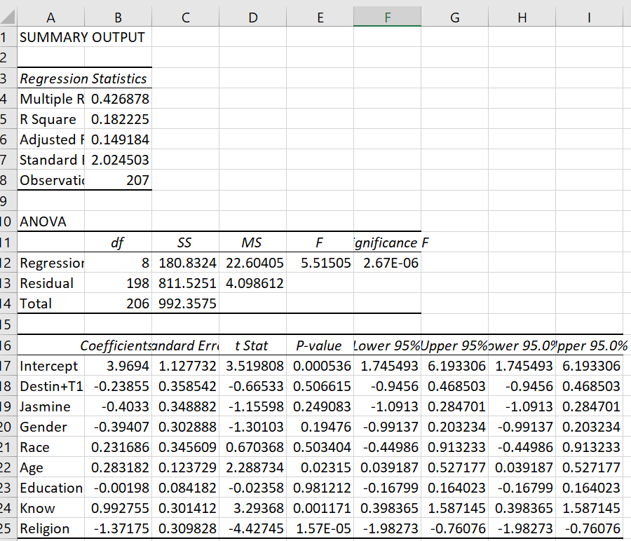

Work Cited

“Abortion and Race.” Abort73.Com / Abortion Unfiltered, abort73.com/abortion/abortion_and_race/.

Dehlendorf, Christine, et al. “Disparities in Abortion Rates: A Public Health Approach.” American Journal of Public Health, vol. 103, no. 10, Oct. 2013, p. 1772. EBSCOhost, doi:10.2105/AJPH.2013.301339.

Dutton, Zoe. “Abortion's Racial Gap.” The Atlantic, Atlantic Media Company, 23 Sept. 2014, www.theatlantic.com/health/archive/2014/09/abortions-racial-gap/380251/.

Foster, Diana Greene, et al. “Socioeconomic Outcomes of Women Who Receive and Women Who Are Denied Wanted Abortions in the United States.” American Journal of Public Health, vol. 108, no. 3, Mar. 2018, p. 407. EBSCOhost, doi:10.2105/AJPH.2017.304247.

Linton, Paul Benjamin. “Should Women Be Prosecuted for Abortion?” Human Life Review, vol. 43, no. 2, Spring 2017, p. 27. EBSCOhost, libproxy.lib.ilstu.edu/login?url=https://search.ebscohost.com/login.aspx?direct=true&db=f5h&AN=123889101&site=eds-live&scope=site.

Maffucci, Maria McFadden. “Fake Clinics--or Fake Feminism?” Human Life Review, vol. 44, no. 2, Spring 2018, p. 11. EBSCOhost, libproxy.lib.ilstu.edu/login?url=https://search.ebscohost.com/login.aspx?direct=true&db=f5h&AN=130412858&site=eds-live&scope=site.

Petersen, Larry R. “Religion, Plausibility Structures, and Education’s Effect on Attitudes toward Elective Abortion.” Journal for the Scientific Study of Religion, vol. 40, no. 2, June 2001, pp. 187–203. EBSCOhost, doi:10.1111/0021-8294.00050.

