Title:

Should States Adopt Overdose Immunity Laws?

Jordan Norton
Illinois State University
jnorton@ilstu.edu

April 19, 2018

State/Local Politics and Public Opinion (April 27, 2018)

Author wishes to acknowledge Dr. Carl Palmer for assistance in gathering, analyzing, and interpreting research data as well as Illinois State University Department of Government and Politics for their access to software and resources for research.

Abstract
Should States Adopt Overdose Immunity Laws?
From 2014-2015, the CDC saw a 72.2% increase in death rates related to synthetic opioids other than methadone, and a 20.6% increase in heroin related death rates. I am going to look into a group of policies collectively called the Drug Overdose Immunity and Good Samaritan Laws with which states are attempting to face the problem. These laws effectively allow individuals to call emergency responders in the case of an overdose without fear of prosecution. The idea behind the laws is that individuals wait too long to call response teams out of fear and that these laws would reduce or eliminate that fear, thereby reducing the number of overdose deaths. Currently, 40 states and Washington D.C. have adopted these laws state-wide. Utilizing data from the CDC and the FBI, I will look into the effectiveness of these laws. I will randomly select one group of counties from those states with the laws and one group of counties from those states without the laws. I will then look at both the drug-related death rates within each county as well as the drug-related arrest rates in each county. I will finally compare death-rates and arrest-rates between counties of those states with and without the laws. I hypothesize that I will find that the counties of those states with the Drug Overdose Immunity and Good Samaritan Laws will have lower drug-related death rates and lower drug-related arrest rates than those counties without the laws.

America is currently facing an epidemic of drug overdoses and other societal costs of drug abuse among communities. Drug death rates from synthetic opioids other than methadone have increased by 72.6% from 2014-2015; for heroin, the rates have increased by 20.6% in the same time period (Rudd, et al. 2016). This epidemic has affected geographically diverse communities across socioeconomic divides and has been partially exacerbated by the quadrupling of opioid prescriptions in America (CDC 2017).
Fragmentation among municipalities at the local level, among states and the federal government have slowed progress in tackling this issue. This has been especially slowed in the face of budget cuts at every level of government and a lack of coordination between states and localities. Recently, though, there has been a reemergence of political will to take this on. The opiate crisis has been the primary public health priority thus far for the Trump administration, as seen when, in 2017, the acting director of the Department of Health and Human Services declared the opioid crisis a public health emergency (DHHS 2017).
Since then, the Trump Administration has requested an increase in the National Drug Control Budget through the Office of National Drug Control Policy (ONDCP) from $27.5 billion in Fiscal Year 2017 to $27.8 billion for Fiscal Year 2018 (ONDCP 2017). The budget included key incentives for treatment, and state grants targeted at opioid addiction treatment. At the same time, however, the Trump Administration’s Department of Justice headed by Jeff Sessions has taken a more punitive path to addressing the issue of opiates in America, vowing to remain tough on crime and reassert itself in the War on Drugs.
For quite some time, states and localities have been experimenting with a variety of techniques aimed at taking on the issues of drug addiction and societal costs. This study will be looking at one group of laws in particular that have so far been successful in forty states. This group of policies are called Good Samaritan Overdose Immunity Laws and are meant to encourage individuals who may be under the influence of drugs to call emergency responders if someone that they are with is experiencing an overdose. The thought behind these laws comes from a group of policies collectively known as harm reduction policies.

Harm Reduction
Harm Reduction International, a large nongovernmental organization dedicated to the spread of these policies states that “Harm reduction refers to policies, programmes and practices that aim to reduce the harms associated with the use of psychoactive drugs in people unable or unwilling to stop. The defining features are the focus on the prevention of harm, rather than on the prevention of drug use itself, and the focus on people who continue to use drugs” (HRI 2018).
These policies may be put into place by local, state or national governments such as city-wide syringe exchange programs or state-wide access to the overdose rescue drug Naloxone. They can also be put in practice at large events which tend to incur excessive drug use such as Burning Man or Lightning in a Bottle. These art and music festivals allow organizations like the Multidisciplinary Association for Psychedelic Studies (MAPS) or Dance Safe to provide drug testing kits or a space for those experiencing challenging psychedelic experiences.
These practices and policies have been a more recent phenomenon, first rising to prominence during the HIV/AIDS epidemic of the 1980s. Many of the policies are aimed at reducing mortality due to overdose and incidents of HIV/AIDS, Hepatitus C, or sexually transmitted diseases among Injection Drug Users (IDUs). With its rise as a popular set of public health policies, states have begun adopting certain policies that would align with such a public health philosophy, aiming to aid rather than punish those with issues of drug abuse and addiction.
These policies have seen pushback as individuals and politicians have seen these policies as condoning drug use. Many think of drug addiction/abuse as a failure of the individual, a trait of the weak willed or lazy, rather than a societal symptom. It is important to note, though, that political will is growing, even among more conservative politicians and states (Nadelmann & LaSalle 2017). Policies supportive of the overdose rescue drug Naloxone and Drug Overdose Immunity Laws have so far been some of the most successful laws at the state level, so it is important to look to look into their efficacy in reducing drug overdoses and drug arrests.

Good Samaritan Drug Overdose Immunity Laws
The Good Samaritan Drug Overdose Immunity Laws have been seen by states as a valuable method in the fight against overdose deaths and they have often been tied to the attempted protection of those individuals utilizing the drug overdose rescue drug Naloxone. With the first laws passed in 2007 by New Mexico, many states were slow to follow. Alaska passed them in 2008, Washington in 2010, this was followed by two more states in 2011 and three in 2012. By 2014 nineteen states total had passed the laws, and at present forty states have these laws, though every state now allows for some sort of access to Naloxone (NCSL 2017).
The laws may vary on a state by state basis. An ONDCP chart from 2014, as seen in Figure 1, shows the range of protections afforded by different states. The protections may include those for the individual reporting an overdose including some states with protections for violation of parole, probation or restraining order. They may also provide guidance on who may use the Naloxone, whether they have received training or whether they must be a first responder (ONDCP 2014).
[Figure 1]
This strategy has been heralded by different groups as effective. In a 2014 resolution, the United States Conference of Mayors declared their support for the policies across the United States (USCM 2014). The Network for Public Health Law described the Drug Overdose and Naloxone Laws as the “low hanging fruit” in public health law as there were no foreseeable negative affects with a possibility of saving lives through overdose intervention (NPHL 2016).
Studies have so far acknowledged that the largest barrier to individuals in calling emergency responders is the fear of police (Baca & Grant 2007; Pollini, et al. 2006). They have shown also that those most likely to witness an overdose were less likely to contact first responders, and that younger individuals were also less likely to call and wait (Follet, 2012). Laws in place may not necessarily be common knowledge though. Police officers and the public must be made aware of the laws, their function, and how they may help their communities. As drug users learn about these laws, they are more likely to call emergency services, and therefore intervention has a higher chance of success (Banta-Green, et al. 2011). This study seeks to determine the effectiveness of these laws through the analysis of Drug-related Death Rates and Drug-related Arrest Rates. It will add an additional measure of policy effectiveness to the existing literature.

Theoretical Framework & Hypotheses
This study utilizes an ordinary least squares (OLS) regression model to determine the relationship between dependent variables and independent variables. In determining the efficacy of Drug Overdose Immunity Laws, it develops a model looking at data sources that would be indicative of a positive/negative relationship between the policies and society. It was determined that one of the most effective measures would be Drug-related Death Rates by county, utilizing data from the Centers for Disease Control’s (CDC) Wide-ranging Online Data for Epidemiologic Research (WONDER). As the primary aim of public health policies such as the one looked into here is to reduce these rates, this number will provide a better understanding of the law’s effects in society and will act as one of the dependent variables. In looking at compressed mortality data, an initial sampling of 883 geographically diverse counties were chosen.
As a secondary measure of the success of these policies, Drug-related Arrest Rates on the county level provided through FBI Statistics are included as a second dependent variable. Due to the nature of these policies and their power in granting immunity and building relationships between officers and the community, this measure will also be a reliable way of examining how these laws might change that dynamic. In looking into available data through the FBI, it was determined that the most recent arrest data came from 2014. Therefore, county-level mortality data from the CDC, as well as all data from independent variables, was also sampled from 2014. Finally, in order to create comparable numbers and eliminate bias towards higher or lower populations, death rates and arrest rates were transformed into rate per 100,000 population.
The primary independent variable in the study is whether or not a county’s state has implemented these Drug Overdose Immunity Laws. In this case, those counties without existing laws in 2014 were coded as “0” and those counties with existing laws in 2014 were coded as “1” in order to analyze the relationship. Additional independent variables are considered as well, in order to create a more accurate study. The study included median income of counties in thousands of dollars, percentages of individuals with less than high school education, high school degree, and bachelor’s degree or more, and percentages of white persons, black persons, and those of Hispanic identity. The final independent variable included is known as the Rural Urban Community Continuum. This variable was chosen as a way to distinguish differences perceived in heavily urbanized areas versus heavily rural areas on a scale of 1-6 moving from more populated areas to less populated areas. These variables were obtained via the United States Census Bureau.
In this study, two hypotheses are proposed. The first hypothesis states that those counties with the Drug Overdose Immunity Laws will have a significantly lower Drug-related Death Rate per 100,000 population than those counties without the laws. This will ultimately provide evidence for this public health policy, and the study would be able to recommend then that states do adopt these laws as a part of an overarching program in reducing overdose deaths. The second hypothesis declares that those counties with the Drug Overdose Immunity Laws will have significantly lower Drug-related Arrest Rates per 100,000 population than those counties without the laws. This would indicate that the immunity prescribed in the law is having an effect on policing, punitive measures, and community trust.

Results and Discussion
An OLS regression was run utilizing the software package Stata as an analytical tool. Results yielded some significance and can be viewed in Table 1 as a series of coefficients, standard errors, and levels of significance.
[Table 1]
In testing for correlation among variables, none were found to be highly correlative among one another. Also, in tests for extreme values, no outliers were found to be problematic; however, one value for Elmore County, Alabama was withheld as it had reported zero arrests for 2014 and was seen as problematic within the data set related to arrest rates.
The sample number for the regression of Arrests/100,000 is also lower than for that of Deaths/100,000 due to data missing within the FBI statistics. When those same data were removed and a regression run for Deaths/100,000 the coefficients and significances were not substantially changed from the original.
The primary hypotheses being tested for within the regression showed significance. In looking at the presence of Laws and the Death Rates/100,000, it was seen that when going from a county without the laws to a county with the laws, there was a drop of 11.33 in the Drug-related Death Rate. This confirmed the first hypothesis of the study. When looking to the second hypothesis test of the presence of Laws and the Arrests/100,000, the data revealed that in moving from a county without the laws to a county with the laws, the Drug-related Arrest Rate dropped by 49.94. This confirmed the second hypothesis and allows the study to conclude that states should adopt Drug Overdose Immunity Laws, as they seem to effectively accomplish what they set out to do with lowered death rates and arrest rates in counties around the country.
Among the independent variables that weren’t specifically hypothesized about, there was also significance. When looking at Median Income, it was shown that as the Median Income rises, death rates and arrest rates fall. Interestingly, as the percentage of individuals with less than a high school education rose, arrest rates fell and as the percentage of those with bachelor’s degrees or higher in a community rose, death rates rose. Among racial and ethnic results, the study found a drop in death rates with increased percentages of whites and blacks with an increased arrest rate in communities with higher percentages of blacks. In communities of higher Hispanic percentage, death rates increased, as did arrest rates. The Rural Urban Community Continuum also had interesting results when compared, as death rates fell by 12.02 with each move toward more rural communities, it was also shown that arrest rates fell by 3.39 with each move toward more rural communities. The study has yielded some interesting results to put into consideration for states thinking about passing laws such as these.

Limitations and Future Research
As the study considers only spatial data via a simple comparison, it is limited. Future research would do well to take time into consideration as well. These studies may utilize a time series panel data analysis wherein each state may be looked at before and after passage of the laws and those states currently without the laws may be used as controls. Another limitation of the study, is in its inability to measure other things that states are doing in an attempt to decrease overdose deaths. Future study would utilize an index of progressive public health policy to determine if there is a correlation between states with other policies and a drop in the death rate or arrest rate.

Figure 1.
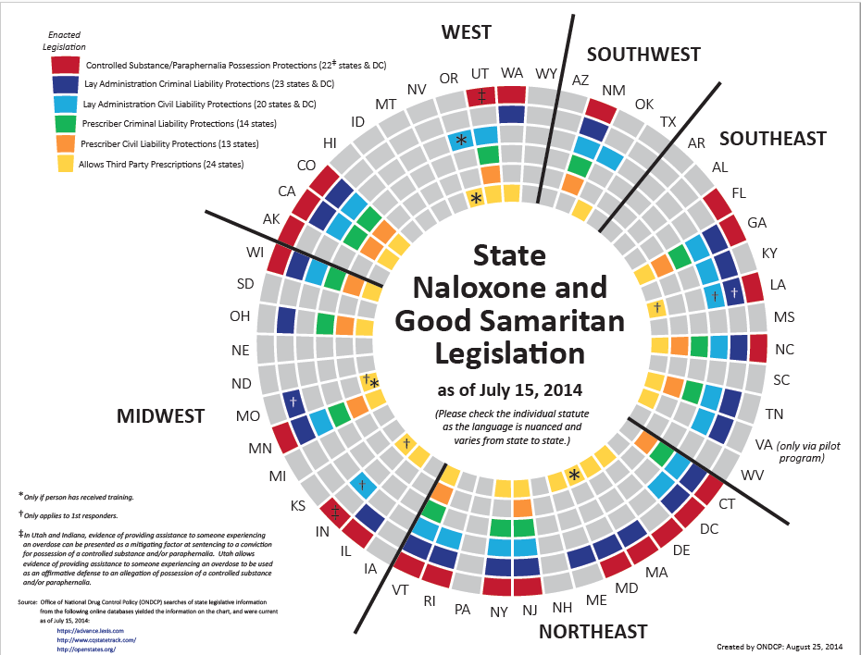
Table 1.
 | Deaths/ 100,000 | Arrests/ 100,000
Laws | -11.33*  (4.57) | -49.94*  (20.21)
Median Income | -1.22**  (0.22) | -2.37*  (0.98)
Less than High School | 0.31  (0.47) | -5.82**  (2.10)
High School | 0.60  (0.40) | 2.66  (1.79)
Bachelor’s Degree + | 5.08**  (0.75) | 0.58  (3.39)
Percent White | -1.71**  (0.31) | 1.59  (1.45)
Percent Black | -1.16**  (0.38) | 6.91**  (1.75)
Percent Hispanic | 0.82**  (0.22) | 4.37**  (0.98)
Rural Urban Continuum | -12.02**  (1.70) | -3.39  (7.54)
N | 883 | 792
R² | 0.26 | 0.08
Cell values are OLS coefficients with robust standard errors in parentheses. DVs scaled to run from 1 (very unlikely to engage in act) to 5 (definitely will engage in act). +: p<0.10; *: p<0.05; **: p<0.01.
Citations

Banta-Green CJ, Grant, K. 2007. “What Heroin Users Tell Us About Overdose.” Journal of Addictive Diseases 26(4): 63-68
Centers for Disease Control (CDC) WONDER. 2018. “Compressed Mortality File” Retrieved from wonder.cdc.gov.
Centers for Disease Control and Prevention (CDC). 2017. “Prescribing Data” Retrieved from https://www.cdc.gov/drugoverdose/data/prescribing.html
Department of Health and Human Services (DHHS). 2017. “HHS Acting Secretary Declares Public Health Emergency To Address National Opioid Crisis” Retrieved from https://www.hhs.gov/about/news/2017/10/26/hhs-acting-secretary-declares-public-health-emergency-address-national-opioid-crisis.html
Florida Department of Law Enforcement. 2016. “UCR Arrest Data” Retrieved from http://www.fdle.state.fl.us/FSAC/Data-Statistics/UCR-Arrest-Data.aspx
Follett K. “Between life and death: The barriers to calling 9-1-1 during an overdose emergency.” Waterloo Region Crime Prevention Council. 2012:1-45.
Harm Reduction International. 2018. “What is Harm Reduction?” Retrieved from https://www.hri.global/what-is-harm-reduction
Nadelmann, Ethan and LaSalle, Lindsay. 2017. “Two Steps Forward, One Step Back: Current Harm Reduction Policy and Politics in the United States”. Harm Reduction Journal 14(37): 1-7.
National Conference of State Legislatures. 2017. “Drug Overdose Immunity and Good Samaritan Laws” Retrieved from http://www.ncsl.org/research/civil-and-criminal-justice/drug-overdose-immunity-good-samaritan-laws.aspx
Network for Public Health Law. 2017. “Legal Interventions to Reduce Overdose Mortality: Naloxone Access and Overdose Good Samaritan Laws” Retrieved from https://www.networkforphl.org/_asset/qz5pvn/network-naloxone-10-4.pdf
Office of National Drug Control Policy (ONDCP). 2017. “National Drug Control Budget: FY 2018 Funding Highlights”. Retrieved from https://www.whitehouse.gov/sites/whitehouse.gov/files/ondcp/Fact_Sheets/FY2018-Budget-Highlights.pdf
Office of National Drug Control Policy (ONDCP). 2014. “State Naloxone and Good Samaritan Legislation” Retrieved from https://obamawhitehouse.archives.gov/sites/default/files/ondcp/Blog/naloxonecirclechart_august2014.pdf
Pollini RA, McCall L, Mehta SH, Celentano DD, Vlahov D, Strathdee SA. 2006. “Response to
overdose among injection drug users.” American Journal of Preventative Medicine 31(3):261-264.
Puzzanchera, C. and Kang, W. 2017. “Easy Access to FBI Arrest Statistics 1994-2014” Retrieved from http://www.ojjdp.gov/ojstatbb/ezaucr/
Rudd, Rose A., Seth, Puja, David, Felicita, Scholl, Lawrence. 2016. “Increases in Drug and Opioid-Involved Overdose Deaths- United States, 2010-2015” Morbidity and Mortality Weekly Report 65(50-51): 1445-1452.
State of Alabama. 2014. “2014 Alabama Sheriff and Police Department Arrests for Sale/Possession of Illegal Drugs” http://www.alea.gov/Documents/Documents/DrugCrime2014.pdf
State of Illinois. 2014. “Index Crime Offense & Crime Rate Data” https://www.isp.state.il.us/docs/cii/cii14/cii14_sectioni_pg11_to_242.pdf
United States Conference of Mayors. 2014. “Resolution: Saving Lives Through Overdose Prevention” Retrieved from https://www.usmayors.org/the-conference/resolutions/?category=d20019&meeting=82nd%20Annual%20Meeting

