Movements of Polarization
The Tea Party and Occupy

Jaron Park
Monmouth College
jpark@monmouthcollege.edu
20 April 2018
Faculty Advisor: Michael Nelson, PhD

27th Annual Illinois State University for Students of Political Science
Normal, Illinois
27 April 2018

Abstract
Are the Occupy and the Tea Party movements an effect or a cause of the political polarization we see today? This paper argues that both are simultaneously an effect and a cause, being an effect of earlier but separate strings of political events that are at certain points intertwined with one another as well as a cause of the continuation and worsening of the current period of political polarization. The Tea Party movement began as a response to President Obama’s 2009 financial proposals with links stretching back to Newt Gingrich’s “Contract with America.” Since its emergence it has become a disruptive force within the Republican Party and has driven it further right. The Occupy movement began as a response to the causes of the Great Recession, in particular predatory loan practices and a lack of judicial activity towards corporations following this and other discoveries, as well as towards the massive upward transfer of wealth that has occurred between 1979 and 2010 and onwards. It has had its own effect on the accompanying Democratic Party by causing an entrenchment, although a far less antagonistic relationship exists between the Occupy movement and the Democratic leadership. Of note is the movement’s enabling and support of the rise of Senator Bernie Sanders as a viable Presidential candidate. These answers are important to achieve an understanding of these grassroots movements and their influence on the electorate from 2010 through to 2016, as well as to come into understanding of the current period of intense polarization.

Introduction
Are the Occupy and Tea Party movements a symptom or a cause of the political polarization we see today? This question is important to achieve understanding of these unique, grassroots movements and their influence on the electorate from 2010 up to 2016, and potentially even 2018, as well as to come into understanding of the current period of polarization. The answer to this question is that they are both a symptom and a cause for the current period of intense polarization, for different reasons respectively. To understand the answer, we must look closely at each movement as well as at the polarization trends we have seen over the course of American history.
The Tea Party and Occupy Movements stand out as the icons of the current American zeitgeist. Two conflicting groups that ironically desire similar goals, at least on select issues, albeit from very different directions of thought, but could not be more opposed to one another. To Occupy supporters, the Tea Party are gun-toting, borderline fascist racists in pursuit of a near confederal governmental system. To the Tea Party, Occupy is a group of liberal “snowflakes”, that worship the likes of Marx and Lenin, in pursuit of a lifetime of work being handed to them directly out of college. These are of course caricatures of these view points, but they stand to illustrate a point on their polarization to one another. This polarization should come as no surprise however as these two groups have both been spawned from the current extreme polarization faced in American politics and have become engines for escalating polarization even further. Both groups stand out in their ability to have upended the national political parties, regardless of their method of doing so, and changing the dynamics, issues, and talking points of the national elections for nearly a decade. Despite these impressive accomplishments, both continue to stand out as enigmas to a majority of the population, including political scientists – as does our current period of polarization.
The current period of polarization is viewed differently upon who you ask. Some view the obstructionism and slow-down of Congressional productivity to be a detriment to American society, while others view it as a positive; either so that Congress takes it time with legislation or for ideological reasons. Some view the clear divide between the parties helpful in knowing who they are voting for while others see the lack of common ground as damaging to our culture. Even among political scientists the current period is up for debate. Some view this period as a return to American political norms, while others view this as unprecedented territory. Some view this new territory as simply a new norm, while others have more apocalyptic visions with the word “civil war” being uttered at times.
Again, to come into understanding we must explore the past. This paper does not offer solutions, nor does it attempt to see where we are going; rather it simply explores how we got here and why. It could be said that the Tea Party has risen from the beginning of the current polarization period in the mid-nineties from Newt Gingrich’s “Contract with America” manifesto. It could be said that the Occupy movement is a revival of the anti-establishment leftist movements of the sixties and seventies. There are many more explanations possible on the origins of each movement, which I will get to later. To begin to seek the understanding I will provide, we must first however look to what has already been said on this topic and the issues at hand.
Literature Review
In exploring this question, we must look at polarization itself. In searching for a tangible and meaningful measure of polarization, a graph released by Christopher Ingraham, from voteview.com and inspired by similar work by Brian Resnick et al., offers graphed ideological positions and party unity within Congress from the 35th up to the 112th with mean DW-nominate scores for each party and Congress as a whole, while showcasing the position of each member. This and the rest of the available data at voteview.com give a picture of the nature of Congress which we can use to put polarization into perspective. To go deeper than Ingraham’s graphics, voteview.com itself was used, a project conducted Keith T. Poole and Howard Rosenthal and continued by Boris Shor, and later by Jeffrey B. Lewis, which uses voting data to represent the ideological positions of each member of Congress, with adjoining rating of each Congress and party in American history, from the first to the current. This data is represented by the DW-NOMINATE score (Dynamic Weighted NOMINAI Three-step Estimation), which uses the common identified dimension of “liberal” vs. “conservative” (Lewis et al.). This is complemented with Poole and Rosenthal’s book on the subject, Ideology & Congress. This perspective is also broadened with additional data from the Brookings Institute’s “Vital Statistics on Congress” page which contains multiple tables of data which can assist in efforts such as the tracking the demographics of Congress, campaign finance, and legislative productivity in each period. Similar research was conducted by David Lee, Marcus J. Hamilton, Mauro Martino, Christian E. Gunning, and John Armistead in the article “The Rise of Partisanship and Super-Cooperators in the U.S. House of Representatives” on PLOS One. This work was also encapsulated by Christopher Ingraham in The Washington Post, in the article “A stunning visualization of our divided Congress.” Focusing in on the polarization between 1949 and 2011, Lee et al., use network diagrams to track the polarization of the House of Representatives specifically, to show the general voting trends of each House of each Congress. Of note in this data, pointed out by Ingraham in his article, is that not only have the parties pulled apart, but the Representatives are voting more similarly to each other as well – showing not only high levels of partisanship but high levels of party loyalty. This research is further explored via Renzo Lucioni’s research from GovTrack.us which is presented in the article “United States of Amoeba” on The Economist. This data can be checked against the voteview.com data – all of which shows that unlike common assertions, the current period of polarization has hit new and unknown territory.
The Brookings Institute also shows that while not at the lowest point of productivity in Congressional history, this distinction belongs almost unanimously to the Congresses under Speaker Newt Gingrich, the current Congress continues the trend of historically low productivity in Congress that began with the Contract with America. The voteview.com data shows us that the levels of partisanship seen during the Civil War, with perhaps exception to the House of the 36th Congress (1859 – 1861), was not that exceptional when compared to other Congresses tracked; and that the period of bipartisanship experienced from the House of the 74th Congress to the House of the 90th Congress (1935 – 1969) was an exceptional period of cooperation, especially when considering the social tension of that time in the US. This research also shows that the House of the 104th Congress (1995 – 1997) experienced partisanship that surpassed any level of partisanship seen in American history - a trend that has only continued with a rise in the level of partisanship in every Congress since. Lewis et al. also show us that while the House of the 36th Congress (1859 – 1861) had one of the high levels of party unity collectively, over 50% of the members of each party had a loyalty rating of 90% or above, this rate also dramatically decreases following secession and the outbreak of the Civil War. Several Congresses have also seen similar levels of party unity in the House since then, however as with partisanship within the House, party unity in the House dramatically rose to record breaking levels with the 104th Congress (1995 – 1997) and while not as consistent of an increase as partisanship, party unity in the House has nonetheless risen since; to its record high set by the 112th Congress (2011 – 2013) in the recorded data. The data based on the House shows that while the argument can be made the partisanship is the rule rather than the exception to American politics, the current period is indeed exceptional and beyond any seen in history – including during one of the bloodiest civil wars in human history.
In what is clearly an exceptional period of polarization, to come to understanding with the period we must first look to why experts believe that this level of polarization is normal, thus requiring us to explore historical polarization. This issue of historical polarization and the common, but wrong, idea that we are returning to our historic norms is explored in The Washington Post’s Monkey Cage blog by David W. Brady and Hahrie Han in the article “Our politics may be polarized. But that’s nothing new.” In this article Brady and Han argue that the current polarization is akin to that seen in the mid-19th century and on until the 1920s. Their article also points out that while today we see polarization being decried by pundits and experts, in the post-war period of the mid-20th century the same group was decrying the cooperation of the era and the inability of the two major parties to separate from one another.
In coming into understanding with political polarization, especially the modern era, several books were consulted. Matt Grossman and David A. Hopkin’s Asymmetric Politics: Ideological Republicans and Group Interest Democrats attempts to break down the Republican and Democratic Parties and get to the source of their identities as political groups: that the Republicans are largely based upon an ideological movement that values loyalty and values while the Democrats are a coalition of social groups that value government action and independent but equal identities. This focuses on the patterns of behaviors by members of both parties and also attempts to explain the reactionary tendencies of both electorates when their values are not met. These separate identities and group operating processes are important to understand the current polarization as with its rise, these values are now more important than ever to the electorate; which in turn decides how they will respond to attempted moderation or further polarized ideological movement. James E. Campbell’s Polarized: Making Sense of a Divided America examines the process of polarization of the American political system, both past and present. In his book, Campbell examines the previous arguments regarding the process of polarization and why it happens. Campbell argues that polarization rises from the electorate upwards, and that the current period was shaped by the positive responses of the electorate among both parties to ideologues during a period of great bipartisanship in the 1960s. While this takes a long view at the process of polarization, Campbell’s logic is helpful is examining how the Tea Party and Occupy have influenced the parties, and what that may mean for the future. Steven E. Schier and Todd E. Eberly’s Polarized: The Rise of Ideology in American Politics takes a more academic approach in analyzing and explaining polarization, looking at not only the parties but the individual politicians, electorate, as well as media and how they figure into the polarization process as well as how they are influenced by, and in turn influence, the polarization process. This gives a more scholarly and thorough examination of polarization. John C. Green, Daniel J. Coffey, and David B. Cohen’s The State of the Parties: The Changing Role of Contemporary American Politics goes in-depth into the shifting nature of Republican and Democratic interparty politics following the 2012 elections. During a time when the Tea Party and Occupy were very present and active parts of the political system, this examination brings closer understanding to the machinations that brought about Congress as we know it today.
It is then natural to come to the machinations within Congress itself; something Sean M. Theriault attempts to do in his book The Gingrich Senators which examines the behavior of the Senators who served in the House with Newt Gingrich. Theriault’s book attempts to explain the polarization caused by Gingrich’s rise through the House and the shift in behaviors within the Republicans to cause the polarization of the 1990s, and their behavior since. Currently the data of the House supports the assertion that our current period of polarization can be traced to at least Gingrich’s Contract with America, if not directly to his election as Theriault argues. Part of this conversation must touch on the cause of the current period of polarization beyond simple politics or Congress however. James C. Garands’s article “Income Inequality, Party Polarization, and Roll-Call Voting in the U.S. Senate” from The Journal of Politics focuses on the theory that high levels of economic inequality, in particular in personal income, leads to high levels of partisanship in the US. Alternatively, Nolan M. McCarty’s article “The Limits of Electoral and Legislative Reform in Addressing Polarization” from the California Law Review examines the work of Professor Richard Pildes whom posits that historical factors rather than an event-based system leads to political partisanship in the US; while also proposing solutions to the issue of polarization which McCarty also examines. The article “Political Polarization as a Social Movement Outcome: 1960s Klan Activism and its Enduring Impact on Political Realignment in Southern Counties, 1960 to 2000,“ by Rory McVeigh, David Cunningham, and Justin Farrell, published in American Sociological Review, transitions to looking at the effect radical social movements can have upon an electorate – albeit while using an extreme example. McVeigh et al., argue that radical social movements can have a direct, short-term impact on voting outcomes which can prolong themselves when the movement becomes socially disruptive and forces new partisan loyalties. While this research looks into the activity of the Ku Klux Klan in the 1960s in certain counties of the American South, and both those counties resulting tendency to vote Republican and the racial attitudes of the residents, this research can also be applied to the current period of polarization and its radical increase in the past six years due to the Tea Party and Occupy movements. Similarly, Michael Walzer argues in his article “Social Movements and Election Campaigns,” published in Dissent, that while militants and organizers of social movements have an effect, a movement must gain popular support to have a lasting effect. While in conjunction with McVeigh et al., this leaves a disturbing but irrelevant notion of the effect of the Ku Klux Klan upon Southern culture, this does however support the extreme increase of polarization in Congress due to the populist and lasting nature of the Tea Party and Occupy movements as they have evolved over time. To piece this literature together into a cohesive argument, we must look at each of the movements independently first.
Tea Party Movement
The Tea Party seems to stand within history as one of the most powerful grassroots movements within American politics since the abolitionist movement. From their ability to command the national spotlight to their effect on their politically aligned party, the Tea Party has been an unnatural force of American politics for close to a decade. During its existence, the Tea Party has focused largely on debt reduction, government spending reduction, and lower taxes by the US federal government; through a diverse coalition of conservative groups consisting of, but not limited to: “economic conservatives, foreign policy hawks, isolationists, racists, cultural conservatives, supporters of and zealots for small government, establishment types, privacy advocates, and others” (“Tea Party Movement” 983). While it seems unique in its appearance and style, it is in fact similar to previous conservative opposition movements, such as the opposition to the New Deal, the Red Panic of the early Cold War, and the shift to the right of the Republican Party in the 1960s; but it has taken on a life of its own beyond its historical predecessors (“Tea Party Movement” 983 – 985).
The origins of the Tea Party remain up to debate, and perhaps this is owed to its coalitional structure. Although it came to prominence with its opposition to American Recovery and Reinvestment Act of 2009 and Patient Protection and Affordable Care Act under President Barack Obama, it can also be traced to opposition to the first round of bailouts, conducted under President George W. Buch, in the Economic Stimulus Act of 2008, Housing and Economic Recovery Act of 2008, and Emergency Economic Stabilization Act of 2008 (“Tea Party Movement” 985; Weigel). Another origin points further back to the Presidential campaign of then Senator Ron Paul of Texas, whose libertarian insurgency saw a major funding push on the anniversary of the Boston Tea Party, December 16th, in 2007; from which the movement sprang forth first as his political base and then as opposition to President Obama’s agenda and their perceived lack of conservatism within the Republican Party (Green; Weigel; Vogel;). Another origin, and perhaps the most common, is attributed to CNBC reporter Rick Santelli who called for a “new tea party” from the floor of the Chicago Mercantile Exchange while on air in response to the American Recovery and Reinvestment Act of 2009, to the support of the traders around him (Ray; “Rick Santelli”). Santelli’s rant soon inspired numerous websites that organized the “Nationwide Chicago Tea Party,” inspired by Santelli’s comments, and succeeding tax protests on Independence Day; including one website by Americans for Prosperity, an organization supported by David H. and Charles G. Koch, commonly known simply as the Koch Brothers, which along with FreedomWorks, ran by former Congressman Dick Armey, previously organized annual Tax Day protests as Citizens for a Sound Economy (Schilling; Ray; Zernicke; Pilkington). Several other unrelated protests to what was seen by supporters as irresponsible fiscal policy and storming of Democratic town halls over the then proposed Patient Protection and Affordable Care Act coalesced into the Taxpayer March on Washington. The Taxpayer March was organized by groups such as the aforementioned FreedomWorks and Americans for Prosperity, as well the 9-12 Project, then Fox News host Glenn Beck’s program of “9 principles and 12 values” emulating his perceived sentiments of the country the day after the 9-11 terrorist attacks, the Tea Party Patriots, one of the Tea Party’s national organizing groups, and the National Taxpayers Union (Ray; Brown; Isenstadt; Phillips; Markman). The Taxpayer March saw a wild array of estimates of turnout from all sides, from some city officials estimating only 100,000 while participating groups estimated 300,000, 600,000, and even up to 2 million (Markman). Yet another theory on the origin of the Tea Party, popularized by former Vice President Al Gore, points to the various special interests involved, such as the Koch Brothers, claims that the movement is in fact a subversive move by corporate elements to further privatize political power within the American political system, although this is largely a conspiracy theory rather than a true origin theory (Gore).
Although the origins of the Tea Party could give us great insight to the group, and it is a valuable aspect to determine, there are simply too many theories currently to assertively say within this paper which one is the truth – and perhaps all are in some way part of this story. What we must focus on however is the story after this moment, from which the Tea Party moved from simply a national level, grassroots tax protest group into a dissident political force that would radically shift the Republican Party over the next several years.
2009 saw the Tea Party realize its political strength in the primary victory of Doug Hoffman in the special election for New York’s 23rd congressional district by edging out Republican establishment candidate Dierdre Scozzafava, who then lost thus allowing the district to turn Democrat for the first time since the 19th century, the general election victory of Scott Brown in the special election for Senator of Massachusetts, replacing deceased Senator Ted Kennedy, and the special election victory of Rand Paul for Senator of Kentucky over the favored candidate, Trey Grayson, in early 2010 (Ray). This realized power lead to a surge of Tea Party candidates in the 2010 Midterm elections, often running against Republican incumbents or otherwise strong establishment Republican candidates, often to the right, which in some cases were viewed as to have cost the Republican party numerous victories (Ray). Nonetheless, the Republicans, as the Tea Party candidates ran as such, were able to take the majority of the House and cut the Democratic majority of the Senate (Ray). Over the course of the next two years, a terse relationship formed in which the Republican establishment attempted to welcome and integrate the Tea Party, largely to avoid the in-fighting witnessed in the 2010 campaigns, but elements on both sides resisted – with some within the establishment seemingly bi-polar in their support and resistance, such as Speaker John Boehner (Ray). Partly due to this love-hate relationship between the establishment and the Tea Party, as well as extremely unconventional views, offensive speech, and other improper political behavior exhibited by numerous candidates, the Republicans lost several seats in the House and Senate to the Democrats, while maintaining their majority in the House (Ray).
2013 saw the Tea Party overplay its political hand as it used a government shutdown as a threat in order to attempt to repeal the Patient Protection and Affordable Care Act, a bluff which President Obama called (Ray). After three weeks, popular opinion turned against the Tea Party-led Republican effort, and a deal was struck which re-opened the government with no meaningful concessions to the Tea Party; leading some to believe that the Tea Part had exhausted its influence and political energy (Ray). The 2014 Midterms saw the Tea Party continue its efforts as a political movement, but a hangover from the 2013 government shutdown was still evident as numerous Tea Party candidates lost to establishment Republican candidates in primary elections; although many establishment Republicans had shifted to the right or further to the right in order to gain the support of the Tea Party (Ray). The general elections of 2014 saw the Republican Party gain a majority in the Senate and keep its majority in the House, with many within the establishment believing they had re-asserted control over their party – and the Tea Party viewing themselves as having “matured” and become integrated within the party rather than having any diminished position (Ray).
2015 saw the Tea Party show that despite thoughts to the contrary it was a still relevant and powerful political force within Republican inter-party politics with the removal of Speaker John Boehner and the Tea Party Caucus threatening to shutdown the government once more over federal funding to the reproductive healthcare organization Planned Parenthood; the political divide over which Boehner could not resolve within the party and thus resigned (Ray). This lead to the election of the Tea Party supported Paul Ryan, now of the Freedom Caucus, a Tea Party-aligned Libertarian caucus, as Speaker of the House (Ray). While 2015 saw Gallup polling indicate that popular support among Americans for the Tea Party was at its lowest ever, the conservative base of the Republican Party was left dissatisfied with the establishment with its failure to pass Tea Party based legislation with its majority (Ray).
This brings us to the 2016 Presidential election, in which non-traditional candidates seeming to consistently poll ahead of establishment candidates that in perhaps any other election would have been solid frontrunners, to which the establishment rallied around any possible challenger to the surging and inexplicably popular Donald Trump – an effort which clearly failed (Ray). In part, the Tea Party paved the way for President Trump’s election with its ability to energize a section of citizens that otherwise felt too disenfranchised or underrepresented to bother with civic activity, who found their ideals and aspirations within President Trump.
Occupy Movement
The Occupy movement is an international political movement striving to address issues related to and fighting against social and economic inequality which began within the United Stated in 2011. Often varied by its local-level organizations, it has almost universally been recognized for its focus on corporate involved in politics, a reduction in democracy globally, and the global financial system (“Occupy Movement” 745 – 746; Lessig). Theories on its origins, or rather its inspiration, tend to be almost universally attributed to the Arab Spring and the 15M Spanish movement, otherwise known as the Indignados Movement), as well as other similar, smaller European groups (“Occupy Movement” 745). The Indignados Movement and anti-austerity protests through Europe in response to the European Union’s measures against its own part in the Great Recession found a sympathetic voice in Adbusters magazine of Canada, which called for a peaceful occupation of Wall Street on 17 September 2011, international Anti-Banks Day, which lead to an estimated 200 people spending the night in Zuccotti Park, with accompanying “sleep-in” protests in European financial centers of London, Brussels and Paris, as well across Spain (“Occupy Movement” 745 – 746). The protests however did not end, and by mid-October, the number of protest sites, now referred to as Occupy [insert city], following a global mobilization on 15 October (“Occupy Movement” 745). Notable among the movement is that each occupation utilized a common methodology with common claims and common features, despite their potentially radically different locations (“Occupy Movement” 745). Occupy Wall Street was not the only location to make a significant impact however, as Occupy Oakland, the second largest Occupy site at an estimated 3,000 protestors, staged a strike of the Port of Oakland on 2 November 2011 which shut down the port and drew an estimated 25,000 protestors (“Occupy Movement” 745). The Occupy Movement in the United States totaled thirty locations, with California having the most Occupy sites (“Occupy Movement” 749). Several universities in California had Occupy movements which focused not only on the wider Occupy movement’s core issues but also on student issues and often coordinated with city-based Occupy camps in their area (“Occupy Movement” 749). Globally the movement achieved over 2,300 various Occupy camps, in 82 countries (“’Occupy Auckland’”; Rogers).
The movement was not without support from those it was criticizing, such as the Los Angeles City Council which passed a unanimous resolution in support of Occupy and Andrew Hain, a member of the Bank of England’s financial policy committee, who stated that “the Occupy movement was correct in its attack on the international financial system.” (Wilson; Kirkup). One of the primary complaints against the Occupy Movement was its lack of leadership or focused goals, which is said to have prevented wider support; although this was a narrative often given by mainstream media, and likely due to the group’s universal system of direct democracy and horizontal decision making (“Occupy Movement” 746 – 747). Within each camp was an assembly open to all protestors, which was then broken down into working groups for specific issues, that were also completely open, which would report back to the assembly (“Occupy Movement” 747). These assemblies and working groups used a system of hand signals for attendees to communicate that were also universally adopted, allowing an Occupier to walk into any camp and, along with similar layouts and structures, be able to seamlessly integrate (“Occupy Movement” 747).
Unlike the Tea Party protests however, the Occupy Movement was responded to with police force en masse; often due to the tendency of the protests to become disruptive to everyday life – particularly in Manhattan (Moynihan). Arrests were frequent, as were accusations of police misconduct and brutality, with most notable examples being Deputy Inspector Anthony Bologna, who was caught unwarrantedly pepper-spraying protestors and the Brooklyn Bridge arrests in which the New York Police Department allowed protestors onto the bridge, with accusations of them even being guided onto the pedestrian walkways of the bridge by police officers, who then apparently enacted a trap which lead to over 700 arrests (“Occupy Movement” 748; Rosen; “700 Arrested”). Protests, where possible, would respond to such events of police brutality and misconduct with lawsuits, as occurred in regards to the Brooklyn Bridge arrests (Harris). Occupy Wall Street was not the only camp with a notable and questionably brutal police response, as the early attempts by Oakland to break up the Occupy Oakland camp two weeks into the protests was littered with accusations of police misconduct, one case which lead to the hospitalization of Scott Olsen, an Iraq War veteran who appeared to be struck in the head by a tear gas canister, later confirmed to be a less-than-lethal ballistic bean bag weapon, and later sued the city over the incident (Burt; Gabbatt; Fernandez). Perhaps the most notable incident of police brutality was at UC Davis where UC Davis Police Lieutenant John Pike was photographed using pepper spray on seated student protestors (Golden).
All camps were cleared, often by force, in the first few months of 2012 and while protests continued after, none were to the scale of the 2011 protests (“Occupy Movement” 749). Since 2012, the Occupy Movement has largely remained as a social network (“Occupy Movement” 749). The movement has also evolved, such Occupy Sandy, a volunteer humanitarian effort to render aid in the aftermath of Superstorm Sandy when the FEMA response was deemed inadequate, among other activist groups that use the Occupy name but do not occupy any particular space (Feuer). The movement, while nothing like its original form, seemed to coalesce politically around socialist Democratic Presidental candidate Senator Bernie Sanders of Vermont in the 2016 Democratic Primaries, even going so far as to launch a protest of CNN headquarters in Hollywood, dubbed Occupy CNN, in protest of the mainstream media’s perceived lack of coverage of the candidate (“Bernie Sanders”). As the 2016 campaign began, Michael Levitin of The Atlantic declared the Occupy movement victorious, despite its lack of visible presence, due to the candidates largely talking about the group’s issues, at least between former Secretary of State Hillary Clinton and Sanders (Levitin).
Congressional Polarization
A History of Partisanship
A subject of great debate over the past few years within political science has been over the matter of current period of polarization – whether it is an exceptional period or simply a return to normal. All indications however show that this is in fact an exceptional period, and all we have to look to is that data. In the sections below, I display and analyze the DW-NOMINATE data of the 36th Congress, the most polarized of the Civil War, as a historical baseline upon which I compare the 104th Congress, during which Newt Gingrich rose as Speaker of the House on his Contract with America manifesto, as well as the 110th Congress, the last before the Tea Party or Occupy movements, the 111th Congress, during which the Tea Party rose up among the electorate, and the 112th, in which the Tea Party candidates assumed their offices within Congress.
The focus of this research is the data provided by Jeffrey B. Lewis et al. via voteview.com. This website contains rollcall data on every Congress, split between the two chambers, which provides both descriptive as well as ideological data. Originally developed by Keith T. Poole and Howard Rosenthal at Carnegie-Mellon University between 1989 and 1992, which has since been continued. This project utilizes the DW-NOMINATE (Dynamic Weighted NOMINAI Three-step Estimation) procedure which scales each individual representative on a spatial map with their combined voting records. This process visualizes the dimensions of congressional voting behavior, the full technical details of which are available in Poole’s Spatial Models of Parliamentary Voting and Poole and Rosenthal’s Ideology and Congress, which also explored the nature of voting within Congress and the political history of the United States through the lens of the ideological dimensions covered through the project (Lewis et al.). These companion works were not used in this research in order to apply their method across a wider spectrum of research on polarization and in understanding the effect of the Tea Party and Occupy on Congress.
The American Civil War
The first example of polarization within Congress is utilizing the data on the 36th Congress, the most polarized of the Congresses assembled over the course of the American Civil War and relating years. This is done as a historical example of extreme polarization, as well as to illustrate the point that this current period has surpassed what was once the most extreme examples of polarization. This is brought on by the often-claimed assertion that we are currently as or more polarized than we are during the Civil War; which as you will see is a true statement. Refer to Appendix A for the data from Lewis et al.
This is the baseline of the “extreme” in terms of polarization, as the DW-Nominate aggregation by Chris Ingraham gives a ideological differential of 0.709, the highest between the 35th to the 40th Congress of the Civil War period, as well as the years leading up to and immediately after the war and reintegration of the Confederate states (Ingraham). Among the parties, the Democrats had an ideological rating of -0.366 with 50% of party members voting with the party 90% or more of the time, while the Republicans had an ideological rating of 0.343 with 51.7% of party members voting with the party 90% or more of the time.
The Gingrich Problem
The 104th Congress saw a break in a historic and unprecedented forty years of a Democratic majority within the House, during which there was also an also historic twenty-six-year period of Democratic control of the Senate. The 104th Congress saw the Republicans take total control through the popularization of Newt Gingrich and Dick Armey’s Contract with America during the election cycle. Refer to Appendix B for the data from Lewis et al.
Ingraham’s aggregate gives this congress an ideological differential of 0.862. Among the parties, the Democrats had an ideological rating of -0.362 with 51.2% of party members voting with the party 90% or more of the time, while the Republicans had an ideological rating of 0.464 with 73.3% of party members voting with the party 90% or more of the time.
Exceptionalism of Contemporary Times
As mentioned above, the 110th Congress was the last Congress to function without the influence of the Tea Party and Occupy movements. It was however subject to the already rising polarization that had been building since the 104th Congress. This Congress passed the Economic Stimulus Act of 2008, Housing and Economic Recovery Act of 2008, and the Emergency Economic Stabilization Act of 2008. This data has been included in order to show the already polarized state of Congress. Refer to Appendix C for the data from Lewis et al.
Ingraham’s aggregate gives this congress an ideological differential of 0.988. Among the parties, the Democrats had an ideological rating of -0.36 with 87.6% of party members voting with the party 90% or more of the time, while the Republicans had an ideological rating of 0.628 with 65% of party members voting with the party 90% or more of the time.
The 111th was the first Congress to feel the influence of the Tea Party, and also one of the most productive Congresses in several years, defying the trends of reduced productivity in response to heightened polarization (“Vital Statistics on Congress”). This was the Congress which passed the Patient Protection and Affordable Care Act as well as the American Recovery and Reinvestment Act of 2009 and the Dodd-Frank Wall Street Reform and Consumer Protection Act. Refer to Appendix D for the data from Lewis et al.
Ingraham’s aggregate gives this congress an ideological differential of 1.001. Among the parties, the Democrats had an ideological rating of -0.343 with 80.7% of party members voting with the party 90% or more of the time, while the Republicans had an ideological rating of 0.658 with 63.9% of party members voting with the party 90% or more of the time.
The 112th Congress was the first to see Tea Party candidates seated, following the 110th Congress, marking the Tea Party’s direct political activity in governance. This Congress also bore witness to the Occupy protests. Refer to Appendix E for the data from Lewis et al.
Ingraham’s aggregate gives this congress an ideological differential of 1.069. Among the parties, the Democrats had an ideological rating of -0.394 with 77.5% of party members voting with the party 90% or more of the time, while the Republicans had an ideological rating of 0.675 with 83.6% of party members voting with the party 90% or more of the time. It is notable that this is the most ideological that the Republican Party has ever been, a feat achieved with every Congress since the 104th Congress.
The Road Ahead
Unfortunately, Chris Ingraham’s aggregation does not extend beyond the 112th Congress and I was unable to conduct my own extension of this project to generate aggregated DW-Nominate scores. The data from Lewis et al. shows us that the polarization of each house of Congress has at least stayed at their record highs, if not grown even further. Refer to Appendices F, G, and H for the data from Lewis et al. on the 113th, 114th, and 115th Congresses.
What we can see from the collective data presented is a clear upwards track in which each party is becoming even more polarized in each house of Congress, and party unity is increasing among both parties. More often than not votes within Congress are divided by party lines. This is a trend that was present before the Tea Party and Occupy, but it is one that has seemed to be exacerbated by their emergence and influence in the American political system. The seeming truth from this research is that the polarization within our political system is going to continue to increase and become worse before it ever has a chance to dissipate.
Conclusion
Thus far we have an outline of the Tea Party, Occupy, and polarization within American politics, so how do these threads twine together? As we can from the data, beginning within the 111th Congress which bared witness to the rise of both movements, and continuing on with the succeeding 112th Congress, we have seen polarization rise to levels hitherto unseen in American politics. This was a wave that began with the 104th Congress but has since reached tsunami proportions.
The research conducted in relation to polarization processes indicate that what we are seeing are the long-term effect of the politics a generation ago or more. The same can be said of the activism of ideological social movements as the activism of the late 2000s and early 2010s was born from the partisanship of the previous decade, and is likely shaping the activism of today – and seems to have exacerbated the polarization trend. Based on previous polarization trends, specifically the rise of the ideologues within both parties from the bipartisanship of the 1960s, it can be assumed that the dramatic increase in ideological purity witnessed within the 104th Congress, as a result of the shift in American politics during the 1960s, has shaped and influenced the polarization of today as well as tomorrow, and that we may be experiencing a runaway period of polarization within our political structure. The data shows us that within an already highly polarized environment, a grassroots social movement can have a direct impact in increasing the polarization of both sides within the American political system and even shift the perception that despite already record setting partisanship, there is a need and room for further separation. Thanks to the digital age and our advancements in social technology, social movements no longer have to wait a generation to see the effect of their work – they merely have to wait a decade or even less.

Appendix A
36th Congress
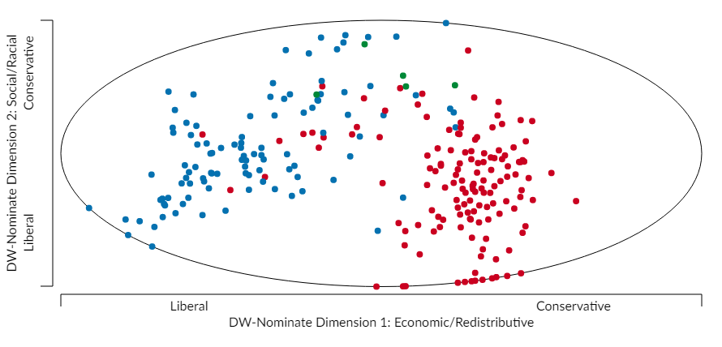
Figure 1. The DW-Nominate Plot of the House of Representatives of the 36th Congress.
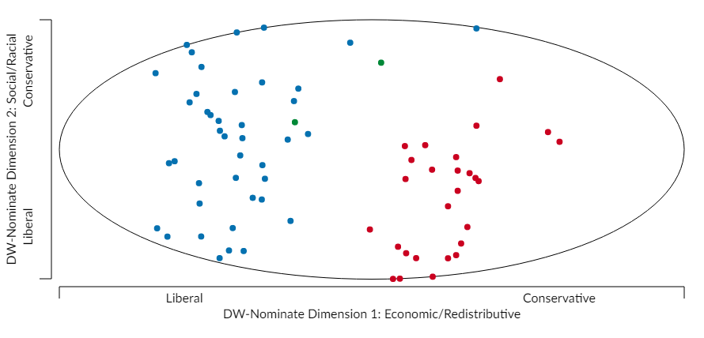
Figure 2. The DW-Nominate Plot of the Senate of the 36th Congress.
Appendix B
104th Congress
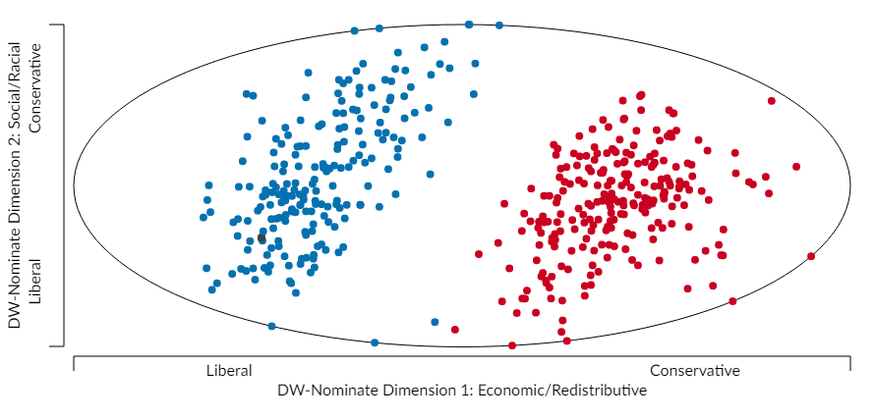
Figure 1. The DW-Nominate Plot of the House of Representatives of the 104th Congress.
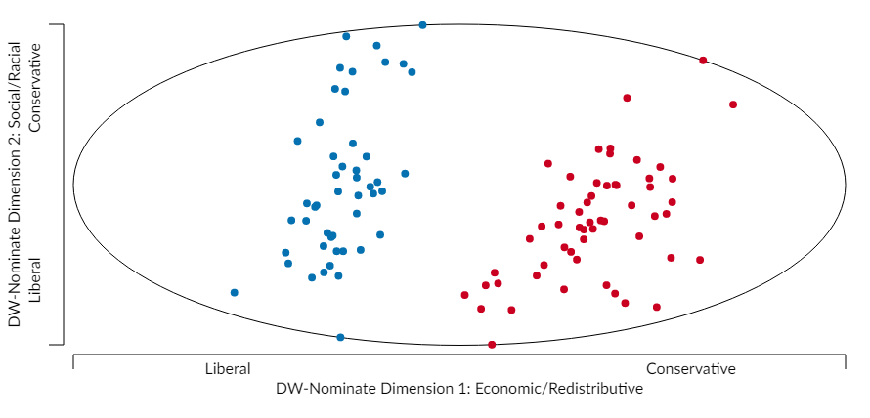
Figure 2. The DW-Nominate Plot of the Senate of the 104th Congress.
Appendix C
110th Congress
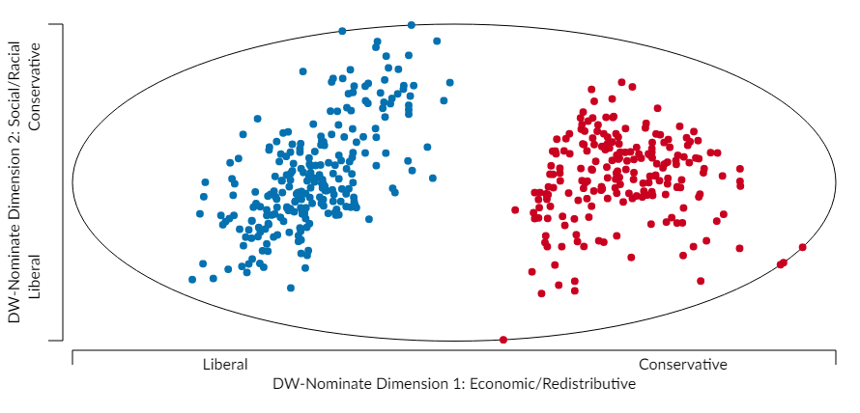
Figure 1. The DW-Nominate Plot of the House of Representatives of the 110th Congress.
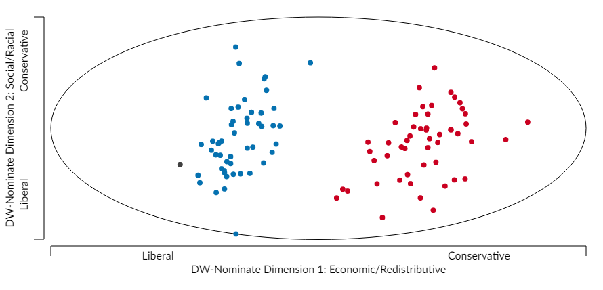
Figure 2. The DW-Nominate Plot of the Senate of the 110th Congress.
Appendix D
111th Congress
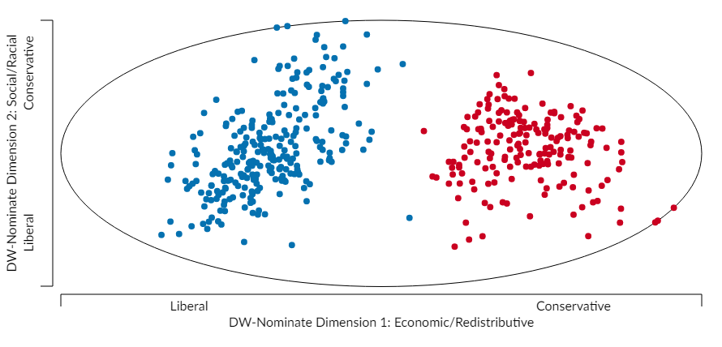
Figure 1. The DW-Nominate Plot of the House of Representatives of the 111th Congress.
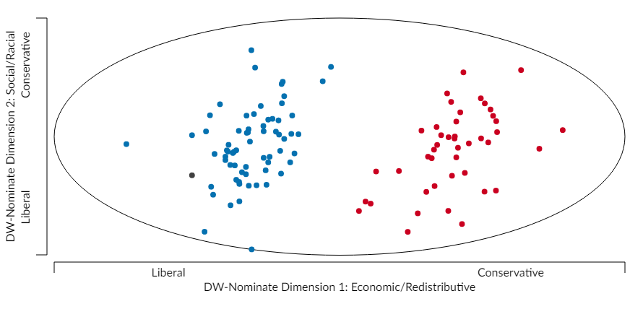
Figure 2. The DW-Nominate Plot of the Senate of the 111th Congress.
Appendix E
112th Congress
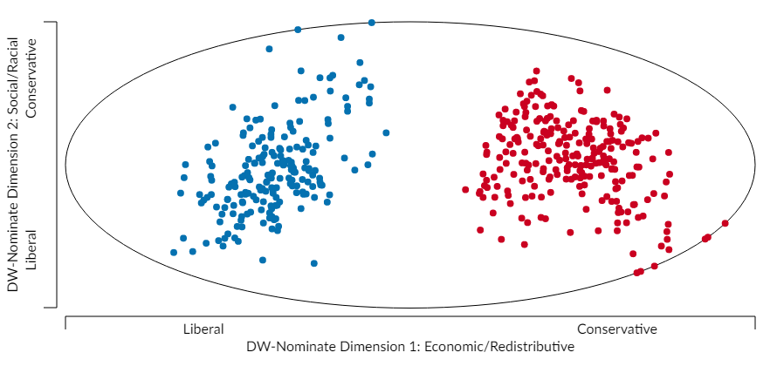
Figure 1. The DW-Nominate Plot of the House of Representatives of the 112th Congress.
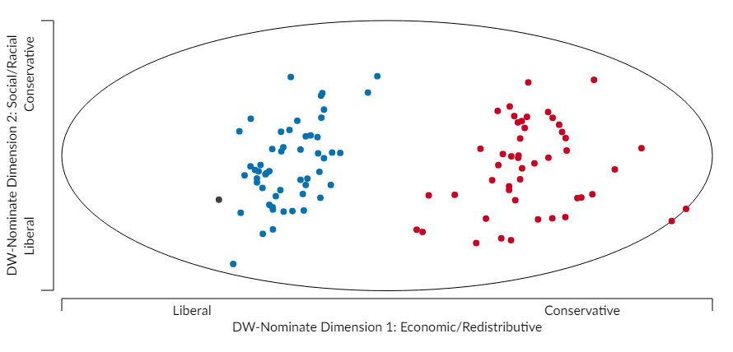
Figure 2. The DW-Nominate Plot of the Senate of the 112th Congress.

Appendix F
113th Congress
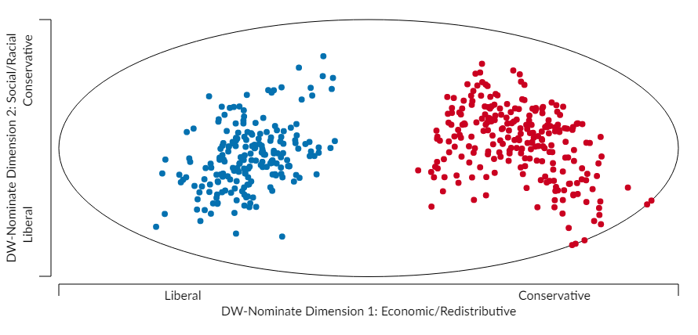
Figure 1. The DW-Nominate Plot of the House of Representatives of the 113th Congress.
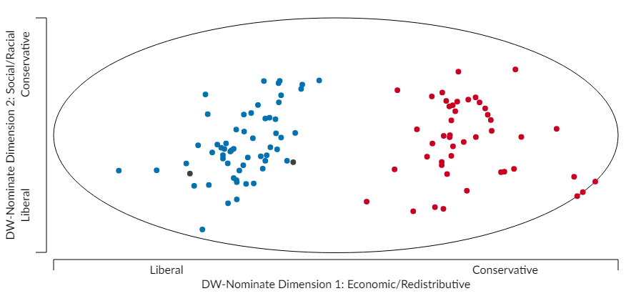
Figure 2. The DW-Nominate Plot of the Senate of the 113th Congress.

Appendix G
114th Congress
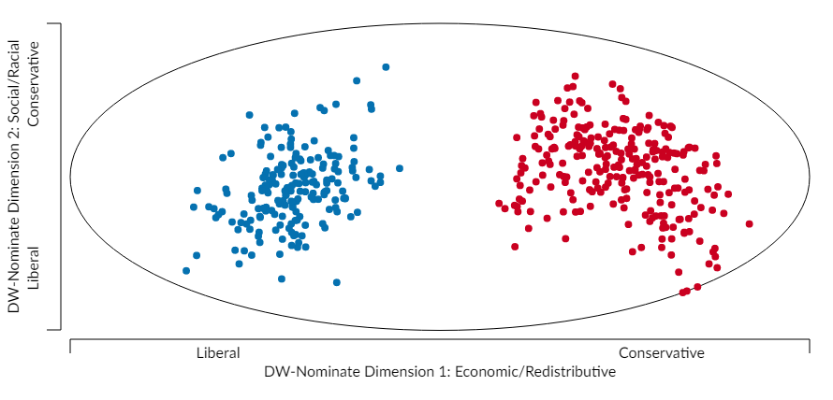
Figure 1. The DW-Nominate Plot of the House of Representatives of the 114th Congress.
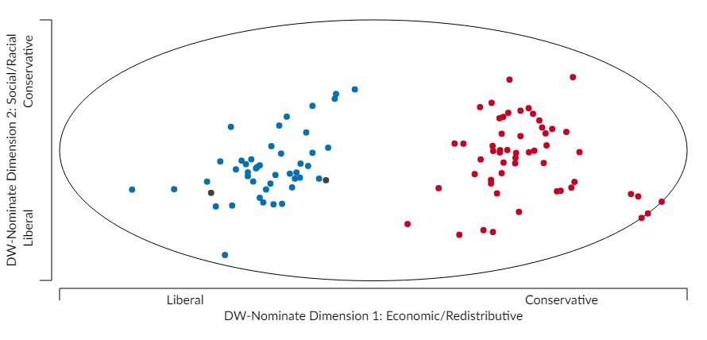
Figure 2. The DW-Nominate Plot of the Senate of the 114th Congress.

Appendix H
115th Congress
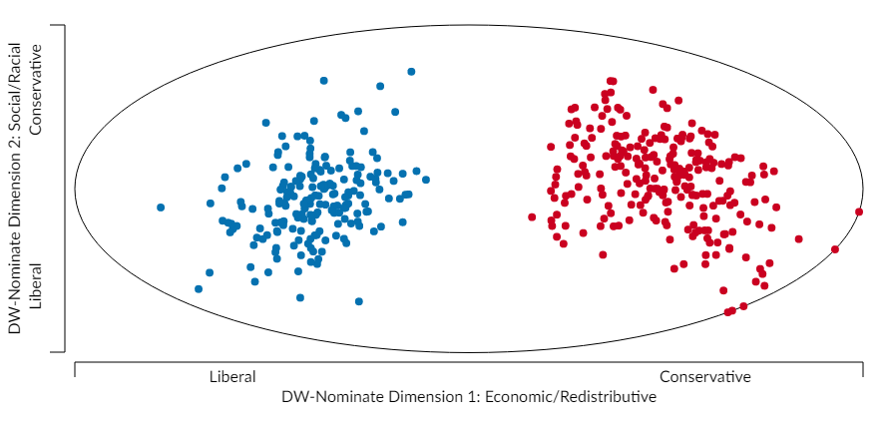
Figure 1. The DW-Nominate Plot of the House of Representatives of the 115th Congress.
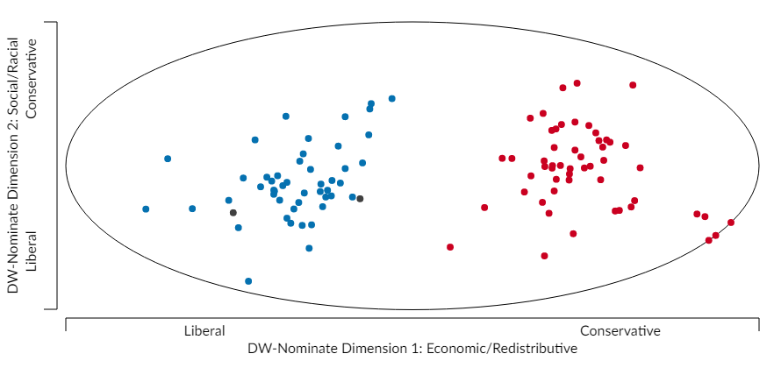
Figure 2. The DW-Nominate Plot of the Senate of the 115th Congress.
Bibliography
“700 Arrested After Wall Street Protest on Brooklyn Bridge.” Fox News, 2 Oct. 2011, http://www.foxnews.com/us/2011/10/01/500-arrested-after-wall-street-protest-on-nys-brooklyn-bridge.html?test=latestnews.
“Bernie Sanders Supporters Protest Election Coverage At Hollywood CNN Building.” CBS Los Angeles, 3 Apr. 2016, http://losangeles.cbslocal.com/2016/04/03/bernie-sanders-supporters-protest-election-coverage-at-hollywood-cnn-building/.
Brady, David W. and Hahrie Han. “Our politics may be polarized. But that’s nothing new.” The Washington Post, 16 Jan. 2014, https://www.washingtonpost.com/news/monkey-cage/wp/2014/01/16/our-politics-may-be-polarized-but-thats-nothing-new/?utm_term=.7d74fbed2067.
Brown, Emma, James Hohmann, and Perry Bacon Jr. “Tens of Thousands Protest Obama Initiatives at Capitol.” The Washington Post, 13 Sep. 2009, http://www.washingtonpost.com/wp-dyn/content/article/2009/09/12/AR2009091200971.html.
Burt, Cecily. “Ousted protesters marching back to Frank Ogawa Plaza.” The Mercury News, 25 Oct. 2011, https://www.mercurynews.com/2011/10/25/ousted-protesters-marching-back-to-frank-ogawa-plaza-2/.
Campbell, James E. Polarized: Making Sense of a Divided America. Princeton Unversity Press, 2016.
Fernandez, Lisa. “Iraq War Veteran Scott Olsen Reaches $4.5M in Occupy Oakland Bean Bag Case.” NBC Bay Area, 21 Mar. 2014, https://www.nbcbayarea.com/news/local/Iraq-War-Veteran-Scott-Olsen-Win-45M-Settlement-in-Occupy-Oakland-Beag-Bag-Case-251438961.html.
Feuer, Ann. “Where FEMA Fell Short, Occupy Sandy Was There.” The New York Times, 9 Nov. 2012, https://www.nytimes.com/2012/11/11/nyregion/where-fema-fell-short-occupy-sandy-was-there.html.
Gabbat, Adam. “Scott Olsen injuries prompt review as Occupy Oakland protests continue.” The Guardian, 26 Oct. 2011, https://www.theguardian.com/world/2011/oct/26/scott-olsen-occupy-oakland-review.
Garand, James C. “Income Inequality, Party Polarization, and Roll-Call Voting in the U.S. Senate.” The Journal of Politics, vol. 71, no. 4, 2010, pp. 1109 – 1128.
Golden, Cory. “UCD police chief placed on administrative leave.” Davis Enterprise, 21 Nov. 2011, https://www.davisenterprise.com/local-news/crime-fire-courts/protests-again-gathering-steam-on-campus/.
Gore, Al. “False Spontaneity of the Tea Party.” Huffington Post, 14 Feb. 2013, https://www.huffingtonpost.com/al-gore/tea-party-koch-brothers-big-tobacco_b_2689380.html.
Green, John C., Daniel J. Coffey, and David B. Cohen, eds. The State of the Parties: The Changing Role of Contemporary American Politics. 7th ed., Rowman & Littlefield, 2014.
Green, Joshua. “Ron Paul: The Tea Party’s Brain.” The Atlantic, Nov. 2010, https://www.theatlantic.com/magazine/archive/2010/11/the-tea-partys-brain/308280/.
Grossman, Matt and David A. Hopkins. Asymmetric Politics: Ideological Republicans and Group Interest Democrats. Oxford University Press, 2016.
Harris, Elizabeth A. “Citing Police Trap, Protestors File Suit.” The New York Times, 4 Oct. 2011, https://www.nytimes.com/2011/10/05/nyregion/citing-police-trap-protesters-file-suit.html.
Ingraham, Christopher. “A stunning visualization of our divided Congress.” The Washington Post, 23 Apr. 2015, https://www.washingtonpost.com/news/wonk/wp/2015/04/23/a-stunning-visualization-of-our-divided-congress/?utm_term=.0254d1cdd2da.
Ingraham, Chris. “Deepening ideological divisions in the house.” Blocks, 28 Dec. 2015, http://bl.ocks.org/cingraham/7487738.
Ingraham, Christopher. “Five charts that show how conservatives are driving partisan rancor in DC.” The Washington Post, 12 Jun. 2014, https://www.washingtonpost.com/news/wonk/wp/2014/06/12/five-charts-that-show-how-conservatives-are-driving-partisan-rancor-in-dc/?utm_term=.1d3269dbce89.
Ingraham, Chris. “Party Unity in Congress, 1857 to 2011.” Blocks, 27 Dec. 2015, http://bl.ocks.org/cingraham/7461221.
Isenstadt, Alex. “’Freedom fighters’ take a stand in D.C.” Politico, 12 Sep. 2009, https://www.politico.com/story/2009/09/freedom-fighters-take-a-stand-in-dc-027070.
Kirkup, James. “Occupy protestors were right, says Bank of England official.” The Telegraph, 29 Oct. 2012, https://www.telegraph.co.uk/finance/newsbysector/banksandfinance/9641806/Occupy-protesters-were-right-says-Bank-of-England-official.html.
Lee, David, Marcus J. Hamilton, Mauro Martino, Christian E. Gunning, and John Armistead Selden. “The Rise of Partisanship and Super-Cooperators in the U.S. House of Representatives.” PLOS, 21 Apr. 2015,
Lessig, Lawrence. “#OccupyWallSt, Then #OccupyKSt, Then #OccupyMainSt.” Huffington Post, 5 Oct. 2011, https://www.huffingtonpost.com/lawrence-lessig/occupywallst-then-occupyk_b_995547.html.
Levitin, Michael. “The Triumph of Occupy Wall Street.” The Atlantic, 10 Jun. 2015, https://www.theatlantic.com/politics/archive/2015/06/the-triumph-of-occupy-wall-street/395408/.
Lewis, Jeffrey B., Keith Poole, Howard Rosenthal, Adam Boche, and Luke Sonnet. Voteview: Congressional Roll-Call Votes Database, 2017, voteview.com/.
Markman, Joe. “Crowd estimates vary wildly for Capitol march.” Los Angeles Times, 15 Sep. 2009, http://articles.latimes.com/2009/sep/15/nation/na-crowd15.
McCarty, Nolan M. “The Limits of Electoral and Legislative Reform in Addressing Polarization.” California Law Review, vol. 99, no. 2, 2011, pp. 359 – 371.
McCarty, Nolan, Keith T. Poole, and Howard Rosenthal. Polarized America: The Dance of Ideology and Unequal Riches. MIT Press, 2006.
McVeigh, Rory, David Cunningham, and Justin Farrell. “Political Polarization as a Social Movement Outcome: 1960s Klan Activism and its Enduring Impact on Political Realignment in Southern Counties, 1960 to 2000.“ American Sociological Review, vol. 79, no. 6, 2014, pp. 1144 – 1171.
Moynihan, Colin. “80 Arrested as Financial District Protest Moves North.” The New York Times, 24 Sep. 2011, https://cityroom.blogs.nytimes.com/2011/09/24/80-arrested-as-financial-district-protest-moves-north/.
“’Occupy Auckland’ protest speaks with many voices.” New Zealand Herald, 29 Oct. 2011, http://www.nzherald.co.nz/nz/news/article.cfm?c_id=1&objectid=10762353.
“Occupy Movement.” Ideas and Movements That Shaped America: From The Bill of Rights to “Occupy Wall Street. 1st ed., 2015.
Phillips, Michael M. “FreedomWorks Harnesses Growing Activism on the Right.” The Wall Street Journal, 5 Oct. 2009, https://www.wsj.com/articles/SB125469984687962987.
Pilkington, Ed. “Republicans steal Barack Obama’s internet campaigning tricks.” The Guardian, 18 Sep. 2009, https://www.theguardian.com/world/2009/sep/18/republicans-internet-barack-obama.
Poole, Keith T. and Howard Rosenthal. Ideology & Congress. Routledge, 2006.
Ray, Michael. “Tea Party movement.” Encyclopedia Britannica Online, https://www.britannica.com/topic/Tea-Party-movement.
Resnick, Brian, Brian McGill and Ella Krivitchenko. “This is What Congressional Gridlock Looks Like in 1 Chart.” National Journal, https://www.nationaljournal.com/s/66925/this-is-what-congressional-gridlock-looks-like-1-chart.
“Rick Santelli and the ‘Rant of the Year’.” YouTube, uploaded by nq792000, 19 Feb. 2009. https://www.youtube.com/watch?v=bEZB4taSEoA.
Rogers, Simon. “Occupy protests around the world: full list visualized.” The Guardian, 14 Nov. 2011, https://www.theguardian.com/news/datablog/2011/oct/17/occupy-protests-world-list-map?newsfeed=true.
Rosen, Daniel Edward. “Is Ray Kelly’s NYPD Spinning Out of Control?” Observer, 1 November 2011, http://observer.com/2011/11/is-ray-kellys-nypd-spinning-out-of-control/?show=all.
Schier, Steven E. and Todd E. Eberly. Polarized: The Rise of Ideology in American Politics. Rowman & Littlefield, 2016.
Schiffrin, Anya and Eamon Kircher-Allen, eds. From Cairo to Wall Street: Voices from the Global Spring. The New Press, 2012.
Schilling, Chelsea. “Join More Than 40 Nationwide Tea Parties.” World News Daily, 25 Feb. 2009, http://wnd.com/2009/90055/.
Skocpol, Theda and Vanessa Williamson. The Tea Party and the Remaking of Republican Conservatism. Oxford University Press, 2012.
“Tea Party Movement.” Ideas and Movements That Shaped America: From The Bill of Rights to “Occupy Wall Street. 1st ed., 2015.
Theriault, Sean M. The Gingrich Senators. Oxford University Press, 2013.
“United States of Amoeba.” The Economist, 5 Dec. 2013, https://www.economist.com/news/united-states/21591190-united-states-amoeba.
Vanden Heuvel, Katrina. “Will Occupy Wall Street’s spark reshape our politics?” Editorial. The Washington Post, 11 Oct. 2011, https://www.washingtonpost.com/opinions/will-occupy-wall-streets-spark-reshape-our-politics/2011/10/10/gIQArPJjcL_story.html?utm_term=.07ffcb68b93b.
“Vital Statistics on Congress.” The Brookings Institute, 7 Sep. 2017, https://www.brookings.edu/multi-chapter-report/vital-statistics-on-congress/.
Vogel, Kenneth P. “’Money bomb’: Ron Paul raised $6 million in 24-hour period,” USA Today, 17 Dec. 2007, http://usatoday30.usatoday.com/news/politics/election2008/2007-12-17-ronpaul-fundraising_N.htm/
Walzer, Michael. “Social Movements and Election Campaigns.” Dissent, 2012, pp. 25 – 28.
Weigal, David. “Five Myths About the Tea Party.” Slate, 9 Aug. 2010, http://www.slate.com/articles/news_and_politics/politics/2010/08/five_myths_about_the_tea_party.html.
West, Cornel. Interview by Amy Goodman. “Cornel West on Occupy Wall Street: It’s the Makings of a U.S. Autumn Responding to the Arab Spring.” Democracy Now!, 29 Sep. 2011, https://www.democracynow.org/2011/9/29/cornel_west_on_occupy_wall_street_its_the_makings_of_a_us_autumn_responding_to_the_arab_spring.
Wilson, Simone. “City Council Unanimously Passes Occupy L.A. Resolution – Protestors Struggle to Distance Themselves From Democrats, Unions.” LA Weekly, 12 Oct. 2011, http://www.laweekly.com/news/city-council-unanimously-passes-occupy-la-resolution-protesters-struggle-to-distance-themselves-from-democrats-unions-2384300.
Zernicke, Kate. “Unlikely Activist Who Got to the Tea Party Early.” The New York Times, 27 Feb. 2010, https://www.nytimes.com/2010/02/28/us/politics/28keli.html.

