Jacob Tomlinson
Dr. Auger
POLS 553: International Relations

Is Congress Still Regionally Divided?: An Analysis of Trubowitz’s Model

Abstract
Peter Trubowitz created a spatial model in 1993 that analyzed Congresses key roll call votes. The votes that he analyzed specifically looked at foreign policy. The model that he created looked to see how members of Congress voted in regards to which state they represented. In this way, his model demonstrated that Congress was regionally divided on foreign policy issues. This study here replicates Trubowitz’s model to see if Congress is still regionally divided over 20 years after Trubowitz published his work. Ultimately, it is found that Congress is no longer divided regionally on key foreign policy issues. I theorize here that this is the case today because the economic situation of the United States as a whole has changed rather dramatically.

Is Congress Still Regionally Divided?: An Analysis of Trubowitz’s Model
What if there were a way to predict how members of Congress were going to vote on foreign policy issues based on where they lived in the United States? Conventional wisdom would suggest that one way to attempt to predict a Congressperson’s vote is to look at their political party or ideology (Poole and Daniels 1985). But what if there is a larger, more expansive predictor of congressional voting on foreign policy issues? That is, perhaps a true predictor of congressional voting on foreign policy issues comes from the region that each congressperson represents. If this were the case, then it may very well be possible to know which foreign policy issue bills will pass and which will not. To answer this question, it is most appropriate to turn to Peter Trubowitz.
In 1993, Peter Trubowitz published an article called “Political Conflict and Foreign Policy in the United States: A Geographical Interpretation” that analyzed just how members of Congress voted on key foreign policy issues. Although more will be explained below, in short, he created a spatial model that concluded Congress was regionally divided on foreign policy issues. Here, I will attempt to recreate the study Trubowitz conducted in order to analyze whether his model stands the test of time. Seeing as it has been slightly over 20 years since Trubowitz’s article was published, many things have changed, which in turn may alter the results of the model. Thus, a question is posed: according to Trubowitz’s model, is Congress still regionally divided based on key foreign policy roll call votes?
I speculate that the answer to that question is no, Congress is no longer regionally divided. Rather, it is my belief and I hypothesize here that due to the differences in time (i.e., the differences between when Trubowitz wrote his article and today) Congress is not divided based on regional lines. Given the changes in the climate of the United States due to events such as 9/11, the economic recession, the ever increasing polarization of Congress, and the Tea Party movement, Congress is no longer regionally divided. Further, I contend that this recreation of Trubowitz’s model may give insight into what the differences in time may be. Of course, below I will speculate as to what the changes might be, but the data may show something entirely different.
Trubowitz’s Geographical Interpretation
Peter Trubowitz begins by stating that his paper offers an alternative argument to what other scholars posit. Trubowitz (1993) argues “since the early 1970s, conflict over foreign policy has been part-and-parcel of a larger, regionally based struggle for national wealth and power” (264). Furthermore, he boldly states that the regional lines have been split based on what the regions believe best in their interest domestically, as well as abroad. That is, the struggle between regions lies in what the region believes to be America’s objectives both at home and in the international system.
Like most excellent political scientists, Trubowitz looked first to history as an indication of regional division in Congress. He notes that “[d]uring the 1890s … the great debate between the ‘imperialists’ and the ‘continentalists’ over overseas expansion pitted the industrial and commercial Northeast against the agrarian South” (265). In other words, at the time the Northeast, in many respects, wanted to be expansive in order to gain access to markets in other parts of the world. This differs from the wants of the South, which wanted to be less expansive. Ideas changed as time gets closer to the Great Depression. Trubowitz describes the Northeast and South as regions that could benefit from an open, interdependent world economy, whereas the West “called for renewed trade protection and opposed attempts to stabilize global commercial and monetary relations” (265). These two historical examples, Trubowitz argues, show that there is, at least from a historical perspective, a regional division in foreign policy that are rooted in regional interests stemming from domestic agendas.
To explain that this regional division has remained relatively unchanged, Trubowitz examines “how members of the House of Representatives vote on key foreign policy issues from the Nixon through Reagan years” (266). To determine what the key foreign policy issues are, he used Americans for Democratic Action, Americans for Constitutional Action and Congressional Quarterly, which all compile lists of key votes in Congress on a variety of issues. After gathering all of that data, Trubowitz sorts through and uses the state as a unit of analysis. In other words, the state’s position on a particular bill is how the majority of that state’s members of Congress vote. It is important to note here that Trubowitz, in the model he created, created an index for how cohesive each state was in their vote. That is, a state’s “score is 100 when there is perfect agreement between the majority position of two state delegations; it is 0 if there is perfect disagreement” (266). After coding states in this manner, Trubowitz used multi-dimensional scaling in order to show the empirical relationship between how each state votes on foreign policy issues under each president between Nixon and Reagan (i.e., Nixon, Ford, Carter, and Reagan). Using this scaling, “[t]he goal is to find the configuration of interpoint distances between state delegations that corresponds as closely as possible to the similarities among the voting behavior of these delegations” (266).
After running the model, Trubowitz finds that voting among states is regional in nature. That is, states are essentially grouped by Northeast and South when analyzing their votes on key foreign policy issues. The West, however, seems to be more mixed within the North and the South. Trubowitz explains that the regional division “falls along lines others have defined as rustbelt-sunbelt” (268). Following this discovery, he sought out reasons for why there is a regional difference in foreign policy ideology. Importantly, he notes that foreign policy conflicts cannot be completely separated from domestic policy conflicts. Thus, turning also to domestic policy struggles is a must.
First, he notes that “[t]he declining economic fortunes of the Northeast led politicians from the region seek ways of reducing the costs of the nation’s foreign policies in order to devote greater resources to domestic problems and needs” (271). In this way, the Northeast and South debate over which policies are best and create a “regional cleavage.” Moreover, in regards to economics, “[w]hile many states located in the [Northeast] experienced sluggish growth rates and economic stagnation, many in the South and West became more prosperous and diversified” (271). As such, the differences in economies creates differences in domestic and foreign policy ideology.
Second, Trubowitz goes on to mention that the differences between the Northeast and the South and West in regards to foreign policy initiatives. Specifically, in the 1970s when the “Northeast was experiencing hard economic times, elected officials and interest groups found it politically advantageous to emphasize the domestic opportunity costs of military intervention, military spending and military aid to the Third World” (271). Due to the economic hardships the Northeast was experiencing, many felt that the South and West were benefiting more so than the Northeast from a military buildup.
Lastly, in regards to foreign economic policy (e.g., trade agreements), regional interests again played a key role in each state’s vote on these issues. In the 1970s as there was great fear that the Northeast would lose more of its industries overseas, the Northeast saw free-trade policies with other countries as negative for the region specifically, and for America more generally. This differs from the opinion of those in the South and the West, as they saw free-trade policies as an attractive option that the United States should pursue (Trubowitz 1993).
To conclude, Trubowitz (1993) notes that his “study suggests that sectionalism remains a persistent force in American political life, and in the foreign policy arena in particular” (273). Now, this may be true as of 1993, but is it still true today?
An Updated Model
Method
To begin, I use a similar method of gathering roll call votes on key foreign policy issues. Like Trubowitz, I use Congressional Quarterly in order to determine what the key votes on foreign policy issues are. I then use the Thomas Library of Congress to find the roll call of the votes and score each state according to how each Congressperson voted on those foreign policy issues. I do not, however, use American for Democratic Action or Americans for Constitutional Action because of the lack of access to each of these resources. I then score the states just as Trubowitz did in his model. That is, the state delegations, rather than the individual House members, are the unit of analysis. Moreover, I score the states on a 0 to 100 scale in terms of their voting cohesiveness. In other words, state that has a score of 0 means that every House member to that state’s delegation voted nay on the bill; a state that has a score of 100 means that every House member to that state’s delegation voted yea on the bill.
Following this, I run the multidimensional scaling model using IMB SPSS Statistics. A multidimensional scaling model was used, like Trubowitz, because it “captures the political geography of voting over foreign policy” (Trubowitz 1993, 266). Thus, below is an image in which shows all 50 states on a graph that are separated by space. The space represents the distance between how the states vote. Thus, states that cluster together vote similarly; states that are further apart vote differently.
Additionally, due to a restraint on information, I analyze only four separate key foreign policy roll call votes of the House of Representatives. However, I provide below a detailed explanation of each vote and describe why I believe the four votes explain the way the states vote just as well as if the information was not limited and I had as many votes as Trubowitz had over the course of four presidencies. The votes that I describe below come from the Obama administration, since this is the current administration at the time of this writing. The votes are also in chronological order. Further, I contend that using votes from this administration will provide the most up to date depiction of a regional divide on foreign policy issues in Congress.
Key Roll Call Votes
Funding for the Afghanistan War. The House vote was held in 2010. This vote was chosen in particular because it has to do with funding a war. Moreover, this vote is important because, as Trubowitz pointed out, those states that may be opposed to the war may be opposed because the money that is appropriated for the war could be used for other domestic purposes. This plays out back when Trubowitz wrote about how the North’s economic policies coincided with their foreign policy.
This bill was also significant for reasons that Frank Oliveri (2011) spelled out. To explain, “President Obama’s request for $33.5 billion in supplemental funding to support his Afghanistan surge strategy split House Democrats into two camps” (Oliveri 2011, 58). He notes that earlier in the year, on a similar bill, House Democrats stood in favor of withdrawing troops from Afghanistan, rather than spending money to keep them there. Perhaps most interesting is that even earlier in President Obama’s term House Democrats were the biggest supporters of Obama and his war-spending efforts (Oliveri 2011). Now, around the time of this bill, there was a stark divide in both Republican and Democrat caucuses in the House. Even more, there were offices in the executive branch, such as the Office of Management and Budget, which came out and issued statements either for or against the funding bill. Ultimately, “[o]n July 27, the House voted, 308-114, to clear the spending measure and support the president’s strategy, but only 148 of 250 Democrats supported the measure, while 160 of 172 Republicans backed the bill” (Oliveri 2011, 58).
Trade Liberalization Agreement. This House vote came in 2011. This vote was chosen in particular because it has to do with trade agreements. Furthermore, this vote was chosen because, as Trubowitz (1993) pointed out, votes on trade agreements were divided among regions. For the most part, if the region is not doing well economically-speaking, then the votes in that region will more than likely be against a free trade agreement.
To elaborate on the key vote of the key vote in the House, as defined by Stephen Gettinger (2012) at Congressional Quarterly, he notes that there were four votes on trade liberalization agreements: “free-trade agreements with Columbia (HR 3078), Panama (HR 3079) and South Korea (HR 3080)” (52) and also the Trade Adjustment Assistance bill (HR 2832). For the purpose of this study, I took all of the votes for each bill and found the mean “yes” and “no” votes and then chose the vote that most closely resembled the mean. In this case, the free-trade agreement between the United States and South Korea was the closest to the mean. Now, the reason for doing this is to get an accurate reflection of trade liberalization agreements in general. It is important, though, to mention that particular members of the House may very well have different reasons for voting differently on each of these bills, which caused the slight variation in vote total. However, for now, and for the purposes of the study presented here, the vote on the United States-South Korea Trade Agreement will provide the fundamental information needed for the model.
Returning to the significance of the House vote, Gettinger (2012) notes that “[m]any Democrats … said that the free-trade agreements could result in significant job losses” (52). On the other side of the spectrum “[b]oth the White House and Republicans said that the pacts will help create jobs by promoting U.S. exports, with Obama predicting a $13 billion boost” (Gettinger 2012, 52). So, seeing as President Obama is a Democrat who is in favor of the bill, and many Democrats in the House opposed the bill, this bill seems to have further implications for divide than just party lines.
Patriot Act Extension. This House vote came in 2011. This vote was chosen because it has to do with putting foreign policy power in the hands of the administration. Moreover, this vote was chosen because if a state or region feels like they are in decline, economically and in terms of voting power, they will more than likely vote against the extension. In addition, if a state or region feels that they are experiencing economic hardship, the members of that state or region would vote against this for fear of giving the Executive Branch more control over money that the economically burdened state or region could use.
Tim Starks (2012) at Congressional Quarterly reported on this House vote and explained its significance. For starters, “Hours before several provisions of the Patriot Act were set to expire, the House cleared a measure May 26 that would extend some of the Obama administration’s anti-terrorism authorities for four years” (Starks 2012, 50). He continues to explain the provisions of the bill that include allowing “the government to seek court orders for roving wiretaps on suspects who use multiple devices or modes of communication, to request access to ‘any tangible thing’ deemed related to a terrorism investigation, and to seek warrants to conduct surveillance of ‘lone wolf’ foreign terrorist suspects who may not be connected to a larger terrorist group” (Starks 2012, 50). Furthermore, this vote is of importance because House GOP leaders, through a procedural maneuver, made it so that the bill only required a simple majority to pass, rather than the original two-thirds majority that it originally required (Starks 2012). Lastly, to show just how significant this bill was, especially to the president, the president “signed the measure hours later with an autopen while on an official trip to Europe” (Starks 2012, 50).
Limitation on Forces in Libya. This House vote also was held in 2011. This vote was chosen because, again, it has to do with exercising military force. As Trubowitz wrote, a military intervention, or even a build up for that matter, would disproportionately benefit a particular region(s) over others if one or two regions were doing worse economically than the other(s). Thus, from this vote, if the United States is still divided into different regions, then after running the model it is probable to see the economically-worse region(s) voting to limit forces in Libya.
Emily Cadei (2012), Congressional Quarterly staff member, wrote about the significance this bill had in the House. She notes in her opening paragraph that “[i]n early June, House Speaker John A. Boehner, R-Ohio, took the unusual step of introducing his own resolution related to U.S. military operations in Libya to fend off passage of a tougher measure. Instead of demanding that all troops withdraw by June 15, as called for in a rival resolution by Dennis J. Kucinich, D-Ohio, Boehner’s measure gave the White House two weeks to justify its strategy on Libya and requested a long list of documents to back up that justification” (Cadei 2012, 50). The rival resolution essentially stopped just short of saying that President Obama was overstepping his war-making authority and because of such, House Speaker Boehner felt that he needed to tone down that language and make the resolution less anti-Obama administration. Nevertheless, the two resolutions were hotly debated and there was widespread contention on Capitol Hill over what resolution should be adopted. Ultimately, House Speaker Boehner’s resolution was adopted, and is used here.
Results
Below is a descriptive statistics table showing the data used for the multidimensional scaling model. Important to note about the table is that the lowest value will be 0 and the highest value will be 100. The mean represents the average of all four key foreign policy votes. This number is important because it shows, on average, how the state voted on all four of the key roll call votes. The standard deviation represents how spread out the votes are for each state delegation in regards to how they change their vote varies from the mean. This number is important because it shows how much the state changes in its vote. It should be stated here that some states (i.e., Alaska, Delaware, Montana, North Dakota, South Dakota, Vermont, and Wyoming) only have one House member that represents the entire state. Thus, because only four key roll call votes are being measured, the above listed states only have an accurate measure of the one individual. This is not to say that they don’t represent the entire state well, or even to say that they don’t vote with their region, but it is to say that because the sample size is relatively small, the results of these particular states may not be indicative of how the state would vote over time or if the sample size were larger.
After running the multidimensional scaling model in SPSS, which appears below the descriptive statistics table, configurations of the model were generated in one, two, and three dimensions. The two dimensional configuration here because, like Trubowitz, it most accurately represented the voting patterns of each state respectively. Moreover, for the purposes of actually viewing the model, the two dimensional configuration is the easiest to both look at
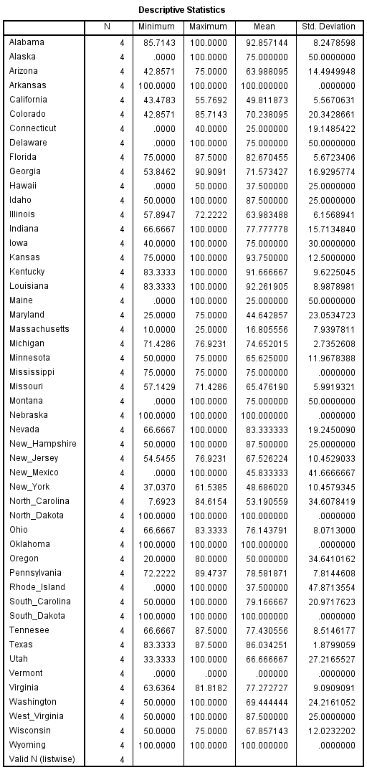
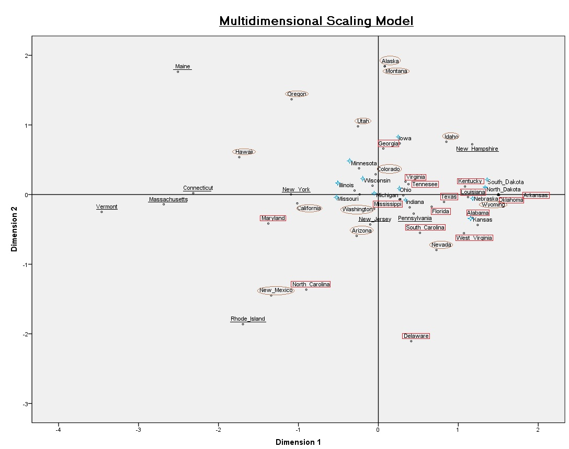
and analyze. At a quick glance, the two dimensional scaling model appears to have clustering of states, to be sure. However, after further analysis, this clustering does not appear to be regionally based. In Trubowitz’s model, he only coded states as Northeast, South, and West. At first, this model did the same. After further examination, the model also included the Midwest for further explanatory power. Trubowitz, in his model, lumped the Midwest into the Northeast. All that said, the states in this model that are from the Northeast are underlined. The states in this model that are from the Midwest are designated with a blue, four-pointed star. The states from the South are designated with a red rectangle. Lastly, the states from the West are designated with a brown circle.
Key: Northeast is underlined. Midwest is next to a blue four-pointed star. South is surrounded in a red rectangle. West is surroumded by a brown circle.
After further visual examination, this model sees a rather large cluster of states from all regions, with outlier states all along the outside of the larger cluster. It is important to remember that Trubowitz’s findings included a clear divide between the Northeast and the South with the West divided into the two regions. This, as it is clear from the model, is not the case. Instead, what is clear, is no true regional division. In fact, it is extremely apparent that there is no true regional division when looking at the cluster of states around Nebraska. States around Nebraska include a great mix of states from the Midwest, West, Northeast, and South. There is, however, a cluster of Midwestern states around Wisconsin. Even then, though, there are states in the West and South that are rather close to the Midwestern states. Thus, it is safe to say, from the analysis presented here that the United States is no longer divided into regions on key foreign policy issues.
The next question, of course, is why this is the case? Why is it that 20 years after Trubowitz found that the House was regionally divided on foreign policy issues, the House is no longer divided regionally on these same issues? I believe that the most important factor contributing to the change in regional lines is the economy. Needless to say, the economy has changed drastically from 1969, which is the year that Trubowitz’s data starts. Two things have been examined here further explaining the grand changes in the overall U.S. economy: U.S. GDP and U.S. national debt.
The U.S. GDP, or gross domestic product, is the most used measure of a nation’s economy. To measure the size of a nation’s economy, GDP represents the goods and services produced and the dollar value of those goods and services. The above chart, provided by data from the U.S. Bureau of Economic Analysis, shows the growth rate of the U.S. GDP from 1969 to 2012. At first glance, this chart just looks like a bunch of ups and downs in GPD growth. After analyzing the years from Trubowitz’s model (i.e., 1969 to 1989), the highest growth rate appears to be about 17% GDP growth and the lowest appears to be at about -7% growth in a single quarter. Most important about analyzing this time period is that more often than not through these years, the GDP growth is positive, and not only slightly positive but there are several occasions when the GDP growth goes over 5%.
However, after the time period of data from the Trubowitz article, the GDP growth rate looks very different. The GDP growth rate after 1989 does not completely stagnate, by any means, but the growth rate slows. On average, between 1992 and 2008 the GDP growth rate looks to be about 2 to 3% growth. Then, the 2008 recession hits and the U.S.
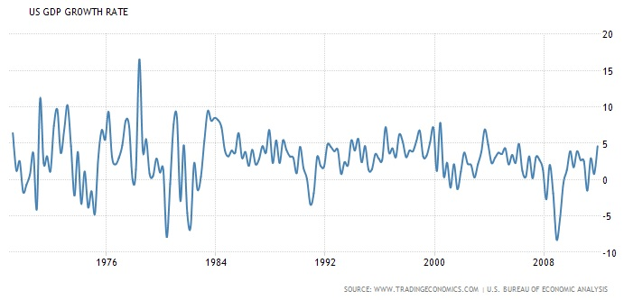
GDP growth rate plummets to about -8%. To be sure, the GDP growth rate bounces back, but not
in an extremely significant way. In fact, between 2008 and 2012, the GDP growth rate does not go above 5%, which seemed to be a rather normal occurrence between 1969 and 1989. This, then, can be said to shape the domestic economic policy of all states; further, it can be said to influence the foreign policy votes in the House of Representatives.
The second important economic variable that I theorize to be a substantial influence on House votes is the United States national debt. The U.S. national debt accumulates when the United States pays for federal government programs, but does not have the revenue – which is typically created through taxes – to pay for those federal government programs. Using data provided by the Office of Management and Budget, the federal agency that assists the president in crafting a federal budget, taking a look at the gross federal debt of the United States is quite easy. In 1969 the gross federal debt was about 365.8 billion dollars. From 1969 to 1989 the gross federal debt grew almost 8 times larger to a whopping 2.9 trillion dollars. Now, while this huge jump in national debt was not really touched upon in Trubowitz’s article, I argue that it lends some explanatory power here. Over the course of time, the national debt continued to grow. In fact, it grew so much that in 2012 the gross federal debt was about 16 trillion dollars, which is astoundingly larger than what the debt was only a little over twenty years prior. And further, because the national debt is so drastically larger than what it was at the time of Trubowitz’s writing, I argue that it has much more of an effect on policy, regardless of the region that a particular state is in.
In addition to that, the national debt gets more attention today than it has in the past. This is not to say that the U.S. national debt did not get any attention; rather, this is to say that the total national debt get much more attention today. As a quick example of how much more the national debt is discussed today than it was in the years of Trubowitz’s writing, a quick search in Google Scholar shows that there are approximately 47,900 results in regards to United States national debt between 1969 and 1989; between 2008 and 2013 there are approximately 60,100 results in regards to United States national debt. This alone shows that in a significantly shorter period of time, there is much more discussion about the United States national debt. Thus, I contend that more attention is spent focused on the national debt across the entire United States, which in turn leads to less regional division on foreign policy issues.
Conclusions and Future Research
I must note here that this study does have its shortcomings. Due to the small sample size the model may be skewed slightly. However, I do provide justification as to why the particular key foreign policy votes are chosen and attempt to replicate the types of votes that Trubowitz mentions in his article. There also may be a slight shortfall with the fact that only one presidency (i.e., the Obama presidency) is used for the study here.
In the future, this study here should be replicated to include key foreign policy votes dating back to the end of Trubowitz’s study to present day. It may even be worth studying when the regional division ended, in order to understand why it may have ended, and where it may go.
Regardless of all of this, the study presented here provides deep insight into the House of Representatives today. Clearly, from the findings presented here, Congress is no longer regionally divided like Trubowitz once found. Instead, it was found here that there is no true regional division of Congress on key foreign policy issues. I theorize that this is the case because the economic conditions of the United States have changed dramatically since Trubowitz ran his model. Nevertheless, the findings here are significant for both foreign policy and American government scholars alike.
References
Poole, Keith T. and R. Steven Daniels. 1985. “Ideology, Party, and Voting in the U.S. Congress, 1959-1980.” American Political Science Review 79 (June): 373-399.
Cadei, Emily. 2012. "Key House Vote of 2011: Limitation on Forces in Libya." CQ Weekly (January): 50-51. http://library.cqpress.com/cqweekly/weeklyreport112-000004009183.
Gettinger, Stephen. 2012. "Key House Vote of 2011: Trade Liberalization Agreements." CQ Weekly (January): 52. http://library.cqpress.com/cqweekly/weeklyreport112-000004009188.
Office of Management and Budget. 2015. “Historical Tables.” White House. https://www.whitehouse.gov/omb/budget/Historicals. Accessed December 9, 2015.
Oliveri, Frank. 2011. "2010 Key House Vote: Funding for Afghanistan War." CQ Weekly (January): 58. http://library.cqpress.com/cqweekly/weeklyreport112-000003788844.
Starks, Tim. 2012. "Key House Vote of 2011: 'Patriot Act' Extension." CQ Weekly (January): 50. http://library.cqpress.com/cqweekly/weeklyreport112-000004009182.
Trading Economies. 2015. “United States GDP.” Trading Economies. http://www.tradingeconomics.com/united-states/gdp. Accessed December 8, 2015.
Trubowitz, Peter. 1993. “Political Conflict and Foreign Policy in the United States: A Geographical Interpretation.” In American Foreign Policy: Theoretical Essays, eds. G. John Ikenberry and Peter L. Trubowitz. New York: Oxford University Press, 263-275.

