Gaoming Zhu
Research Honor Draft
04/01/2019
Polarized China: The Effect of Media Censorship on People’s Ideology

Abstract: Ideological polarization is not a unique product of western politics. A national survey (2007-2014) revealed that the overarching division in Chinese society is split between nationalism and cultural liberalism. Why does polarization happen in society where state ideology dominates the political apparatuses? This paper approaches this puzzle by examining the relationship between individuals’ media diet facilitated by media censorship policies and their ideology in China. The findings suggest that polarization as an outcome is caused by nationalists adhering to heavily state-controlled media, while liberals seek less censored resources. The findings also suggest that polarization as a process is due to the fact that agnostics who use the media mainly for learning purposes tend to stay or become nationalists, while agnostics who use media mainly for entertainment purposes tend to become liberals.

Key words: Political Polarization, China, ideology, media

Introduction
Political polarization does not exclusively exist in western politics characterized by partisan politics and fundamental disagreement. A national survey (Chinese Political Compass) conducted from 2007 to 2014 found that Chinese citizens are also polarized among a few issues that are ideologically connected. However, unlike Americans who are well-known to be polarized between liberalism and conservatism, Chinese citizens are found ideologically split between nationalism and cultural liberalism (Wu, 2014). Nationalism in China mainly means a “China-as-superpower” mindset and cultural liberalism is closely associated with “individual freedom and individual rights” values. These definitions are provided by previous research (Wu, 2014; J.Y. Wu, 2017) and confirmed by this study later through factor analysis. Notably, ideological polarization in China is both a state and a process. That is, not only ideologues are not willing to listen to each other but the agnostics in the middle have undergone fast dispersion to the extreme. Existing theories on this topic mainly focus on the political polarization in democratic states, are insufficient to explain the polarization happening in China, thus this paper strives to find what factors might contribute to this ideological polarization phenomenon in Chinese society and how. Since it is commonly agreed that the polarization in China can be traced to the emergence of unofficial newspapers and media censorship does not come without cost (C.C.Lee, 1990; Elejalde et al, 2018; Li, 2016), this paper hypothesizes that this phenomenon is partially caused by the dual effects of media censorship policies.

1. Background and Literature Review
1.1. Media in China
The Chinese news media has traditionally served as the mouthpiece of the party-state since Maoist era. After Tiananmen Square Incident in 1989, the guidance of public opinion was singled out as a major concern of the party state. The state officially endorsed the idea of “taking positive propaganda as the main thrust” and avoid too much attention to sensitive news (Chan, 2007). Particularly, the state emphasizes the “correctness” of guiding public opinion and media serves to strengthen the legitimacy of the party. To fulfill its goal in “guiding” the public, the state closely controls the content appeared on media. As a result, Chinese media environment endures very strict censorship. Media censorship means that any popular media in China should not openly challenge its political lines or policies. However, the degree of state censorship varies based on its relationship with the government and the nature of the media type, with the state-owned or state-funded media bearing the most intensive censorship while giving some leeway to other media resources. Scholars found that while the media censorship policies to some extent strengthen state support, they simultaneously alienate the “active readers” who witnessed the information gap reported by different media sources (Lei, 2011).
Ideological polarization is defined as the polarization over “a configuration of ideas and attitudes in which the elements are bound together by some form of constraint or functional interdependence” (Converse, 1964). Prior studies approach the puzzle of ideological polarization mainly through two directions-- individuals’ internal biased information-processing habits and the external forces posed by political campaigns or media in shaping individuals’ attitudes. Selective Exposure and Negative Campaigning are the most eminent theories respectively. In addition, ever since the popularization of internet, many scholars also consider internet use as a factor that triggers and facilitates ideological polarization.

1.2.1 Polarization and Selective Exposure
Selective exposure occurs when individuals exhibit bias in their information consumption patterns (Lazarsfeld, Berelson, & Gaudet, 1944). Stroud (2008) found that media users tend to allocate a disproportionate amount of their news diet to attitude-consistent content while intending to avoid attitude-discrepant content. He also provided compelling evidence suggesting that selective exposure, made worse by the rise of new media, including cable television and the internet, contributes to affective polarization. The media influence individual opinion though a number of techniques such as issue-framing, agenda-setting, constructing reality (Bourdieu, 2001), emphasizing identity (Mills, 1956), etc. There are at least three reasons that explain why selective exposure encourages affective polarization. First, according to Iyengar’s social identity theory (2012), selective exposure leads to perceived polarization via activating partisan identities, which are characterized by positive evaluations of the in-group and negative evaluations of the out-group (Billig & Tajfel, 1973). Second, according to Bandura’s affective learning theory (2001),citizens often turn to “elite cues” for developing and refining their own political attitudes (Watts, Domke, Shah, & Fan, 1999; Zaller, 1990). When exposed to partisan news where out-parties are denigrated and attacked, people have the tendency to learn and mimic the negative emotions on display (Jamieson & Cappella, 2008). Third, attitude rehearsal theory suggests that the more one thinks about an attitude object, the more polarized one’s attitudes become (Tesser & Leone, 1977).

1.2.2. Polarization and Negative Campaigning
Candidates routinely spend more time attacking their opponents than promoting themselves (Geer 2010). Negative messages are recycled ad infinitum by journalists who seek conflict and controversy above all else. Coverage of advertising has become a staple feature of news, so much so that the 2004 Swift Boat ad impugning Senator Kerry’s Vietnam War record generated more news stories than the war in Iraq (Geer 2010). Also, suggested by Iyengar (2012), since individuals typically categorize themselves into multiple groups, an important question concerns the hierarchy of group affiliations. In the case of party identification, for instance, we might expect strong partisans to carry more biased perceptions of their opponents. Therefore, negative campaigning exacerbates polarization through heightening the salience of partisan identity among all other identifiers. Iyengar et al. (2012) provide compelling evidence implicating negative campaign advertising. They pointed out that during the 2004 and 2008 U.S. presidential elections individuals living in battleground states, who presumably had extensive exposure to political advertising, exhibited greater affective polarization and polarized more rapidly over the election period than individuals in other states. Most recently, Lelkes, Iyengar, and Sood (2013) find that after the debut of the conservative-leaning Fox News channel in 1996, access to cable television in the U.S. was associated with higher levels of affective polarization among Republicans.

1.2.3. Polarization and Internet Use
Despite their prominence, these two theories seem insufficient to explain the polarization happening in China. After all, there is no party competition in China, and with information censorship Chinese citizens can not submerge themselves into news they like. Scholars who see this then attribute the reasons for polarization to the popularity of internet.
Given the Chinese state’s firm control in traditional media, the Internet has been expected to bring about political and social change in China since its introduction (Lei, 2011). The internet has facilitated the rise of online public opinion and promotes a broad discussion about the contemporary public sphere in China (Stockmann et al. 2017). As Tai and Sun (2007) noted that information is not easily available from the Chinese mainstream media and the significance of the Internet is that it allows audiences get rid of traditional media dependencies and to create information by being both producers and disseminators. Studies found that Chinese netizens users are more politically opinionated (Le, Y., & Yang, B. 2009). In addition, they are more likely to be simultaneously supportive of the norms of democracy and critical about the party-state and the political conditions in China. Therefore, those scholars believe that internet use facilitates polarization in China by bringing liberal ideas to Chinese society and enabling liberal conversations.
However, this paper takes the position internet use theory is not sufficient to explain the polarization in China either. Scholars tend to neglect that unlike democratic societies where structure of the online media environment much mirrors the off-line division in politics (Hindman, 2009), in China, the Internet also bears state censorship, given the degree of censorship is clearly less than state official media, leading to relative freer expression of opinion and freer flow of information (Zhao, 2010). In addition, with the popularization of smartphones, people’s reading habits changed and most state-owned and fund media went digital. Today, internet is more of a platform rather than a single factor that can potentially affect people’s ideology. However, this paper does agree with the logistics of the internet use theory, that shying away from traditional state-controlled media might help people to construct different ideology.

2. Hypotheses:
This paper hypothesizes that the current state of polarization in China, people being polarized over a few issues, is partially caused by people’s different media diet when learning about political knowledge. Due to the information censorship policies, it is clear that most state-owned and state-funded media are saturated with nationalistic values. This media environment might attract existing nationalists and strengthen their attitudes but it does not come without cost. For people who witness the information gap between different media sources might suspect the authenticity of tightly state-owned media and escape to other media sources. Drawing on the above theories and observations, this paper thus formulates these hypotheses.
H1: The more nationalistic one is, the more likely s/he uses tightly state-controlled media to learn politics.
H2: The more liberal one is, the more likely one s/he uses loosely state-controlled media to learn politics.
Polarization in China is both a state and a process. Wu ( 2013) found that, the fast decrease of agnostics, which amounts to the thinning of the middle position holders, contributes to overall polarization. So, what turns those agnostics into ideologues and how? This paper hypothesizes that the development of polarization is related to the purpose of individuals’ use of media. This hypothesis is based on the findings of Wojcieszak and Mutz (2009) which suggest that the potential for deliberation occurs where politics comes up only incidentally, but is not the central purpose of the discussion space. That is to suggest that among agnostics, those who use media mainly for learning purposes are potential to become nationalists while those who use media mainly for entertainment purposes are potential to become liberals. Drawing on the above reasons, this paper thus formulates two further hypotheses.
H3: Nationalists are more likely to use media for learning purposes than are agnostics.
H4: Liberals are more likely to use media for entertainment purposes than are agnostics.

3. Method
3.1. Data resources
This study collected its survey data (N=583) through Qualtrics anonymously in China. The study is self-administered. The link to the questionnaire was initially distributed from the researcher’s personal social media account and disseminated through friends and relatives to a larger pool of participants.

3.2. Measurements

3.2.1 Ideology--nationalism versus liberalism (Independent variable of H1 and H2)
To estimate a participant’s ideology, this study borrows the statements of the Chinese Political Compass, a Chinese version of online political ideological self-assessment. The Chinese Political Compass consists of dozens of statements, programmed to return scores of ideological leanings based on participants’ attitudes toward individual statement. For the questionnaire, this study borrows 9 statements regarding nationalism and 9 statements regarding cultural liberalism. See Appendix for the full questionnaire.
After factor analysis, I decided to retain only six of these statements that are most closely associated within each category as the direct reflection of individual’s ideology. For nationalism, the factors include national leader image, military training, national integrity, national interests, reunification of Taiwan and current political system. This paper considers these 6 factors closely associated with “China-as-super”mindset which confirms the definition of nationalism provided by previous research (Wu 2013). Therefore, this paper only use participants’ scores on these 6 states to assimilate their degree of nationalism. Similarly, this paper only uses another 6 statements to assess respondents’ degree of liberalism and the remained items are believed all relate to individual rights and individual freedom, which again confirms previous studies definition of liberalism. In other words, in China, nationalism means a “China-as-superpower” mindset and liberalism mainly concerns individual freedom and individual rights. See Table 1 and Table 2.
The degree of a participant’s nationalism is scored from 0 to 1, with 1 being very nationalist and 0 being very un-nationalist. The score of a participant’s degree of nationalism is based on the average of his or her attitudes on all of the six statements regarding nationalism. Similarly, the score of a participant’s degree of cultural liberalism is based on the average of his attitudes on all of the six statements regarding cultural liberalism. The degree of a participant’s liberalism is scored from 0 to 1, with 1 being very liberal and 0 being very un-liberal.Note that this study does not automatically consider nationalism and liberalism as natural opposites. Each participant is given two scores for his degree of nationalism and liberalism based on different statement sets. In other words, potentially, a participant can be both a nationalist and a liberal.
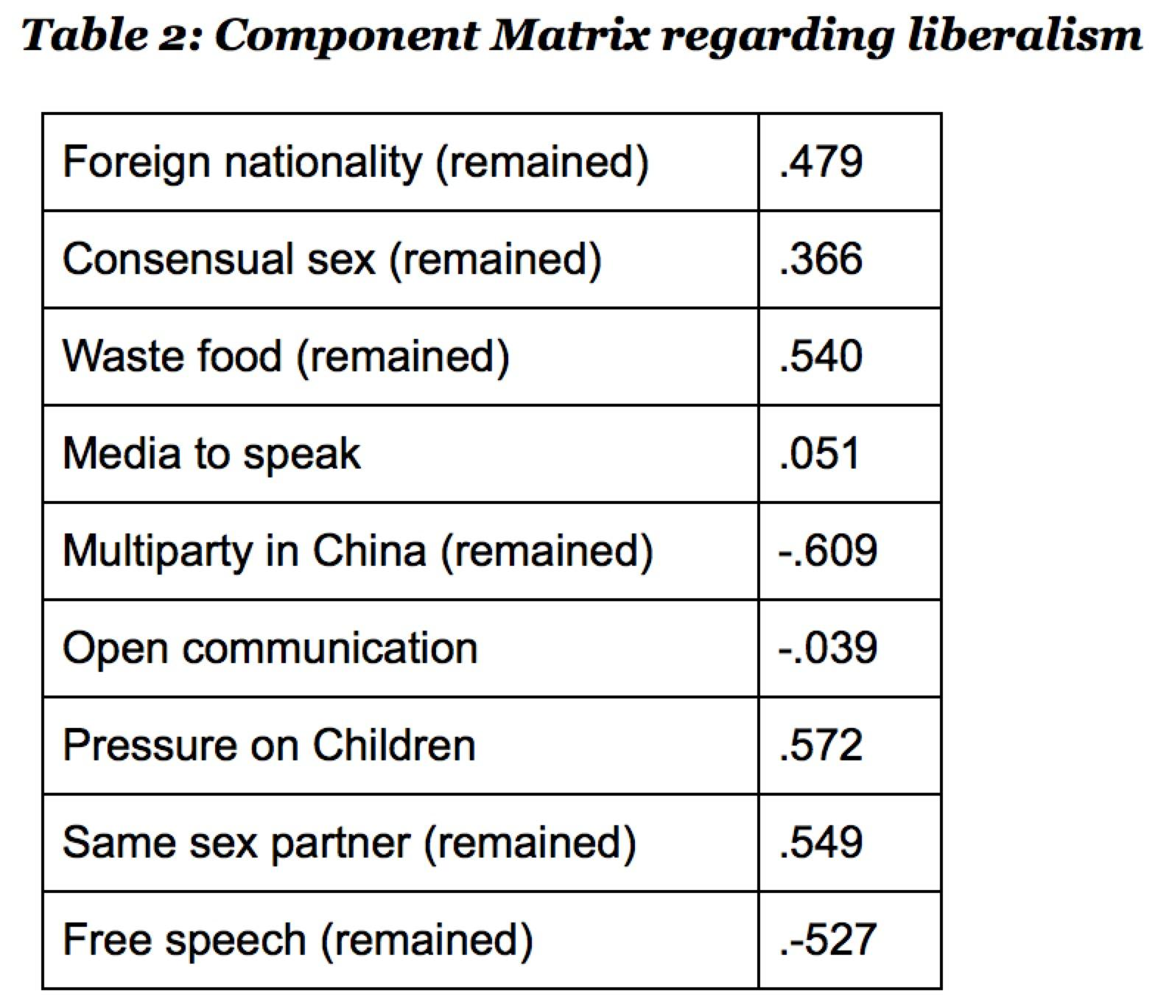
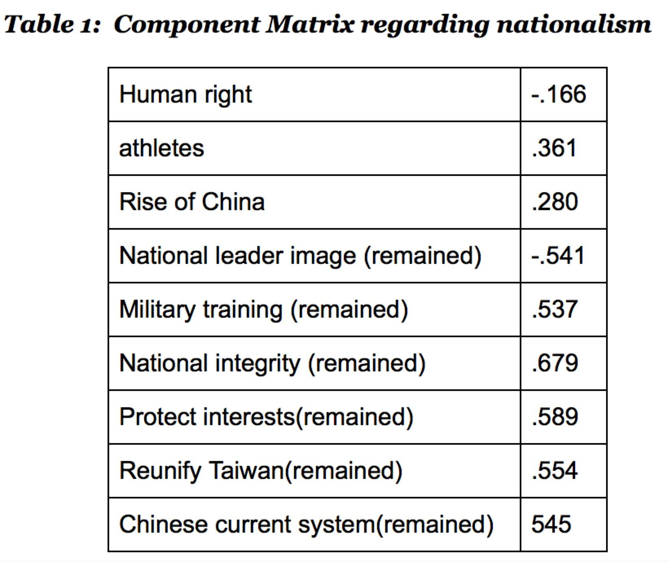
This study defines nationalists as people whose scores regarding nationalism is higher than 0.671 and defines non-nationalists as people whose score is lower than 0.33. Similarly, this study defines liberals as people whose score regarding liberalism is higher than 0.671 and non-liberals as people whose score is lower than 0,33. The rest of people are those who do not generate any preference over either nationalist values or liberals values. The intersection of moderate in nationalism and moderate in liberalism is defined as the “agnostics”. There are in total 127 agnostics out of the 583 participants. These people are specifically examined by this research. See table 4.

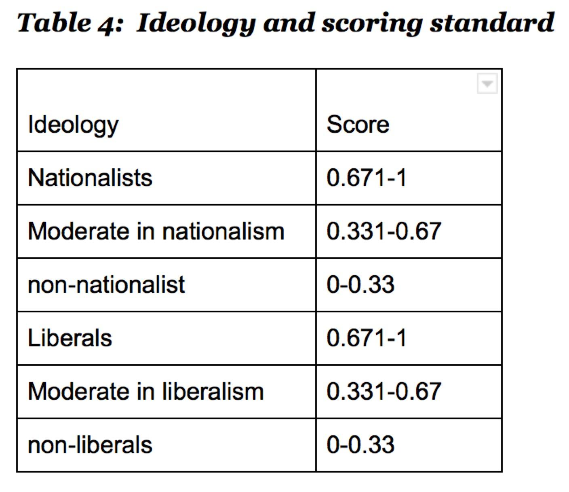
3.2.2. individual’s media diet-- tightly vs. loosely censored media (dependent variable of H1 and H2)

This paper classifies media resources based on the degree of state-censorship one bears. Studies show that the deeper state-censorship, the more nationalistic the news resources tend to be. Based on this standard, this paper classify news resources in China into four groups and the degree of censorship decreases successively --state official media eg: CCTV; for-profit commercial news portal (eg:Baidu News); social media eg: (Wechat): overseas media eg: (New York Times). State official media receives the most censorship and become the most nationalist while overseas media receives almost no censorship and are the most progressive media resources. For profit news portal, by the time this research is conducted, two facts came to mind. Many big news portals such as Baidu, Sohu etc. have officially announced their advocacy of party policies and Fenghuang news, the well known more progressive news portal was ordered by the government to “self-regulate”. These facts signal state’s strengthening censorship over big news portals, thus I classify it as the tightly state-censored media type. Social media and overseas media altogether are considered as loosely state-controlled media due to their discursive nature. Admittedly, the classification of media types is not absolute and is based on this researcher’s own evaluation but its confirmed through a pretest. See Table 5.

3.2.3. Ideology -- Ideologues vs. Agonistics (Independent Variable of H3 and H4)

Ideologues are nationalists and liberals and the classification is the same as mentioned above. Agnostics are defined as lying of the intersection of moderates in nationalism and moderates in liberalism. Those are people who do not show any consistent preference toward either liberalism or nationalism. There are 127 agnostics out of the 583 participants.

3.2.4. Purpose of Media Consumption -- Entertainment vs Learning (Dependent variable of H3 and H4)
For the purpose of media consumption, this paper offers five options -- entertainment, learning about political knowledge, learning others’ views, communication, and others. See the appendix for the full questionnaire. Among these options, entertainment or killing time is coded as entertainment purposes, while learning about political knowledge, learning others’ views and communicating with others are collectively coded as learning purposes.

Table 5: Degree of censorship of different media sources
Media diet | Degree of state censorship | Classification  (coded as)
State official media  eg: CCTV | Most Comprehensive  state-censorship | Tightly state controlled media
For-profit news portal  eg: Baidu News | Moderate  state-censorship | Tightly state controlled media
Social media:  eg: Wechat | Relatively light  state-censorship | Loosely state controlled media
Overseas news  eg: NYT | No state-censorship | Loosely state controlled media

4. Findings
4.1. Descriptive Statistics
583 individuals participated in this survey. Among those people, 41.9% are male, 58.1% are female. The national gender ratio is 53.5% male to 46.5% female. It contains a relatively diverse age span, ranging from 18 to 70. The majority (66.5%) of the participants have at least college education. At the national level, only 9% of the total population has a college degree . See Figure 4-6. Therefore, the dataset is not representative at the national level, as it includes more female and well-educated participants.
In terms of media diet, when asked about “if you want to learn about a particular political news or event, which type of media would be your primary choice?” Overall, about half of participants claim that they use state-owned and state-fund media as their primary media type to learn about politics, while the other half use less censored media types. It’s unexpected to see that only about 15% participants use social media, which is readily accessible to most Chinese due to the popularization of smartphones. See Figure 4.
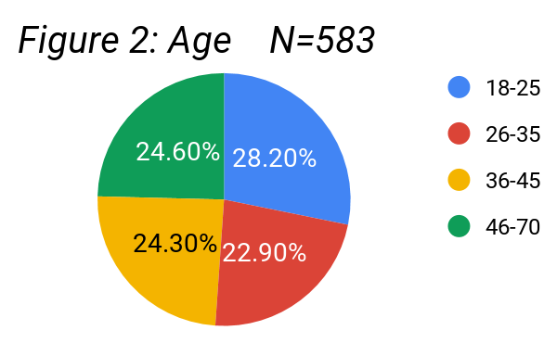
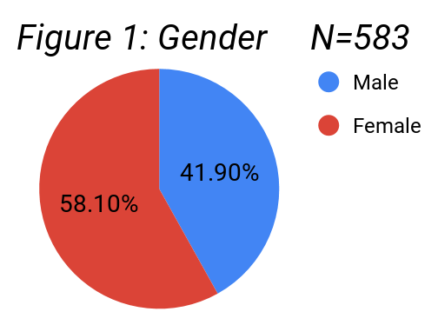

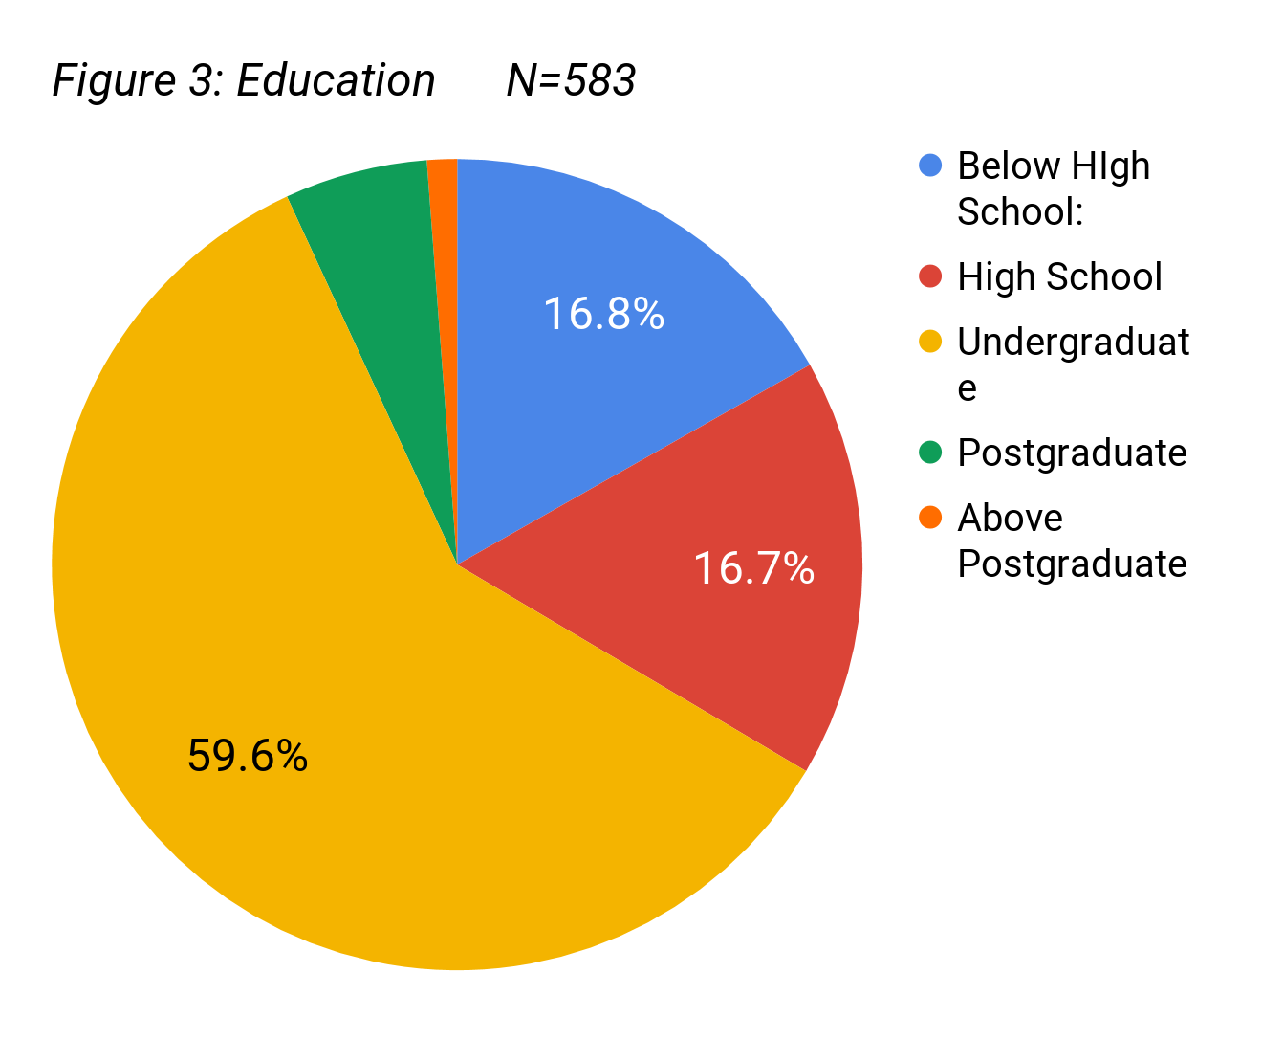
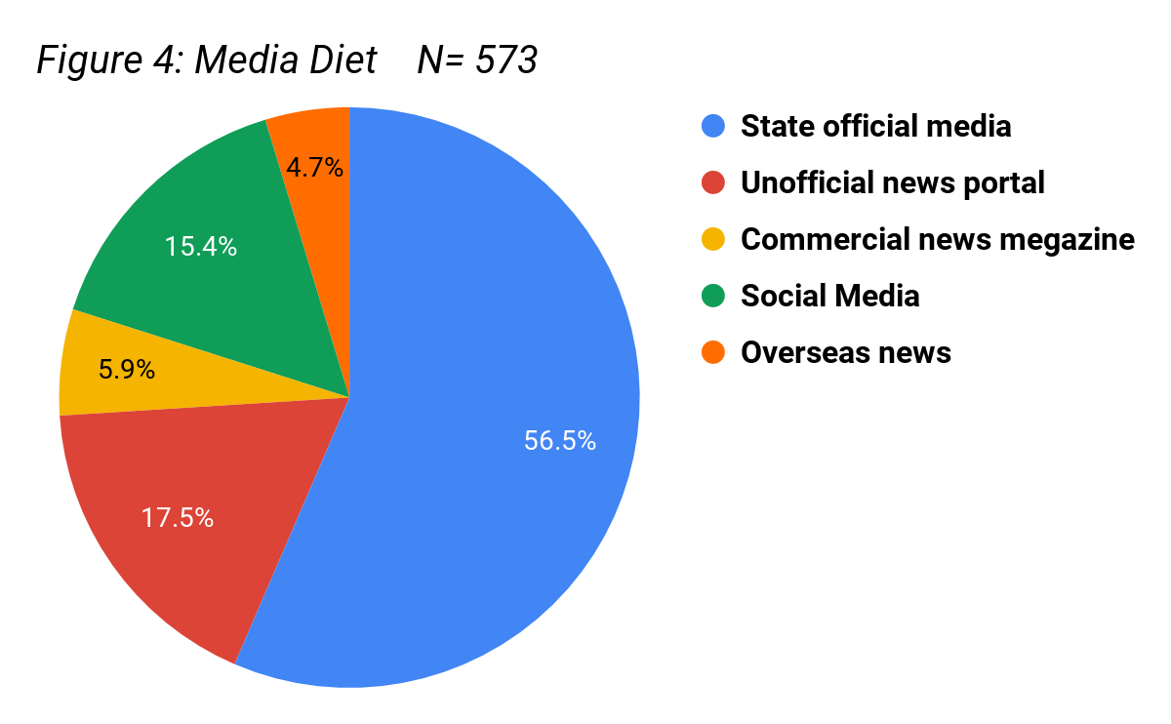

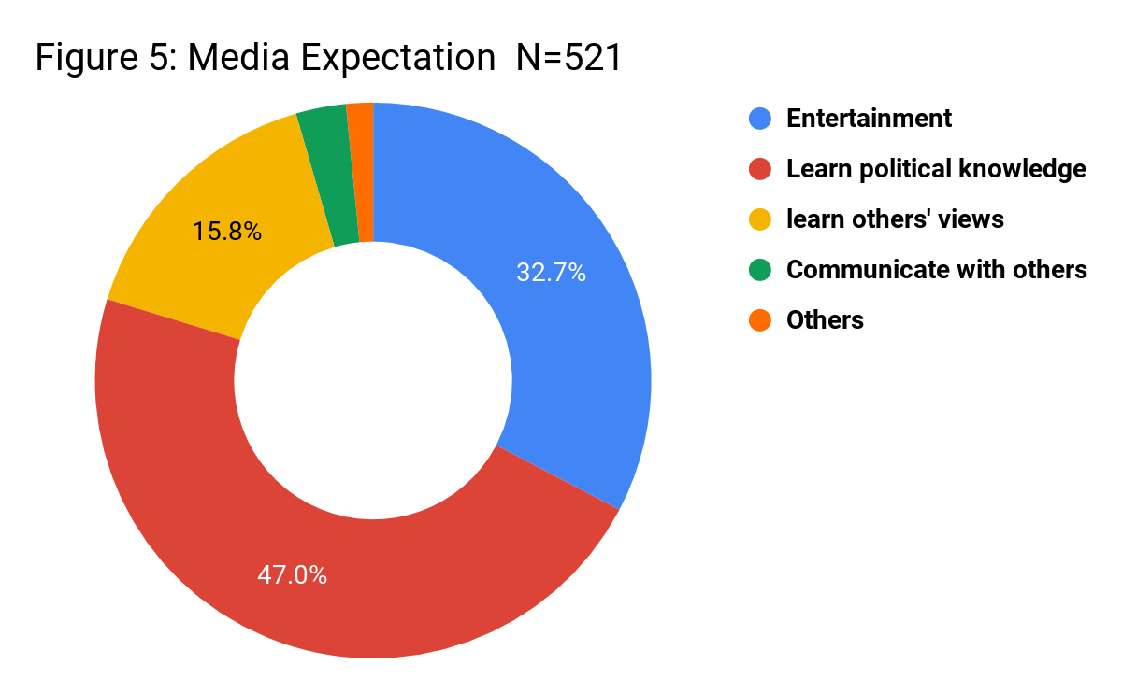
In terms of the expectation of media consumption, most people claim that they use their declared media to learn about political knowledge, learn others’ views or communicate with others, what collectively refer to as “learning purposes”. On the other hand, 29.2% of the participants claim that they use the media mainly to entertain, referred as “entertainment purposes”. See Figure 5.

In terms of the assessment of credibility of different media sources, a large majority (85.1%) believes that the state official media is either credible or very credible, collectively refer to as credibility rate. Surprisingly, overseas media is considered the next credible sources (54.7%). The neutrality rate is the lowest for unofficial news portal. See Figure 6.
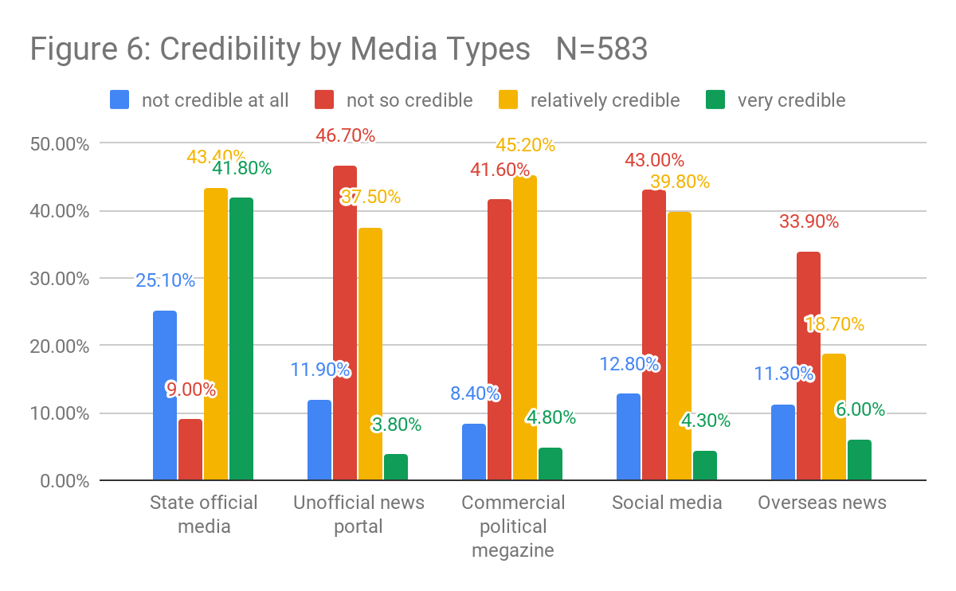

In terms of the assessment of neutrality of difference media sources, still a great majority considers state official media as very neutral or relatively neutral sources, collectively refer to as neutrality rate. The neutrality rate is lowest for unofficial news portal. See Figure 7.
Respondants’ degree of liberalism and degree of nationalism are measured by different statements and lie along different dimensions. The findings confirm that in Chinese society, pro-nationalism does not directly translate to liberalism and vice versa. However, it is also very rare (around 10%) for one to be both a nationalist and a liberal. In fact, nearly half (48.9%) of the respondents are nationalist who remain moderate on liberal statements. See Figure 8. (eg: M-N & M-L refers to moderate in nationalism and moderate in liberalism.) Given liberals and nationalists are not natural antagonists, the finding also shows that the more liberal one is, the less likely one become a nationalist. See Figure 9.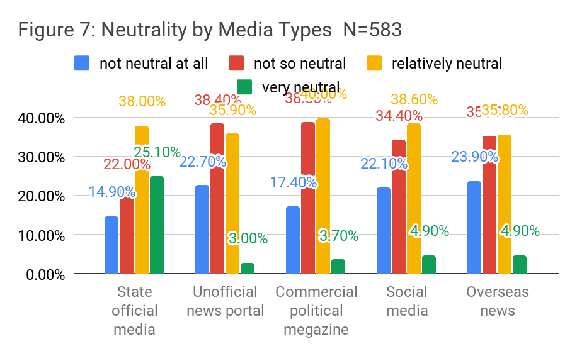
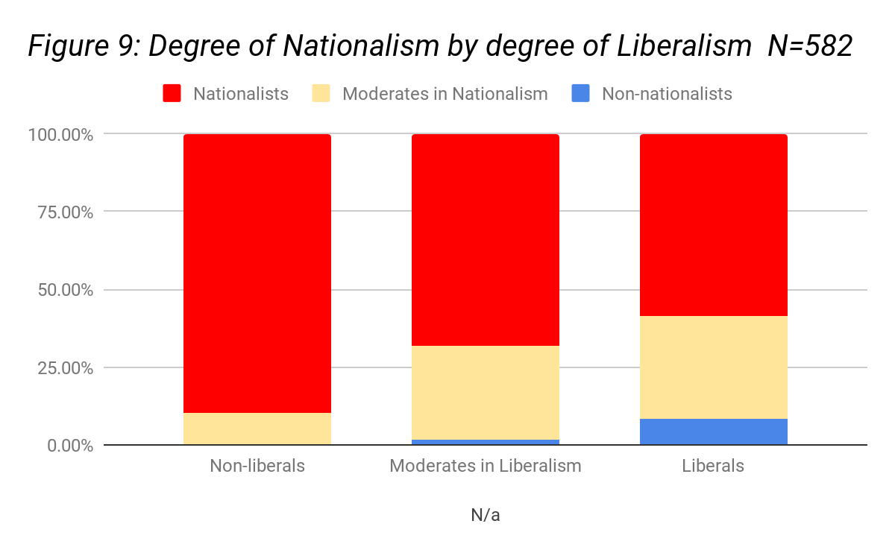
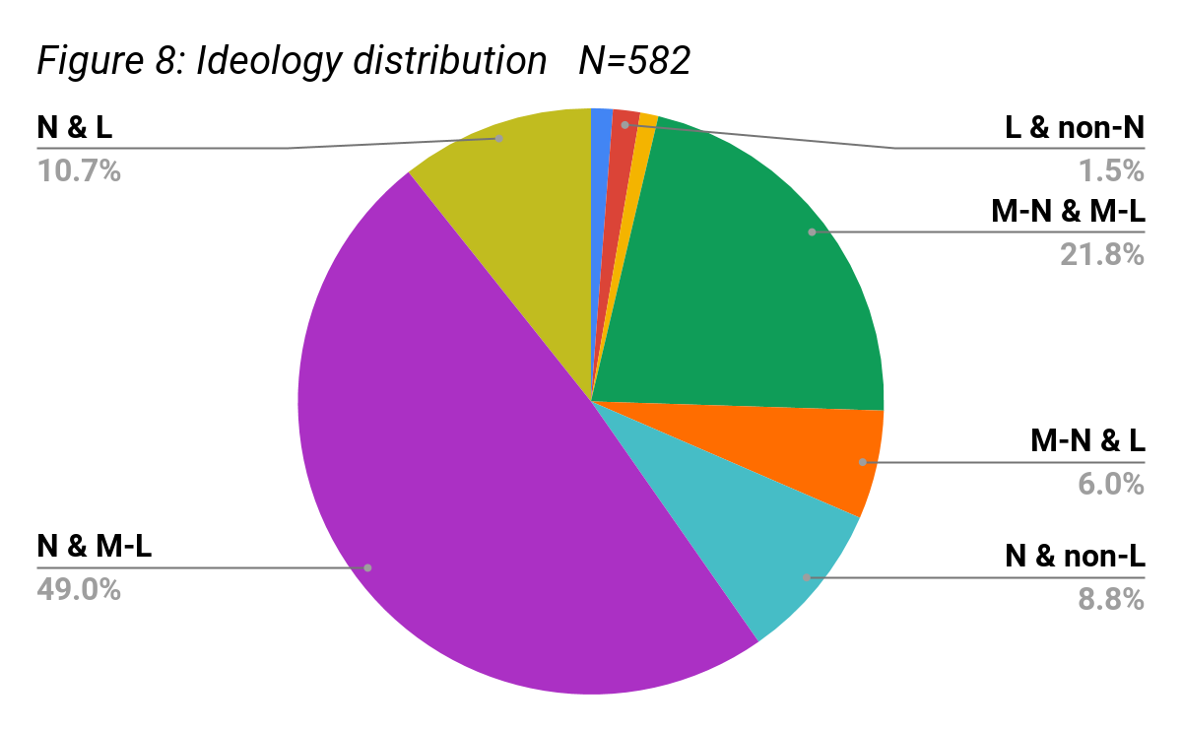

4.2. Testing the hypotheses
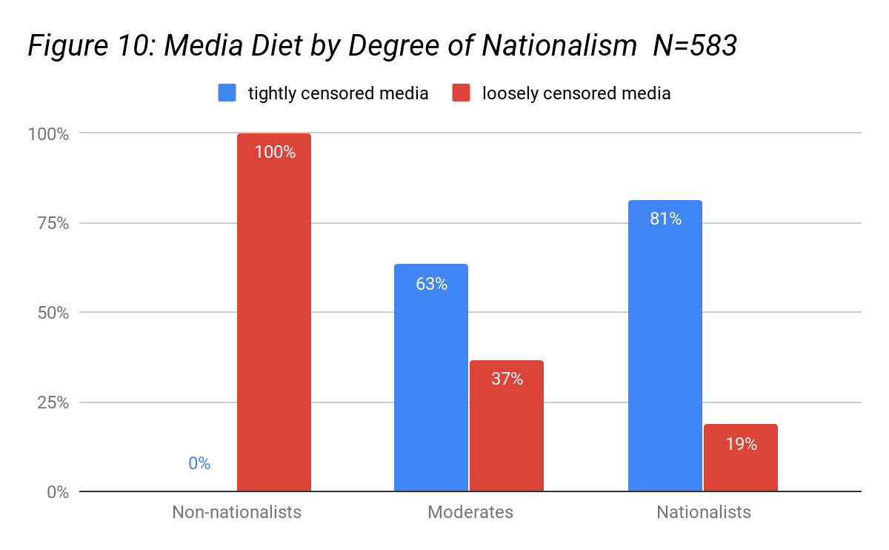
4.2.1. The overall finding confirms the H1: the more nationalistic one is, the more likely he or she uses tightly state-controlled media to learn about politics. Among non-nationalists, none of these repondants ever uses tightly state-censor media to learn about politics, 63% moderates use tightly state-censor media and 81% of nationalists use tightly state-controlled media. See Figure 10.

Note: Phi value: .448; Approximate Significance: 000;
Cramer’s V: .317; Approximate Significance: 000;

4.2.2. The overall finding confirms H2: the more liberal one is, the more likely he or she uses loosely state-controlled media to learn about politics. Among non-liberals, only 7.1% of them use loosely state-censored media, 25.9% of moderates use loosely state-censored media and 37.1% of liberals use loosely state-censored media. See Figure 11.
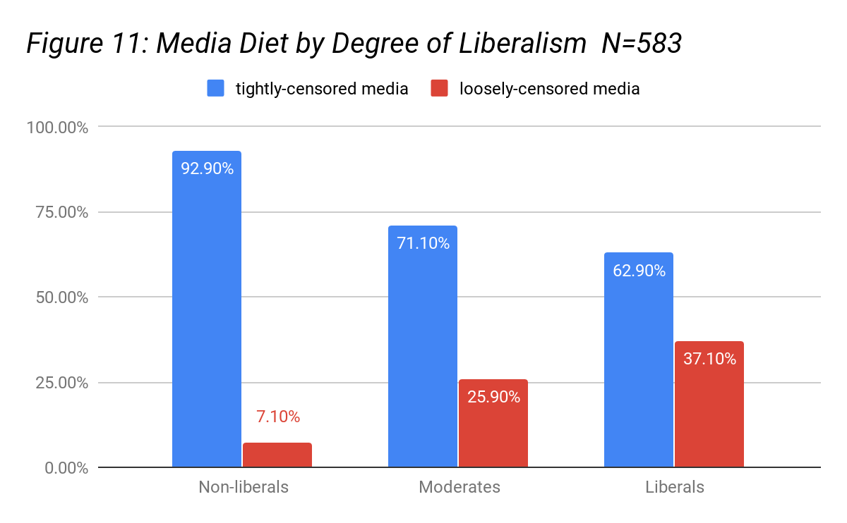
Note: Phi value: .214; Approximate Significance: 001;
Cramer’s V: .151; Approximate Significance: 001;

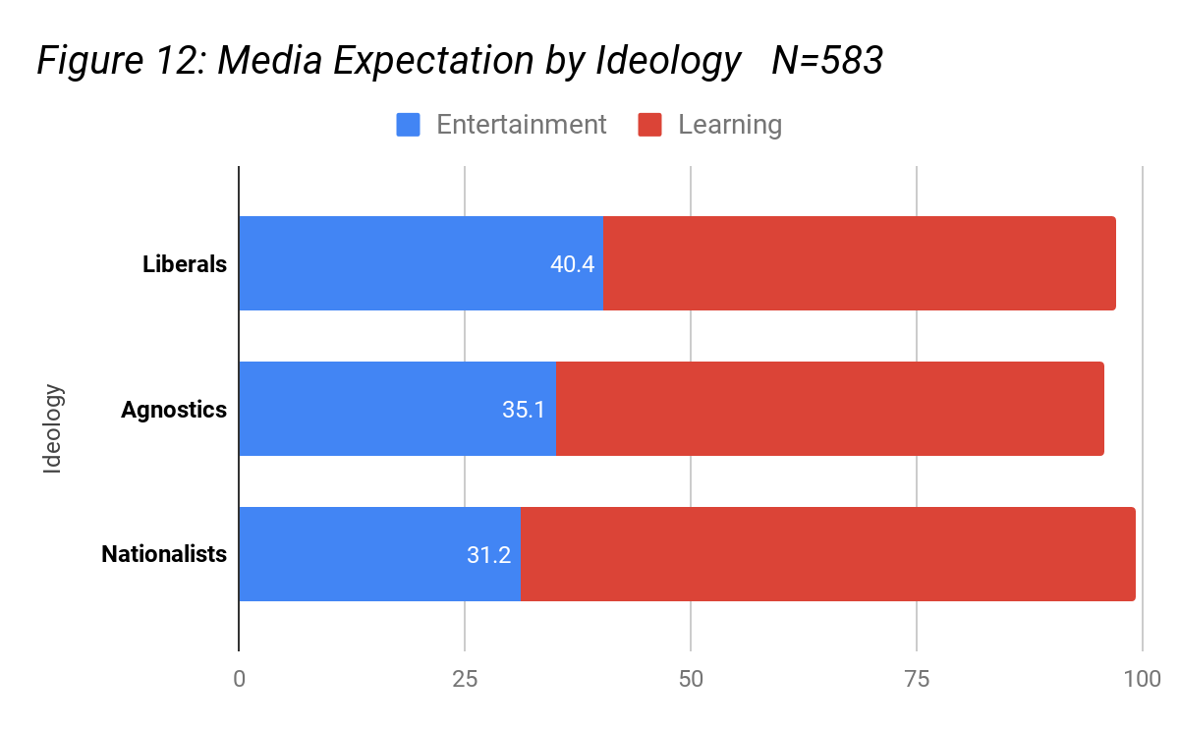
4.2.3. The overall finding confirms both H3: nationalists are more likely to use media for learning purposes than agnostics and H4: liberals are more likely to use media for entertainment purposes than agnostics. As indicated by Figure 12.

Note: for H3: Phi value: .315; App Sig: 000; Cramer’s V: .223; Approximate Significance: 000;
for H4: Phi value: .209; App Sig: 011; Cramer’s V: .148; Approximate Significance: 011;

5. Discussion
As indicated by Figure 4, given counterintuitive, nearly half of the participants use state official media as their primary media to learn about politics while less than one third use loosely regulated media such as commercial magazines, social media or overseas media. This finding shows that state official media still dominates people’s media diet in learning about politics in China.
As indicated by Figure 7 and Figure 8 , given the clear ideological affiliation of state-owned and state-fund media, participants still rank these tightly censored media types as the most credible and neutral media sources with respect to others. This finding suggests that the strategy of media censorship and the penetration of patriotic education worked in China.
Furthermore, in China, pro-nationalism does not directly translate to anti-liberalism and vice versa. However, only about ten percent of the participants are both liberals and nationalists based on this paper’s standard (score >0.67). The number is even smaller if we raise the bar. That means the extremists are generally mutually exclusive. A small majority of people are nationalists with moderates attitudes toward liberalism.
Given both liberals and nationalist exist in Chinese society, the numbers are uneven. More than half of the participants are able to possess consistent nationalistic values while only about 10 percent are able to possess consistent liberal values. This finding supports Wu’s (2014) study that viewed chronically, it was a smaller liberal-oriented interpretive community that arise from the dense mainstream and soon become consolidated that construct the liberal community in China. Liberals in China are still considered a minority given their voice is high.
While nationalists in China generally adhere to nationalistic media, liberals in China, different from those liberals in western countries, are open to nationalistic values to a certain extent. However, compared with others, they are clearly more likely to use less censored media type where learning opinions different from what the state commonly endorses is possible. The reason might be that the media censorship policies which help penetrate nationalistic ideology also alienate people who can witness the information gap from accessing to less regulated or non-regulated media sources. Knowing that the state affiliated media speak for the party rather than for the truth leads them to seek for “different sources”.
DiMaggio et al. (1996) found that in the U.S. ideologues use the media to learn politics while agnostics use it mainly for entertainment purposes. This finding works differently for liberals and nationalists in China. In fact, in China, the more nationalistic one is, the more likely he or she is using news media for learning purposes while the more liberal one is, the more likely he or she is using it for entertainment purposes. This finding resonates Wu’s (2014) study that suggests liberalism in China came from entertainment. The reason might be that most Chinese grow up in a nationalistic educational setting and have strong predilections to uphold nationalistic values. When they actively use media to learn, they would hardly encounter any cross-cutting exchanges. Therefore, the use of media only strengthens their degree of nationalism. Meanwhile, when people use the media mainly for entertainment purpose, they may feel more comfortable to deliberate those cross-cutting liberal ideas that spilled over incidentally.
6. Conclusion:
It is unexpected to see the formation of political polarization happening in an undemocratic regime where the state controls ideological apparatuses. This essay posits that the formation of ideological polarization in China occurs as a result of different media diet of people in learning politics. In other words, nationalists adhere to nationalistic news resources while liberals adhere to less regulated media sources. For media type, being less regulated per se does not mean being progressive. In fact, there is no “progressive media” in opposition of nationalistic media where people can learn liberal values. That’s the reason why this study concludes that most theories in western politics do not work for China’s situation. In other words, this paper posits that the reason liberals turn to less regulated sources is due to the side effects of media censorship policies. It is the dual effects of the information censorship that contribute to the current state of polarization. As for the process of polarization, that is why the agnostics in the middle constantly shift to the extreme, this finding confirms that it is due to different purpose of media consumption. That resonates Mutz’s study that potential for deliberation occurs where politics comes up only incidentally, but is not the central purpose of the discussion space.

Reference:

Althusser, L. (1971), Lenin and Philosophy, and other Essays. London, England: New Left Books

Baldassarri, D., & Goldberg, A. (in press). Neither ideologues, nor agnostics: Alternative voters’ belief system in an age of partisan politics. American Journal of Sociology.

Chinese Political Compass (CPC). (n.d.). Retrieved from http://zuobiao.me

Converse, P. E. (1964). The nature of belief systems in mass publics. In D. Apter (Ed.), Ideology and discontent (pp. 206–261). New York, NY: Free Press.

Chin-Chuan Lee (1990), “Mass media: of China, about China” , The interplay of Politics and journalism (New York: Guilford Press, 1990)

Chan, (2007), “Guiding Public Opinion Through Agenda-Setting: China’s Media Policy Since the 1990s.” Journal of Contemporary China, Nov, 547-559

Converse, P. E. (1964). The nature of belief systems in mass publics. In D. Apter (Ed.), Ideology and discontent (pp. 206–261). New York, NY: Free Press.

DiMaggio, P., Evans, J., & Bryson, B. (1996). Have Americans’ social attitudes become more polarized? American Journal of Sociology, 102, 690–755.

Festinger (1957): A Theory of cognitive dissonance. Stanford, CA: Stanford University Press.
Green and Gerber (1995): American Political Science Review Vol. 102, No. 1 February 2008

Green and Gerber, 1999: Gerber, Alan, and Donald Green. "Misperceptions about perceptual bias." Annual review of political science 2.1 (1999): 189-210.

Jamieson & Cappella, 2008: Jamieson, Kathleen Hall, and Joseph N. Cappella. Echo chamber: Rush Limbaugh and the conservative media establishment. Oxford University Press, 2008.

Le, Y., & Yang, B. (2009). Ideological and political factions of China’s Internet users [Chinese]. Twenty- First Century, 112, 22–36.

Lei, Y.-W. (2011). The political consequences of the rise of the Internet: Political beliefs and practices of Chinese netizens. Political Communication, 28, 291–322.

Stroud, N. J. (2008). Media use and political predispositions: Revisiting the concept of selective exposure.Political Behavior, 30, 341–366.

Tang, W. (2005). Public opinion and political change in China. Stanford, CA: Stanford University Press.

Wu, Angela Xiao（2014）International Journal of Communication, 2014, Volume 8, Issue 1, p. 2650

Wu, AX (2014) 'Ideological polarization over a China-as-superpower mind-set: An exploratory charting of belief systems among Chinese internet users, 2008-2011' International Journal of Communication, vol. 8, no. 1, pp. 2650-2679.

Ya-Wan Lei (2011) The Political Consequence of the Rise of the Internet: Political Beliefs and Practices of Chinese Netizens, 291-322

Iyengar et al. (2012) :Iyengar, Shanto, Gaurav Sood, and Yftach Lelkes. "Affect, Not Ideology A Social Identity Perspective on Polarization." Public opinion quarterly 76.3 (2012): 405-431.

Iyengar, S., & Hahn, K. S. (2009). Red media, blue media: Evidence of ideological selectivity in media use. Journal of Communication, 59, 19–39.

Chinese Political Compass (CPC). (n.d.). Retrieved from http://zuobiao.me
It is at birth ratio.
This number is reported by last census in 2010.
Supporting information (SI) is located at http://angelaxiaowu.com/files/IJoC_supporting_material.pdf.
See https://www.cfr.org/backgrounder/media-censorship-china

